 | INTERNATIONAL TELECOMMUNICATION UNION  TELECOMMUNICATION  STANDARDIZATION SECTOR  STUDY PERIOD 2025-2028 |  |  |  | TSAG-TD35
 |  |  |  |  | TSAG
 |  |  |  |  | Original: English
 |  |  |  |  | Geneva, 26-30 May 2025
TD
(Ref.: ITU-D TDAG-DT/6(REV.3)
Source: |  | ITU-D TDAG
Title: |  | LS/i/r on Work on Digital Transformation (reply to TSAG-LS24) [from ITU-D TDAG]
LIAISON STATEMENT
For action to: |  |  |  | TSAG
For information to: |  |  |  | -
Approval: |  |  |  | ITU-D TDAG meeting, 23 May 2024
Deadline: |  |  |  | -
Contact: |  |  | Ms Roxanne McElvane Webber, Chairman TDAG |  |  | E-mail: roxanne.webber@fcc.gov
Contact: |  |  | Mr Bruno Ramos,  Deputy to the Director, a.i., Telecommunication Development Bureau |  |  | E-mail: bruno.ramos@itu.int

Please see below.

Telecommunication Development  Advisory Group (TDAG)  31st Meeting, Geneva, Switzerland, 20-23 May 2024 |  |  |  | 
 |  |  |  | TDAG – LS xx
 |  |  |  | 23 May 2024
 |  |  |  | English only
Chair, Telecommunication Development Advisory Group (TDAG)
Reply Liaison statement to TSAG: Work on Digital Transformation
For action to: |  | TSAG
For information to: |  | --
Deadline: |  | --
Contact: | Name/Organization/Entity: |  | Ms Roxanne McElvane Webber, Chairman TDAG
 | Phone number: |  | +1 202 418 1489
 | E-mail: |  | roxanne.webber@fcc.gov
Contact: | Name/Organization/Entity: |  | Mr Bruno Ramos, Deputy to the Director, a.i., Telecommunication Development Bureau
 | Phone number: |  | N/A
 | E-mail: |  | bruno.ramos@itu.int
Summary:
This liaison statement contains a reply to TSAG-LS24 liaison statement to TDAG which provided additional information on TSAG Rapporteur Group on Sustainable Digital Transformation.
TDAG acknowledges the liaison statement TSAG-LS24 and, as requested, provides this reply to clarify the role of ITU-D and BDT in Digital Transformation.
Digital Transformation is integral part of the ITU-D mandate as established by the outcomes of the 2022 World Telecommunications Development Conference (WTDC). In particular, WTDC-22 adopted the Kigali Action Plan (KAP) which identifies Digital Transformation as one of the five ITU-D priorities. See figure below (extracted from the final report of WTDC 2022).
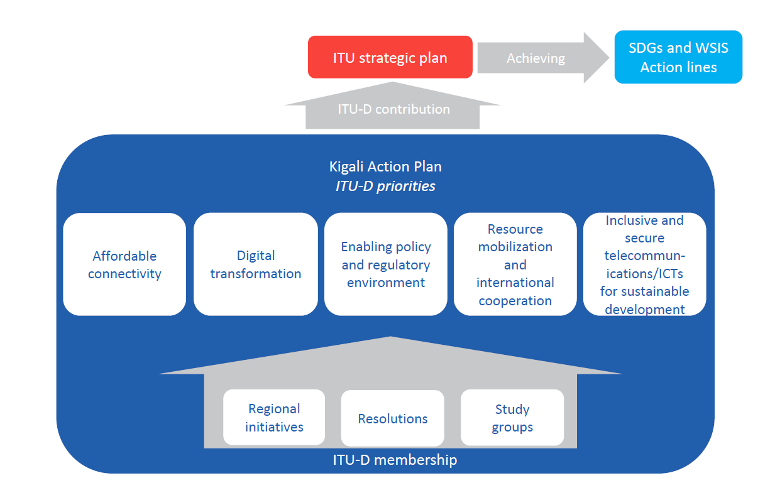

The objective of this priority is to: (1) develop telecommunications/ICTs, applications, and services to close the digital divide and empower people and societies for sustainable development; (2) support ITU-D membership in fostering digital transformation through ICT entrepreneurship, increased innovation in the ICT ecosystem, and to empower and create new opportunities for grassroots stakeholders in the telecommunication/ICT sector.
As such, the BDT, through its Secretariat, is currently executing a series of initiatives, programmes and activities aimed at achieving digital transformation in a holistic and systematic manner.
- BDT work on Digital Transformation implemented through the BDT Operational Plan for the period June 2023 – April 2024 can be found in document TDAG-24/2.
- BDT-wide efforts to support individual countries plans and efforts towards digital transformation. Notable examples include:
  - Digital government transformation
    - Increasing access for Member States to ITU tools and knowledge products to accelerate digital transformation through the GovStack project, under which a set of 15 specifications for digital government building blocks (e.g., Id, payments, exchange, consent, registries, e-Signature, GIS, eMarketplace, etc.) were published
  - Capacity and Skills Development Programmes, Tools, and Platforms
    - The ITU Academy and the ITU Academy Training Centres (ATCs)
    - Capacity Development for Digital Transformation funded by the European Commission to provide ITU Academy training to policymakers and government officials within the ICT sector.
    - The Digital Transformation Centres (DTC) Initiative
  - Policy and Regulation Tools
    - The Digital Regulation Platform and Training
    - The G5 Benchmark employed to assess of the state of readiness of national policy, legal and governance frameworks for digital transformation.
    - The visualization tools on the G5 Accelerator platform that allow for a deep and customized analysis of data based on 54 indicators by region and country.
  - Data and Analysis
    - ITU Statistics collects and disseminates vital information and research to support evidence-based decision-making for universal and meaningful connectivity and sustained digital transformation.
    - The ITU Environment Division produces key products and services, including data and analysis, for a green digital transformation.
  - Digital infrastructure planning, development, and deployment.
  - Initiatives on gender, youth, accessibility, and cybersecurity to support inclusive digital transformation, and safe use of digital technologies and services.
Given the importance of this topic for the work of ITU-D, TDAG agrees to liaise with TSAG to ensure cohesion of efforts, avoid duplication of mandates and scope of work, and to foster cross-sector coordination.
Finally, ITU-D does not develop technical standards, including for digital transformation, and as such, duplication of work in this regard is not envisioned.
With the above in mind, ITU-D shall proceed with its work in relation to digital transformation as envisaged under WTDC Kigali Action Plan (KAP)
Thanking TSAG in advance and looking forward to constructive and effective coordination.
________________

