 | INTERNATIONAL TELECOMMUNICATION UNION  TELECOMMUNICATION  STANDARDIZATION SECTOR  STUDY PERIOD 2025-2028 |  |  | SG13-TD178/WP3
 |  |  |  | STUDY GROUP 13
 |  |  |  | Original: English
Question(s): |  | 2/13 |  | Tashkent, 28 October - 6 November 2025
TD
Source: |  | Editors
Title: |  | Draft new Recommendation ITU-T Y.NGNe-NCI-arch: "Functional architecture of NGN evolution for support network and cloud interworking"
Contact: |  | Wei Wang  China Telecom  China | Tel:+86-10-50902397  E-mail: wangw36@chinatelecom.cn
Contact: |  | Yue Su  MIIT  China | Tel:+86-10-  E-mail: suyue1@caict.ac.cn
Contact: |  | Nanxiang Shi  China Mobile  China | Tel:  E-mail: shinanxiang@chinamobile.com
Contact: |  | Huan Deng  China Telecom  China | Tel: +86-010-50902867  E-mail: denghuan@chinatelecom.cn

Abstract: | This document is the output of draft Recommendation: “Functional architecture of NGN evolution for support network and cloud interworking”. This document includes the results of discussion in the Q2/13 meeting which was held on 28 October - 6 November, 2025.

This document is the output document for draft Recommendation ITU-T Y.NGNe-DCI-arch “Functional architecture of NGN evolution for support network and cloud interworking” based on the previous output document TD35/WP3, the following contribution, and the meeting discussion (28 October - 6 November 2025).
TD 35  (WP3/13) | Editor | Draft new Recommendation ITU-T Y.NGNe-NCI-arch: "Functional architecture of NGN evolution for support network and cloud interworking" | 2/13
Base text from the previous SG13 Plenary meeting (March 2025).

C334 | China Academy of Information and Communications Technology | ITU-T Y.NGNe-NCI-arch "Functional architecture of NGN evolution for support network and cloud interworking " - Proposes to revise the content of clause 6 and 7 to Y.NGNe-NCI-arch | Q2/13 | Accepted with modifications
- Proposal of contribution
This contribution proposes to revise the content of clause 6 and 7 to Y.NGNe-NCI-arch based on TD35/WP3 from SG13 meeting held on March 2025.

- Meeting results
The meeting agreed to accept this contribution with modifications.

Table of Contents
1. Scope 4
2. References 4
3. Definitions 4
4. Abbreviations and acronyms 5
5. Conventions 5
6. Background and motivations 5
7. Functional architecture of next generation network evolution to support network and cloud interworking 8
7.1. Functional entities on service stratum 8
7.2. Functional entities of network and cloud interworking on transport stratum 8
8. References points of network and cloud interworking 9
8.1. Internal reference points 9
8.2. External reference points 9
9. Security considerations 9

Draft new Recommendation ITU-T Y.NGNe-NCI-arch

Functional architecture of NGN evolution for support network and cloud interworking

Scope
This draft Recommendation specifies the functional architecture of NGN evolution for support network and cloud interworking, which defines the functional entities (FEs), the reference points between different functional entities, the service procedures and security considerations about NGN evolution for support network and cloud interworking.
The scenarios, requirements and capabilities of NGN evolution for support network and cloud interworking has been proposed in ITU-T Y.2347. This draft Recommendation also builds on published Recommendations [ITU-T Y.2301] and [ITU-T Y.2302].

References
The following ITU-T Recommendations and other references contain provisions which, through reference in this text, constitute provisions of this Recommendation. At the time of publication, the editions indicated were valid. All Recommendations and other references are subject to revision; users of this Recommendation are therefore encouraged to investigate the possibility of applying the most recent edition of the Recommendations and other references listed below. A list of the currently valid ITU-T Recommendations is regularly published.
The reference to a document within this Recommendation does not give it, as a stand-alone document, the status of a Recommendation.
[ITU-T Y.2301] Recommendation ITU-T Y.2301 (2013), Network intelligence capability enhancement – Requirements and capabilities.
[ITU-T Y.2302] Recommendation ITU-T Y.2302 (2014), Network intelligence capability enhancement – Functional architecture.
[ITU-T Y.3512] Recommendation ITU-T Y.3512 (2014), Cloud computing – Functional requirements of Network as a Service.
[ITU-T Y.3515] Recommendation ITU-T Y.3515 (2017), Cloud computing – Functional architecture of Network as a Service.
[ITU-T Y.2347] Recommendation ITU-T Y.2347 (2024), Requirements and scenarios of NGN evolution for support network and cloud interworking.
TBD

- Definitions
- Terms defined elsewhere
This Recommendation uses the following terms defined elsewhere:

3.1.1 Next Generation Network (NGN) [ITU-T Y.2001]: A packet-based network which is able to provide telecommunication services and able to make use of multiple broadbands, QoS-enabled transport technologies and in which service-related functions are independent from underlying transport-related technologies. It enables unfettered access for users to networks and to competing service providers and/or services of their choice. It supports generalized mobility which will allow consistent and ubiquitous provision of services to users.
3.1.2 Network Intelligence Capability Enhancement (NICE) [ITU-T Y.2301]: An enhancement for NGNs supporting some intelligent capabilities for the provisioning of services according to requirements of users and application providers. These intelligent capabilities (termed as "NICE capabilities") enable operators to assign and dynamically adjust specific network resources based on the requirements, as well as support interfaces for users and applications enabling on-demand resource and service provision.

- Terms defined in this Recommendation

- Abbreviations and acronyms
AI: Artificial intelligence
FE: Functional entity
NCI: Network and cloud interworking
QoS: Quality of service
SFE: sub functional entity
- Conventions
In this Recommendation:
The keywords "is required to" indicate a requirement which must be strictly followed and from which no deviation is permitted, if conformance to this Recommendation is to be claimed.
The keywords "is recommended" indicate a requirement which is recommended but which is not absolutely required. Thus, this requirement need not be present to claim conformance.

Background and motivations
  - Functional architecture of NICE

NICE is the evolution of NGN, which enhances its intelligent capabilities and enables operators to adjust resources in specific networks to meet user demands. In addition, NICE also supports the network to provide interfaces to users and applications, so that users and applications can access resources in the network. Since network and cloud interworking may involve resource interoperability and unified management between different management domains in practical applications, such as cloud and network belonging to different operators, the Open environment FE, Policy control FE, Policy enforcement FE and other FE functions in the NICE functional architecture can be applied to network and cloud interworking scenarios.
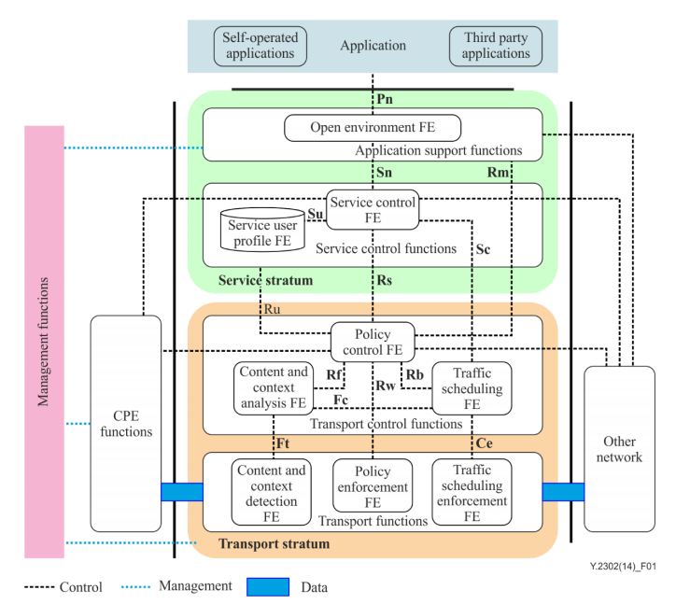
Figure 6-1 Functional architecture of NICE

The functional architecture of NICE includes service stratum and transport stratum. The service stratum contains application support functions and service control functions. The transport stratum contains transport control functions and transport functions.
However, the FEs in the NICE functional architecture cannot fully support the capabilities required by NCI, such as:
1) The Policy Control FE in the NICE functional architecture only focuses on network bandwidth and QoS when generating policies. In NCI, more indicators need to be considered when generating policies, such as computing resources, multi-dimensional resource comprehensive scheduling efficiency, etc.
2) The Policy Enforcement FE in the NICE functional architecture only receives and executes policies related to bandwidth and QoS management. In NCI, policies related to computing resources and multidimensional resource scheduling should also be supported.
3) The Content and context detection FE in the NICE functional architecture only obtains user location information. In NCI, it also needs to obtain the distribution of computing resources, etc.
4) The Policy control FE in the NICE functional architecture does not have the ability to resist malicious attacks. If there are malicious attack sources in other networks, the decision-making process of Policy control FE may be disrupted. Therefore, it is necessary to enhance the safety protection capabilities of Policy control FE.
For other FEs, corresponding enhancements are also needed to enhance the intelligence, agility, reliability of the NICE system to meet the needs of NCI. According to the requirements and capabilities mentioned in [ITU-T Y.2347], a new functional entity which can achieve the test and simulation of end to end service should be added into the functional architecture:
- Service simulation testing FE, which can achieve seamless automatic testing of service capabilities across multiple operators through capabilities such as digital twins, artificial intelligence, and simulation, to test the functions such as service activation and verification. Testing can be performed by both service providers and users.
- Policy optimization FE, which support the policy optimization based on AI, machine learning, and large model algorithms. This FE can assist Policy Control FE in improving and optimizing the policy for unified scheduling of cloud and network resources.

Editors’ note: to consider whether we need policy optimization FE or enhance policy control FE to perform the same functionalities, contributions are welcome.

  - Enhanced functional architecture of NICE to support network and cloud interworking
The functional architecture of enhanced NICE to support NCI is shown in Figure 2. The major components of this functional architecture are in alignment with the NICE functional architecture. In addition, the Service simulation FE is located in the service stratum to achieve seamless automatic simulation and testing of service capabilities in combination with the real-time status of the network.
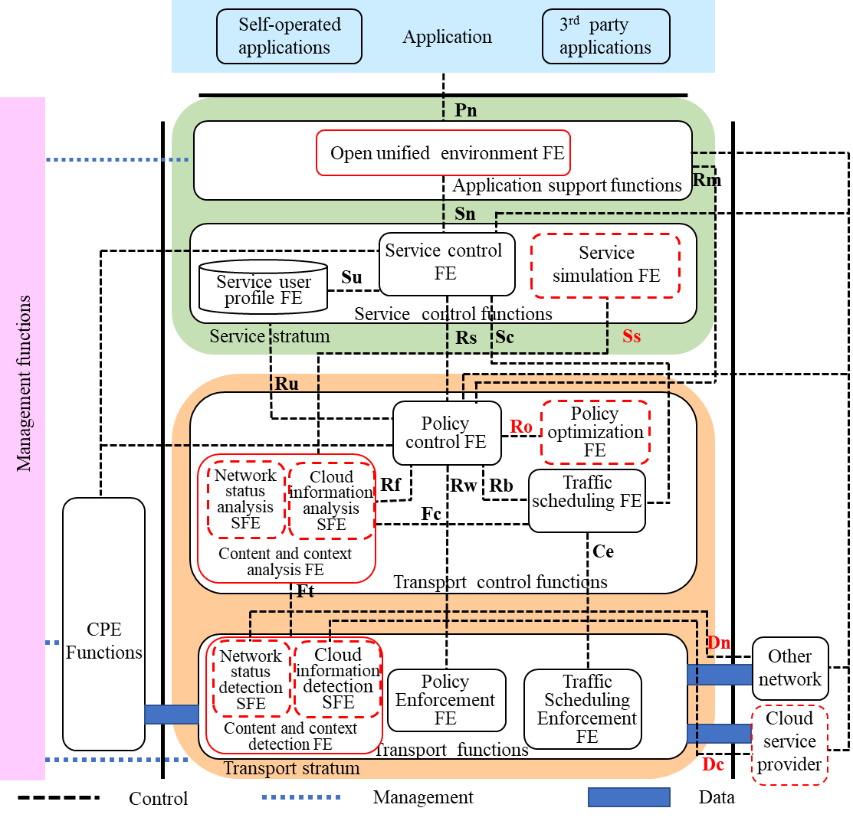
Figure 6-2 Functional architecture of enhanced NICE to support network and cloud interworking
The FEs with solid red border in Figure 2 should be enhanced, and the FEs and SFEs with red dashed border are newly added FEs and SFEs. The red reference points are the newly added.
The Open environment FE should be enhanced to the Open unified environment FE, which should support the opening of capabilities to third-party cloud service providers and network operators.
The Service simulation FE should support seamless automatic testing of service capabilities across multiple operators.
The Policy optimization FE should support the improve and optimization of the policy for unified scheduling of cloud and network resources.
The Content and context detection FE should contain two sub-FEs: Network status detection SFE and Cloud information detection SFE. These two SFEs are responsible for detecting network status provided by network operators and cloud information provided by cloud service providers, respectively. Due to the two SFEs can only obtain the network status and cloud information from trusted network provider and cloud service provider, they also need to obtain the corresponding information through new interfaces with other networks and cloud service providers. Then the two SFEs should report the detected information to the corresponding analysis FEs. The cloud information detection SFE should also be able to detect and report computing resources.
The Content and context analysis FE should contain two sub-FEs: Network status analysis SFE and Cloud information analysis SFE. These two SFEs are responsible for receiving and analysing network/cloud status or information from the corresponding detection SFE. Their calculation results can help Policy control FE complete policy optimization, and can also help Service simulation FE complete network state simulation and testing.
In addition to exchanging data with other networks, the transport layer also needs to exchange data with cloud service providers.

Functional architecture of next generation network evolution to support network and cloud interworking

Functional entities on service stratum
Editor’s note: this section will provide the descriptions of functional entities of network and cloud interworking on service stratum, contributions are welcomed.
7.1.1 Open unified environment FE
The Open unified environment FE supports the opening of capabilities to third-party service providers and network operators for integrated services which require network resource and cloud resource coordination. Its core value lies in breaking down traditional silos between network operators and cloud service providers, establishing a standardized and scalable capability opening platform that enables seamless collaboration across multi-domain entities for integrated service delivery.
7.1.2 Service simulation FE
The Service simulation FE, which leverages technologies such as digital twins, AI, to enables seamless and automated simulation and testing of services across multiple operators, including service activation and service verification. These tests can be executed by either the network provider or cloud service provider.
Service simulation FE receives the analysis results of network resource and cloud resource utilization and availability information from the content and context analysis FE.

Functional entities of network and cloud interworking on transport stratum
Editor’s note: this section will provide the descriptions of functional entities of network and cloud interworking on transport stratum, contributions are welcomed.
7.2.1 Content and context analysis FE
The Content and context analysis FE is a core enhanced functional entity in the transport stratum of the enhanced NICE architecture, specifically optimized to address the demand for accurate, real-time, and multi-dimensional resource insight in network and cloud interworking (NCI) scenarios.
The main functionalities of Content and context analysis FE are aligned with [ITU-T Y.2302], and it is enhanced to contain two sub-FEs: Network status analysis SFE and Cloud information analysis SFE. These two SFEs receive and analyse network/cloud status or information from the corresponding detection SFE.
7.2.2 Policy optimization FE
The Policy optimization FE supports the policy optimization based on AI, machine learning, and large model algorithms. This FE can assist the Policy Control FE in improving and optimizing the policy for unified scheduling of cloud and network resources.
The Policy optimization FE should send the results of policy optimization to the Policy control FE for reference.
7.2.3 Content and context detection FE
The Content and context detection FE is a foundational enhanced FE in the transport stratum of the enhanced NICE architecture, tasked with the core responsibility of collecting real-time, accurate, and comprehensive resource data across network and cloud domains for network and cloud interworking (NCI) scenarios.
The main functionalities of Content and context detection FE are aligned with [ITU-T Y.2302], and it is enhanced to contain two sub-FEs: Network status detection SFE and Cloud information detection SFE. These two SFEs detect network status provided by network operators and cloud information provided by cloud service providers, respectively.
The Network status detection SFE can obtain the network status from other trusted network providers, and report the detected information to the Network resource analysis SFE.
The Cloud information detection SFE can obtain the cloud information from other trusted cloud service providers, and report the detected information to the Cloud resource analysis SFE.

References points of network and cloud interworking

Internal reference points
Editor’s note: this section will provide the descriptions of internal reference points of network and cloud interworking, contributions are welcomed.

External reference points
Editor’s note: this section will provide the descriptions of external reference points of network and cloud interworking, contributions are welcomed.

Security considerations
Editor’s Note: The security considerations of this draft recommendation except for the general security issues of network and cloud interworking will be addressed in this clause, contributions are welcomed.

_______________________

