 |  | International telecommunication union  Telecommunication Standardization Bureau
 |  |  | Geneva, 15 August 2025
Ref: | Corrigendum 1 to TSB Collective letter 2/3  SG3/MA |  | - To Administrations of Member States of the Union;  - The State of Palestine (Res. 99 (Rev. Dubai, 2018));  - To ITU-T Sector Members;  - To ITU-T Associates of Study Group 3;  - To ITU Academia
Tel: | +41 22 730 6828
Fax: | +41 22 730 5853
E-mail: | tsbsg3@itu.int
Web: | https://itu.int/go/tsg3
Subject: | Plenary meeting of Study Group 3; Geneva, 7 November 2025
Dear Sir/Madam,
Further to TSB Collective letter 2/3 of 4 June 2025, we would like to call your attention to TSB Circular 48 Corrigendum 1 (15 August 2025), which concerns the TAP Member State consultation on Determined draft ITU-T D.1142 (ex D.IoTpolicy). Member States are kindly reminded that the deadline for replies to this consultation is 2359 hours UTC on 28 October 2025.
Yours faithfully,  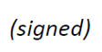  Seizo Onoe  Director of the Telecommunication  Standardization Bureau | 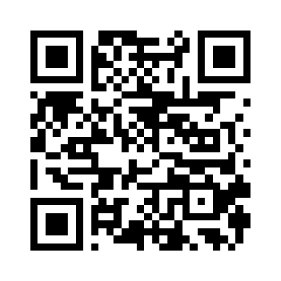ITU-T SG3
 | Latest meeting information

