International telecommunication union
Telecommunication Standardization Bureau
 |  | Geneva, 7 March 2024
Ref: | TSB Circular 178 | To:  - Administrations of Member States of the Union;  - ITU-T Sector Members;  - ITU-T Associates;  - ITU Academia;  - Regional telecommunication organizations;  - Intergovernmental organizations operating satellite systems;  - The United Nations;  - Specialized Agencies of the United Nations and the International Atomic Energy Agency
Contact: | Mr Bilel Jamoussi
Tel: | +41 22 730 6311
Fax: | +41 22 730 5853
E-mail: | gss@itu.int
Copy:
- Chairs and Vice-Chairs of ITU-T Study Groups/TSAG;
- Director of the Telecommunication Development Bureau;
- Director of the Radiocommunication Bureau

Subject: | Global Standards Symposium (GSS-24): Charting the Next Digital Wave: Emerging Technologies, Innovation, and International Standards; New Delhi, India, 14 October 2024
Dear Sir/Madam,
In her Circular letter No. 23/42, and further letters DM-23/1013, DM-23/1014 and DM-23/1015, all dated 30 October 2023, the Secretary-General of the International Telecommunication Union (ITU) announced that the Global Standards Symposium 2024 (GSS-24) will take place in New Delhi, India, on 14 October 2024, followed by the World Telecommunication Standardization Assembly (WTSA-24) from 15 to 24 October 2024.
It is my pleasure to invite both members and non-members of ITU to participate in the GSS-24, which will be held at the same venue as WTSA-24, namely the Convention Center Bharat Mandapam, Pragati Maidan, New Delhi, India. GSS-24 will provide a high-level forum for discussion and coordination, with the theme “Charting the Next Digital Wave: Emerging Technologies, Innovation, and International Standards”.
A High-Level Segment on “Catalysing change: industry & ministerial leaders crafting the future of innovation” will take place from 1130 to 1300 IST, on 14 October 2024. This High-Level Segment will bring together ministers, CEOs, mayors, and academic presidents to engage in a unique dialogue on the innovation of ecosystems, harmonizing regulatory approaches, and harnessing emerging technologies including AI, metaverse, and quantum computing.
More information on the GSS-24, including the draft programme, is available on the GSS website.
Please note that the India Mobile Congress 2024 jointly organized by the Indian Government and the Cellular Operators Association of India will take place in the same venue (Pragati Maidan New Delhi) starting on 15 October 2024.
Whether attending in person or following the discussions remotely, registration is required for all participants and will be carried out exclusively online. Participants representing ITU members are requested to register on the WTSA-24 registration website and those from non-members are invited to register at the following link: https://www.itu.int/net4/CRM/xreg/web/Registration.aspx?Event=C-00013545.
The WTSA-24 website also contains practical information for the event, including visa requirements and hotel details.
General information for participants related to visa, travel, and safety and security measures in force as of 26 February 2024 are available in the Annex 1.
I look forward to welcoming you in New Delhi.
Yours faithfully,  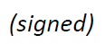  Seizo Onoe  Director of the Telecommunication  Standardization Bureau | 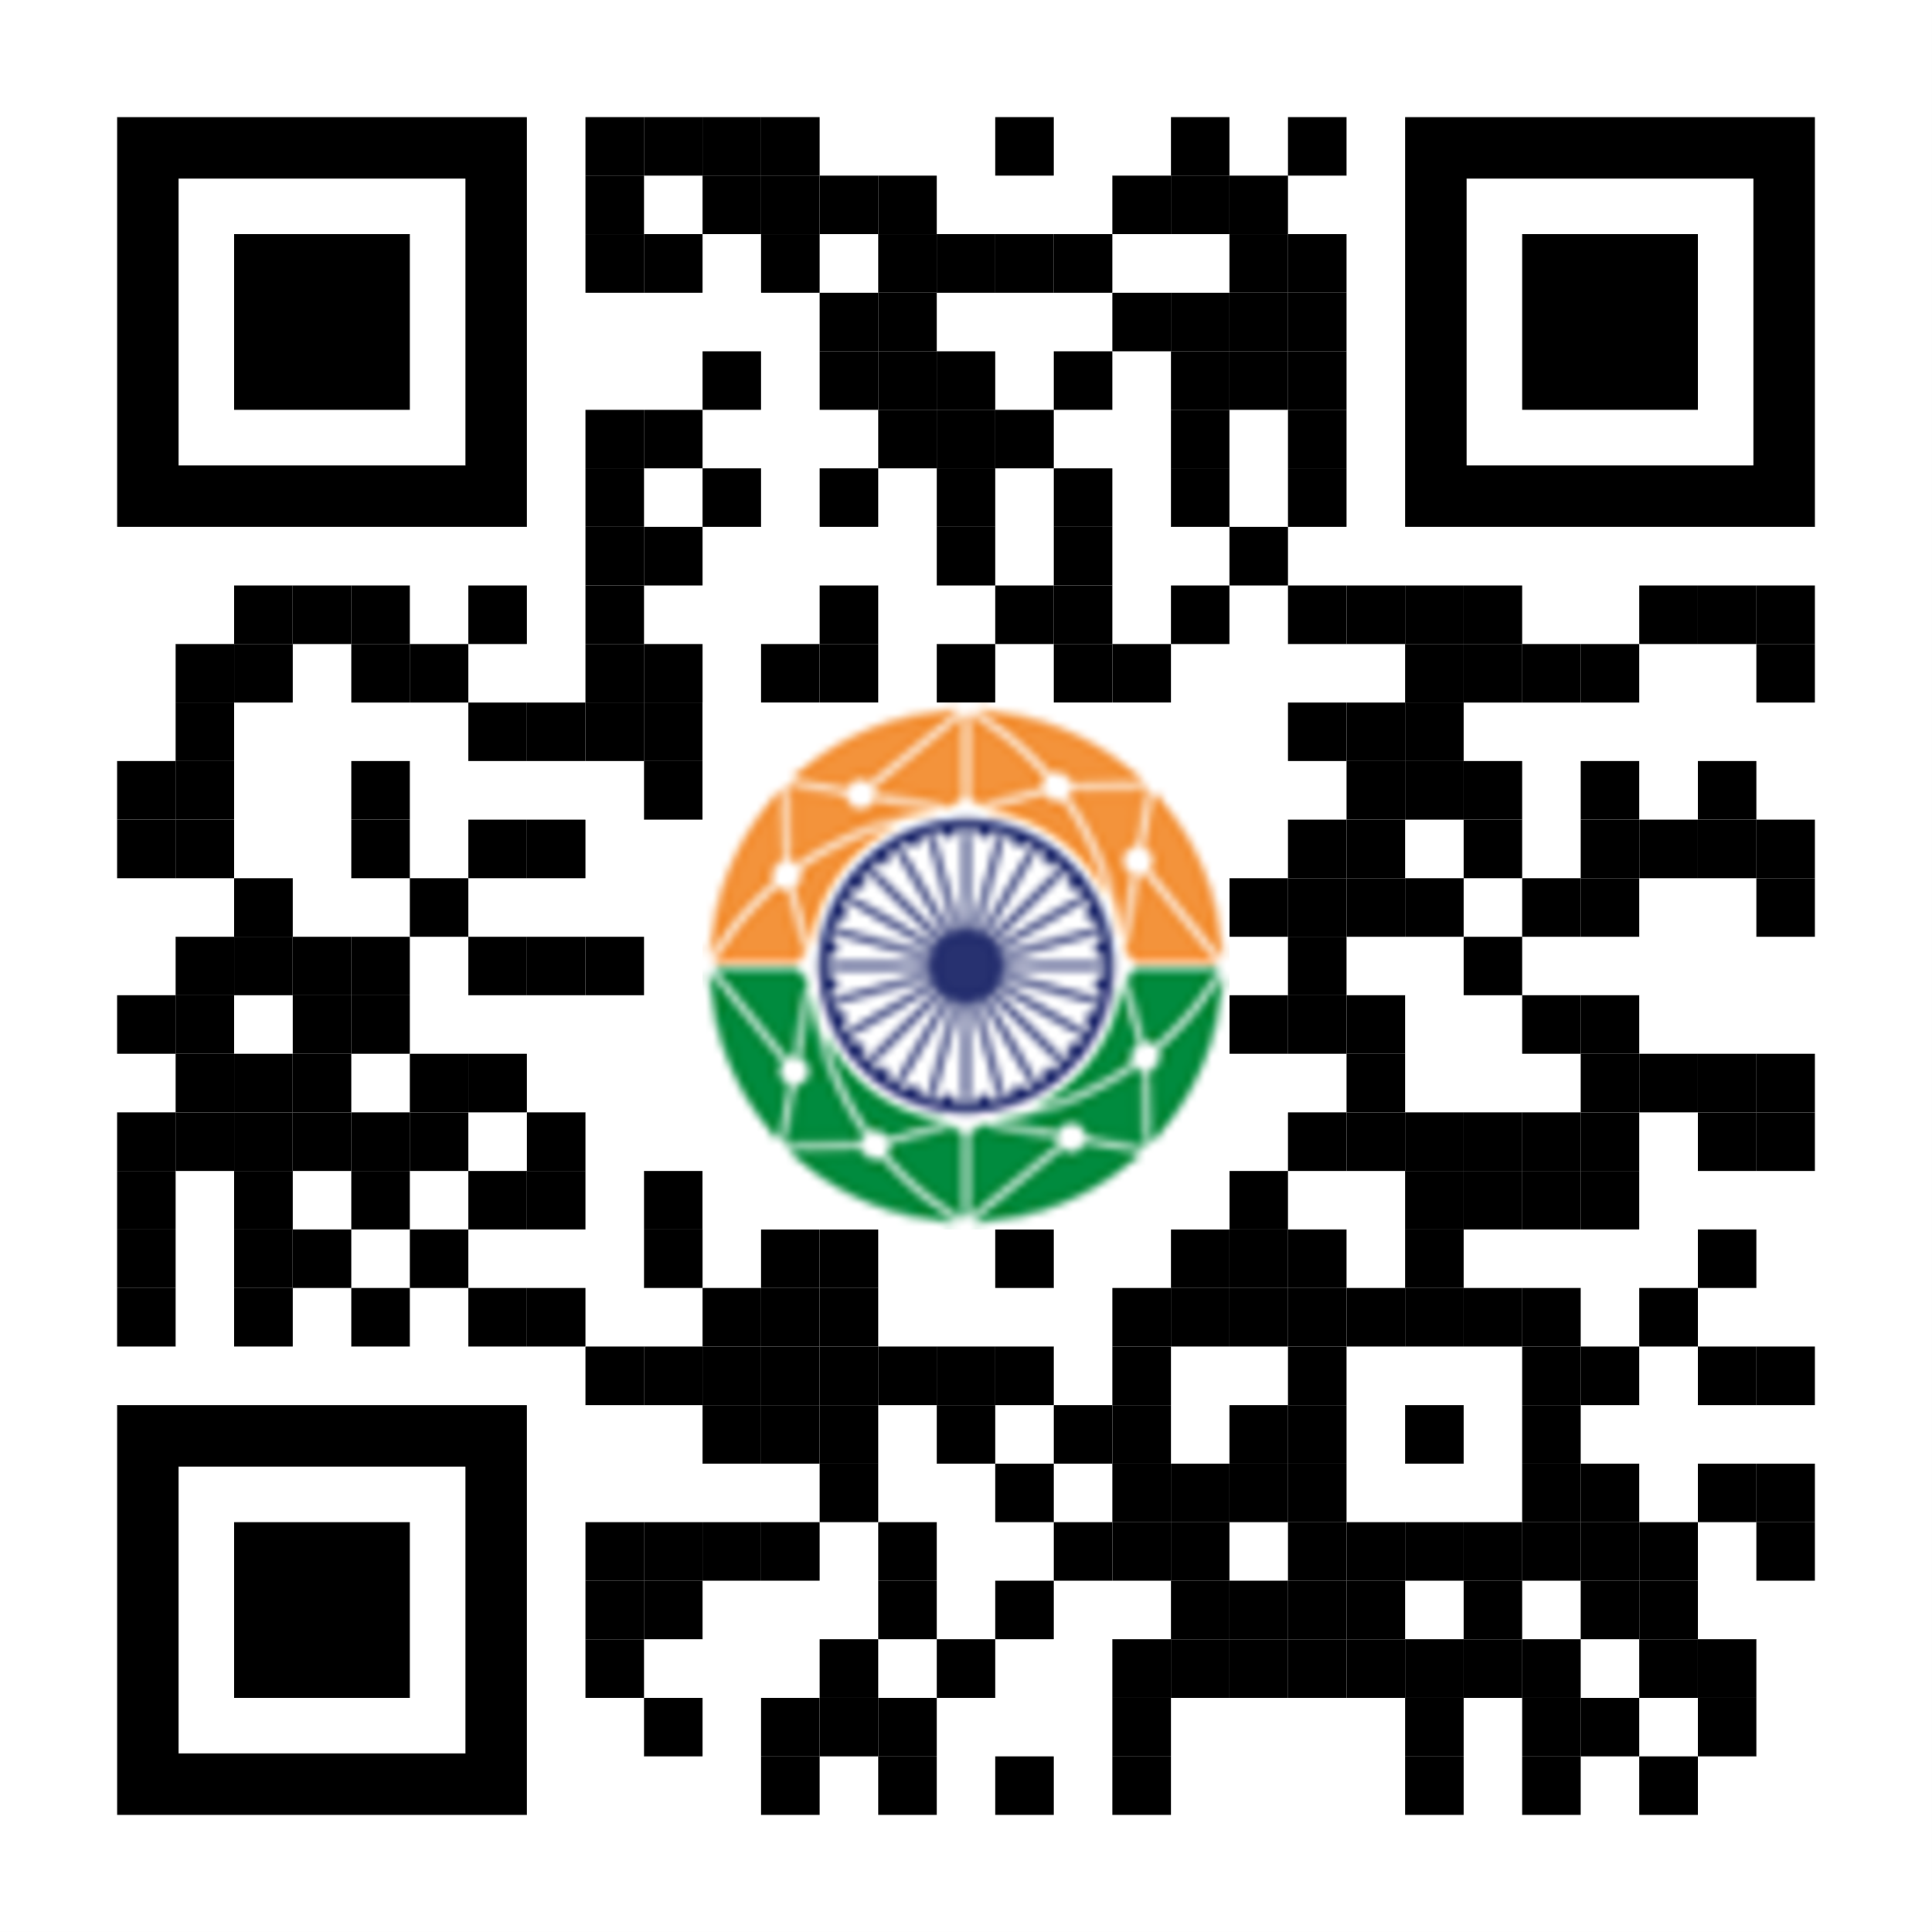

ANNEX 1
(To TSB Circular 178)
Information for participants on visa, travel, measures
in place in New Delhi, India
1.1 Visa request
- Check Visa Requirements: While citizens of several countries enjoy visa-free entry to India, others require a visa. It is recommend checking the official Indian visa website (https://indianvisaonline.gov.in/visa/) to determine your specific requirements.
- Apply for Your Visa Early: To ensure a smooth visa application process, we advise applying well in advance of the event, preferably 2-to-3 months before your planned travel date.
- Online Application: Most visa applications can be submitted conveniently online through the Indian e-Visa portal (https://indianvisaonline.gov.in/evisa/tvoa.html).
- Visa Fees: Visa fees vary based on your nationality and type of visa. Check the official website for the current fee structure.
- Documentation: Ensure you have all required documents ready, including your passport, travel itinerary, proof of accommodation, and confirmation of GSS registration.
- Visa Processing Time: Processing time can vary depending on your nationality and application type.

____________________

