 | INTERNATIONAL TELECOMMUNICATION UNION  TELECOMMUNICATION STANDARDIZATION SECTOR  STUDY PERIOD 2022-2024 |  |  | TSAG-TD561
 |  |  |  | TSAG
 |  |  |  | Original: English
Question(s): |  | N/A |  | Geneva, 29 July - 2 August 2024
TD
(Ref.: SG13-LS150)
Source: |  | ITU-T Study Group 13
Title: |  | LS/i on the use of the term “IMT-2030” within ITU-T [from ITU-T SG13]
LIAISON STATEMENT
For action to: |  |  | ITU SG2, SG3, SG5, SG9, SG11, SG12, SG15, SG16, SG17, SG20
For information to: |  |  | ITU-R WP 5D, TSAG
Approval: |  |  | ITU-T Study Group 13 meeting (Geneva, 11 March 2024)
Deadline: |  |  | 11 July 2024
Contact: |  |  | Kazunori TANIKAWA  NICT  Japan | E-mail: kazu.tanikawa@nigt.go.jp

A new liaison statement has been received from SG13.
This liaison statement follows and the original file can be downloaded from the ITU ftp server at http://handle.itu.int/11.1002/ls/sp17-sg13-oLS-00150.docx.

 | INTERNATIONAL TELECOMMUNICATION UNION  TELECOMMUNICATION  STANDARDIZATION SECTOR  STUDY PERIOD 2022-2024 |  |  |  |  | SG13-LS150
 |  |  |  |  |  | STUDY GROUP 13
 |  |  |  |  |  | Original: English
Question(s): |  | 6, 20, 21, 22, 23/13 |  |  |  | Geneva, 4-15 March 2024
Ref.: SG13-TD220-R1/PLEN
Source: |  | ITU-T Study Group 13
Title: |  | LS on the use of the term “IMT-2030” within ITU-T
LIAISON STATEMENT
For action to: |  |  |  | All ITU-T SGs
For information to: |  |  |  | TSAG, ITU-R WP 5D
Approval: |  |  |  | ITU-T Study Group 13 meeting (Geneva, 11 March 2024)
Deadline: |  |  |  | 14 July 2024
Contact: |  |  | Kazunori TANIKAWA  NICT  Japan |  | E-mail: kazu.tanikawa@nigt.go.jp

Abstract: | This liaison statement contains the SG13 advice on the use of a term “IMT-2030” within all ITU-T Study Groups.

- Background
For coming IMT-2030 era, ITU-T Study Group 13 would like to share a guideline on the usage of the term “IMT-2030” within ITU-T.
Report ITU-R M.2516-0 “Future technology trends of terrestrial International Mobile Telecommunications systems towards 2030 and beyond” (November 2022) and Recommendation ITU-R M.2160 on the “IMT-2030 Framework” (November 2023) were officially published.
However, there has been no detailed specifications of IMT-2030 yet. Figure 1 shows a timeline on defining IMT-2030 standards according to the “IMT-2030 Framework”.

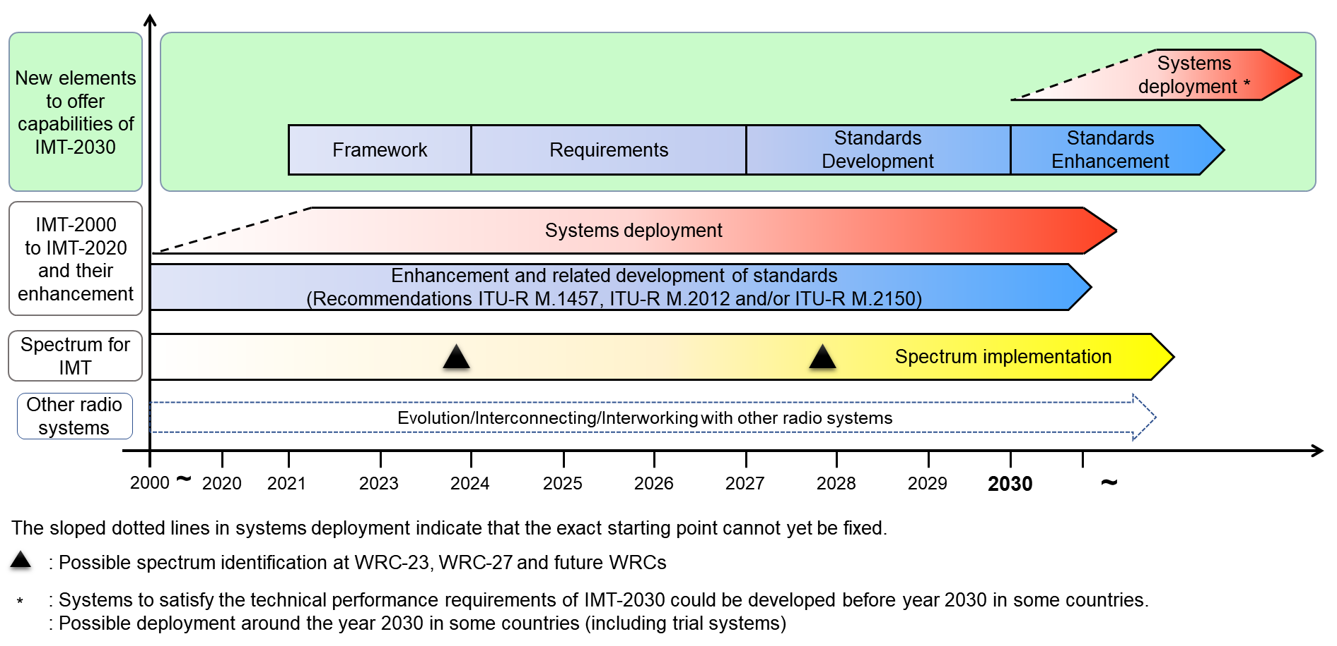

Figure 1: Timeline of ITU-R on IMT-2030
ITU-R expects that:
- requirements of IMT-2030 are finalized in 2027;
- standards of IMT-2030 are finalized in 2030.
NOTE 1 ‒ IMT-2030 standards will be defined based on IMT-2030 submission and evaluation process. The process means that SDOs including 3GPP propose their radio interface technology (RIT) specifications and upon successful evaluation, to be included in the IMT-2030 ITU-R Recommendations and ITU-R endorses them.
NOTE 2 - Initial information about “IMT-2030” is available on the dedicated IMT-2030 website of ITU-R WP 5D. Beside the generic info, WP 5D of ITU-R is currently working on the first official IMT-2030 documents, namely “IMT-2030 Background” (IMT-2030/1) and “Process for IMT-2030” (IMT-2030/2), which are expected to be finalised in October 2024.
In correspondence with this timeline, 3GPP announced its time plan of 6G according to SP-231693 RP-233985 AI 6.1 (3GPP TSG#102 Joint Session, December 2023) as follows:
- Studies for 6G in 3GPP are expected to start from Release 20 (Requirements studies start from September 2024, Other studies start from year 2025);
- IMT-2030 submission and normative work for 6G in 3GPP are expected to start from Release 21 (starting year 2027).

- Suggestion
SG13 would like to recommend all Study Groups that:
- ITU-T Recommendations should include only “IMT-2030” rather than “6G” in similar way as the continuation of the use of “IMT-2020” rather than “5G” to keep alignment with terminology used in ITU-T and ITU-R per Resolution ITU-R 56-3;
- each ITU-T Recommendation regarding IMT-2030 should refer to relevant normative standards: ITU-R Recommendations on IMT-2030. If other SDOs, working in the area of IMT-2030 Technical Specifications are concerned, refer to those as 6G.
NOTE 3 ‒ Same way as treatment of IMT-2020, SG13 is planning to develop fundamental Recommendations on the non-wireless part of IMT-2030 systems such as terms and definitions, framework, requirements, and architecture. After completion of these Recommendations, all SGs will be informed and invited to refer to these ITU-T Recommendations complementing the work of ITU-R’s and other SDOs.
________________

