 | INTERNATIONAL TELECOMMUNICATION UNION  TELECOMMUNICATION  STANDARDIZATION SECTOR  STUDY PERIOD 2022-2024 |  | TSAG-TD494
 |  |  | TSAG
 |  |  | Original: English
Question(s): |  | N/A | Geneva, 29 July – 2 August 2024
TD
Source: |  | TSB
Title: |  | Digital Transformation Activities in 2024
Contact: |  | Cristina Bueti  TSB; ITU Focal Point on Smart Sustainable Cities & Communities | Tel: +41227306301  E-mail: cristina.bueti@itu.int

Abstract: | This TD contains information on the Digital Transformation Activities in 2024.
Please see below information on Digital Transformation Activities in 2024:
Digital Transformation Dialogues (DTD)
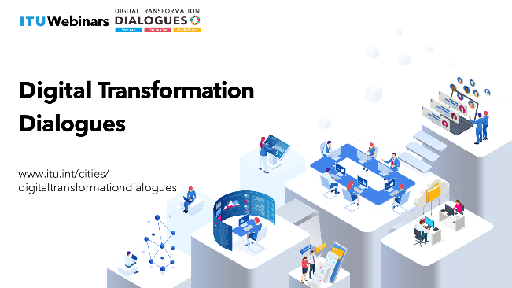
The International Telecommunication Union (ITU) has been organizing the Digital Transformation Dialogues (DTD). DTD offer a dynamic platform to facilitate a deeper understanding of emerging technologies to reshape traditional processes, improve operational efficiency and unlock new possibilities for innovation and standardization. The Digital Transformation Dialogues seeks to address evolving themes associated with digital transformation, foster cooperation among city stakeholders, and examine the role of standardization within this domain. The Digital Transformation Dialogues serve as a unique platform for highlighting the latest work and outcomes of the ITU-T Focus Groups, Initiatives and ITU-T Study Groups.
The Digital Transformation Dialogues encompass:
- Digital Transformation Webinars covering topics ranging from Internet of Things (IoT), digital twin, metaverse, brain computer interface, cloud computing and artificial intelligence (AI) to data analytics, while delving into how we can harness the power of digital technologies to drive positive change and deliver sustainable value in the digital era to support the next digital wave.
- Fireside Chats serve as a global platform for industry experts, thought leaders, and professionals to share their expertise on leveraging digital technologies across different verticals including smart cities, banking, transport, health, cybersecurity and sustainability to engage a diverse audience and explore the possibilities and challenges of the ever expanding digital landscape.
- Ask the Expert Sessions help participants gain valuable insights into the vast ITU-T standardization hemisphere, while putting the spotlight on relevant best practices and emerging trends to facilitate informed decision-making in the quest for digital transformation.
The following events have been held in 2024:
Fireside Chats:
- Ethical Horizons: Navigating Responsible AI in the Digital Landscape (16 April 2024)
- Beyond Boundaries: Revolutionizing Banking through Digital Transformation (14 March 2024)
- Prospects for Surgical Advances (18 January 2024）
Ask the Expert Sessions
- Assessing the circularity of ICT goods (22 May 2024)
- Breaking barriers in the metaverse: Improving accessibility (25 April 2024)
- Guardians of Authenticity: Battling Counterfeiting (28 March 2024)
- Urban Intelligence Unveiled: AI Principles for Smart Cities (21 February 2024)
- Digital twin for smart cities (30 January 2024）
- Ask the Expert Session - Rester connecté: Explorer l’itinérance mobile internationale (27 June 2024)
- Ask the Expert Session - Exploring DLT Beyond Cryptocurrency: Applications and Opportunities (23 July 2024)
Webinars
- Greening the Future: Navigating Digital Transformation for Land Restoration (5 June 2024)
- Connected Communities: Harnessing the Power of Digital Public Infrastructure (21 May 2024)
- UN 2.0 Week Side event on Harnessing the metaverse and virtual worlds for global impact (26 April 2024)
- Metaverso 360°: Explorando la Accesibilidad, la Inclusión y los Derechos Humanos en Dominicana Innova (22 April 2024)
- Immersive Inclusivity: Enhancing Virtual Worlds with Accessibility (2 April 2024)
- Unleashing the Power of Digital Water Solutions: Exploring the flow of emerging technologies (22 March 2024)
- Future of real-love in the virtual world: The Perfect Date (14 February 2024）
Please see below upcoming events:
- Webinar - City Horizons: Celebrating World Cities Day and Shaping Urban Futures (31 October 2024)
- Ask the Expert Session – Smart Submarine Cables: The future of disaster management (05 November 2024)
More information on the Digital Transformation Dialogues is available at: https://www.itu.int/cities/digitaltransformationdialogues/
- Digital Transformation Resource Hub
Throughout 2024, the Digital Transformation Resource Hub continued to collate a range of quality publications on various digital transformation topics such as smart sustainable cities, AI, IoT, blockchain, digital twin, metaverse, and digital transformation trends.
- Publications
Between January and June 2024, the ITU developed and distributed two key publications and five case studies focused on the topics of smart sustainable cities and the metaverse.
- 1st UN Executive Briefing on Unlocking the potential of virtual worlds and the metaverse for the Sustainable Development Goals
- Guiding principles for artificial intelligence in cities
  - Case study – Hong Kong, China
  - Case study – Dubai, United Arab Emirates
  - Case study – Buenos Aires, Argentina
  - Case study – Singapore, Singapore
  - Case study – Copenhagen, Denmark

- Digital Transformation and Cities Digest
Throughout 2024, the ITU has consistently published the Digital Transformation and Cities Digest, with editions being released in January, March, May and July. Copies of the Digest are available for access on the Digital Transformation and Cities Digest webpage.

- U4SSC Thematic Group on Enabling People-Centred Cities through Digital Transformation
As part of the United for Smart Sustainable Cities (U4SSC), which is a global UN initiative supported by 19 UN entities, a Thematic Group on Enabling People-Centred Cities through Digital Transformation is conducting its work through four working groups:
- Working Group 1: Setting the Context: Digital Transformation for People-oriented Cities
- Working Group 2: Policy Benchmarks for Digital Transformation for People-oriented Cities
- Working Group 3: Digital Transformation Assessment for People-oriented Cities
- Working Group 4: Guidelines for Unlocking Net Zero in Cities Through Sustainable Digital Transformation
More information is available at: https://u4ssc.itu.int/thematic-groups/.

____________

