 | INTERNATIONAL TELECOMMUNICATION UNION  TELECOMMUNICATION  STANDARDIZATION SECTOR  STUDY PERIOD 2022-2024 |  |  |  | TSAG-TD476
 |  |  |  |  | TSAG
 |  |  |  |  | Original: English
Question(s): |  |  | N/A |  | Geneva, 22-26 January 2024
TD
Source: |  |  | Chair, SG13; Chair, SG17
Title: |  |  | Collaboration on QIT-related work between ITU-T Study Group 13 and 17
Contact: |  | Kazunori Tanikawa  NICT  Japan |  | E-mail: kaz.tanikawa@nict.go.jp
Contact: |  | Heung Youl Youm  Soonchunhyang University  Korea (Republic of) |  | E-mail: hyyoum@sch.ac.kr

Abstract: | In May 2023, TSAG requested the Chairs of SG13 and SG17 to clarify the collaboration related to quantum information technologies between both Study Groups. This TD contains the outcome of the informal consultations between both SG13 and SG17 Chairs and their corresponding agreement on this matter.

It is important to note that quantum information technologies (QITs) cut across multiple domains thus standardization work in this area requires collaboration across different ITU-T study groups. Within ITU-T, work related to QIT has been ongoing in:
– Question 2/11 “Signalling requirements and protocols for services and applications in telecommunication environments” covering protocol aspects
– Question 6/13 “Networks beyond IMT-2020: Quality of service (QoS) mechanisms” covering quality of service aspects
– Question 16/13 “Future Networks: Trustworthy and Quantum Enhanced Networking and Services” covering network aspects
– Question 15/17 “Security for/by emerging technologies including quantum-based security” covering security aspects
With respect to the work of Study Groups 13 and 17 on QIT, it is noted that the focus of work has aligned (and continues to align) to a clear demarcation i.e., SG17 addressing security aspects of QIT-related work and SG13 addressing the network and QoS aspects, as illustrated in Figures 2 and 3 of Y Suppl. 74 “ITU-T Y.3800-series Standardization roadmap on quantum key distribution networks”:
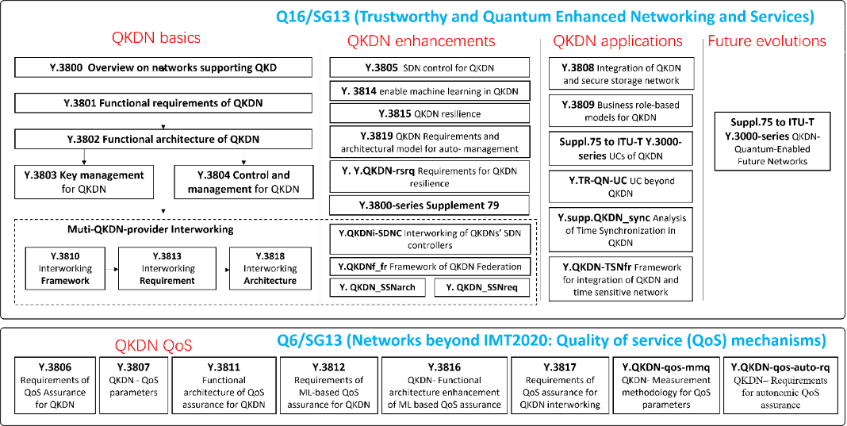
Figure 1 - QKDN standardization landscape in ITU-T SG13 (from Figure 2 of Y Suppl. 74)
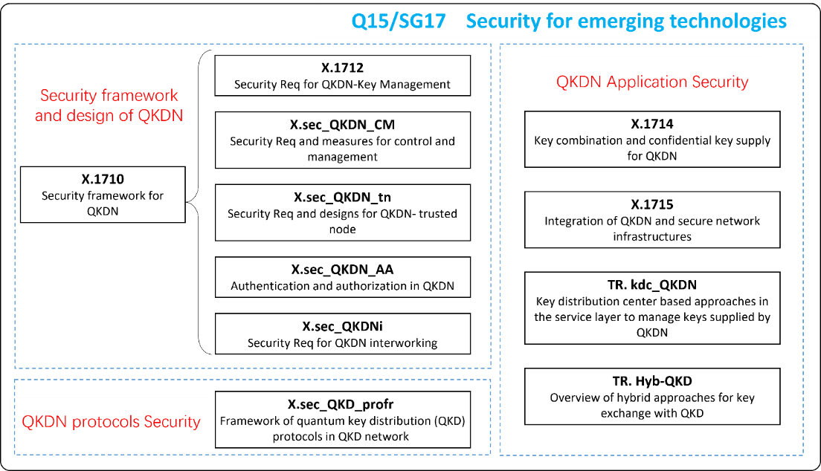
Figure 2 - QKDN standardization work items in SG17 (from Figure 3 of Y Suppl. 74)
There has been active collaboration between both groups evidenced by the active and continued liaison information exchange reporting on their work progress and planned work on QITs.
Although QIT-related work has largely focused on QKDN, it is worth noting that SG13 has begun to survey studies on quantum networks in preparation to initiate new work items on this area in the next Study period. There is also ongoing discussion towards the consideration for the establishment of a new Question in SG13 covering quantum networks in the next Study period.
Given the excellent ongoing collaboration between SG13 and SG17 on QITs, both Chairs agree for QIT standardization work to continue being driven with the current demarcation i.e., in SG13 on networking aspects and in SG17 on the security aspects (as lead study group of security) with continued liaison exchanges to ensure both groups are well informed on the ongoing activities related to QIT.
_________________________

