 | INTERNATIONAL TELECOMMUNICATION UNION  TELECOMMUNICATION  STANDARDIZATION SECTOR  STUDY PERIOD 2022-2024 |  | TSAG-TD451
 |  |  | TSAG
 |  |  | Original: English
Question(s): |  | N/A | Geneva, 22 - 26 January 2024
TD
Source: |  | TSB
Title: |  | Toolkit on Digital Transformation for People-Oriented Cities and Communities
Contact: |  | Cristina Bueti  TSB | Email: cristina.bueti@itu.int

Abstract: | This TD contains information on the Toolkit on Digital Transformation for People-Oriented Cities and Communities.
In the evolving digital landscape, which is now characterized by complexities related to artificial intelligence, metaverse, digital transformation, ITU together with other 13 UN entities acknowledges the imperative to cultivate expertise in future ICT standardization.
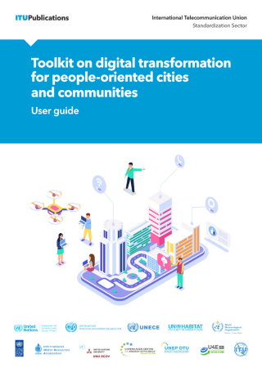
The International Telecommunication Union (ITU) together with other 13 UN entities, including United Nations Industrial Development Organization (UNIDO); International Energy Agency (IEA); United Nations Department of Economic and Social Affairs (UNDESA); United Nations Human Settlements Programme (UN-Habitat); International Water Resources Association (IWRA), United Nations Economic Commission for Europe (UNECE); World Meteorological Organization (WMO); United Nations Development Programme (UNDP), United Nations University Operating Unit on Policy-Driven Electronic Governance (UNU-EGOV), United Nations Environment Programme and Technical University of Denmark (UNEP DTU), Copenhagen Center of Energy Efficiency (CCEE), United 4 Efficiency (U4E) and Food and Agriculture Organization of the United Nations (FAO), have developed the Toolkit on Digital Transformation for People-Oriented Cities and Communities.
The Toolkit on Digital Transformation for People-Oriented Cities and Communities is a comprehensive guide designed to help cities and communities leverage digital technologies for sustainable development. It provides practical strategies and tools to address challenges and harness opportunities in the digital age.
The toolkit emphasizes a people-oriented approach, focusing on improving quality of life, promoting inclusivity, and enhancing service delivery. Covering areas such as digital infrastructure, data management, and digital services, it aims to support policymakers, city leaders, and stakeholders in their digital transformation journeys.
The resources contained in the Toolkit include ITU-T standards and guidance, the latest research and projections, and cutting-edge reports on a variety of timely topics relevant to the digital transformation of cities and communities.
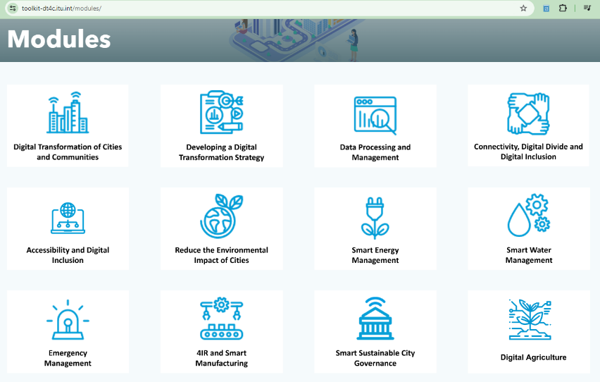
12 modules have been developed covering the topics from Smart Sustainable City Governance to Smart Manufacturing. 2023 saw the release of the latest module of the toolkit on Digital Agriculture developed together with FAO.
The toolkit is being used by various universities and the University of Buenos Aires has created a specific course.
More information on the Digital Transformation Toolkit is available at: https://toolkit-dt4c.itu.int/.

____________

