 | INTERNATIONAL TELECOMMUNICATION UNION  TELECOMMUNICATION  STANDARDIZATION SECTOR  STUDY PERIOD 2022-2024 |  | TSAG-TD440R1
 |  |  | TSAG
 |  |  | Original: English
Question(s): |  | N/A | Geneva, 22 - 26 January 2024
TD
Source: |  | TSB
Title: |  | Digital Transformation Dialogues and Year in Review 2023
Contact: |  | Cristina Bueti  TSB; ITU Focal Point on Smart Sustainable Cities & Communities | Tel: +41227306301  E-mail: cristina.bueti@itu.int

Abstract: | This TD contains information on the Digital Transformation Dialogues and Year in Review 2023.
Please see below information on Digital Transformation Dialogues and Year in Review 2023:
Digital Transformation Dialogues (DTD)
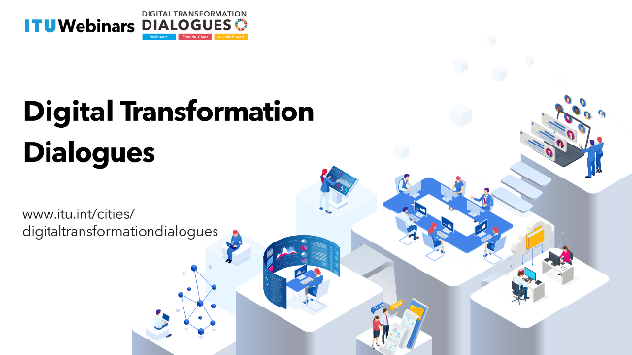
The International Telecommunication Union (ITU) is organizing the Digital Transformation Dialogues (DTD). It offers a dynamic platform to facilitate a deeper understanding of emerging technologies to reshape traditional processes, improve operational efficiency and unlock new possibilities for innovation and standardization. The Digital Transformation Dialogues seeks to address evolving themes associated with digital transformation, foster cooperation among city stakeholders, and examine the role of standardization within this domain. The Digital Transformation Dialogues serve as a unique platform for highlighting the latest work and outcomes of the ITU-T Focus Groups, Initiatives and ITU-T Study Groups.
The Digital Transformation Dialogues will encompass:
- Digital Transformation Webinars covering topics ranging from Internet of Things (IoT), digital twin, metaverse, brain computer interface, cloud computing and artificial intelligence (AI) to data analytics, while delving into how we can harness the power of digital technologies to drive positive change and deliver sustainable value in the digital era to support the next digital wave.
- Fireside Chats serve as a global platform for industry experts, thought leaders, and professionals to share their expertise on leveraging digital technologies across different verticals including smart cities, banking, transport, health, cybersecurity and sustainability to engage a diverse audience and explore the possibilities and challenges of the ever expanding digital landscape.
- Ask the expert: ITU-T Standard in Focus Sessions will help participants gain valuable insights into the vast ITU-T standardization hemisphere, while putting the spotlight on relevant best practices and emerging trends to facilitate informed decision-making in the quest for digital transformation.
Please see below upcoming events:
- Fireside Chat - Prospects for Surgical Advances (18 January 2024)
- Ask the Expert Session - Digital twin for smart cities (30 January 2024)
- Webinar - Future of real-love in the virtual world: The Perfect Date (14 February 2024)
- Ask the Expert Session - AI in cities (21 February 2024)
- Fireside Chat - Digital Transformation and Banking (29 February 2024)
- Webinar - Unleashing the Power of Digital Water Solutions: Exploring the flow of emerging technologies (22 March 2024)
- Webinar - Sustainable Horizons: Digital Transformation for a Greener Tomorrow (June 2024)
More information on the Digital Transformation Dialogues is available at: https://www.itu.int/cities/digitaltransformationdialogues/
Year in Review 2023 – Advancing digital transformation
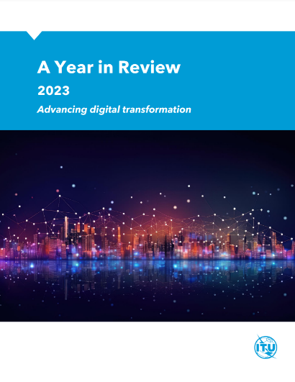
The ITU made significant progress in 2023 in the fields of digital transformation, smart sustainable cities, and the metaverse. The 'Year in Review' report and webpage provide a comprehensive overview of key achievements and activities completed throughout the year, with the support of ITU’s smart cities and the metaverse team.
One of the highlights has been the ITU Focus Group on metaverse, which within the space of less than one year, managed to hold ITU record-breaking meetings in terms of the number of participants and approved deliverables. The enthusiasm demonstrated by Focus Group experts from around the world underscored the importance of shaping the metaverse to benefit everyone, everywhere.
ITU’s commitment to enabling cities and communities to become smarter and more sustainable was evident not only in its support for the United for Smart Sustainable Cities (U4SSC) initiative but also in the significant achievements of ITU-T Study Group 20. This included the establishment of the Study Group 20 Regional Group for Asia Pacific increasing participation of stakeholders from this vibrant region.
During 2023, the ITU continued its advocacy and support for its members to harness the opportunities offered by digital transformation. Through its webinar series, toolkit, and resource hub, the ITU collaborated with governments, industry, academia, civil society sector partners, as well as the broader UN system. This collaboration ensured global reach and a comprehensive understanding of the power of digital technologies to contribute to the achievement of the UN Sustainable Development Goals. To learn more, visit the 2023 Year in Review website or read the report.
- Publications
Over the course of 2023, ITU produced and disseminated eight high-quality publications on a range of digital transformation topics.
  - Guide for smart and sustainable city leaders
  - Enabling digital transformation in smart sustainable cities – Master plan
  - Reference framework for integrated management of an SSC
  - Executive briefing on the metaverse
  - Building a people-centered digital future for cities and communities
  - Procurement guidelines for smart sustainable cities
  - The role of digital technologies in aging and health
  - Compendium of practices on innovative financing for smart sustainable cities projects
- Digital Transformation and Cities Digest
To keep key stakeholders up to date the first Digital Transformation and Cities Digest was launched in June 2023. The Digest provides information on ITU’s latest work related to digital transformation, smart sustainable cities, and the metaverse, as well as upcoming events and new publications. Copies of the Digest can be accessed from the Digital Transformation and Cities Digest webpage.
- Digital Transformation Resource Hub
Throughout 2023, the Digital Transformation Resource Hub continued to collate a range of quality publications on various digital transformation topics such as smart sustainable cities, AI, IoT, blockchain, digital twin, metaverse, and digital transformation trends.
____________

