 | INTERNATIONAL TELECOMMUNICATION UNION  TELECOMMUNICATION STANDARDIZATION SECTOR  STUDY PERIOD 2022-2024 |  |  |  | TSAG-TD359
 |  |  |  |  | TSAG
 |  |  |  |  | Original: English
Question(s): |  | N/A |  |  | Geneva, 22-26 January 2024
TD
(Ref.: CITS-Doc 10)
Source: |  | Collaboration on ITS Communication Standards (CITS)
Title: |  | LS/i on the establishment of an Expert Group on Communications Technology for Automated Driving [from CITS]
LIAISON STATEMENT
For action to: |  |  | CCSA, ITU-R SG 5, ARIB, ETSI TC ITS, SAE, 3GPP TSG SA, 3GPP TSG RAN, ISO TC 22, ISO TC 204, CEN/TC 278, TSDSI, UNECE/WP.29, 5GAA, 1609 WG, IMDA, TIAA, TTA PG905, Connected Car WG, Automotive WG, WWRF Connected Car VIP WG, IEEE 802.11 TGbd, IEC SEG11, ISO TC 241, C-SAE, ITU-T SG12, SG16, SG17, SG20, C2C-CC, CATARC, C Roads initiative
For information to: |  |  | ITU-T SG2, SG3, SG5, SG9, SG11, SG13, SG15, TSAG
Approval: |  |  | CITS Meeting (e-meeting, 22 September 2023)
Deadline: |  |  | N/A
Contact: |  |  | T. Russell Shields  Chair CITS | Email: russell.shields@outlook.com
Contact: |  |  | Stefano Polidori  TSB / ITU  Switzerland | Tel: +41 79 599 1413  Email: tsbcits@itu.int

A new liaison statement has been received from CITS.
This liaison statement follows and the original file can be downloaded from the ITU ftp server at http://handle.itu.int/11.1002/ls/sp17-cits-iLS-00014.docx.

 | INTERNATIONAL TELECOMMUNICATION UNION  TELECOMMUNICATION  STANDARDIZATION SECTOR  STUDY PERIOD 2022-2024 |  |  |  |  | CITS-LS14
 |  |  |  |  |  | Collaboration on Intelligent Transport Systems Communication Standards
 |  |  |  |  |  | Original: English
 |  |  |  |  |  | E-meeting, 22 September 2023
Ref.: (Doc 10)
Source: |  |  | Collaboration on ITS Communication Standards (CITS)
Title: |  |  | LS on the establishment of an Expert Group on Communications Technology for Automated Driving
LIAISON STATEMENT
For action to: |  |  |  |  | ITU-R SG 5, ITU-T SG 16, SG 12, SG 17, SG 20, UNECE WP.29, ARIB, CCSA, CEN TC 278, ETSI TC ITS, C2C-CC, IEC SEG 11, IEEE 1609, IEEE 802.11-TGbd, , IMDA, ISO TC 22, ISO TC 204, ISO TC 241, SAE International, C-SAE, TIAA, TSDSI, TTA PG905, TTC Connected Car WG, W3C Automotive WG, WWRF Connected Car VIP WG, 5GAA, 3GPP SA, 3GPP RAN, CATARC, C-Roads initiative
For information to: |  |  |  |  | ITU-T TSAG, SG 2, SG 3, SG 5, SG 9, SG 11, SG 13, SG 15
Approval: |  |  |  |  | CITS Meeting (e-meeting, 22 September 2023)
Deadline: |  |  |  |  | N/A
Contact: |  | T. Russell Shields  Chair CITS |  |  |  |  | Email: russell.shields@outlook.com
Contact: |  | Stefano Polidori  TSB / ITU  Switzerland |  |  |  |  | Tel: +41 79 599 1413  Email: tsbcits@itu.int
Keywords: |  |  |  | Intelligent transport systems (ITS); ITS communication standards; communications technology for automated driving;
Abstract: |  |  |  | Through this liaison statement, the ITU Collaboration on ITS communication standards (ITU CITS) would like to inform about the establishment of an Expert Group on Communications Technology for Automated Driving. ITU-T SG 16, ITU-R SG 5, and organizations participating in ITU CITS are invited to provide experts to participate in this Expert Group.
The ITU CITS serves as an international platform for the coordination of globally acceptable and harmonized standards on Intelligent Transportation Systems (ITS) in order to enable the rapid deployment of fully interoperable ITS communication-related products and services.
In keeping with its mandate, at its meeting held on 22 September 2023, ITU CITS discussed communications technology for automated driving. It was determined that communications will become an important part of automated driving. Collision avoidance, cooperation between vehicles, and many other uses for specific vehicle to vehicle communications will be needed for complete roll out of automated driving. It was suggested that merging by a vehicle diving automatically is the most complex communications application and that the communications technology that will allow 100% successful merging of an automatically driven vehicle into a crowded lane in every situation will also support the other communications needs of automated driving. Therefore, it is suggested that the Expert Group first explore the communications technology needed for automatically driven vehicles merging into crowded lanes. A detailed description of this application is in the concept note attached as Annex 1.
In relation to communications for automated driving, ITU CITS noted that:
- the related technology development will benefit from international standardization.
- the regulations adopted by UNECE WP.29 are technologically neutral by policy. Therefore, the communications technology for automatically driven vehicles must be handled separately from WP.29 regulation efforts.
- recently, WP.29 created the Task Force on Vehicular Communications (TF VC) under the ITS Informal Group.
- there is an expectation that WP.29/GRVA will draft more extensive regulations for automatically driven vehicles.
To foster studies under the ITU CITS framework, which has participation by major standards bodies in this field, ITU CITS established the “Expert Group on Communications Technology for Automated Driving (EG-ComAD)”.
EG-ComAD is chartered to explore the communications technologies for automatically driven vehicles, including the communications technology to be equipped in all new vehicles (including new vehicles without automated driving capability) to achieve the required volume of equipped vehicles to support automated driving, including enabling reliable automated merging.
ITU-T SG 16, ITU-R SG 5, and other organizations participating in ITU CITS are invited to provide experts to participate in EG-ComAD.
The ITU CITS Secretariat (tsbcits@itu.int) is at your disposal for any queries.
ANNEXES: 3
– Concept Note: CITS Expert Group on Communications Technology for Automated Driving
– Possible Steps Coordinated with the Expert Group
– Terms of Reference for the Expert Group on Communications Technology for Automated Driving
APPENDIX (informative): 1
– Possible Scenario and Technology Overview
ANNEX 1
CONCEPT NOTE:
CITS Expert Group on Communications Technology for Automated Driving
1 Background
Automated driving systems (ADS) features are starting to appear in production vehicles purchased by individuals. The commercial deployment of vehicles with ADS features has been supported by the UNECE World Forum for Harmonization of Vehicle Regulations (WP.29). WP.29 has released Regulation 157 for ADS features in light vehicles up to 60 kph on expressways. Regulation 157 has been used in some vehicles (e.g. high-end Mercedes and Honda vehicles) in limited locations. WP.29 has already released an amendment to Regulation 157, effective January 1, 2024, to allow the ADS features to have speeds up to 130 kph and change lanes, still limited to expressways.
In parallel, WP.29 has created the informal working groups named Validation Method for Automated Driving (VMAD) and Functional Requirements for Automated and Autonomous Vehicles (FRAV) under the Working Party on Automated/Autonomous and Connected Vehicles (GRVA). VMAD and FRAV are scheduled to release a combined final document in June 2024. This effort is expected to lead to the creation of a WP.29 informal working group under GRVA to draft more extensive regulations for vehicles with ADS features.
Recently, WP.29 created the Task Force on Vehicular Communications (TF VC) under the ITS Informal Group. The TF VC, through the ITS Informal Group, is likely to recommend, by late 2024, that WP.29 create an informal working group to start an effort for a regulation to require all new light vehicles (not just vehicles with ADS features) to have communications technology with an application to support light vehicles with ADS active to merge into congested lanes by giving appropriate space for the vehicle with ADS active to merge in.
1.1 Automotive Industry Timing
A regulation for vehicle communications is not likely to be finished by WP.29 before 2027. After its completion, any WP.29 regulation for vehicle communications is likely to require a period of two-three years for vehicle manufacturers to prepare their new vehicles to comply with the new regulation.
Thus, under such a regulation, vehicle communications equipment supporting automated merging will not likely start to be installed in light vehicles before 2030. Then, there will be the need for at least a three-four-year period until there are enough equipped vehicles on the road to reliably do automated merging by vehicles with ADS active in all locations in the jurisdiction.
Consequently, ADS features in light vehicles will likely have to exclude the locations of lane merging from their operational design domain (ODD) until at least 2034. The timing for heavy vehicles will be later if ever.
1.2 Motivation
In order to enhance the roll out of ADS products and secure their safety value, it is important to include “vehicles automated merging in all locations” in the vehicles ODD for ADS features. It will enhance the current limitation of ODDs for ADS features that does not provide a very good consumer experience, limiting the prospects for the deployment of ADS features in the near future. Synergy among several relevant Standards Developing Organizations (SDOs) and industry might facilitate the development of necessary technical standards and regulatory policies, which are now the missing links in constructing the required industrial value chain.
2 Suggested approach
It is suggested to initiate studies by an Expert Group of the ITU Collaboration on ITS Communications Standards (CITS), which has participation by major standards bodies in this field.
The regulations adopted by WP.29 are technologically neutral by policy. The technology for merging by vehicles with ADS active must be handled separately from WP.29 regulation efforts. It is understood that 100% reliability could be impossible to achieve with any technology. The Expert Group aims to identify the level of failure that authorities in different jurisdictions might be able to accept. In addition, the Expert Group will need to estimate the costs related to different levels of reliability and who will be responsible for the costs at each level. The technology development will benefit from international standardization.
Some experts believe that the current vehicle communications technology is not capable of doing merging by vehicles with ADS active into congested lanes with a determined level of reliability (determined-reliable) and safety. The possible limitations are both software and spectrum related, including:
- Although the message sets for merging have been worked on by standards organizations in China, Europe, and U.S., these message sets have not been worked through for the complexity of the application by vehicles with ADS active to support determined-reliable merging.
- The spectrum currently used for vehicle communications technology (mostly 5.9 GHz) might not have the bandwidth necessary for the volume of messages that will occur to support determined-reliable merging for vehicles with ADS active into heavily congested lanes in complex expressway junctions.
- The 5.9 GHz spectrum in use for vehicle communications technology does not have the necessary protection against out-of-band interference needed for the determined-reliable merging by vehicles with ADS active into all congested lanes.
- The communications environment for the determined-reliable merging by vehicles with ADS active into congested lanes will be very complex, including merging in tunnels, elevated highways, etc., with much metal and concrete, which will pose serious challenges to communications.
- The current protocol for vehicle communications technology (C-V2X) will need to be extended, probably in concert with other SDOs such as 3GPP, to support the determined-reliable merging by vehicles with ADS active into congested lanes.
- Given the long lives of vehicles, the communications technology for the determined-reliable merging by vehicles with ADS active into congested lanes must include a capability of over-the-air upgrade for both protocols and spectrum.
This is a non-exhaustive list of items that the Expert Group will examine in the first step for examining communications technology for automated driving. The Expert Group will recommend approaches to handle each item needing effort. As the Expert Group explores the communications technology for merging by automated driven vehicles, the Expert Group must ensure that the communications technology will handle all other needs of automated driven vehicles.
ANNEX 2
Possible Steps Coordinated with the Expert Group
- As soon as practical, ITU-T commences the work on developing a Recommendation on the communications technology for automated driving, including merging by automated driven vehicles.
- As ITU-T is working on the communications driving technology for automated driving, ITU-R explores the possible technology approaches as requested by Member States.
- Based on the ITU-T Recommendation and as requested by Member States, ITU-R performs its normal work to produce a Recommendation on the Technical and Operational Characteristics of automated driving communications technology.
- After completion of Step 3, the spectrum requirements and justification should be clear and a suitable bandwidth and home in ITU-R might emerge.
ANNEX 3
Terms of Reference for the Expert Group on Communications Technology for Automated Driving
The “Expert Group on Communications Technology for Automated Driving” of the ITU Collaboration on ITS Communications Standards (the “Expert Group”) is chartered to explore the communications technologies for automated driven vehicles, including the communications technology to be equipped in all new vehicles to achieve the required volume of equipped vehicles to enable reliable automated merging.
The working methods of the Expert Groups will be in accordance with the ITU CITS, which is its parent group.
Participation in the Expert Group is open to ITU CITS participants, which include experts from ITU members, UNECE WP.29 participant entities, and SDOs participating in the ITU CITS.
The Expert Group management will be composed of experts from different and mutually-complementary professional backgrounds. An initial composition might be two co-Chairs, one from the automotive industry and one from the wireless communications industry.
The Expert Group will analyse the current vehicle communications technology for automated driven vehicles, recommend solutions that need international standardization, and identify areas that need further work.
The Expert Group will identify the related timelines necessary to allow installation in vehicles, possibly as early as 2030, of the vehicle communications technology for automated driving including to support the determined-reliable merging by vehicles with ADS active into congested lanes.
NOTE: Although there are many important communications applications to support road safety, the determined-reliable merging by vehicles with ADS active is the most complex. It is expected that vehicles equipped with the communications technology for automated merging will be able to support the other communications-based road safety applications, including collision avoidance and vehicle cooperation.
The Expert Group will identify application areas that need international standardization. Its members will report related findings to ITU-T SG 16 for possible actions.
Based on the identified application approach, the Expert Group will identify spectrum needs, as appropriate, and interested Member States will make appropriate requests to ITU-R SG 5 for possible actions.
NOTE: Additional spectrum would need modifications to the frequency allocation (e.g. ITU-R Radio Regulations) which requires studies that in return need a prior WRC Agenda Item and a subsequent WRC decision. When applying the timing desired by the automotive industry, it must be taken into consideration, that an according Agenda Item must be available for WCR-27 to get a decision at WRC-31. This means, that ITU-R SG 5 might address vehicle technology for automated driving in the ITU-R study period 2023-2027 as part of its proposed Question “Future-ITS-CAV/5”. How to meet the timing needed by the vehicle industry will need to be considered by ITU-R SG 5.
APPENDIX (informative)
Possible Scenario and Technology Overview
The initial implementation of automated merging using communications will be for light vehicles with ADS active, needing a space to merge into a new line (the space needed is estimated of possibly up to eight meters to handle large pickup trucks). The Expert Group will have the task of determining the size of the vehicles to be supported and the related space needed. Larger vehicles will be handled later, if at all.
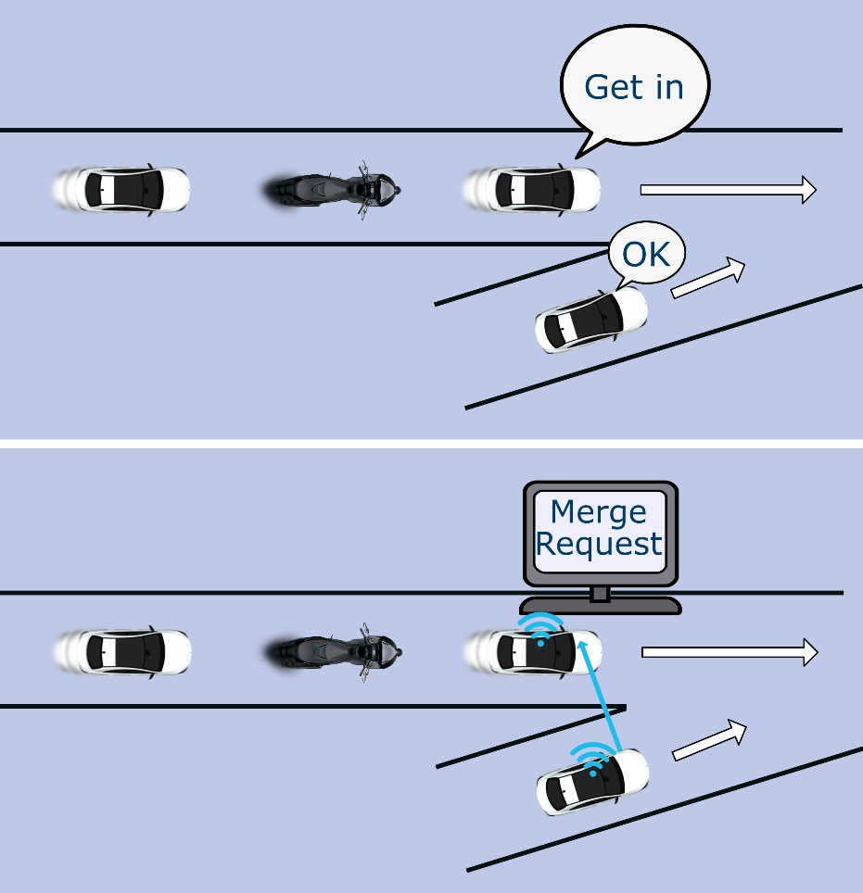
Human with eye contact
Automated with communications

The vehicle with ADS active wanting to merge in will send a general message that can be heard by all equipped vehicles in the area, stating:
- Where it is.
- The lane into which it plans to merge.
- The estimated time when it will reach the merge point.
“Possible vehicles” that might be able to allow the merging vehicle in will respond with a direct message to the merging vehicle. As the merging vehicle proceeds, it will have two-way communications with the Possible Vehicles, trimming the possibilities as it gets closer to the merge point. The number of Possible Vehicles may vary as some vehicles will no longer be Possible Vehicles as traffic moves. If the required number of Possible Vehicles for the required merging gets too low, a new emergency general message will be sent to all vehicles in the area asking for additional vehicles to identify themselves as possibilities.
Finally, upon approaching the merge point, the merging vehicle will select one of the Possible Vehicles to let it in. The merging vehicle will confirm the selection by a message to the selected Possible Vehicle. The two vehicles will then use their cameras and direct communications for the merge to be completed, controlled by the vehicle with ADS active that is merging in.
Note:
- By 2030, all new vehicles in major jurisdictions should have front-facing cameras and other sensors for mandated automated emergency braking systems (AEBS).
- A vehicle might be a Possible Vehicle simultaneously for multiple merging-in vehicles with ADS active.
- A key task of the Expert Group will be to collect large, complex examples of the merging environment in all major jurisdictions as well as appropriate other jurisdictions. The Expert Group will model the application and communications technology for each example.
- An additional task of the Expert Group will be to determine the penetration of equipped vehicles necessary in each jurisdiction to achieve the determined-reliable merging by vehicles with ADS active.
- To protect vehicles with ADS active that are merging in, any WP.29 regulation requirements for vehicle communications should not allow that the communications application for merging in to be turned off. For such a limitation, WP.29 might have to work with the UNECE Global Forum for Road Traffic Safety (WP.1).

