 | INTERNATIONAL TELECOMMUNICATION UNION  TELECOMMUNICATION  STANDARDIZATION SECTOR  STUDY PERIOD 2022-2024 |  | TSAG-TD142
 |  |  | TSAG
 |  |  | Original: English
Question(s): |  | RG-WM | Geneva, 12-16 December 2022
TD
Source: |  | RG-WM Rapporteur
Title: |  | Working document to support the discussion on the SG9 and SG16 issue with smart TV Operating System
Contact: |  | Olivier Dubuisson  Orange  France | Tel: +33 6 74 95 46 37  E-mail: olivier.dubuisson@orange.com
Abstract: This TD is a working document to support the discussion on the SG9 and SG16 issue with smart TV Operating System based on TD70, TD96 and TD107.
Action: This TD is proposed for discussion in RG-WM.

The initial position of Study Group 16 was to amend the title and scope of the J series of ITU-T Recommendations since the limitation in scope was not evident from the Recommendations title and scope, but Study Group 9 did not agree, so the compromise was to modify the scope and maintain the title as it was.
The issue at stake seems to be the fact that the J-series (as well as any other series) only includes the "title" of the Recommendations in the pages where the download is made. To help readers of ITU-T Recommendations to identify their scope, it is suggested to study a way to add the Recommendation "scope" in the pages where the download is made.

The TSB report in TD28 shows that this has been half-done:
As pointed out in the incoming Liaison Statement TSAG-TD107, TSB would like to remind that detailed information on ITU-T Recommendations is available on this Website, which has been recently enhanced to specify series titles, such as on ITU-T J.1204. However, the distribution pages for final publication such as T-REC-J.1204 are outside TSB’s purview and difficult to change.

There are two ways to download an ITU-T Recommendation:
- The following one under the purview of TSB, which seems providing the complete information on the Recommendation (it is worth to note that this page also displays the "summary" of the related Recommendation, which normally includes information on its scope):
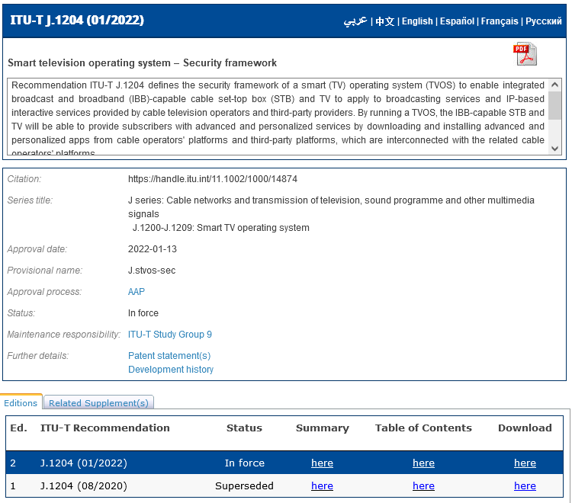
- A second one under the purview of ITU IS, which only includes the title of the Recommendation:
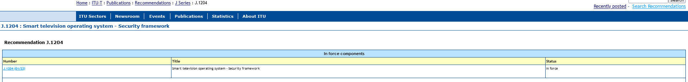

Although the problem was identified for the Smart Cable TV related Recommendations, Study Group 16 considers that this issue is not strictly related to the J-series, so an eventual solution could be generalized to all series of ITU-T Recommendations (TD70):
As this issue was raised, it seems that it is not a confined to the J-series. Therefore, we would like to draw the attention of TSAG Rapporteur Group on Working Methods (RG-WM) on assistance for improving visibility in general of metadata related to ITU-T Recommendations and to include it as a follow up item in its action list.

It is proposed that, noting the good progress made so far (see TD28), TSAG requests TSB to continue to work with ITU IS Department to make the Recommendation-series title also available in their set of Recommendation download pages.
An example of rendering could be:
J series: Cable networks and transmission of television, sound programme and other multimedia signals
J.1200-J.1209: Smart TV operating system
J.1204 : Smart television operating system - Security framework
Recommendation J.1204

In force components
Number | Title | Status
J.1204 (01/22) | Smart television operating system - Security framework | In force

_______________________

