|  |  |  |  |
| --- | --- | --- | --- |
|  | INTERNATIONAL TELECOMMUNICATION UNION  **TELECOMMUNICATION STANDARDIZATION SECTOR**  STUDY PERIOD 2022-2024 | | TSAG-TD119 |
| TSAG |
| Original: English |
| **Question(s):** | | N/A | Geneva, 12-16 December 2022 |
| **TD** | | | |
| **Source:** | | Liaison officer to IEC/SMB/SG 12 | |
| **Title:** | | Progress report for IEC/SMB/SG 12 "Digital Transformation and Systems Approach" | |
| **Contact:** | | Olivier Dubuisson Orange France | Tel: +33 6 74 95 46 37 E-mail: [olivier.dubuisson@orange.com](mailto:olivier.dubuisson@orange.com) |
| **Abstract:** | | This TD, which is not necessarily exhaustive, is a collection of excerpts of output documents of past TSAG meetings, WTSA-20 and PP-22 which are potentially relevant to the work of RG-WM. | |

**Action**: WP-IEWPR is asked to note this document.

Mr Dubuisson is representing TSAG at IEC/SMB/SG 12 since 8 July 2022. The reason for this relationship is to keep TSAG informed of the progress made by IEC on Standards-based, Machine-readable, Adaptive, Requirements-based, and Testable (SMART) standards (see [WTSA-20 Proceedings](https://www.itu.int/pub/T-REG-LIV.1-2022/en), V-2.2 – Committee 3, clause 2.2.2).

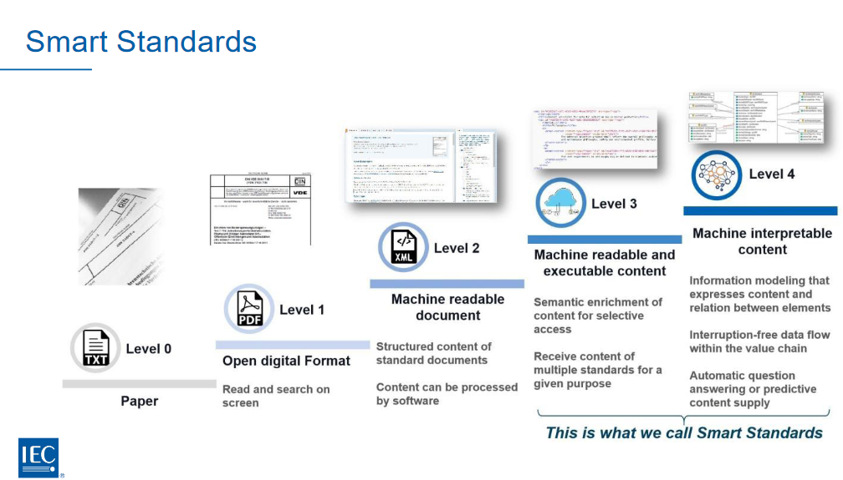

On 27 Sep 2022, the IEC Academy gave a webinar "IEC SMART Standards" which provides a good overview of the work achieved so far (see [video](https://iec.zoom.us/rec/share/Wrozf82TLvY6Owa4yCY64lt5YGu5R87zP4bwK9efwlSyCCIVFk0I-HRrVqn6OZvd.m8wwsbYK8pTN9K_F), [presentation](https://www.iec.ch/system/files/2022-10/smartwebinarslides_0.pdf), [Q&A](https://www.iec.ch/system/files/2022-10/qa_smart-webinar_0.pdf)).

IEC/SEG 12 is divided into taskforces:

TF 1 – Working more digitally

Develop a framework for working more digitally.

Develop a capability model (potentially incl. benchmarking).

Collect Use Cases and Use Stories.

Prepare and recommend pilot projects.

Develop guidance on working more digitally.

Investigate and prioritize necessary IT developments.

TF2 - Produce more digital content

Develop a Framework for machine interpretable standards

Most generically useful APIs are those that provide access to specific provisions from specific collections (standards)

TF3 – Semantic interoperability and Information Models

One concrete step for SMART Standards is the Standard Information Model (SIM) which built the digital skeleton for the new standard representation. The first draft should be evaluated by a pilot to get first experiences with the model and derive potential modifications and improvements.

IEC/SMB agreed to establish an implementation group to speed up the piloting and development of the SG 12 concepts.

IEC and ISO agreed a collaboration framework in Q1 2022. This sets out a common vision, governance framework, and collaboration on technical solutions. As the work progresses, ISO and IEC will become more aligned, with the intention of offering the market a common SMART platform where multiple actors can plug their solution and deploy. SG12 is supporting this goal and is working with ISO teams.

_______________________