 | INTERNATIONAL TELECOMMUNICATION UNION  TELECOMMUNICATION  STANDARDIZATION SECTOR  STUDY PERIOD 2022-2024 |  |  |  | TSAG-TD058
 |  |  |  |  | TSAG
 |  |  |  |  | Original: English
Question(s): |  | N/A |  |  | Geneva, 12-16 December 2022
TD
Source: |  | Director, TSB
Title: |  | ITU Journal on Future and Evolving Technologies – Publications and Webinar series
Contact: |  |  | Alessia Magliarditi  TSB | Tel: +41 22 730 5882  E-mail: alessia.magliarditi@itu.int

Abstract: | The ITU Journal on Future and Evolving Technologies has published seven issues – one regular issue, six special issues – in 2022. Furthermore, seven special issues are still calling for papers for publication in 2023. This document provides details on publications and also on the new Webinar Series launched this year.

1 Introduction
The ITU Journal on Future and Evolving Technologies (ITU J-FET) was launched in September 2020 under the leadership of the Editor-in-Chief, Prof. Ian F. Akyildiz (Ken Byers Chair Professor Emeritus in Telecommunications at Georgia Tech, USA and Chief Executive Officer at Truva Inc.; h-index: 134; Citations: 138’000+). In only two years 129 papers have been published in 15 issues, authored by 535 researchers, 70% of which come from academia.
The Journal’s achievements have been acknowledged by the ITU Secretary-General, Mr. Zhao, who invited Prof. Akyildiz to join PP-22 in Bucharest, to officially recognize his “commitment and outstanding contribution to the ITU Journal, ensuring the publication of impactful results to advance science”, in front of the ITU Members, during the ITU Journal’s Ceremony that took place on 10 October 2022.
ITU Member States had adopted a new Resolution at the ITU Plenipotentiary Conference, which convened in Dubai, United Arab Emirates, from 29 October to 16 November 2018, to support the further development of the ITU Journal. Members resolved to establish collaborative efforts with the research community and to raise awareness of the ITU Journal worldwide (Resolution 207 (Dubai, 2018)).
ITU J-FET considers yet-to-be-published papers addressing fundamental and applied research. It shares new techniques and concepts, analyses and tutorials, and learnings from experiments and physical and simulated test beds. It also discusses the implications of the latest research results for policy and regulation, legal frameworks, the economy and society. Its interdisciplinary approach reflects ITU’s comprehensive field of interest and explores the convergence of ICT with other disciplines.
ITU J-FET is committed to the timely publication of very high quality, peer-reviewed, original papers. Free, fast, for all, the Journal aims to promote accessibility of research to academics and industry researchers across the world. The publication is free of charge for both readers and authors, highlighting the true sense of the term "open access". The international Editorial Board of experts, who are in the forefront of the telecommunications research world (70% from academia), is committed to providing detailed, constructive feedback on submitted papers, as well as a fast turn-around time of less than 3 months from submission to publication.
In December 2022, the ITU J-FET completed Volume 3 (2022) which includes seven issues – one regular issue and six special issues, and forewords from the ITU Secretary-General and the Director of the Telecommunication Standardization Bureau. A new set of special issues has been developed, with the calls for papers announced and publication anticipated for 2023.
Achieving a significant impact factor is a goal for this Journal and will derive from the relevance of journal papers to the priorities of academia, industry and governments, leading the way to new frontiers in research.


2 Publication of the ITU J-FET regular issues
The ITU J-FET published its first issue (Volume 1(2020), Issue 1) in December 2020 which included ten original research papers that highlight emerging technologies in the field of ICT.
In April 2021, the second regular issue of the ITU J-FET was published (Volume 2 (2021), Issue 1), with eight published papers highlighting the areas of cryptocurrency, wireless sensor networks and spectrum allocation.
Both regular issues, each containing forewords from the ITU Secretary-General and the Director of the Telecommunication Standardization Bureau, as well as an Editorial from the Editor-in-Chief, are available to download from the ITU Journal website, free of charge.
The third regular issue of the ITU Journal (Volume 2 (2021), Issue 2) was published in December 2021 and includes eleven research papers and a survey that provide an in-depth analysis of wireless networks and B5G communication systems.
The fourth regular issue was published last September (Volume 3 (2022) - Issue 2) and
gathers ten papers on topics ranging from holographic communications, digital twins, and edge computing to the growing research challenges in wireless communications associated with extended reality that are receiving a high number of citations.

3 Publication of the ITU J-FET special issues
The ITU Journal publishes original research online all year round, welcoming papers at any time, on all topics within its scope (please visit the about ITU J-FET webpage for detailed information) and with the aim of building bridges between disciplines, connecting theory with application, and stimulating international dialogue on the future and evolution of the digital transformation. In addition to the continuous publication of papers on subjects within the ITU Journal’s scope, in 2022 (Volume 3), the ITU J-FET also welcomed papers related to its six special issues that are listed below.
Previous volumes are available for free download at the Journal’s Digital Library: Volume 1 (2020) and Volume 2 (2021).

- Towards vehicular networks in the 6G era

The first published special issue of this year is on the vehicular networks in the 6G era.
Published in July 2022, the issue contains seven academic research papers presenting novel contributions dealing with rising communication and networking technologies for vehicular networks, in a holistic fashion or at different layers, to meet the high expectations of the 6G era.
The Editorial Board of this issue includes Anna Maria ​Vegni, Università degli Studi Roma Tre, Italy , as Leading Guest Editor; and the following Guest Editors: Valeria Loscrí​, Inria Lille-Nord Europe, France​​; Thomas D.C. Little​, Boston University, USA; and Ivan Wang-Hei Ho​, The Hong Kong Polytechnic University, Hong Kong, China.

- 2nd edition of the AI and machine learning solutions in 5G and future networks
AI​​ and machine learning sol​utions​ in 5G and future networks builds on the standards work of ITU including on ML architecture (ITU Y.3172), data handling (ITU Y.3174), intelligence level (ITU Y.3173) and ML marketplace (ITU Y.3176) as well as on the ITU AI/ML in 5G Challenge, a global competition with partners (telecom operators, vendors, and academia) that hosts problem statements. Based on results from this Challenge in 2021, hosts and participants were encouraged to submit their solutions for publication in this special issue of the ITU Journal.
This issue contains sixteen papers dedicated to the exploration of artificial intelligence and machine learning in 5G and future networks as well as enabling technologies and tools in networks.
This issue was completed with the support of the Challenge Organizers (Reinhard Scholl and Thomas Basikolo, ITU, and Vishnu Ram, Independent Researcher), and leading experts as members of the Editorial Board: Leading Guest Editor is Aldebaro Klautau, The Federal University of Pará (UFPA), Brazil; the Guest Editors are Michaela Blott, Xilinx, USA/Ireland; José Suárez-Varela​, Universitat Politècnica de Catalunya, Spain; Nada Golmie, National Institute of Standards and Technology (NIST), USA; Sevgi Gurbuz, Universi​ty of Alabama, USA.

- Emerging trends and applications in future communication networks
Future emerging networks are envisaged to deliver high data rates to a large number of users within tight time boundaries, respecting energy consumption constraints and security demands and satisfying high and reliable bit rates. ​​​This is expected to support a​​ wide variety of emerging applications (e.g., health monitoring, smart cities/buildings, underwater, UAV and IoT applications) as well as evaluation and experimentation in these environments (e.g., performance analysis, experimentation, epidemics and malware behavior, machine learning and artificial intelligence, edge computing).
Papers included in this issue explore state-of-the-art developments regarding high data rate communication among diverse devices (e.g., terahertz, millimeter wave, powerline and D2D communications, etc.) as well as future networks as they will emerge in the new decade (e.g. beyond 5G).​
The Editorial Board of this issue on Emerging trends and applications in future communication networks includes Merouane Debbah​, CentraleSupélec and TII, France and UAE, as Leading Guest Editor; and the Guest Editors Konstantinos Oikonomou, Ionian University, Greece​​​​; Petar Djuric​, Stony Brook University, USA; Octavia Dobre​, Memorial University, Canada; Zoran Hadzi-Velkov, Ss Cyril and Methodius University, North Macedonia.
- Integrated and autonomous network management and control for 6G time-critical applications

The special issue on Integrated and autonomous network management and control for 6G time-critical applications​​ called for original research on three different tracks: new architectures for network management and control; network reliability, fast scalability, reconfigurability and energy efficiency for time-critical applications; and use cases and enabling technologies.
Seven papers have been selected for publication, with the support and contribution of the Leading Guest Editor, Franco Davoli, University of Genoa, Italy; and the Guest Editors Riccardo Trivisonno, Huawei, Germany; Adnan Al-Anbuky​, Auckland University of Technology, New Zealand; Raffaele Bolla, University of Genoa and CNIT, Italy; Melike Erol-Kantarci, University of Ottawa, Canada; Carla Raffaelli, University of Bologna, Italy; Patrick Waldemar​, Telenor, Norway.

- Future of networking beyond 2030

This special issue on Future of networking beyond 2030 comprises seven insightful papers highlighting innovative Internet services and enabling technologies, Machine Learning and AI for networking, Green Internet, Internet addressing and routing, emerging Internet applications and scenarios, and network architecture and protocols.
The Editorial board includes Richard Li, Futurewei Technologies, Inc., USA, as Leading Guest Editor, and the Guest Editors Flavio Esposito, Saint Louis University, USA; Ruidong Li, Kanazawa University, Japan; Tarik Taleb, ​University of Oulu, Finland​; Stuart Clayman, University College London, UK.
- Digital continuum and next generation networks

This special issue on Digital continuum and next generation networks addresses complementary aspects of emerging trends and innovative approaches in communications and networks research. The overall aim was to highlight selected driving technologies, techniques, and principles that will enable the next generation of networked communication systems and their effective take-​up in smart society, production, and the economy.
The explosive growth and the rapid changes in the fields of communications and networking ask for innovative approaches to ensure efficient performance and the provision of advanced services to users. These innovative approaches include, but are not limited to, network optimization, efficient data management, cognitive computing, blockchain-based solutions and unconventional hardware and software design and deployment. Such approaches can be proven useful not only in the operations of current networks but also in the design of future network architectures – evolutionary or disruptive.
The eight selected papers focus on research work that explores new and compelling communications and networking scenarios and applications, particularly where this work goes beyond providing a general overview and instead offers compelling scientific insights.
The Editorial board includes ​Christos Douligeris​, University of Piraeus, Greece, as Leading Guest Editor, and the Guest Editors Luca Foschini​, University of Bologna, Italy; Theofanis P. Raptis​, National Research Council (CNR), Italy; Eirini Eleni Tsiropoulou​, University of New Mexico, USA; Gang Li, Deakin University, Australia​​.

4 New series of special issues announced
The ITU Journal has announced a new series of five special issues to be published in 2023 and paper submissions are currently welcome. These issues continue to look towards exploring the areas of future and intelligent technologies and with an emphasis on 5G and 6G wireless systems​, as well as papers on ​​​​​​​AI-driven security, AI for accessibility, and the metaverse.
More information on the Editorial Board, scope and topics​​, publication rights and copyright​, submission guidelines and templates​​, and review policy can be found online.

I. |  | The special issue on AI-driven security in 5G and beyond seeks novel contributions dealing with security issues in networking technologies in the 5G and beyond era through utilization of AI tools.  The deadline for paper submission is 16 January 2023.
II. |  | In these highly virtualized and distributed environments that characterize the landscape of 5G and 6G networks, several challenges arise related to the management and orchestration of resources, which are the target of this special issue on Network virtualization, slicing, orchestration, fog and edge platforms for 5G and 6G wireless systems​.  Deadline for submissions is 23 January 2023.
III. |  | The AI for accessibility special issue seeks contribution on the use of AI technology on developing or evaluating systems and services for people with different range of abilities. ​  Researchers are welcome to submit their work by 28 February 2023.
IV. | 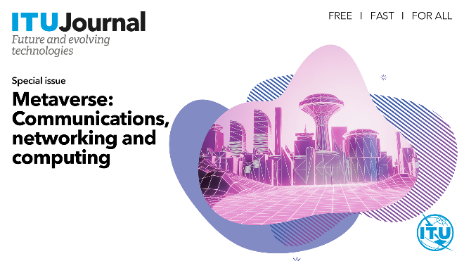 | The special issue on Metaverse: Communications, networking and computing​ aims to attract submissions of cutting-edge research from academia and industry, particularly those emphasizing theories, algorithms, techniques, prototypes, and applications for 6G communication, networking and computing technologies that can generate breakthroughs for Metaverse research.  Deadline for submissions is 3 March 2023.
V. |  | This special issue seeks contributions that propose and evaluate intelligent techniques for networking and distributed systems, as well as encouraging a thorough discussion of the advantages and disadvantages of these solutions, addressing the trade-offs involved in their adoption.  Submissions to this issue on Intelligent technologies for future networking and distributed systems are welcome by 31 July 2023.

5 New series of Webinars
A new webinar series beginning on 16 March highlights the research breakthroughs reshaping our digital environment and transforming the way we experience business and daily life.
The series, open to anyone interested in the topics, free of charge, is presented as part of the ITU Journal on Future and Evolving Technologies
The ten webinars organized this year featured specialist, tech-focused master classes on several topics. Details are provided below and at the relevant webpages.
Each webinar also included the “Wisdom Corner: Live Life Lessons” where participants had the chance to hear from the speakers about their impactful life lessons as well as their advice to young researchers in the field of ICTs.
All recordings can be watched at the ITU Journal Webinars Series playlist on Y​ou​Tube.

 | 
 | 
 | 
 | 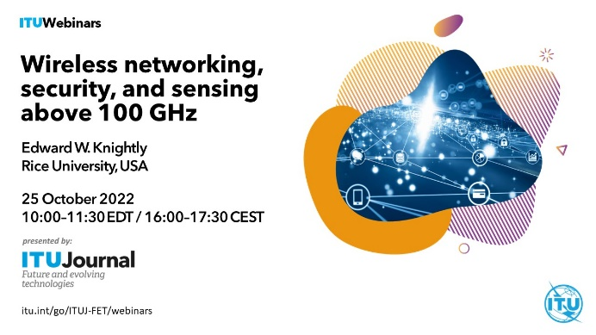
 | 

For more information on the ITU J-FET activities, please visit the ITU Journal webpage or contact the ITU Journal Team at journal@itu.int.
________________

