 |  | International telecommunication union  Telecommunication Standardization Bureau
 |  |  | Geneva, 17 February 2023
Ref: | Addendum 2 to  TSB Collective letter 4/13  SG13/TK |  | - To Administrations of Member States of the Union;  - To ITU-T Sector Members;  - To ITU-T Associates of Study Group 13;  - To ITU Academia
Tel: | +41 22 730 5126
Fax: | +41 22 730 5853
E-mail: | tsbsg13@itu.int
Web: | http://itu.int/go/tsg13
Subject: | Meeting of Study Group 13; Geneva, 13 – 24 March 2023
Dear Sir/Madam,
I wish to inform you that draft new Recommendation ITU-T Y.3140 “Service brokering network framework for Trusted Reality” received comments during the Last Call period of AAP-19, dated 16 December 2022.
The comment resolution for this draft Recommendation is still in progress and since a planned study group meeting is sufficiently close, the Chairman of Study Group 13, in consultation with TSB, took the decision in accordance with Recommendation ITU-T A.8, § 4.4.2, as reflected in TSB AAP-22, dated 16 February 2023, to consider this draft new Recommendation for approval at the Study Group 13 meeting taking place from 13 to 24 March 2023 in Geneva. Corresponding documentation is available in SG13-TDs 270, 271 and, 272/WP1.
I wish you a productive and enjoyable meeting.
Yours faithfully,  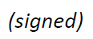  Seizo Onoe  Director of the Telecommunication  Standardization Bureau | 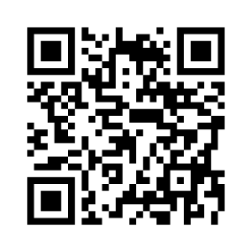 ITU-T SG13
 | Latest meeting information

