 |  | International telecommunication union  Telecommunication Standardization Bureau
 |  |  | Geneva, 6 February 2023
Ref: | Addendum 1 to  TSB Collective letter 4/13  SG13/TK |  | - To Administrations of Member States of the Union;  - To ITU-T Sector Members;  - To ITU-T Associates of Study Group 13;  - To ITU Academia
Tel: | +41 22 730 5126
Fax: | +41 22 730 5853
E-mail: | tsbsg13@itu.int
Web: | http://itu.int/go/tsg13
Subject: | Meeting of Study Group 13; Geneva, 13 – 24 March 2023
Dear Sir/Madam,
I wish to draw your attention to agenda item 12 of this SG13 meeting where approval of draft new Recommendation ITU-T Y.2086 “Framework and Requirements of Decentralized Trustworthy Network Infrastructure” will be considered. Corresponding documentation is available in TDs 188, 189, 190 and, 191/WP3.
The draft new Recommendation ITU-T Y.2086 “Framework and Requirements of Decentralized Trustworthy Network Infrastructure” received substantial comments during the Last Call period of AAP-110, dated 16 August 2021. The comments resolution for this draft Recommendation was in progress for quite some time. Since a planned study group meeting was approaching, the Chairman of Study Group 13, in consultation with TSB, took the decision in accordance with Recommendation ITU-T A.8, § 4.4.2, as reflected in TSB AAP-13, dated 16 September 2022 to consider this draft new Recommendation for approval at the Study Group 13 meeting taking place from 13 to 24 March 2023,.
I wish you a productive and enjoyable meeting.
Yours faithfully,  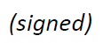  Seizo Onoe  Director of the Telecommunication  Standardization Bureau | 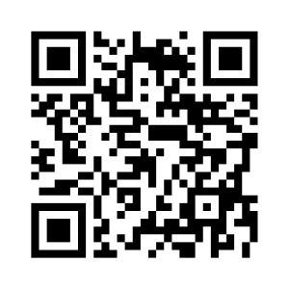 ITU-T SG13
 | Latest meeting information

