 |  | International telecommunication union  Telecommunication Standardization Bureau
 |  |  | Geneva, 29 August 2022
Ref: | Addendum 1 to  TSB Collective letter 2/5  SG5/RU |  | - To Administrations of Member States of the Union;  - To ITU-T Sector Members;  - To ITU-T Associates of Study Group 5;  - To ITU Academia.
Tel: | +41 22 730 5356
Fax: | +41 22 730 5853
E-mail: | tsbsg5@itu.int
Web: | https://www.itu.int/go/tsg5
Subject: | UPDATE: Meeting of Study Group 5; Rome (Italy), 17-27 October 2022

Dear Sir/Madam,
Please note that the venue for the next ITU-T Study Group 5 meeting (Electromagnetic fields (EMF), environment, climate action, sustainable digitalization, and circular economy) and the 14th Symposium on ICT, Environment, Climate Change and Circular Economy has changed. Both events will now take place at the School of Economics at the University of Rome Tor Vergata. The event and meeting dates remain the same:
- ITU-T Study Group 5 meeting: 17 – 27 October 2022.
- 14th Symposium on ICT, Environment, Climate Change and Circular Economy: 25 October 2022.
More information will be available on the ITU-T Study Group 5 homepage.
I wish you a productive and enjoyable meeting.
Yours faithfully,  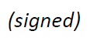  Chaesub Lee  Director of the Telecommunication  Standardization Bureau | 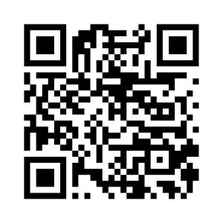 ITU-T SG5
 | Latest meeting information

