 |  | International telecommunication union  Telecommunication Standardization Bureau
 |  |  | Geneva, 28 April 2022
Ref: | Corrigendum 2 to  TSB Collective letter 1/2  SG2/RC |  | - To Administrations of Member States of the Union;  - To ITU-T Sector Members;  - To ITU-T Associates of Study Group 2;  - To ITU Academia
Tel: | +41 22 730 5415
Fax: | +41 22 730 5853
E-mail: | tsbsg2@itu.int
Web: | www.itu.int/go/tsg2
Subject: | Meeting of Study Group 2; Geneva, 16 to 20 May 2022 - Extension of Contribution deadline
Dear Sir/Madam,
Please note that due to the postponement of the start of this meeting of ITU-T Study Group 2 (Geneva, 16-20 May 2022), and in conformance with clause 3.2.5 of Recommendation ITU-T A.1 (2019), the Contribution deadline for the meeting has been extended to 23h59 (Geneva time) on Tuesday, 3 May 2022.
I wish you a productive and enjoyable meeting.
Yours faithfully,  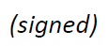  Chaesub Lee  Director of the Telecommunication  Standardization Bureau | 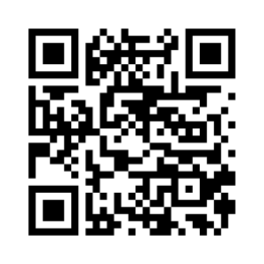 ITU-T SG2
 | Latest meeting information

