World Telecommunication Standardization Assembly (WTSA-20)  Geneva, 1-9 March 2022 | 
PLENARY MEETING | Revision 1 to  Document 43-E
 | 28 February 2022
 | Original: English
Director of TSB
Conclusions of the FOURTH Global Standards Symposium

Abstract: | This report summarizes the conclusions of the fourth Global Standards Symposium.
Contact: | TSB | E-mail: bilel.jamoussi@itu.int
Please see below the conclusions of the 4th Global Standards Symposium.




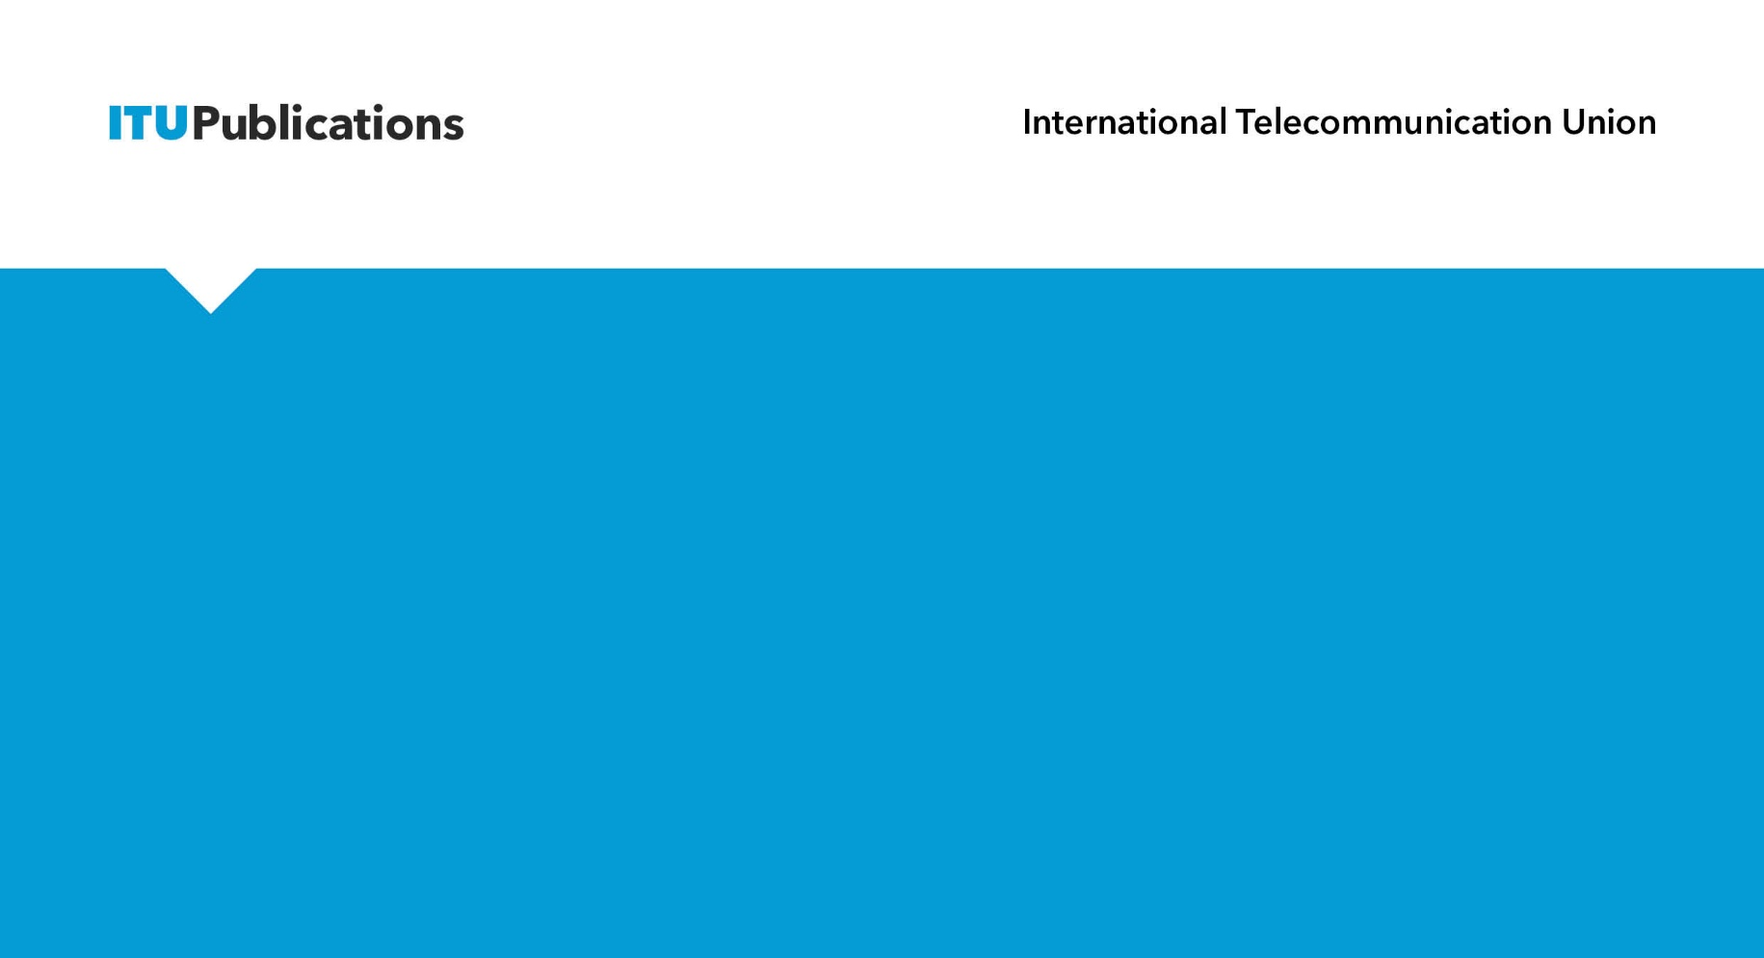
​
The 4th Global Standards Symposium
Conclusions
Standardization Sector


Conclusions of the 4th
Global Standards Symposium

The fourth Global Standards Symposium (GSS-20) held on 28 February 2022, in Geneva (Switzerland), brought together thought leaders in the standardization sphere to deliberate on international standards to enable digital transformation to achieve the Sustainable Development Goals (SDGs).

Introduction
GSS-20 laid the foundation for how stakeholders could work in collaboration to develop international standards, guidelines and frameworks for driving digital transformation for the Sustainable Development Goals (SDGs) elucidated in the 2030 Agenda for Sustainable Development, the Glasgow Climate Pact, the Paris Agreement, and the World Summit on Information Society (WSIS) Action Lines.

Section 2 summarizes the key findings and recommendations of each session conducted as a part of GSS-20. The final programme, speaker biographies and presentations are available at: https://gss.itu.int/programme/.
In accordance with Resolution 122 (Rev. Guadalajara, 2010) of the Plenipotentiary Conference and ITU Council Resolution 1272 (MOD), the conclusions of GSS-20 detailed by this report are transmitted for consideration by WTSA-20.

Main Conclusions of GSS-20
 | World Standards Cooperation Update on Sustainable Digital Transformation for the SDGs
The GSS-20,
Recognizing that the International Telecommunication Union (ITU), the International Organization for Standardization (ISO), and the International Electrotechnical Commission (IEC) play a leading role in facilitating and harmonizing the global standardization efforts for sustainable digital transformation,

- Calls for continued collaboration between the international standards developing organizations (SDOs) including ITU, IEC and ISO as well as other standard-setting entities such as ETSI, IEEE, IETF, W3C, 3GPP (among others), to facilitate digital transformation.
- Works towards bridging the standardization gaps between developed and developing countries and scaling up of technology rollouts to achieve the 2030 Agenda for Sustainable Development.
- Urges the adoption of international standards as a key enabler for digital transformation, recognizing that international standards can facilitate the ongoing digitalization of cities, communities, industries and sectors by enhancing productivity, security, efficiency and by promoting interoperability between platforms.

 | High-level dialogue on unlocking the full potential of digital transformation for the SDGs, with international standards
The GSS-20,
Recalling that international standards play a vital role in unleashing the full potential of digital transformation, attaining the SDGs and implementing the Glasgow Climate Pact and Paris Agreement,
- Provides a platform for discussions relating to concrete technological and digitalization guidance, digital transformation in addressing existing global challenges, including inequality and the digital divide. Emerging economies are particularly at risk of being left behind.
- Leverages standards developed by ITU and other SDOs (e.g. ISO, IEC, as well as other standard-setting entities) to help to build a shared vision of digital transformation, one that is rooted in universal values as contained in the SDGs. Such a scenario can be fostered by opening up the standardization domain to various stakeholders by sectors or regions to ensure that different perspectives and requirements are captured in the quest for digital transformation.
- Calls for ITU to play a key role together with ISO and IEC, and contribute actively, for instance, to the Council of Engineers for the Energy Transition (CEET) to achieve net-zero emission by 2050 and to provide a decarbonization pathway for the telecommunication/ICT sector in response to a decision by António Guterres, United Nations Secretary-General, to establish a group of experts to propose clear standards to measure and analyse net-zero commitments from non-state actors.

 | Towards people-oriented cities and communities: Driving cross-sectoral digital innovation and transformation
The GSS-20,

Recalling that cities and communities play a predominant part in accelerating digital innovation and transformation towards a people-oriented digital economy, governance and information society as well as encompassing sectors such energy, water, health, agriculture and mobility domains,
- Invites ITU to continue to support the activities of the United for Smart Sustainable Cities (U4SSC), in cooperation with the United Nations Economic Commission for Europe and UN-Habitat, including the implementation of the U4SSC Key Performance Indicators (based on Recommendation ITU-T Y.4903) and Recommendation ITU-T Y.4904 “Smart sustainable cities maturity model”, which contain the necessary tools for short and medium term implementation so that cities are able to measure their smart urban strategies, and assess progress towards the SDGs. It also encourages ITU to continue to support the establishment of U4SSC Country Hubs to leverage on the need for building global, national and local cooperation and collaboration in order to build people oriented smart cities and communities.
- Emphasizes the importance of collaboration through open platforms, such as the ITU/FAO Focus Group on AI and IoT for digital agriculture, for stimulating the deployment of digital technologies and innovations in the agricultural sector in support of sustainable agricultural practices.
- Encourages ITU to strengthen collaboration with industry fora (e.g., oneM2M, LoRa Alliance, etc) and other standard-setting entities, leveraging collaborative platforms such as the IEC/ISO/ITU Joint Smart City Task Force in order to accelerate digital transformation in the urban domain.

- Recognizes the importance of connectivity of schools and acknowledges the Giga initiative, an ITU/UNICEF initiative.

 | How can we make digital transformation sustainable?
The GSS-20,
Recalling that digital transformation plays an indispensable role in promoting sustainability, circularity and resilience,

- Stresses the need for international standards to enable the acceleration of the transition to a net zero, energy efficiency, circular economy fulfilling the SDGs within planetary boundaries and protecting biodiversity. It also urges ITU to continue strengthening collaboration with other SDOs, including ISO, IEC, and other United Nations entities such as UNEP, UNIDO, WMO and UNFCCC to meet the goals set in the Paris Agreement, Glasgow Climate Pact and ITU’s Connect 2030 Agenda.
- Recommends ITU to continue the development of standards to support the telecommunication/ICT sector’s transition towards a circular economy by providing guidance on the requirements of global sustainable products. In this context, Recommendation ITU-T L.1023 provides useful guidance to design and to verify the circularity of telecommunication/ICT products taking into consideration the concept of extended producer responsibility.
- Encourages the telecommunication/ICT Sector to commit to net zero objectives by prioritizing the reduction of scope 1, 2 and 3 emissions in line with Recommendation ITU-T L.1471, in particular stressing the emission reductions during this decisive decade as outlined in Recommendation ITU-T L.1470, and by developing solutions that help other sectors reduce their footprints.
- Stresses that standards such as Recommendation ITU-T L.1380 series can facilitate energy saving and carbon emission reduction by providing guidance on how smart energy can be achieved to maximize the use of renewable and clean energy sources with digital technologies.
- Encourages ITU to continue to set targets and develop standards, trajectories and databases in these areas, including the impact on biodiversity, to support a science-based and fair assessment and evolution of the environmental impacts of telecommunication/ICT, thereby strengthening its positive effects and counteracting any adverse effects.
- Emphasizes that open platforms such as the ITU Focus Group on Environmental Efficiency for Artificial Intelligence and other Emerging Technologies (FG-AI4EE), can facilitate knowledge transfer and identify the standardization needs for improving the sustainability aspect of digital transformation.
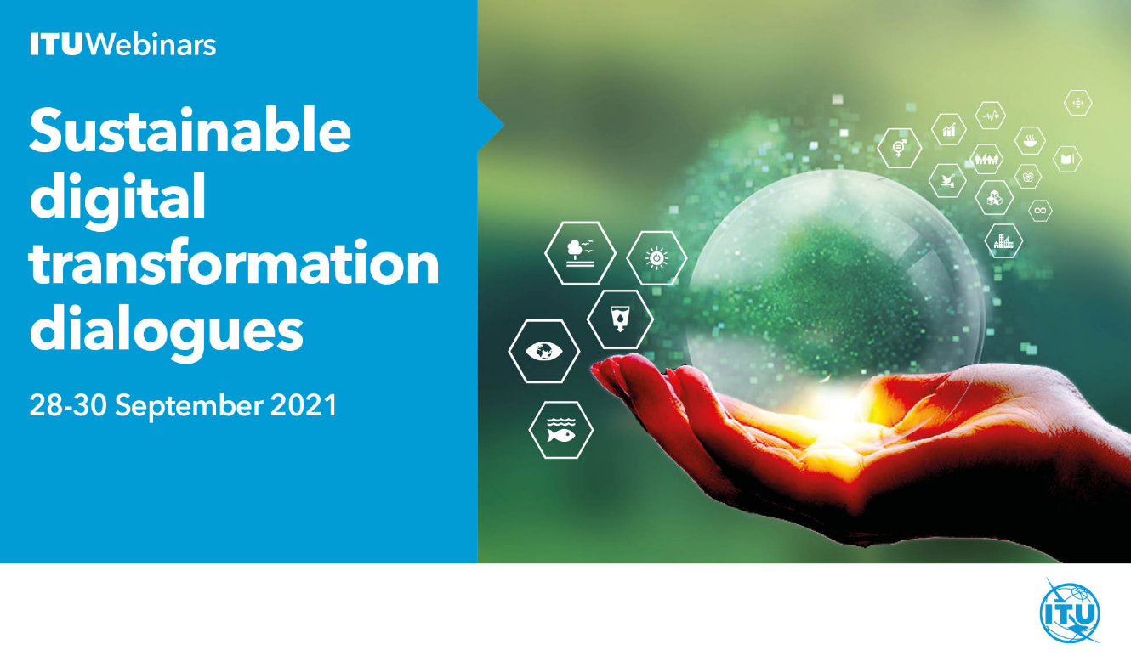

 | Artificial intelligence for road safety
The GSS-20,
Recognizing that digital innovation as well as connectivity plays a decisive and important role in enabling assisted and automated driving and ensuring road safety for all,

- Puts the spotlight on the role of ITU, other SDOs and UN entities in harnessing the potential of AI, and other digital technologies in enhancing road safety through better collection and analysis of crash data, improving the road communication infrastructure, increasing the efficiency of post-crash response, inspiring the development of road safety functions leveraging on mobile phone penetration. ITU together with the Office of the Secretary-General's Envoy on Technology and the United Nations Secretary-General’s Special Envoy for Road Safety, launched the AI for Road Safety initiative, to support in particular developing countries to fully benefit from available technologies aimed at improving road safety, including support of data collection.
- Advances the importance of standards developed by relevant standardisation and regulatory organisations in their respective areas of competence, including ITU, ISO as well as UNECE and other standards/regulations entities in bridging the road safety divide.
- Encourages ITU to provide additional necessary telecommunication guidance in the area of telecommunications and connectivity on the deployment of self-driving vehicles, and in this respect encourages ongoing pre-standardization efforts by the ITU Focus Group on AI for Autonomous and Assisted Driving (FG-AI4AD) with the aim to ensure that performance of AI on roadways meets, or exceeds, the performance of a responsible human driver.
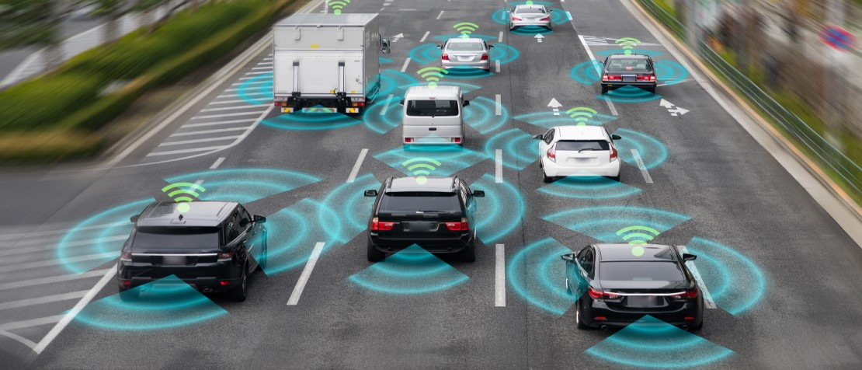

 | Digital health technologies for equitable access to healthcare services
The GSS-20,
Noting that digital health systems have the potential to fundamentally transform the healthcare services for the elderly and the poor and those in rural communities and empower patients and healthcare providers to deliver better care and improve treatments for all, especially during global health emergencies, vulnerable persons and in situations of destress,

- Strengthens the role of digital technologies in contributing to the achievement of SDG 3 on good health and well-being by boosting quality healthcare services and address the medical needs for the older population and SDG 9 on accelerating industry innovation and infrastructure, while ensuring usability and accessibility from their inception phase (as preconized by the Universal Design principle in UN Convention on the Rights of Persons with Disabilities) to improve the uptake and efficiency of technologies amongst older adults, as well as amongst persons with disabilities and with specific needs.
- Promotes the adoption of international technical standards such as Recommendation ITU-T F.780.2 that defines use cases and requirements for accessible telehealth services as well as of the joint ITU and WHO standard H.870 for safe listening devices and systems that bring together specifications, assessment methodologies, guidelines frameworks and best practices that aim to enhance digital healthcare services for the elderly and persons with disabilities, as well as persons with specific needs.
- Recognizes that global collaboration is essential for timely, relevant and efficient response and emphasizes the role played by partnership platforms such as the Joint Initiative Council for Global Health Informatics Standardization (JIC) and the ITU/WHO Focus Group on Artificial Intelligence for Health (FG-AI4H).


 | Boosting financial inclusion for all with digital transformation
The GSS-20,
Recognizing that developing countries are already capitalizing on the widespread use of ICTs to bring all people within reach of financial services,

- Encourages ITU and other SDOs to support the outcomes of the Financial Inclusion Global Initiative and the development of technical standards that aim to lower the cost of ICTs, enhance the resiliency of digital infrastructure, and support high levels of security for financial transactions.
- Recognizes that improving financial inclusion and digital services will require countries to expand their digital public infrastructure, and the digital systems that can facilitate improved government services such as digital identity, data exchange, and payment delivery. To do so, digital public goods (e.g. digital identity, etc) should be considered by governments and the DPG Standard stewarded by the Digital Public Goods Alliance can help ensure these technologies are safe, secure, and utilize digital best practices. | 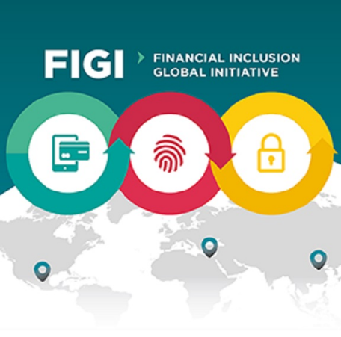

 | Standards as key enablers to overcome challenges and maximize opportunities to accelerate digital transformation and achieve the SDGs
GSS-20 stressed,
Recognizing the crucial role played by standards in enhancing digital transformation and achieving the SDGs,

- Urges collaboration among standards bodies to address the disparity between developing and developed countries in their ability to access and implement standards and frameworks to accelerate digital transformation, and participate in their development on an equal footing through instruments such as the ITU Bridging the Standardization Gap (BSG) Programme.
- Invites ITU to continue playing an active role in facilitating and informing ITU membership regarding action-oriented standards such as trajectories and guidelines, in order to accelerate their implementation at the local, regional, national and international levels.

Background Information
- Global Standards Symposia (GSS) provide an ideal platform for high-level standardization policy debates that explore the evolving dynamics of information and communication technology (ICT), and associated implications for the expanding technical standardization landscape. Previous global standards symposia were held in Johannesburg in 2008, Dubai in 2012, and Hammamet in 2016, and precede ITU's quadrennial World Telecommunication Standardization Assembly (WTSA).
- The participants of GSS-20 contributed actively to the discussions, exchanged views on what they perceived to be the key elements to be considered for these frameworks, and also underscored which of these elements should be assigned priority in terms of ITU’s standardization work during the next study period (2022–2024). The main discussions during this landmark event covered a diversity of topics, including smart cities and communities, digital agriculture, digital inclusion, AI for road safety, autonomous driving, financial inclusion, sustainability, accessibility, and health care, in the context of technology-centric standardization.
- Welcome remarks were delivered by H.E. Ms Nele Leosk, Ambassador-at-Large for Digital Affairs, Ministry of Foreign Affairs, Estonia and Mr Houlin Zhao, Secretary-General, ITU. A series of keynotes were delivered during GSS-20 by: H.E. Mr Nizar Ben Neji, Minister, Ministry of Communication Technologies, Tunisia; H.E. Ms Ursula Owusu-Ekuful, Minister, Ministry for Communications and Digitalisation, Ghana; H.E. Ms Khumbudzo Phophi Silence Ntshavheni, Minister, Ministry of Communications and Digital Technologies, South Africa (Republic of); H.E. Ms Karoline Edtstadler, Federal Minister for the EU and Constitution, Austria; H.E. Mr Teodoro Willink, Vice-Minister, Telecommunications Ministry of Science, Technology and Telecommunications (MICITT), Costa Rica; Mr Jean Todt, UN Special Envoy for Road Safety; Mr Marcus Shingles, CEO, Exponential Destiny; and Mr Okan Geray, Strategic Planning Advisor, Digital Dubai.
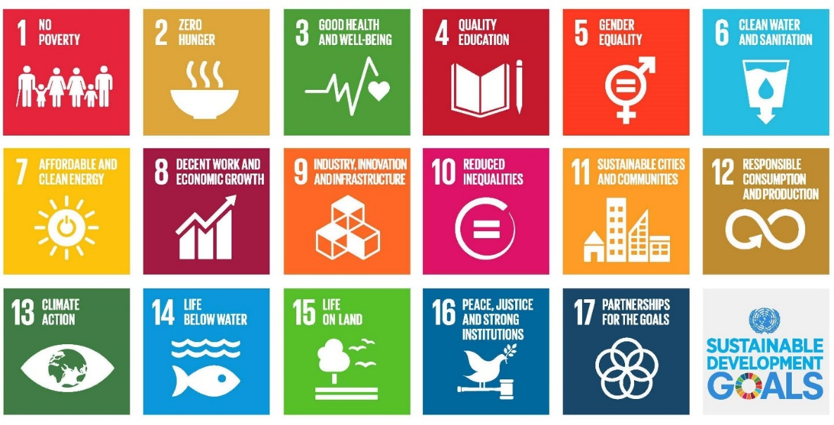
- The symposium comprised seven sessions dedicated to the theme of “International Standards to enable the digital transformation and achieve the SDGs” and a U4SSC ceremony with cities.

International Telecommunication Union
gss@itu.int

This standard is being implemented in more than 150 cities worldwide, including Daegu, Mashhad, Bizerte, Dubai, Singapore, Riyadh and Valencia.

