|  |  |
| --- | --- |
| World Telecommunication Standardization Assembly (WTSA-20) Geneva, 1-9 March 2022 |  |
|  |  |
|  |  |
| PLENARY MEETING | Addendum 26 to Document 40-E |
|  | **7 February 2022** |
|  | **Original: Russian** |
|  | |
| ITU Member States, members of the Regional Commonwealth in the field of Communications (RCC) | |
| PROPOSED MODIFICATION OF RECOMMENDATION ITU-T A.25 | |
|  | |
|  | |

Introduction

Common problems in the application of Recommendations ITU-T A.5 and A.25

During the current study period, in applying Recommendations ITU-T A.5 and A.25 the ITU-T membership has repeatedly been confronted with differences in the understanding of the procedures used for documents of external organizations.

Two common problems have been identified.

1 The original information for application of the Recommendations in question is provided by rapporteurs, editors or representatives of organizations based on their understanding of the need for the information in question. When TSB becomes involved in preparing the necessary forms for Recommendations A.5 and A.25, the correspondence takes place directly between TSB and the small circle of experts involved. At the stage where a proposal is made in a meeting of the study group to adopt the submitted documents, none of the original documents are provided to the ITU membership; this regularly leads to complications in evaluating decisions as to whether or not the organization or its documents meet the requirements of the Recommendations. The ITU membership should be given access to the necessary original documents before taking their decision, including documents that concern the organization’s policy on intellectual property rights (IPR).

2 The view is sometimes expressed that, once an external organization has been successfully qualified as meeting the requirements of Annex B of Recommendation A.5, and thereupon Annex A of Recommendation A.5 or Recommendation A.25 is applied, compliance with all IPR rules becomes automatic and there is no need to review individual documents in applying Annex A of Recommendation A.5 and Recommendation A.25. This understanding is incorrect: a review is needed at this stage, too, to confirm that documents meet the concrete requirements of ITU, including those pertaining to IPR. During the review, the ITU membership is also entitled to examine the necessary documents that the organization concerned has provided. However, these aspects are not indicated in an exact and clear manner in the texts that are in force, which has led to repeated delays caused by the last-minute discovery, just prior to taking a decision, of the need for an additional review of concrete documents to ascertain whether they meet the specific requirements of documents relating to IPR, both those of ITU and those of the external organization.

It is therefore proposed to modify Recommendations ITU-T A.5 and A.25 so as to standardize the approach as much as possible and make the texts clearer for all parties concerned.

Proposal

It is proposed that modifications and additions be made to sections of Recommendation ITU-T A.25 and its appendices, as indicated in the text that follows.

MOD RCC/40A26/1

Recommendation ITU‑T A.25



Generic procedures for incorporating text  
between ITU‑T and other organizations

Summary

Recommendation ITU‑T A.25 addresses the process of incorporating text (in whole or in part, with or without modification) of documents from another organization into an ITU‑T Recommendation (or another ITU‑T document). Similarly, guidance is provided for other organizations incorporating text (in whole or in part, with or without modification) from ITU‑T Recommendations (or other ITU‑T documents) in their documents.

# 1 Scope

This Recommendation provides generic procedures for incorporating (in whole or in part, with or without modification) the documents of other organizations (including consortia, forums, and national and regional standards development organizations) in ITU‑T Recommendations (or other ITU‑T documents), and provides guidance for other organizations on how to incorporate ITU‑T Recommendations (or other ITU‑T documents), in whole or in part, in their documents. These procedures are applied each time a proposal for incorporation is made.

The case of normatively referencing the documents of other organizations in ITU‑T Recommendations is addressed in [ITU‑T A.5].

# 2 References

The following ITU‑T Recommendations and other references contain provisions which, through reference in this text, constitute provisions of this Recommendation. At the time of publication, the editions indicated were valid. All Recommendations and other references are subject to revision; users of this Recommendation are therefore encouraged to investigate the possibility of applying the most recent edition of the Recommendations and other references listed below. A list of the currently valid ITU‑T Recommendations is regularly published. The reference to a document within this Recommendation does not give it, as a stand-alone document, the status of a Recommendation.

[ITU‑T A.5] Recommendation ITU‑T A.5 (2019), *Generic procedures for including references to documents of other organizations in ITU‑T Recommendations*.

[PP Res. 66] Plenipotentiary Conference Resolution 66 (Rev. Dubai, 2018), *Documents and publication of the Union*.

# 3 Definitions

## 3.1 Terms defined elsewhere

This Recommendation uses the following terms defined elsewhere:

**3.1.1** **approved document** [ITU‑T A.5]: An official output (such as a standard, a specification, an implementation agreement, etc.) which has been formally approved by an organization.

**3.1.2 non-normative reference** [ITU‑T A.5]: The whole or parts of a document where the referenced document has been used as supplementary information in the preparation of the Recommendation or to assist the understanding or use of the Recommendation, and to which conformance is not necessary.

**3.1.3** **normative reference** [b-ITU‑T A.1]: The whole or parts of another document where the referenced document contains provisions which, through reference to it, constitute provisions to the referring document.

## 3.2 Terms defined in this Recommendation

This Recommendation defines the following term:

**3.2.1 draft document**: An output from an organization, which is still in draft form.

# 4 Abbreviations and acronyms

This Recommendation uses the following abbreviations and acronyms:

TSB Telecommunication Standardization Bureau

# 5 Conventions

None.

# 6 Generic procedures for incorporating text of other organizations in ITU‑T documents

This clause addresses the process of incorporating text (in whole or in part) from another organization into an ITU‑T document (see the diagram in Appendix I). This process is expected to be rarely used because ITU‑T study groups are encouraged to rather use the normative reference process explained in [ITU‑T A.5].

## 6.1 Process for incorporation

**6.1.1** An ITU‑T study group or ITU‑T members may identify the need to specifically incorporate text (in whole or in part, with or without modification) from a draft or approved document from another organization within a draft ITU‑T Recommendation (or another draft ITU‑T document). The need to incorporate text may also be identified by the organization itself. ITU‑T study groups are strongly encouraged to incorporate approved text rather than draft text from other organizations and, whenever possible, to incorporate text without modification.

**6.1.2** Information to explain why incorporation was chosen over a normative reference should be provided in a TD (or a contribution), as outlined in clauses 6.1.2.1 to 6.1.2.10 (see also Appendix II).

**6.1.2.1** Description of the referenced document (incl. full copy): A clear description of the document considered for incorporation (type of document, title, number, version, date, etc.). (See also clause 6.2.2.)

**6.1.2.2** Status of approval: Incorporating text that has not yet been approved by the organization can lead to confusion; thus, incorporating is usually limited to approved documents. If absolutely necessary, incorporation of text from a draft document can be made where cooperative work requiring cross-incorporation is being approved by ITU‑T and another organization in approximately the same time-frame.

**6.1.2.3** Justification for the specific incorporation, including why it is inappropriate to reference the text in the draft ITU‑T Recommendation (or other draft ITU‑T document).

**6.1.2.4** Intellectual property rights[1]1 issues (patents, copyrights for software or texts, marks), if any: see clauses 6.2 and 6.3. The study group (working party) must carefully examine the document proposed for incorporationto identify any concrete questions relating to IPR, independently of any IPR policy questions that may have come to light when the organization being referenced was undergoing A.5 qualification (see Annex B of Recommendation ITU-T A.5). Documents related to such concrete IPR questions (issues) should accompany the justification for documentation purposes.**6.1.2.5** Other information that might be useful in describing the "quality" of the document (e.g., whether products have been implemented using it, whether conformance requirements are clear, whether the specification is readily and widely available).

**6.1.2.6** Degree of stability or maturity of the document (e.g., length of time it has existed).

**6.1.2.7** Relationship with other existing or emerging documents.

**6.1.2.8** List of normative references within the incorporated document: All normative references within the incorporated document should be listed (see also clause 6.2.2 c).

**6.1.2.9** Qualification of the organization (per Annex B of [ITU‑T A.5]): This needs to be done only the first time a document from the organization is being considered for incorporation, and only if such qualification information has not been already documented. Qualification of an organization is reviewed on a regular basis (any study group willing to incorporate a document from the organization may perform the review). In particular, if the patent policy of that organization has changed, it is important to check that the new patent policy is consistent with the Common Patent Policy for ITU‑T/ITU-R/ISO/IEC and the Guidelines for the Implementation of the Common Patent Policy for ITU‑T/ITU-R/ISO/IEC.

NOTE – In case of a partnership project that is not a legal entity, qualification (per Annex B of [ITU T A.5]) is required for each organization in the partnership project.

**6.1.2.10** Document maintenance process: Approved Recommendations need to be reviewed and maintained over time. This may require collaborative effort with the other organization. Depending on new agreements reached between the ITU‑T study group and the other organization, new versions of the incorporated text can be produced by the ITU‑T study group or by the other organization. Therefore, it shall be clarified if maintenance of the text is a shared responsibility between the ITU‑T study group and the organization (see [b-ITU‑T A.Sup5], in particular clause 10), or if the organization is responsible of producing new versions of the incorporated text.

**6.1.3** As soon as the documents to be incorporated are received (see clause 6.2.2), they are made available, with the agreement of the study group chairman, and subject to the permission arrangements set out in clause 6.2 and to the copyright arrangements set out in clause 6.3, for advance consideration by the relevant group. They are issued, together with information about them (see clause 6.1.2), as a TD at a study group or working party meeting, normally at least one month before the start of the meeting at which the ITU‑T Recommendation (or other ITU‑T document) is planned for determination for TAP consultation, or consent for AAP last call (or agreement). When the other organization is responsible of producing new versions of the text (see clause 6.1.2.10), the draft resulting ITU‑T Recommendation is notified by a circular at least three months before the start of the meeting at which the Recommendation is planned for determination for TAP consultation or consent for AAP last call.

**6.1.4** The study group (or working party) evaluates this information (see clause 6.1.2) and decides whether to make the incorporation. The format for documenting the study group or working party decision is given in Appendix II.

**6.1.5** When an ITU‑T study group decides to incorporate text (in whole or in part, with or without modification) from another organization in its own document, it notifies the organization about the actions taken concerning this text. The use, acceptance or reproduction of such text by the ITU‑T study group is subject to the permission arrangements set out in clause 6.2 and to the copyright arrangements set out in clause 6.3.

**6.1.6** The resulting ITU‑T Recommendation (or ITU‑T document) shall identify the incorporated text, and shall provide a bibliographic reference to the document of the organization and to its particular version. In case the text of another organization is incorporated in whole and without modification, the bibliographic reference in the ITU‑T Recommendation is followed by a note indicating that the referenced text is technically equivalent to the ITU‑T Recommendation.

**6.1.7** The cover sheet of the resulting ITU‑T Recommendation will draw the attention of implementers to potential notices of intellectual property received by the other organization as they may also apply to the ITU‑T Recommendation.

## 6.2 Permission arrangements

**6.2.1** At the earliest possible moment (see clause 6.1.3), upon the request of the study group or working party, the Telecommunication Standardization Bureau (TSB) will ensure that the organization (or designated contact point for a joint collaboration arrangement – see clause 7.3 of [ITU‑T A.5]) has provided a written statement in which it agrees to:

– the distribution of the material for discussions within the appropriate groups, and

– its possible use (in whole or in part, with or without modification) in any resulting ITU‑T Recommendations (or other ITU‑T documents) that are published (see [PP Res. 66]).

**6.2.2** TSB will also get from the organization a full copy of the existing document, preferably in electronic format (see clause 6.1.3). No reformatting is necessary. The objective is to have referenced documents available via the web at no cost, so that the study group (or working party) may proceed with its evaluation. Accordingly, if a document to be incorporated in whole or in part is available in this manner, it is sufficient to provide its exact location on the web. The document should conform to the following criteria:

a) should contain no confidential information;

b) should indicate the source within the organization (e.g., committee, subcommittee, etc.);

c) should differentiate between normative references and non-normative references.

**6.2.3** Should the organization decline to provide such statement or fail to do so, the incorporation shall not be made. In this case, the decision to incorporate the reference (according to [ITU‑T A.5]) instead of the text shall be made by consensus.

## 6.3 Copyright arrangements

The subject of modifications to texts and arrangements for royalty-free copyright licences, including the right to sub-license, for texts accepted by ITU‑T, is a matter to be agreed upon between TSB and the particular organization. However, the originating organization retains the copyright and change control for its texts, unless explicitly relinquished. (See also clauses 6.1.2.10, 6.1.6 and 6.2.1.)

# 7 Generic procedures for incorporating text of ITU‑T documents in the documents of other organizations

Organizations are strongly encouraged to reference approved ITU‑T documents as appropriate to progress their work. This clause addresses the process of incorporating text (in whole or in part, with or without modification) from an ITU‑T document in a document of another organization. This process is expected to be rarely used.

## 7.1 Documents sent to other organizations

**7.1.1** An organization may incorporate text (in whole or in part, with or without modification) from a draft or approved ITU‑T Recommendation (or of other documents produced by ITU‑T), as all or part of the text of its draft document. Organizations are strongly encouraged to incorporate approved text rather than draft text from ITU‑T and, whenever possible, to incorporate text without modification.

**7.1.2** When an organization decides to accept ITU‑T text, it notifies TSB about the actions taken concerning this text. The use, acceptance or reproduction of such text by the qualified organization is subject to the permission arrangements set out in clause 7.2 and to the copyright arrangements set out in clause 7.3.

## 7.2 Permission arrangements

**7.2.1** At the earliest possible moment, the organization will ensure that the TSB has provided a written statement that it agrees to the distribution of the material for discussions within the appropriate groups and possible use (in whole or in part, with or without modification) in any documents of the organization.

**7.2.2** Should the ITU decline to provide such statement, or fails to do so, the incorporation shall not be made.

## 7.3 Copyright arrangements

The subject of modifications to texts and arrangements for royalty-free copyright licences, including the right to sub-license, for texts accepted by qualified organizations and their publishers and others, is a matter to be agreed upon between TSB and the particular organization. However, the ITU retains the copyright and change control for its texts, unless explicitly relinquished.

Appendix I  
  
Workflow for incorporating text of another organization

(This appendix does not form an integral part of this Recommendation.)

Figure I.1 describes the workflow for incorporating text of another organization.

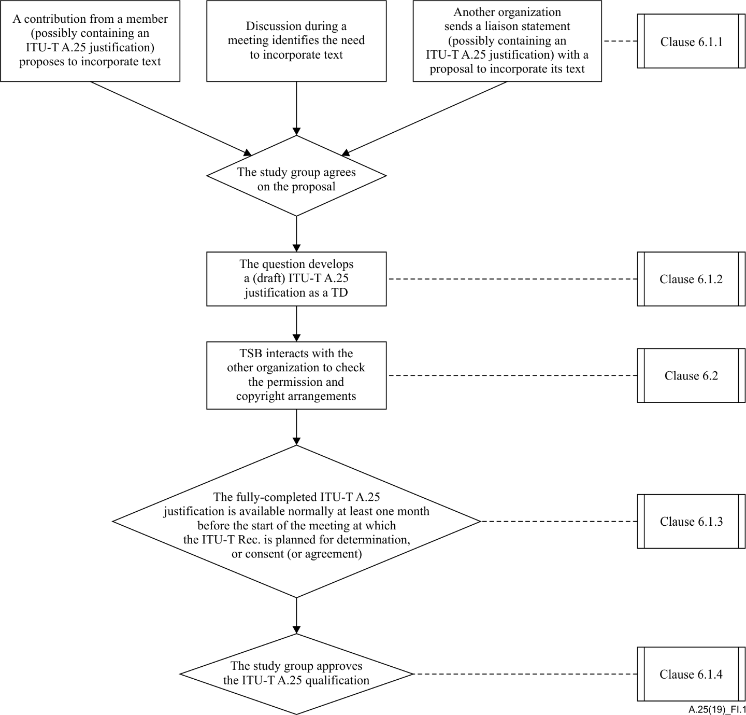

Figure I.1 – Workflow for incorporating text of another organization

Appendix II  
  
Format for documenting a study group or working party decision

(This appendix does not form an integral part of this Recommendation.)

## II.1 Description of the referenced document (incl. full copy)

*[Insert clear description of the document considered for incorporation, e.g., type of document, title, number, version, date, etc.]*

*[Insert number of the TD containing the document or URL to the document on the website of the other organization]*

NOTE – No reformatting is necessary. The objective is to have referenced documents available via the web at no cost, so that the study group (or working party) may proceed with its evaluation. Accordingly, if a document to be incorporated in whole or in part is available in this manner, it is sufficient to provide its exact location on the web. On the other hand, if the document is not available in this manner, a full copy must be provided (preferably in electronic format).

## II.2 Status of approval

NOTE – Incorporating text that has not yet been approved by the organization can lead to confusion; thus, incorporating is usually limited to approved documents. If absolutely necessary, incorporation of text from a draft document can be made where cooperative work requiring cross-incorporation is being approved by ITU‑T and another organization in approximately the same time-frame.

*[Choose status of approval from the drop-down list]*

## II.3 Justification for the specific incorporation

*[Insert justification, including why it is inappropriate to reference the text in the draft ITU-T Recommendation or other draft ITU-T document]*

## II.4 Intellectual property rights) issues (patents, copyrights for software or text, marks)

*[Insert current information, if any, about patents, copyrights for software or text, marks, etc.]*

*Documents related to such concrete IPR questions (issues) should accompany the justification for documentation purposes.*

## II.5 Other information

*[Insert other information that might be useful in describing the "quality" of the document, e.g. whether products have been implemented using it, whether conformance requirements are clear, whether the specification is readily and widely available]*

## II.6 Stability or maturity of the document

*[Insert degree of stability or maturity, e.g. length of time it has existed]*

## II.7 Relationship with other existing or emerging documents

*[Insert relationship]*

## II.8 List of normative references within the incorporated document

NOTE – When text from a document is to be incorporated in an ITU‑T Recommendation, all normative references within the incorporated document should be listed. The document should differentiate between normative references and non-normative references.

*[List all normative references]*

## II.9 Qualification of the organization (per Annex B of [ITU‑T A.5])

NOTE – This needs to be done only the first time a document from the organization is being considered for incorporation, and only if such qualification information has not been already documented. Qualification of an organization is reviewed on a regular basis (any study group willing to incorporate a document from the organization may perform the review). In particular, if the patent policy of that organization has changed, it is important to check that the new patent policy is consistent with the Common Patent Policy for ITU T/ITU‑R/ISO/IEC and the Guidelines for the Implementation of the Common Patent Policy for ITU‑T/ITU-R/ISO/IEC. In case of a partnership project that is not a legal entity, qualification (per Annex B of [ITU T A.5]) is required for each organization in the partnership project.

*[Insert number of the TD containing the A.5 qualification of the organization if it is not yet qualified]*

## II.10 Document maintenance process

NOTE – Approved Recommendations need to be reviewed and maintained over time. This may require collaborative effort with the other organization. Depending on new agreements reached, new versions of the incorporated text can be produced by the ITU‑T study group or by the other organization. Therefore, it shall be clarified if maintenance of the text is a shared responsibility between the ITU‑T study group and the organization (see [b-ITU‑T A.Sup5], in particular clause 10), or if the organization is responsible of producing new versions of the incorporated text.

*[Describe the maintenance process]*

Bibliography

[b-ITU‑T A.1] Recommendation ITU‑T A.1 (2012), *Working methods for study groups of the ITU Telecommunication Standardization Sector (ITU‑T).*

[b-ITU‑T A.Sup5] ITU‑T A-series Recommendations – Supplement 5 (2016), *Guidelines for collaboration and exchange of information with other organizations.*

1. 1 See: https://www.itu.int/ipr