 |  | International telecommunication union  Telecommunication Standardization Bureau
 |  |  | Geneva, 21 December 2021
Ref:  Contact | TSB Circular 364  FNC-2022/SP  Stefano Polidori |  | To:  - Administrations of Member States of  the Union;  - ITU-T Sector Members;  - ITU-T Associates;  - ITU Academia
Tel: | +41 22 730 5858
Fax: | +41 22 730 5853
E-mail: | tsbevents@itu.int |  | Copy to:  - The Chairmen and Vice-Chairmen of  Study Groups;  - The Director of the Telecommunication Development Bureau;  - The Director of the Radiocommunication Bureau
Subject: | Symposium on the Future Networked Car (FNC-2022)  (Fully virtual meeting, 22-25 March 2022)
Dear Sir/Madam,
1 I am very pleased to inform you that International Telecommunication Union (ITU) and the United Nations Economic Commission for Europe (UNECE) will be co-organizing the 17th edition of the Symposium on the Future Networked Car (FNC-2022) taking place virtually from 22-25 March 2022 from 13h00 to 16h00 CET each day.
The Symposium will be preceeded by the meeting of the Collaboration on Intelligent Transport Systems Communication Standards (CITS) taking place on 18 March 2022. For more information on the CITS meeting, see: https://www.itu.int/go/cits.
2 Since its conception in 2005, the Symposium on the Future Networked Car seeks to bring together representatives of the automotive, information and communications technology industries, along with government leaders and regulators, to discuss the status and future of vehicle communications and automated driving from both technical and regulatory viewpoints.
FNC 2022 panelists will examine the global regulatory framework that will support deployment of highly automated mobility solutions as well as the latest technolgy advances in the areas of vehicle connectivity and applications of artificial intelligence (AI) to enhance driverless vehicle operation, vehicle design and manufacturing, road maintenance, traffic flow management, and passenger experience. The Symposium will delve into the relationships between vehicle communications and automated/autonomous driving by analyzing the crucial role of regulatory frameworks to realize future intelligent transport systems (ITS). Collaboration among the various standards bodies as well as defining specific areas where AI will be most useful are essential components to sucesfully realize the future of mobility.

The structure of the Symposium will be as follows (see in ANNEX for a draft programme):
22 March 2022, 13h00-13h30 CET: | OPENING CEREMONY
22 March 2022, 13h30-16h00 CET: | SESSION 1: Government Authorities’ Advances in Intelligent Transport Systems
23 March 2022, 13h00-16h00 CET: | SESSION 2: Artificial General Intelligence Applied to Vehicle Safety, Services, and Transport Management: Current Status and Future Directions
24 March 2022, 13h00-16h00 CET: | SESSION 3: Automated Driving Systems for Consumer and Other Vehicles (Trucks, Delivery, Shuttles, Robotaxis, Etc.)
25 March 2022, 13h00-16h00 CET: | SESSION 4: Wireless Communications Applied to Vehicle Safety, Services, and Transport Management - Current Status and Future Directions
3 The discussions will be held in English only.
4 Participation is open to ITU Member States, Sector Members, Associates and Academic Institutions and to any individual from a country which is a member of the United Nations who wishes to contribute to the work. This includes individuals who are also members of international, regional and national organizations. Participation in the Symposium will be free of charge.
5 All relevant information pertaining to the Symposium, (speakers, draft programme, remote connection details, registration links) will be made available on the main event website found at: https://fnc.itu.int/
Kindly note that registration is mandatory. The website will be regularly updated as new and modified information becomes available. Participants are requested to check the symposium website periodically for updates. Please do not hesitate to contact Mr Stefano Polidori (stefano.polidori@itu.int) should you need additional information on the programme.
For information on sponsorship opportunities for the FNC-2022, please contact tsbevents@itu.int.
Yours faithfully,
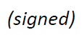
Chaesub Lee
Director of the Telecommunication
Standardization Bureau
Annexes: 1
ANNEX
FNC-2021 Draft Programme
Fully virtual, 22-25 March 2022
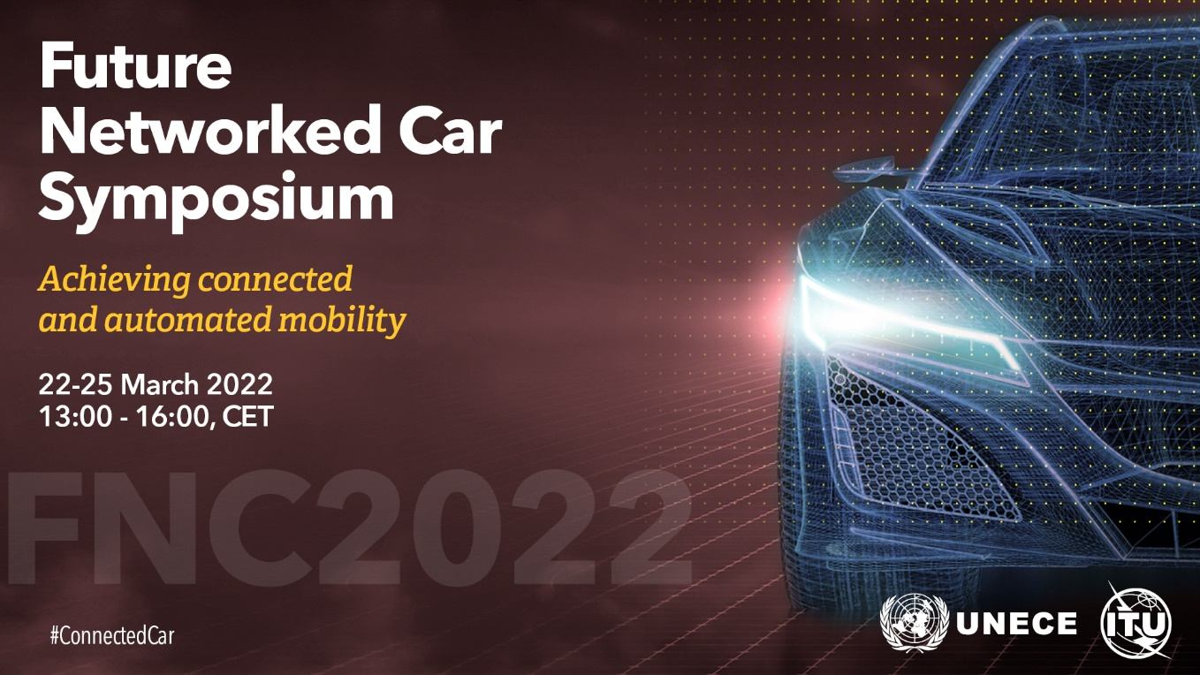

22 March 2022 (13h00-16h00 CET)
OPENING
Opening addresses from ITU and UNECE
SESSION 1 – Government Authorities’ Advances in Intelligent Transport Systems
UNECE has worked on Intelligent Transport Systems since 2008. The Inland Transport Committee adopted its first UNECE Roadmap on ITS in 2012. Since then, UNECE has advanced the field of ITS across the different modes of inland transport, such as ADAS and Automated Driving Systems for road transport, as well as smart shipping for inland waterways. In addition, ITS applications related to transport of dangerous goods, ITS for climate-change mitigation, and smart roads were also considered within a holistic approach.
Last year, the symposium’s first session included presentations about the activities of the World Forum for Harmonization of Vehicle Regulations (WP.29) related to automated driving systems, over-the-air software updates, and cybersecurity management.
One of the highlights of 2021 was the adoption in February of the revised UNECE Roadmap on ITS. The first session of this years’ symposium will explore the achievements of the Intelligent Transport Systems sectors and the views of regulators and policy makers.
Moderator: TBC
23 March 2022 (13h00-16h00 CET)
SESSION 2: Artificial General Intelligence Applied to Vehicle Safety, Services, and Transport Management: Current Status and Future Directions
Artificial General Intelligence (AGI) is the hypothetical ability of an intelligent agent to understand and learn any intellectual task that a human can. It possesses the ability to analyse a situation on its own and take a calculative decision without being programmed in advance. AGI, also called ‘Strong AI’, with its six major branches (machine learning, neural network, robotics, expert systems, fuzzy logic and natural language processing) is being applied to many application areas, including driverless vehicle operation, vehicle design and manufacturing, road maintenance, traffic flow management, and passenger experience. While Weak AI has proven to be excellent at accomplishing one goal at a time, AGI will be able to accomplish multiple goals at the same time so it can, for example, drive a car. This panel will present and discuss views on the current status of AGI in general, on vehicle-related applications of AGI, different scenarios and timelines for their implementation, and concerns for how humans and AGI can co-exist.
Moderator: Michael L. Sena, Publisher and Editor of “The Dispatcher”
24 March 2022 (13h00-16h00 CET)
SESSION 3: Automated Driving Systems for Consumer and Other Vehicles (Trucks, Delivery, Shuttles, Robotaxis, Etc.)
The past year saw a reassessment of automated driving with the conclusion that achieving full autonomy would take longer than originally anticipated. Research and progress are nevertheless advancing. Key to understanding the pace and path of AV adoption is better understanding individual use cases. This panel will review emerging AV applications – commercial vehicles, delivery drones and vans, shuttles, robotaxis – to better understand the challenges and opportunities associated with AV technology and the state of development and market adoption.
Moderator: Roger Lanctot, Director, Automotive Connected Mobility, Strategy Analytics
25 March 2022 (13h00-16h00 CET)
SESSION 4: Wireless Communications Applied to Vehicle Safety, Services, and Transport Management - Current Status and Future Directions
Wireless communication use is expanding in transport across many applications to improve operations, to provide better information to the general population, and to improve the user experience in-vehicle.
5G and direct communications to/from and between vehicles will allow new and improved applications.
This panel will present and discuss views on the current status of wireless communications for vehicle- related applications, different scenarios and timelines for their implementation, and opportunities for transport authorities and vehicle manufacturers to extend the use of wireless communications.
Moderator: T. Russell Shields, President and CEO, RoadDB LLC

__________________

