International telecommunication union
Telecommunication Standardization Bureau
 |  |  | Geneva, 7 February 2020
Ref: | Corrigendum 1 to  TSB Circular 227 |  | To:  - Administrations of Member States of  the Union;  - ITU-T Sector Members;  - ITU-T Associates;  - ITU Academia
Tel: | +41 22 730 5858
Fax:  E-mail: | +41 22 730 5853  tsbfgvm@itu.int
Copy to:
- The Chairmen and Vice-Chairmen of
Study Groups;
- The Director of the Telecommunication Development Bureau;
- The Director of the Radiocommunication Bureau
Subject: | Eighth meeting of ITU-T Focus Group on Vehicular Multimedia (FG-VM) – e-meeting
Dear Sir/Madam,
Further to TSB Circular 227 of 21 January 2020, this corrigendum informs you that the scheduled meeting of the ITU-T Focus Group on vehicular multimedia (FG-VM), which was planned in Singapore, will be held as an e-meeting due to the coronavirus emergency. Therefore, the 8th meeting of the FG-VM will be held electronically,12-13 March 2020 from 12h00 to 15h00 (CET).
Please consult the webpage for additional information:
https://www.itu.int/en/ITU-T/focusgroups/vm
Yours faithfully,  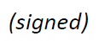  Chaesub Lee  Director of the Telecommunication  Standardization Bureau | 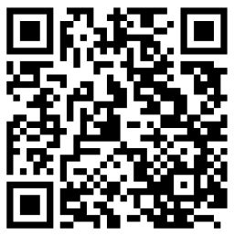  Latest meeting information

