International telecommunication union
Telecommunication Standardization Bureau
 |  |  | Geneva, 21 January 2020
Ref: | TSB Circular 227  FG-VM/SP |  | To:  - Administrations of Member States of  the Union;  - ITU-T Sector Members;  - ITU-T Associates;  - ITU Academia
Tel: | +41 22 730 5858
Fax: | +41 22 730 5853
E-mail: | tsbfgvm@itu.int
Copy to:
- The Chairmen and Vice-Chairmen of
ITU-T Study Groups;
- The Director of the Radiocommunication Bureau;
- The Director of the Telecommunication Development Bureau
Subject: | Eighth meeting of ITU-T Focus Group on Vehicular Multimedia (FG-VM) – Singapore, 12-13 March 2020
Dear Sir/Madam,
I would like to inform you that the eight meeting of ITU-Focus Group on Vehicular Multimedia (FG-VM) will be held in Singapore from 12 to 13 March 2020, kindly hosted by Desay SV Automotive Singapore.
The event will take place at:
Rendezvous Hotel
9 Bras Basah Road, Singapore 189559
Tel: +65 63360220

1 Background
The Focus Group will analyse and identify gaps in the vehicular multimedia networks standardization landscape and draft technical reports and specifications covering, among others, vehicular multimedia use cases, requirements, applications, interfaces, protocols, architectures and security.
FG-VM was established by ITU-T Study Group 16 at its meeting in Ljubljana (9-20 July 2018). The FG-VM Management team is:
– Chair of FG-VM: Jun Li (TIAA, People’s Republic of China)
– Vice-Chair of FG-VM: Gaëlle Martin-Cocher (Blackberry, Canada)
– Vice-Chair of FG-VM: Kaname Tokita (Honda, Japan).

FG-VM held seven meetings so far: first meeting in Ottawa, Canada on 11 October 2018, hosted by BlackBerry; second meeting in Tokyo, Japan on 23-25 January 2019, hosted by TTC, Japan; third meeting in Geneva, Switzerland, 18-19 March 2019, hosted by ITU; fourth meeting was held electronically on 16-17 May 2019; fifth meeting in Changchun, China, 11-12 July 2019, hosted by TIAA; sixth meeting in, Budapest, Hungary, 11-12 September 2019, hosted by ITU TELCOM WORLD; seventh meeting in Geneva, Switzerland, 12-13 December 2019, hosted by ITU.
The FG-VM structure and leadership is:
WG1: Vehicular Multimedia use cases and Requirements
– Chair: Gaëlle Martin-Cocher (Blackberry, Canada)
– Vice-chair: Kaname Tokita (Honda, Japan)
– Vice-chair: Lu Yu (Changan Automobile Co, LTD, China)
– Vice-chair: Guo Yansong (Great Wall Motor Co, LTD, China).
WG2: Vehicular Multimedia Architecture
– Chair: Yajun Kou (Global Fusion Media Technology and Development Co. Ltd, China)
– Vice-chair: Dimitri Konstantas (University of Geneva, Switzerland)
– Vice-chair: Jie Li (China Telecom, China).
WG3: Implementation aspects of Vehicular Multimedia
– Chair: TBD.

2 Eighth meeting of ITU-Focus Group on Vehicular Multimedia (FG-VM)
The meeting will start at 09:30 hours on 12 March 2020 and will conclude at 17:30 hours on 13 March 2020. Participant registration will begin at 08:30 hours.
A draft agenda, meeting documents and additional information will be available from the FG-VM homepage in advance of the meeting.
The main objective of this eighth meeting is to advance the development on the second FG-VM Technical Report on “Vehicular Multimedia Architecture”. See the output document (FG-VM-O-035) from the seventh meeting of FG-VM, 12-13 December 2019.
The FG-VM has already successfully published a Technical report on "Use cases and requirements for the vehicular multimedia networks" (FGVM-01R1).
Written contributions are invited to further progress this draft Technical Report. Contributions are also invited to further advance the study charter of FG-VM.
For more information please contact tsbfgvm@itu.int. Also, more information will be available on the FG-VM webpage.

3 Registration and other logistics information
To enable the host to make the necessary logistic arrangements, participants are required to pre-register online via the FG-VM webpage as soon as possible, and no later than 22 February 2020. Registration is required for remote participation as well as on-site participation.
To attend the eighth meeting of ITU-T Focus Group on Vehicular Multimedia (FG-VM), participants may register on the ITU website.

Participation in FG-VM is free of charge and open to all, including governments, automotive and telecom/ICT industries and associations, academia and research institutions, non ITU Members and individuals. Anyone interested in updates and announcements related to this group is invited to subscribe to the FG-VM mailing list. Details on how to subscribe can be found on the FG-VM homepage: https://itu.int/go/fgvm. See the step by step instructions here.
Practical meeting information is set out in Annex 1, and a visa support letter can be requested using the form in Annex 2. The discussions will be held in English only, and will be supported by remote participation; details will be made available on the FG-VM homepage.

4 Key deadlines:
12 February 2020  (soft deadline) | - Submit requests for visa support letters (see Annex 2)
22 February 2020 | - Pre-registration (online via the FG-VM homepage)
5 March 2020 | - Submit written contributions (by e-mail to tsbfgvm@itu.int)
I wish you a productive and enjoyable meeting.
Yours faithfully,  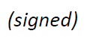  Chaesub Lee  Director of the Telecommunication  Standardization Bureau | Latest meeting information
Annexes: 2
ANNEX 1
Eight meeting of ITU-T FG-VM:
Singapore, 12-13 March 2020
Practical meeting information for participants
WORKING METHODS AND FACILITIES
DOCUMENT SUBMISSION AND ACCESS: The meeting will be run paperless. Written contributions to the Focus Group meeting are encouraged and should be submitted by e-mail to tsbfgvm@itu.int by 5 March 2020 at the latest using the document template available on the FG-VM homepage. Access to all input and output documents will be provided from the FG-VM collaboration site (free ITU account required).
WIRELESS LAN facilities are available at the meeting venue.
PRE-REGISTRATION
PRE-REGISTRATION: Pre-registration for on-site or remote participation is to be done via the FG-VM homepage preferably by 22 February 2020.
PRACTICAL INFORMATION

1. Meeting Venue
Rendezvous Hotel
9 Bras Basah Road, Singapore 189559
Tel: +65 63360220
Email: info.rhs@fareast.com.sg

Please see below a map:
https://www.google.com/maps/place/Rendezvous+Hotel+Singapore/@1.2984968,103.8479736,18z/data=!4m11!1m2!2m1!1sHotel+Rendezvous!3m7!1s0x31da19bca2ddeb3d:0x873e3e522ce5befa!5m2!4m1!1i2!8m2!3d1.2985226!4d103.849141

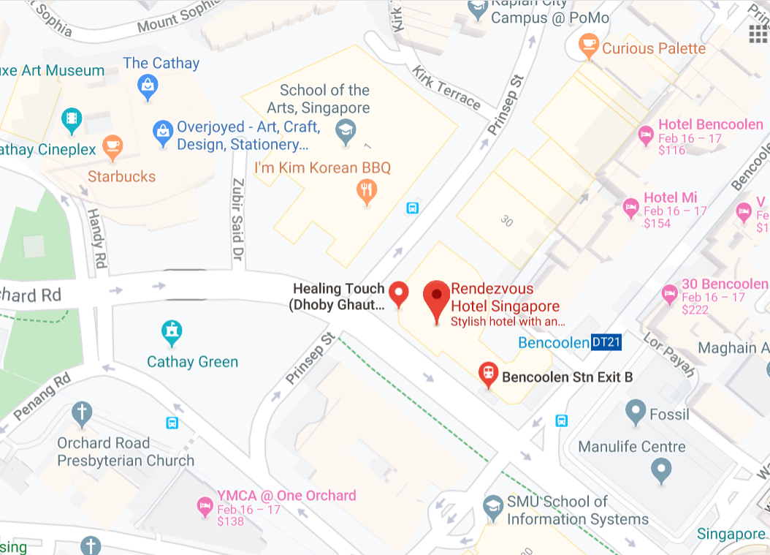

2. Transportation and site information
Changi International Airport is 25 minutes from the meeting venue by car, which will take you about approximately SGD 25. Grab may cost less depending on the peak hour time.
Public transport is available from Changi Airport to the meeting venue but it may take some time. (approximately around 52 minutes in bus). From Changi Airport there is a direct bus, (bus number 36) or you can take the Metro Train, therefore it is a personal choice to choose the best mode of transport depending on the availability of the time.
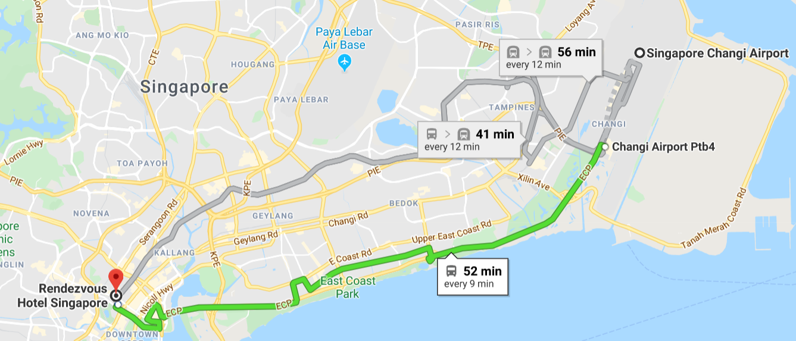

3. Passports and visas
All foreign visitors entering Singapore must have a valid passport. Visitors from countries whose citizens require a visa should at the earliest time and well in advance of travel apply for a visa at a Singapore Embassy or consulate.

See below for more information related to entry into Singapore:
https://www.ica.gov.sg/visitor/visitor_entryvisa

For requesting an invitation letter for visa purposes to the Host, please see Annex 2.

The focal point for visa support at Desay SV Automotive, Singapore is:
Name: Mr Krishna Prasath
E-mail: Prasath.Chandrashekar@desay-svautomotive.com
Tel: +65 83106485

4. Climate in March in Singapore
Monthly average values of the temperature and precipitation in Singapore, are given in the table below:
Weather in March in Singapore. The average temperature in Singapore in March is fairly hot at 25°C (76 °F). Afternoons can be very hot with average high temperatures reaching 32°C (90 °F). Overnight temperatures are generally somewhat warm with an average low of 20°C (68 °F).

 | March
Average maximum temperature | 32 degrees Celsius
Average minimum temperature | 25 degrees Celsius
Average precipitation | 171 mm

5. Hotels
Please make your hotel reservation by yourself. We suggest to book the hotel of the meeting venue.
Strand Hotel Singapore
25 Bencoolen Street, Singapore 189619
Tel: +65 63381866
Enquiries & RESERVATIONS
reservations@strandhotel.com.sg

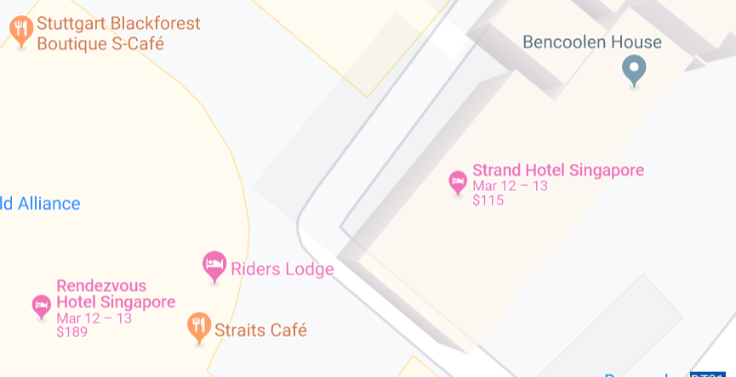

6. Internet access and wireless coverage at the venue
Wireless Internet will be provided to you by the hotel.

7. Technical assistance
In case you have any technical problem at the venue (e.g., connecting to Internet, finding meeting rooms, etc.) please see the host on site.

8. Electricity
The electricity in Singapore is generally 230V, 50 Hz. Please make sure you have the proper adapter.
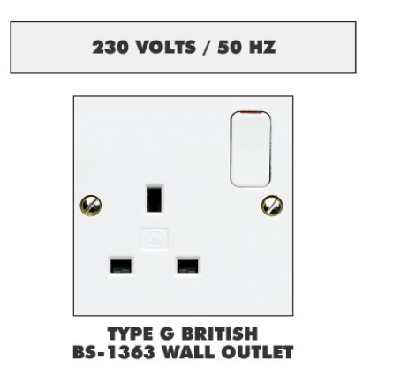Singapore Standard

9. Useful information

9.1 Time Zone: GMT+8:00.

9.2 Currency exchange
The currency in Singapore is the Singapore Dollars; please check the currency exchange rate in the local bank system or use the following link as a reference: http://www.xe.com/

9.3 Tipping: Tipping is not necessary.

10. Additional information

10.1 Mobile phone coverage: 3G, 4G services are provided by SingTel, StarHub and M1.

10.2 Emergency Numbers: In case of emergency, please dial 995.

10.3 Sightseeing:
https://www.timeout.com/singapore/attractions/the-best-singapore-attractions

11. Contact person
Name: Mr Krishna Prasath
E-mail: prasath.chandrashekar@desay-svautomotive.com
Tel: +65 83106485
ANNEX 2
Application form for visa support letter
All foreign visitors entering Singapore must have a valid passport. Visitors from countries whose citizens require a visa should at the earliest opportunity and well in advance of travel apply for a visa at a Singapore embassy or consulate. You may need a letter of invitation from the Singaporean host, which you will need to present to the Singaporean embassy/consulate in your area in order to obtain your visa. The visa must be requested as soon as possible and at least six weeks before the start date of the meeting and obtained from the office (embassy or consulate) representing Singapore in your country or, if there is no such office in your country, from the one that is closest to the country of departure. In order to obtain an invitation letter, please:
a) Fill out the form below.
b) Provide an electronic copy of your passport (name, date of birth, nationality, photo, passport number, expiration date of passport, etc., must be seen clearly).
c) Provide an electronic copy of previous Singaporean visa and records (if you have been to Singapore before).
d) Send the info in a), b) and c) as e-mail attachments to -Prasath.Chandrashekar@desay-svautomotive.com; please indicate as the subject “Application form for visa support letter for ITU-T FG-VM meeting (12-13 March 2020)”.
(Please do not forget to attach a copy of your passport photograph page before sending.)
In order to receive a support letter, your information should be provided to the host (Prasath.Chandrashekar@desay-svautomotive.com) before 12 February 2020.
Please inform the host clearly if you need the original visa support documents, or only the electronic and scanned documents would be sent to you.
NOTE – The Host will do its best to provide invitation letters that are requested after this date; however, we cannot guarantee that you will receive your visa in time for the FG-VM meeting.
Given name (first name)
Family name (last name)
Date of Birth (dd/mm/yyyy)
Gender (male/female)
Nationality
Valid passport number
Passport valid until (dd/mm/yyyy)
Country to submit your visa application
Postal address for your visa support documents to be shipped to | Address | (street)  (city)  (Province)
 | Postal Code
 | Country
 | Telephone number
The above address is: (please select one) |  | Office / home / other (specify: )
Occupation and job title
Name of company/organization
Company/organization address
Office telephone number |  | +
Fax number |  | +
Email address

