|  |  |  |  |  |
| --- | --- | --- | --- | --- |
| The International Teleocmmunication Union - Connecting the World. | | **International telecommunication union**  **Telecommunication Standardization Bureau** | |  |
|  | | | Geneva, 20 June 2019 | |
| **Ref:** | **Corrigendum 1 to TSB Circular 175** | | **To:**  - Administrations of Member States of the Union;  - ITU-T Sector Members;  - ITU-T Associates;  - ITU Academia | |
| **Tel:** | +41 22 730 5858 | |
| **Fax:** | +41 22 730 5853 | |
| **E-mail:** | [tsbfgvm@itu.int](mailto:tsbfgvm@itu.int) | |
|  |  | | **Copy to:**  - The Chairmen and Vice-Chairmen of ITU-T Study Groups;  - The Director of the Radiocommunication Bureau;  - The Director of the Telecommunication Development Bureau | |
| **Subject:** | **Fifth meeting of ITU-T Focus Group on Vehicular Multimedia (FG-VM) – Changchun, China, 11-12 July 2019** | | | |

Dear Sir/Madam,

I would like to inform you that the **fifth meeting of ITU-Focus Group on Vehicular Multimedia   
(FG-VM)** will be held in Changchun, China from 11 to 12 July 2019, kindly hosted by Telematics Industry Application Alliance (TIAA), People’s Republic of China.

The FG-VM will be preceded by a meeting of the Joint Project Team (JPT) between ISO/TC22/SC31/WG8 and Q27/16 and will be held in parallel to the 8th TIAA Conference on 12‑13 July 2019.

The events will take place at:

*Four Points by Sheraton Changchun*

*No 5666 Guigu Street, Hi-tech Zone, Changchun*

*Jilin Province, China*

1 **Background**

The Focus Group will analyse and identify gaps in the vehicular multimedia networks standardization landscape and draft technical reports and specifications covering, among others, vehicular multimedia use cases, requirements, applications, interfaces, protocols, architectures and security.

FG-VM was established by ITU-T Study Group 16 at its meeting in Ljubljana (9-20 July 2018). The FG-VM Management team is:

– **Chair of FG-VM**: Jun Li (TIAA, People’s Republic of China)

– **Vice-Chair of FG-VM**: Gaëlle Martin‑Cocher (Blackberry, Canada)

– **Vice-Chair of FG-VM**: Kaname Tokita (Honda, Japan).

FG-VM held four meetings so far: first meeting in Ottawa, Canada on 11 October 2018, hosted by BlackBerry; second meeting in Tokyo, Japan on 23-25 January 2019, hosted by TTC, Japan; third meeting in Geneva, Switzerland, 18-19 March 2019, hosted by ITU; fourth meeting was held electronically on 16-17 May 2019.

The FG-VM structure and leadership is:

**WG1: Vehicular Multimedia use cases and Requirements**

– **Chair**: Gaëlle Martin-Cocher (Blackberry, Canada)

– **Vice-chair**: Kaname Tokita (Honda, Japan)

– **Vice-chair**: Lu Yu (Changan Automobile Co, LTD, China)

– **Vice-chair**: Guo Yansong (Great Wall Motor Co, LTD, China).

**WG2: Vehicular Multimedia Architecture**

– **Chair**: Yajun Kou (Global Fusion Media Technology and Development Co. Ltd, China)

– **Vice-chair**: Dimitri Konstantas (University of Geneva, Switzerland)

– **Vice-chair**: Jie Li (China Telecom, China).

**WG3: Implementation aspects of Vehicular Multimedia**

– **Chair**: TBD.

2 **Fifth meeting of ITU-Focus Group on Vehicular Multimedia (FG-VM)**

The meeting will **start at 0930 hours** on **11 July 2019** and will conclude at **18:00** hours on **12 July 2019**. Participant registration will begin at 0830 hours.

A draft agenda, meeting documents and additional information will be available from the [FG-VM homepage](https://www.itu.int/en/ITU-T/focusgroups/vm/Pages/default.aspx) in advance of the meeting.

The main objective of this fifth meeting is to advance the development on the FG-VM Technical Report on “**Use cases and requirement for the vehicular Multimedia Networks (VMN)**”. See the output document ([FG‑VM‑O‑014](https://extranet.itu.int/sites/itu-t/focusgroups/vm/output/Forms/04.aspx)) from the fourth meeting of FG-VM, 16-17 May 2019.

**Written contributions** are invited to further progress this draft Technical Report. **Contributions** are also invited to further advance the study charter of FG-VM.

For more information please contact [tsbfgvm@itu.int](mailto:tsbfgvm@itu.int). Also, more information will be available on the [FG-VM webpage](https://www.itu.int/en/ITU-T/focusgroups/vm/Pages/default.aspx).

3 **Registration and other logistics information**

To enable the host to make the necessary logistic arrangements, participants are required to **pre‑register online** via the FG-VM homepage as soon as possible, and **no later than 25 June 2019**. Registration is required for remote participation as well as on-site participation.

To attend the **fifth meeting of ITU-T Focus Group on Vehicular Multimedia (FG-VM)**,participants may register on the [ITU website](https://itu.int/go/fgvm).

Participation in FG-VM is free of charge and open to all, including governments, automotive and telecom/ICT industries and associations, academia and research institutions, non ITU Members and individuals. Anyone interested in updates and announcements related to this group is invited to subscribe to the **FG-VM mailing list**. Details on how to subscribe can be found on the FG-VM homepage: <https://itu.int/go/fgvm>.

Practical meeting information is set out in **Annex 1**,and a visa support letter can be requested using the form in **Annex 3**. The discussions will be held in English only, and will be supported by **remote participation**; details will be made available on the FG-VM homepage.

4 **Key deadlines:**

|  |  |
| --- | --- |
| 11 June 2019 (soft deadline) | - Submit requests for visa support letters (see **Annex 3**) |
| 25 June 2019 | - Pre-registration (online via the [FG-VM homepage](https://www.itu.int/en/ITU-T/focusgroups/vm)) |
| 1 July 2019 | - Submit written contributions (by e-mail to [tsbfgvm@itu.int](mailto:tsbfgvm@itu.int)) |

I wish you a productive and enjoyable meeting.

|  |  |
| --- | --- |
| Yours faithfully,  *(signed)*  Chaesub Lee Director of the Telecommunication Standardization Bureau | Latest meeting information |

**Annexes: 3**

ANNEX 1

**Fifth meeting of ITU-T FG-VM:**

**Changchun, China, 11-12 July 2019**

**Practical meeting information for participants**

**WORKING METHODS AND FACILITIES**

**DOCUMENT SUBMISSION AND ACCESS:** The meeting will be run paperless. Written contributions to the Focus Group meeting are encouraged and should be submitted by e-mail to [tsbfgvm@itu.int](mailto:tsbfgai4h@itu.int) by **1 July 2019** at the latest using the document [template](https://staging.itu.int/en/ITU-T/focusgroups/vm/Documents/FG-VM-I-template.docx) available on the [FG-VM homepage.](https://www.itu.int/en/ITU-T/focusgroups/vm) Access to all input and output documents will be provided from the [FG-VM collaboration site](https://extranet.itu.int/sites/itu-t/focusgroups/vm/SitePages/Home.aspx) ([*free ITU account required*](https://www.itu.int/en/ties-services/Pages/default.aspx)).

**WIRELESS LAN** facilities are available at the meeting venue.

**PRE-REGISTRATION**

**PRE-REGISTRATION:** Pre-registration for on-site or remote participation is to be done via the FG‑VM homepage preferably by **25 June 2019**.

**PRACTICAL INFORMATION**

1. Meeting Venue

*Four Points by Sheraton Changchun*

*No 5666 Guigu Street, Hi-tech Zone, Changchun*

*Jilin Province, China*

Tel: 86- 13843134767

E-mail: ethan.sang@fourpoints.com

Please see below a map:

<http://www.google.cn/maps/place/Four+Points+By+Sheraton+Changchun,+Hi-Tech+Zone/@43.8028777,125.2357398,14.5z/data=!4m5!3m4!1s0x5e385ba90a3c4a47:0xecc69f562bd153ec!8m2!3d43.79906!4d125.23151?hl=en>

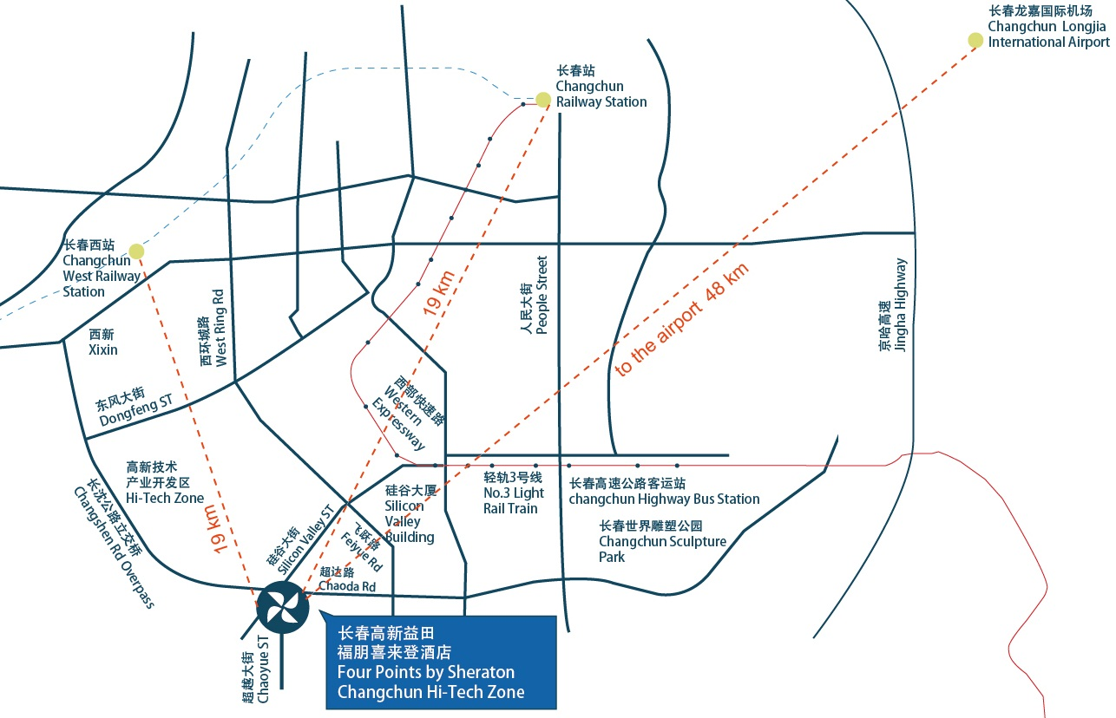

2. Transportation and site information

Changchun Longjia International Airport is 1 hour from the meeting venue by car, which will take you about RMB 120 including expressway toll.

There is no direct public bus line from the airport to the meeting venue, therefore, using a taxi may be your best choice. Please use “Taxi direction” in Annex 2.

3. Passports and visas

All foreign visitors entering China must have a valid passport. Visitors from countries whose citizens require a visa should at the earliest time and well in advance of travel apply for a visa at a Chinese Embassy or consulate.

See below for more information related to entry into The People’s Republic of China:

<http://cs.mfa.gov.cn/wgrlh/lhqz/lhqzjjs/t1095035.shtml>

For requesting an invitation letter for visa purposes to the Host, please see **Annex 3**.

The focal point for visa support at TIAA, China is:

Name: Ms Zhufang Wu

E-mail: [zhufang916@tiaa.org.cn](mailto:zhufang916@tiaa.org.cn)

Tel: +86 10 88687092

4. Climate in July in Changchun, China

Monthly average values of the temperature and precipitation in Changchun, China, are given in the table below:

Weather in July in Changchun. The average temperature in Changchun in July is fairly hot at 22 °C (71.6 °F). Afternoons can be very hot with average high temperatures reaching 27 °C (80.6 °F). Overnight temperatures are generally somewhat warm with an average low of 16 °C (60.8 °F).

|  |  |
| --- | --- |
|  | July |
| Average maximum temperature | 26 degrees Celsius |
| Average minimum temperature | 17 degrees Celsius |
| Average precipitation | 160 mm |

5. Hotels

Please be informed that the venue has recently changed due to unforeseen circumstances. If delegates have previously booked into the Changchun Garden Hotel, or other hotel near the previous venue, they may request assistance to cancel their previous booking (without fee) to:

* Ms Cindy (吴祝方) at [zhufang916@tiaa.org.cn](mailto:zhufang916@tiaa.org.cn)

The new venue is the [Four Points by Sheraton Changchun](https://www.marriott.com/cgqfp).

Please make your hotel reservation by yourself. We suggest to book the hotel of the meeting venue.

*Four Points by Sheraton Changchun*

*No 5666 Guigu Street, Hi-tech Zone, Changchun*

*Jilin Province, China*

Tel: 86- 13843134767

E-mail: [ethan.sang@fourpoints.com](mailto:ethan.sang@fourpoints.com)

Website: <https://www.marriott.com/cgqfp>

A preferential rate would be 360CNY /night by mentioning TIAA or TIAA Changchun conference at the time of booking by email to [ethan.sang@fourpoints.com](mailto:ethan.sang@fourpoints.com).

6. Internet access and wireless coverage at the venue

Wireless Internet will be provided to you by the hotel.

7. Technical assistance

In case you have any technical problem at the venue (e.g., connecting to Internet, finding meeting rooms, etc.) please see the host on site.

8. Electricity

The electricity in China is generally 220V, 50 Hz. Please make sure you have the proper adapter.

 Chinese standard

Such a socket is common in China, Australia, New Zealand and many other countries.

9. Useful information

9.1 Time Zone: GMT+8:00.

9.2 Currency exchange

The currency in China is the **RMB Yuan / CNY (￥)**; please check the currency exchange rate in the local bank system or use the following link as a reference: <http://www.xe.com/>

9.3 Tipping: Tipping is not necessary.

10. Additional information

**10.1** **Mobile phone coverage**: GSM and CDMA, WCDMA, TD-SCDMA, TD-LTE services provided by China Mobile, China Unicom and China Telecom.

10.2 Emergency Numbers: In case of emergency, please dial 110.

10.3 Sightseeing: <http://en.changchun.gov.cn>

11. Contact person

Name: Ms Zhufang Wu

E-mail: zhufang916@tiaa.org.cn

Tel: +86 10 88687092

ANNEX 2  
One-page taxi direction

The following card may be useful for participants who do not speak Chinese.  
Please bring this page with you and show it to any Chinese speaker when you need help.

请带我去：

**长春高新益田福朋喜来登酒店**

电话: +86 13843134767

地址：长春市硅谷大街5666号

如有问题，可联系我的中国朋友：吴祝方女士，+86 15117958405

ANNEX 3  
Application form for visa support letter

All foreign visitors entering China must have a valid passport. Visitors from countries **whose citizens require a visa should at the earliest opportunity and well in advance of travel apply for a visa at a Chinese embassy or consulate**. You may need a letter of invitation from the Chinese host, which you will need to present to the Chinese embassy/consulate in your area in order to obtain your visa. The visa must be requested as soon as possible and at least six weeks before the start date of the meeting and obtained from the office (embassy or consulate) representing China in your country or, if there is no such office in your country, from the one that is closest to the country of departure. In order to obtain an invitation letter, please:

a) Fill out the form below.

b) Provide an electronic copy of your passport (name, date of birth, nationality, photo, passport number, expiration date of passport, etc., must be seen clearly).

c) Provide an electronic copy of previous Chinese visa and records (if you have been to China before).

d) Send the info in a), b) and c) as e-mail attachments to [zhufang916@tiaa.org.cn](mailto:zhufang916@tiaa.org.cn) ; please indicate as the subject **“Application form for visa support letter for** **ITU‑T FG-VM meeting (11-12 July 2019)”**.

*(Please do not forget to attach a copy of your passport photograph page before sending.)*

***In order to receive a support letter, your information should be provided to the host (***[zhufang916@tiaa.org.cn](mailto:zhufang916@tiaa.org.cn)***) before 10 June 2019.***

***Please inform the host clearly if you need the original visa support documents, or only the electronic and scanned documents would be sent to you.  
NOTE – The Host will do its best to provide invitation letters that are requested after this date; however, we cannot guarantee that you will receive your visa in time for the FG-VM meeting.***

|  |  |  |
| --- | --- | --- |
| Given name (first name) | |  |
| Family name (last name) | |  |
| Date of Birth (dd/mm/yyyy) | |  |
| Gender (male/female) | |  |
| Nationality | |  |
| Valid passport number | |  |
| Passport valid until (dd/mm/yyyy) | |  |
| Country to submit your visa application | |  |
| Postal address for your visa support documents to be shipped to | Address | (street)  (city)  (Province) |
| Postal Code |  |
| Country |  |
| Telephone number |  |
| The above address is: (please select one) | | Office / home / other (specify: ) |
| Occupation and job title | |  |
| Name of company/organization | |  |
| Company/organization address (fill in “same as above” if shipping address is your office) | |  |
| Office telephone number | | + |
| Fax number | | + |
| Email address | |  |

_________