|  |  |  |  |
| --- | --- | --- | --- |
| The International Teleocmmunication Union - Connecting the World. | | **国 际 电 信 联 盟**  **电信标准化局** |  |
|  | | | 2019年6月4日，日内瓦 |
| **文号：** | **电信标准化局第175号通函** | | **致：**  – 国际电联各成员国主管部门；  – ITU-T部门成员；  – ITU-T部门准成员；  – 国际电联学术成员 |
| **电话：** | +41 22 730 5858 | |
| **传真：** | +41 22 730 5853 | |
| **电子邮件：** | [tsbfgvm@itu.int](mailto:tsbfgvm@itu.int) | | **抄送：**  – ITU-T各研究组正副主席；  – 无线电通信局主任；  – 电信发展局主任 |
| **事由：** | **ITU-T车载多媒体焦点组（FG-VM）第五次会议 （2019年7月11-12日，中国，长春）** | | |

尊敬的先生/女士：

我谨通知您，**ITU-T车载多媒体焦点组（FG-VM）第五次会议**将于2019年7月11-12日在中国长春市由中华人民共和国车载信息服务产业应用联盟（TIAA）盛情承办。

在FG-VM会议之前，将召开ISO/TC22/SC31/WG8和第Q27/16号课题的联合项目组会议，并且第八届TIAA大会将于2019年7月12-13日与FG-VM会议并行召开。

活动将在以下地点举办：

中国吉林省

长春市创业大街1447号

长春花园酒店

# 1 背景

焦点组将分析和确定车载多媒体网络标准化领域的差距，并起草技术报告和规范，其中包括车载多媒体使用案例、要求、应用、接口、协议、架构和安全性等。

ITU-T第16研究组在卢布尔雅那召开的会议（2018年7月9-20日）上设立了FG-VM。FG-VM的管理团队包括：

– **FG-VM主席：**李峻（中国车载信息服务产业应用联盟（TIAA））

– **FG-VM副主席：**Gaëlle Martin‑Cocher（加拿大黑莓公司）

– **FG-VM副主席：**Kaname Tokita（日本本田公司）

FG-VM目前已召开四次会议：首次会议于2018年10月11日在加拿大渥太华召开，由黑莓公司承办；第二次会议于2019年1月23至25日在日本东京召开，由日本TTC承办；第三次会议于2019年3月18-19日在瑞士日内瓦召开，由国际电联承办；第四次会议于2019年5月16-17日通过电子方式召开。

FG-VM的结构和领导班子如下：

**第1工作组：车载多媒体的使用案例和要求**

– **主席**：Gaëlle Martin‑Cocher女士（加拿大黑莓公司）

– **副主席**：Kaname Tokita先生（日本本田公司）

– **副主席**：鲁宇（中国长安汽车有限公司）

– **副主席**：郭岩松（中国长城汽车有限公司）

**第2工作组：车载多媒体的架构**

**– 主席：**寇亚军（中国Global Fusion媒体技术与发展有限公司）。

– **副主席**：Dimitri Konstantas（瑞士日内瓦大学）

– **副主席**：李洁（中国电信）

**第3工作组：车载多媒体的落实问题**

**– 主席：**待定。

# 2 ITU-T车载多媒体焦点组（FG-VM）第五次会议

会议将于**2019年7月11日9:30开始**并于**2019年7月12日18:00**结束。与会者注册工作将自8:30开始。

会议议程草案、会议文件及其他信息将在会议开始前在[FG-VM主页](https://www.itu.int/en/ITU-T/focusgroups/vm/Pages/default.aspx)上发布。

第五次会议的主要目标是推进关于**“车载多媒体网络（VMN）的使用案例和要求”**的FG-VM技术报告的制定。请参阅于2019年5月16-17日举办的FG-VM第四次会议的[输出](https://extranet.itu.int/sites/itu-t/focusgroups/vm/SitePages/Home.aspx)文件（[FG-VM-O-014](https://extranet.itu.int/sites/itu-t/focusgroups/vm/output/Forms/04.aspx)）。

欢迎就进一步推进本技术报告草案的制定提交**书面文稿**。亦欢迎就进一步促进FG-VM研究规划的制定提交**文稿**。

欲获取更多信息，请联系：[tsbfgvm@itu.int](mailto:tsbfgvm@itu.int)。此外，更多信息将在[FG-VM主页](https://www.itu.int/en/ITU-T/focusgroups/vm/Pages/default.aspx)上提供。

# 3 注册和其他会务信息

为使主办方能够做出必要的会务安排，请与会者尽快且**不迟于2019年6月25日**通过FG-VM主页进行**网上预注册**。远程参会和现场参会均需注册。

参加**ITU-T车载多媒体焦点组（FG-VM）第五次会议**，与会者可在[国际电联网站](https://itu.int/go/fgvm)上注册。

参与FG-VM工作不收取任何费用，来自政府、汽车和电信/ICT行业及协会、学术界和研究机构、非国际电联成员和个人等所有相关方均可参加。如对有关此焦点组的最新消息和公告感兴趣，请加入**FG-VM电子邮件通讯录。**有关如何加入的详细信息见FG-VM主页：<https://itu.int/go/fgvm>。

会议实用信息见**附件1**。可使用**附件3**中的表格申请签证协办函。讨论将仅用英文进行，可**远程参会**；详细信息将在FG-VM主页上提供。

# 4 重要截止日期：

|  |  |
| --- | --- |
| 2019年6月11日 （建议截止日期） | – 提交签证协办函申请（见**附件3**） |
| 2019年6月25日 | – 预注册（通过[FG-VM主页](https://www.itu.int/en/ITU-T/focusgroups/vm)在线进行） |
| 2019年7月1日 | – 提交书面文稿（通过电子邮件发送至[tsbfgvm@itu.int](mailto:tsbfgvm@itu.int)） |

您与会顺利且富有成效！

|  |  |
| --- | --- |
| 顺致敬意！  （原件已签）  电信标准化局主任  李在摄 | 最新会议信息 |

**附件：3件**

**ANNEX 1**

**Fifth meeting of ITU-T FG-VM:**

**Changchun, China, 11-12 July 2019**

**Practical meeting information for participants**

**WORKING METHODS AND FACILITIES**

**DOCUMENT SUBMISSION AND ACCESS:** The meeting will be run paperless. Written contributions to the Focus Group meeting are encouraged and should be submitted by e-mail to [tsbfgvm@itu.int](mailto:tsbfgai4h@itu.int) by **1 July 2019** at the latest using the document [template](https://staging.itu.int/en/ITU-T/focusgroups/vm/Documents/FG-VM-I-template.docx) available on the [FG-VM homepage.](https://www.itu.int/en/ITU-T/focusgroups/vm) Access to all input and output documents will be provided from the [FG-VM collaboration site](https://extranet.itu.int/sites/itu-t/focusgroups/vm/SitePages/Home.aspx) ([*free ITU account required*](https://www.itu.int/en/ties-services/Pages/default.aspx)).

**WIRELESS LAN** facilities are available at the meeting venue.

**PRE-REGISTRATION**

**PRE-REGISTRATION:** Pre-registration for on-site or remote participation is to be done via the FG‑VM homepage preferably by **25 June 2019**.

**PRACTICAL INFORMATION**

**1. Meeting Venue**

*Changchun Garden Hotel*

*No.1447, Chuangye Street, Changchun*

*Jilin Province, China*

Tel: + 86 13943172403

E-mail: emma.yao@huayuan-hotel.com.cn

Please see below a map: <http://www.google.cn/maps/@43.8682642,125.2549159,17.71z?hl=en>

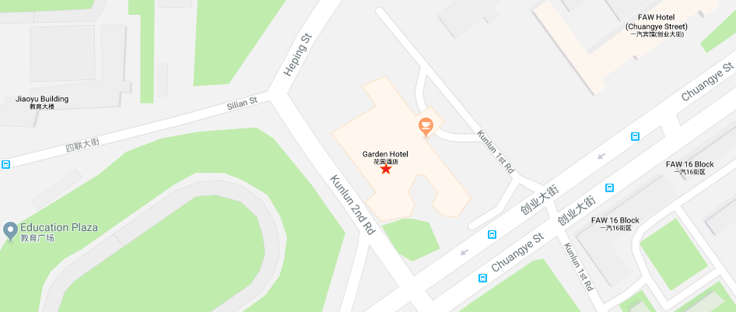

**2. Transportation and site information**

Changchun Longjia International Airport is 1 hour from the meeting venue by car, which will take you about RMB 120 including expressway toll.

There is no direct public bus line from the airport to the meeting venue, therefore, using a taxi may be your best choice. Please use “Taxi direction” in Annex 2.

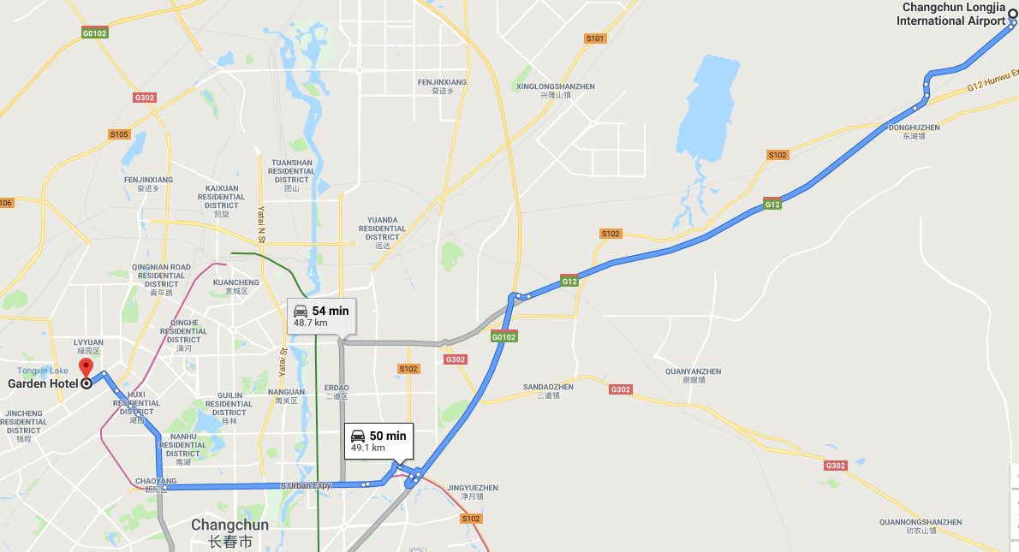

**3. Passports and visas**

All foreign visitors entering China must have a valid passport. Visitors from countries whose citizens require a visa should at the earliest time and well in advance of travel apply for a visa at a Chinese Embassy or consulate.

See below for more information related to entry into The People’s Republic of China:

<http://cs.mfa.gov.cn/wgrlh/lhqz/lhqzjjs/t1095035.shtml>

For requesting an invitation letter for visa purposes to the Host, please see **Annex 3**.

The focal point for visa support at TIAA, China is:

Name: Ms Zhufang Wu

E-mail: [zhufang916@tiaa.org.cn](mailto:zhufang916@tiaa.org.cn)

Tel: +86 10 88687092

**4. Climate in July in Changchun, China**

Monthly average values of the temperature and precipitation in Changchun, China, are given in the table below:

Weather in July in Changchun. The average temperature in Changchun in July is fairly hot at 22 °C (71.6 °F). Afternoons can be very hot with average high temperatures reaching 27 °C (80.6 °F). Overnight temperatures are generally somewhat warm with an average low of 16 °C (60.8 °F).

|  |  |
| --- | --- |
|  | July |
| Average maximum temperature | 26 degrees Celsius |
| Average minimum temperature | 17 degrees Celsius |
| Average precipitation | 160 mm |

**5. Hotels**

Please make your hotel reservation by yourself. We suggest to book the hotel of the meeting venue.

*Changchun Garden Hotel*

*No.1447, Chuangye Street, Changchun, Jilin Province*

Tel: +86 13943172403

E-mail: [emma.yao@huayuan-hotel.com.cn](mailto:emma.yao@huayuan-hotel.com.cn)

A preferential nightly rate can be obtained by mentioning TIAA or TIAA Changchun conference at the time of booking.

**6. Internet access and wireless coverage at the venue**

Wireless Internet will be provided to you by the hotel.

**7. Technical assistance**

In case you have any technical problem at the venue (e.g., connecting to Internet, finding meeting rooms, etc.) please see the host on site.

**8. Electricity**

The electricity in China is generally 220V, 50 Hz. Please make sure you have the proper adapter.

 Chinese standard

Such a socket is common in China, Australia, New Zealand and many other countries.

**9. Useful information**

**9.1 Time Zone:** GMT+8:00.

**9.2 Currency exchange**

The currency in China is the **RMB Yuan (￥)**; please check the currency exchange rate in the local bank system or use the following link as a reference: <http://www.xe.com/>

**9.3 Tipping:** Tipping is not necessary.

**10. Additional information**

**10.1** **Mobile phone coverage**: GSM and CDMA, WCDMA, TD-SCDMA, TD-LTE services provided by China Mobile, China Unicom and China Telecom.

**10.2 Emergency Numbers: In case of emergency, please dial 110.**

**10.3 Sightseeing:** <http://en.changchun.gov.cn>

**11. Contact person**

Name: Ms Zhufang Wu

E-mail: zhufang916@tiaa.org.cn

Tel: +86 10 88687092

**ANNEX 2  
  
One-page taxi direction**

The following card may be useful for participants who do not speak Chinese.  
Please bring this page with you and show it to any Chinese speaker when you need help.

请带我去：

**长春花园酒店**

电话: +86 13943172403

地址：中国吉林省长春市创业大街1447号

如有问题，可联系我的中国朋友：吴祝方女士，+86 15117958405

**ANNEX 3  
Application form for visa support letter**

All foreign visitors entering China must have a valid passport. Visitors from countries **whose citizens require a visa should at the earliest opportunity and well in advance of travel apply for a visa at a Chinese embassy or consulate**. You may need a letter of invitation from the Chinese host, which you will need to present to the Chinese embassy/consulate in your area in order to obtain your visa. The visa must be requested as soon as possible and at least six weeks before the start date of the meeting and obtained from the office (embassy or consulate) representing China in your country or, if there is no such office in your country, from the one that is closest to the country of departure. In order to obtain an invitation letter, please:

a) Fill out the form below.

b) Provide an electronic copy of your passport (name, date of birth, nationality, photo, passport number, expiration date of passport, etc., must be seen clearly).

c) Provide an electronic copy of previous Chinese visa and records (if you have been to China before).

d) Send the info in a), b) and c) as e-mail attachments to [zhufang916@tiaa.org.cn](mailto:zhufang916@tiaa.org.cn) ; please indicate as the subject **“Application form for visa support letter for** **ITU‑T FG-VM meeting (11-12 July 2019)”**.

*(Please do not forget to attach a copy of your passport photograph page before sending.)*

***In order to receive a support letter, your information should be provided to the host (***[zhufang916@tiaa.org.cn](mailto:zhufang916@tiaa.org.cn)***) before 10 June 2019.***

***Please inform the host clearly if you need the original visa support documents, or only the electronic and scanned documents would be sent to you.  
NOTE – The Host will do its best to provide invitation letters that are requested after this date; however, we cannot guarantee that you will receive your visa in time for the FG-VM meeting.***

|  |  |  |
| --- | --- | --- |
| Given name (first name) | |  |
| Family name (last name) | |  |
| Date of Birth (dd/mm/yyyy) | |  |
| Gender (male/female) | |  |
| Nationality | |  |
| Valid passport number | |  |
| Passport valid until (dd/mm/yyyy) | |  |
| Country to submit your visa application | |  |
| Postal address for your visa support documents to be shipped to | Address | (street)  (city)  (Province) |
| Postal Code |  |
| Country |  |
| Telephone number |  |
| The above address is: (please select one) | | Office / home / other (specify: ) |
| Occupation and job title | |  |
| Name of company/organization | |  |
| Company/organization address (fill in “same as above” if shipping address is your office) | |  |
| Office telephone number | | + |
| Fax number | | + |
| Email address | |  |

______________