|  |  |  |  |  |
| --- | --- | --- | --- | --- |
| ITU logo | | **国 际 电 信 联 盟**  **电信标准化局** | |  |
|  | | | 2017年3月22日，日内瓦 | |
| 文号： | **电信标准化局第16号通函**  TSB 讲习班/SP | | **致：**  - 国际电联成员国主管部门；  - ITU-T部门成员；  - ITU-T部门准成员；  - ITU-T学术成员 | |
| 联系人： | **Stefano Polidori** | |
| 电话： | +41 22 730 5858 | |
| 传真： | +41 22 730 5853 | |
| 电子 邮件： | [tsbworkshops@itu.int](mailto:tsbworkshops@itu.int) | | **抄送：**  - ITU-T研究组正副主席；  - 电信发展局主任；  - 无线电通信局主任 | |
| 事由： | **国际电联关于通过综合宽带有线网传送电视和节目的讲习班 2017年5月26日，中国，杭州** | | | |

尊敬的先生/女士：

1 我高兴地通知您，国际电联关于**通过综合宽带有线网传送电视和节目**的讲习班将于2017年5月26日在中国杭州举办。讲习班将于第9研究组（宽带有线与电视）会议（2017年5月24日至31日）同时同地召开，详情见[TSB集体函1/9](https://www.itu.int/md/T17-SG09-COL-0001)。

讲习班将自9时30分开始。与会者的注册工作将自8时30分于会场入口处开始。有关会议的补充信息见本函**附件A**。

2 讨论将仅以英文进行。

3 国际电联成员国中愿参加此工作的任何个人均可参加此讲习班。特别地，讲习班面向有线电视运营商、服务提供商、供应商、研究机构、学术界，以及国际、区域和国家标准制定机构（SDO）及其他感兴趣的机构。讲习班不收取任何费用。

4 活动旨在推动综合宽带有线电信网的节目传送最前沿技术，并概述近期有关有线技术的趋势和策略。

有线行业（包括服务提供商和供应商）面临快速演变和竞争激烈的环境，这主要受技术创新及客户对高清和创新电视服务的需求所引发，可以通过提供革命性的体验来吸引用户，如虚拟现实和增强现实。

在这种情形下，标准制定机构（SDO）也需要迅速采取行动，跟上这些创新，制定有关宽带和视频技术的新标准，最终可能会被采用和部署在产品和服务中，以满足客户的需求。

5 讲习班旨在：

– 分享有关近期有线宽带和电视技术发展趋势的信息；

– 探索为用户提供富有魅力的观看体验的策略；

– 分析当前的标准化活动并确定差距；

– 审查关键技术领域，并确定未来标准化的重点；

– 讨论各标准机构如何协调一致地达成这些目标。

6 讲习班期间将组织举办一个展览，邀请专家展示有线网络领域近期的研究成果，这将增加人们对未来标准化工作的兴趣，有助于推动标准化工作的未来发展。鉴于展览空间有限，将根据先到者优先的原则接受参展商。要求有意展示其工作的专家在2017年4月15日前提交参展申请。申请表可以在讲习班网页和下面的附件C中找到，并应提交给展览主办方，即[ouyangfeng@abs.ac.cn](mailto:ouyangfeng@abs.ac.cn)，抄送：[tsbsg9@itu.int](mailto:tsbsg9@itu.int)。

7 讲习班网页将提供讲习班计划草案。研讨会计划涵盖以下主题：

a) 有线电视业务和技术方面的最新趋势。

b) 综合服务（电视、节目和相关应用）传送机制和/或网络。

c) 创新型电视服务、体验和技术，如AR、VR、3D、UHDTV（4k/8k）、智能家居、物联网（IoT）。

d) 集成智能终端和/或相关软件。

e) 综合宽带广播网络的融合服务平台。

f) 有线电视系统、网络和服务的规划、实施和部署，特别是对发展中国家。

8 有关讲习班的更新信息将在活动网站上提供：<http://www.itu.int/en/ITU-T/Workshops-and-Seminars/201705/Pages/default.aspx>。

9 为便于电信标准化局和东道国能够就讲习班的组织做出必要安排，请您尽快通过在线表格<http://itu.int/reg/tmisc/3000968>**在2017年5月11日之前**进行注册。**请注意，讲习班的与会者只能通过在线方式进行预注册。**

10 我谨提醒您，一些国家的公民需要获得签证才能入境中国并在此逗留。**签证必须至少在讲习班开始日的四（4）个星期前**向驻贵国的中国代表机构（使馆或领事馆）申请，并随后领取。如果贵国没有此类机构，则请向驻出发国最近的国家的此类机构申请并领取。请见**附件B**的邀请函，并请注意，签证的审批需可能造成延误，因此请尽早提出签证申请。

顺致敬意！

电信标准化局主任

李在摄

**附件：3件**

**ANNEX A**

**PRACTICAL INFORMATION**

(Please see an updated version of this practical information on the [workshop webpage](http://www.itu.int/en/ITU-T/Workshops-and-Seminars/201705/Pages/default.aspx))

## Meeting Venue

Zhejiang Hotel

Hotel Reservations: +86-571-87180808

Address: No. 278 Santaishan Road, Hangzhou, Zhejiang, China

<http://www.zhejianghotel.com/en/reservation.html>

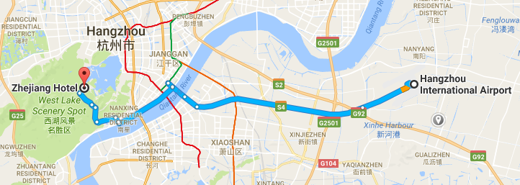

## Transportation and site information

35 km to Xiao Shan International Airport; 10 km to the railway station; 20 km to the south railway station; 0 km to the West Lake.

## Passports and Visas

All foreign visitors entering China must have a valid passport. Visitors from countries whose citizens require a visa should apply for a visa at a Chinese Embassy or consulate as early as possible and well in advance of travel.

For an invitation letter, please see **Annex B**.

## Climate (end of May in Hangzhou)

Monthly average values for temperature and precipitation in Hangzhou are given in the table below:

|  |  |
| --- | --- |
|  | **May** |
| Average max temperature | 25http://www.travelchinaguide.com/images/c-words/degree.gifC / 77http://www.travelchinaguide.com/images/c-words/degree.gifF |
| Average minimum temperature | 17http://www.travelchinaguide.com/images/c-words/degree.gifC / 63http://www.travelchinaguide.com/images/c-words/degree.gifF |
| Average precipitation | 157 mm |

## Hotels

In addition to the hotel venue, Zhejiang Hotel (see item 1 above), other close hotels are:

**5.1** Hangzhou Sunday Sunny Resort

<http://www.hzstsz-hotel.com>

Hotel Reservations: +86-571-87975888

Address: No. 200 Santaishan Road, Hangzhou, Zhejiang, China

The distance from Hangzhou Sunday Sunny Resort to the meeting venue is approximately 0.5 km.

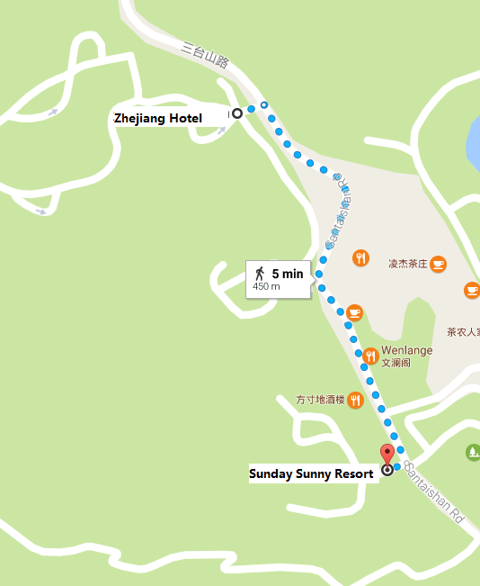

**5.2** West Lake State Guest Hotel

[http://www.xihusgh.com](http://www.xihusgh.com/Home/Index/1c7cb643-d2f7-4d1c-93bc-79fbff26c051)

Hotel Reservations: +86-571-87979889

Address: 18 Yanggongti Road, Hangzhou, Zhejiang, China

The distance from West Lake State Guest Hotel to the meeting venue is approximately 2 km.

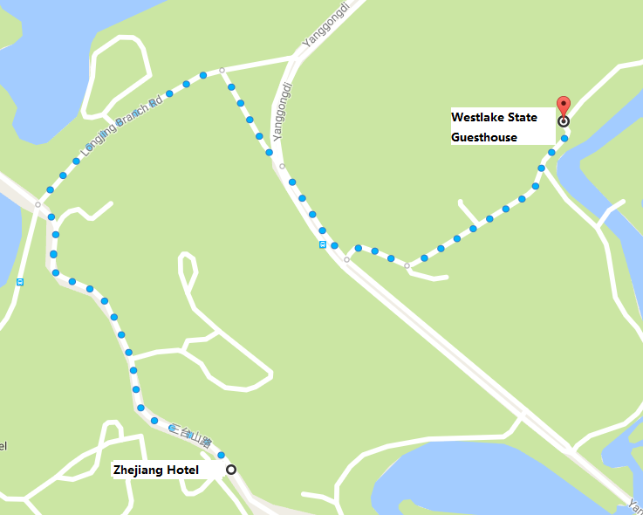

## Internet access and wireless coverage at the venue

All meeting rooms will have a wireless network with access to the Internet. Every guest room offers high-speed Internet access free of charge. Internet access will be provided using the LAN technologies listed below:

Wireless via Wi-Fi: IEEE 802.11a/n on 5.2 GHz and 802.11g/n on 2.4 GHz.

## Technical assistance

In case you have any technical problem at the venue (e.g., connecting to Internet, finding meeting rooms, etc.) please contact for help:

Mr Luo Xinqi: +86 13588774554 [luoxq@wasu.com](mailto:luoxq@wasu.com).

## Electricity

The electricity in China is generally 220V, 50 Hz. Please make sure you have the proper adapter.

 Chinese standard

Such sockets are common in China, Australia, New Zealand and many other countries.

## Currency exchange

The currency in China is the **RMB Yuan (￥)**, the exchange rate of US$ and RMB is around 6.878. Please check the currency exchange rate in the local bank system or use the following link as a reference: <http://www.xe.com/>

## Additional information

**10.1 Mobile phone:** GSM and CDMA, WCDMA, TD-SCDMA, TD-LTE services provided by China Mobile, China Unicom and China Telecom.

**10.2 Tipping:** Tipping is not necessary.

**10.3 Time zone**: GMT+8:00.

**10.4 Emergency number:** In case of emergency, please dial 110.

**10.5 Sightseeing:** For more information see <http://en.gotohz.com/>

## Contact person

Mr OUYANG Feng: +86 13511029034 ([ouyangfeng@abs.ac.cn](mailto:ouyangfeng@abs.ac.cn)).

# ANNEX B

**INVITATION LETTER REQUEST FORM**

All foreign visitors entering China must have a valid passport. Visitors from countries **whose citizens require a visa should apply for a visa at a Chinese Embassy or Consulate as early as possible and well in advance of travel.** You may need a letter of invitation from the Chinese host, which you will need to present to the Chinese Embassy/Consulate in your area in order to obtain your visa. The visa must be requested as soon as possible and at least one month before the start date of the meeting and obtained from the office (Embassy or Consulate) representing China in your country or, if there is no such office in your country, from the one that is closest to the country of departure. In order to obtain an invitation letter, please:

a) Complete the form below.

b) Provide an electronic copy of your passport (name, date of birth, nationality, passport number, expiration date of passport, etc., must be seen clearly).

c) Provide an electronic copy of any previous Chinese visas and records.

d) Send the information in a), b) and c) as email attachments to [gebing@abs.ac.cn](mailto:gebing@abs.ac.cn) and [ouyangfeng@abs.ac.cn](mailto:ouyangfeng@abs.ac.cn); please mark as reference in the subject **“Invitation letter request for** **ITU Workshop on TV and content delivery on Integrated Broadband Cable Networks  
Hangzhou, China, 26 May 2017”**.

(It is recommended to scan your passport so that it is discernible and can be used).

|  |  |  |  |  |  |
| --- | --- | --- | --- | --- | --- |
| **Company** |  | | | | |
| **Applicant Information** |  | | | **❒Mr ❒Miss ❒Ms ❒Mrs** | |
|  | | | **Date of birth :** | |
|  | | | **Place of Issue:** | |
| **Date of Issue:** | | | **Date of Expiry:** | |
| **Marital Status:** | | |  | |
| **If the country in which you will obtain your visa is different from your nationality, please indicate it here:** | | | | |
| **Address** | **Telephone Number:**  **Fax Number:**  **E-mail:** | | | | |
| **Note** |  | | | | |
| **Date of arrival in China** | |  | **Date of departure from China** | |  |

*(Please do not forget to attach a copy of your passport photograph page before sending.)*

***In order to receive an invitation letter, your request should reach the host before 24 April 2017.***

**ANNEX C**

**EXHIBITORS’ APPLICATION FORM**

**ITU Workshop on TV and content delivery on Integrated Broadband Cable Networks**

**(Hangzhou, China, 26 May 2017)**

***Note****: Please complete and return to* [*ouyangfeng@abs.ac.cn*](mailto:ouyangfeng@abs.ac.cn) *(cc:* [*tsbsg9@itu.int*](mailto:tsbsg9@itu.int)*) by* ***15 April 2017*** *to reserve a booth. Considering the limited space and options, all participants should provide their own computers and storage, and please keep them to a minimum.*

|  |  |  |
| --- | --- | --- |
| **Company name** | **Contact person including contact details** | **E-mail address** |
|  |  |  |

|  |  |
| --- | --- |
| **Type of equip. to be displayed** |  |

|  |  |  |
| --- | --- | --- |
| **Item(s) required** | **Description** | **Quantity** |
| Tables |  |  |
| Chairs |  |  |
| Flat screens |  |  |
| Network switch |  |  |
| Power supply |  |  |
| Space required |  |  |
| Panels |  |  |
| Power consumption expected for equipment: |  |  |
| Dimension, weight of equipment |  |  |
| Additional notes  (if any) |  |  |

______________