国 际 电 信 联 盟
电信标准化局

2017年2月1日，日内瓦

文号：  电话：  传真： | 电信标准化局第3号通函修订1  +41 22 730 6828  +41 22 730 5853 | 致：  - 国际电联各成员国主管部门；  - ITU-T部门成员；  - ITU-T第12研究组的部门准成员；  - ITU-T学术成员
电子  邮件： | tsbsg12@itu.int | 抄送：  - 各研究组的正副主席；  - 电信发展局主任；  - 无线电通信局主任；  - 视频质量专家组（VQEG）的联合主席

事由： | 第12研究组和VQEG呼吁参与以下工作：AVHD-AS/P.NATS阶段2：用于  估计自适应流类应用的视频质量的意见模型

行动： | 请最迟在2017年2月17日之前通过发邮件给tsbsg12@itu.int宣布贵方参与  AVHD-AS/P.NATS阶段2开发的最终且具有约束力的意向
尊敬的先生/女士，
1 ITU-T第12研究组（性能、服务质量（QoS）和体验质量（QoE））的第14号课题旨在加快P.NATS阶段2方面的工作，即，用于估计自适应流类应用视频质量的意见模型。
2 此项工作将作为ITU-T第14/12号课题与视频质量专家组（VQEG）的一项联合项目开展，而且将被称为AVHD-AS/P.NATS阶段2。
3 有关AVHD-AS/P.NATS阶段2的参与呼吁见本通函附件1。
4 如果贵方能够在2017年2月17日之前通过发邮件给tsbsg12@itu.int宣布贵方参与AVHD-AS/P.NATS阶段2开发的最终且具有约束力的意向，我将不胜感激。
5 任何希望了解此参与呼吁进一步细节或澄清的要求，均应发给Jörgen Gustafsson先生（jorgen.gustafsson@ericsson.com）、Alexander Raake先生（alexander.raake@tu-ilmenau.de）、Shahid Mahmood Satti先生（ss@opticom.de）和Silvio Borer先生（Silvio.Borer@rohde-schwarz.com）。
6 我谨希望强调贵方参与此项工作的重要性，因为它将有助于ITU-T第12研究组和VQEG推进有关自适应流业务视频质量建模方面的工作。
顺致敬意!

电信标准化局主任
李在摄先生
附件：1件

ANNEX 1
(to TSB Circular 3 Rev.1)
Call for participation on AVHD-AS/P.NATS Phase 2
Opinion model for estimating video quality of adaptive streaming services
Abstract
This Call for Participation is directed to all parties who are interested to contribute to AVHD-AS/P.NATS Phase 2 models for objective assessment of progressive download and adaptive streaming type video. Those parties are invited to announce their interest in contributing to AVHD-AS/P.NATS Phase 2 and spending further active development and analysis efforts into the project. Interested parties are expected to announce their final and binding intention to participate by 17 February 2017.
Background
The ITU-T P.1203 series of standards which target the parametric and bitstream based modelling of video quality have recently been consented to support progressive download and adaptive streaming types of HD video using H.264 video codec. The next step in Q14/12 model standardization is to broaden the scope of P.1203 for various video codecs and higher resolution, aiming at a more comprehensive model that can meet the requirements of modern day Ultra HD video streaming applications.
The ITU-T J.341/J.342 and J.343 series of standards were developed within VQEG targeting pure pixel-based and hybrid models to support video quality measurement for HDTV digital cable and IP-based video services, respectively. At present no standardized pixel-based and hybrid models are available for adaptive streaming applications. In addition, modern day streaming services involve a plethora of video codecs and streaming resolutions (up to and including Ultra-HD) for which these types of models need to be researched.
In an effort to measure video quality in a broad operational scope – ranging from head-end encoding optimization to in-network and client side quality monitoring – this project aims to develop different type of models using a common training/validation dataset to determine the potential of these model types in challenging measurement scenarios.
AVHD-AS/P.NATS Phase 2 work item
The AVHD-AS/P.NATS Phase 2 model will be developed using a dedicated training phase with a jointly developed set of training databases followed by cross-validation using a jointly developed set of validation databases.
The AVHD-AS/P.NATS Phase 2 work item is planned to have three tracks. Track 1 is a bitstream-based parametric video-only model, where the provided information is given in the same way as P.1203.1. As such, the first track is planned to result in an extension of P.1203.1 for a broader scope. In tracks 2 and 3, Recommendations are being developed which describe how the output of pure pixel-based and hybrid models can be used to obtain the quality of long (up to five minutes) videos in the context of adaptive streaming.

The building blocks of the AVHD-AS/P.NATS Phase 2 models are shown in Figure 1 below:
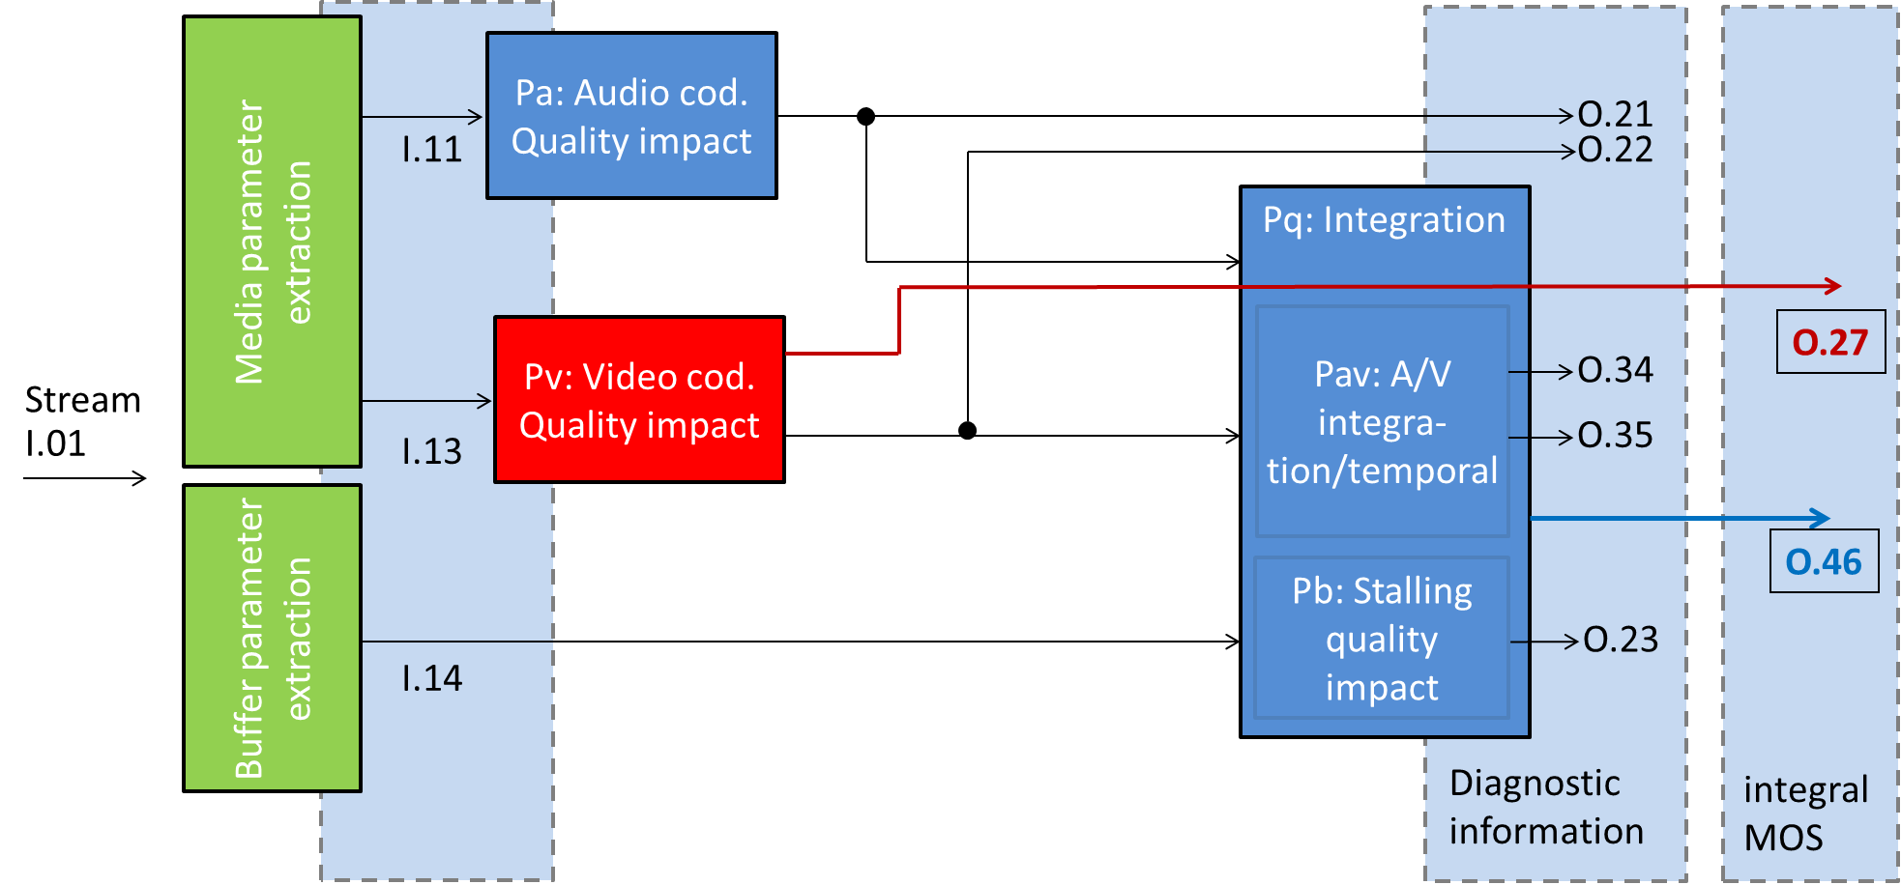

Figure 1 (a): Building blocks of the bitstream model (track1), only red shaded blocks will be developed, blue blocks are taken from P.1203 for characterization
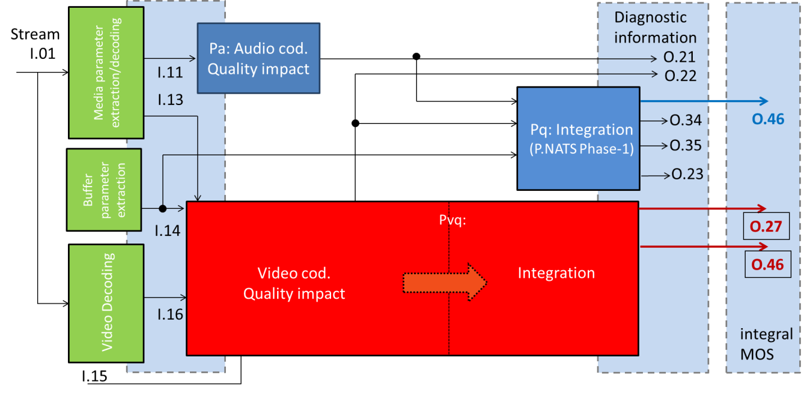
Figure 1 (b): Building blocks of the pixel-based (track2) and hybrid models (track3), only red shaded blocks will be developed, blue blocks are taken from P.1203 for characterization
The individual outputs can be summarized as follows:
- O.27: Final short-term video coding quality score
  - Single score for each short-length video, on 1-5 quality scale
  - Excludes aspects of temporal integration with initial- or re-buffering
- O.46: Final media session quality score
  - Single score for the session, on a 1-5 quality scale
  - Includes initial buffering and stalling and rate adaptivity aspects.
- O.22: Video coding quality per output sampling interval
  - Multiple segment scores provided per session and on a 1-5 quality scale
- O.21: Audio coding quality per output sampling interval
  - Multiple segment scores provided per session and on a 1-5 quality scale

- O.23: Perceptual buffering indication
  - Single score on a 1-5 quality scale for the session
- O.34: Audiovisual segment coding quality per output sampling interval
  - Multiple segment scores provided per session
- O.35: Final long-term audiovisual coding quality score
  - Single score for the session, on a 1-5 quality scale
  - Includes aspects of temporal integration with initial- or re-buffering

It is noted that the output nomenclature can be read as follows: The last number is incrementally specifying the index of the output, the first number specifies the level at which the information is obtained (the higher, the closer to the final media session quality score).
Requirements on parties
Interested parties are requested to announce their participation by 17 February 2017, and may then take part in continue creating a set of documents specifying the project layout and modus operandi. Note that many documents are already available and have been agreed by the proponents who provisionally have responded to the call for participation. New parties need to accept the decisions concerning the project already agreed by the parties already participating. The parties which take part in in the coming steps can then contribute to drafting the required documents, and take part in finally creating the new AVHD-AS/P.NATS Phase 2 Recommendation. This work will include producing four databases per proponent.
The announcement of participation in the mentioned project is divided into two steps:
- Interested parties had to announce their provisional intention to participate in the AVHD-AS/P.NATS Phase 2 development by 9 January 2017 to tsbsg12@itu.int. This deadline has passed and eleven companies have indicated provisionally their participation in this project.
- A binding commitment to participate in the AVHD-AS/P.NATS Phase 2 development has to be made by 17 February 2017 to the secretariat of ITU-T SG12 (tsbsg12@itu.int), and to the VQEG AVHD Co-Chairs (cs@opticom.de; Quan.Huynh-Thu@cisra.canon.com.au; mpinson@ntia.doc.gov). Note that parties not responding to the first provisional call are welcome to join the project by answering to this second call. The final commitment is based on a Requirement Specification and Terms of Reference for AVHD-AS/P.NATS Phase 2 that is considered as sufficient by Q14/12 and VQEG/AVHD for starting the development work, and which will be established jointly involving all declared participants according to this call for participation. It is noted that in case of later withdrawal, leaving parties have to grant usage of their already contributed test databases. These aspects will be, as it was done for example for the P.NAMS & P.NBAMS, POLQA and P.NATS development, legally handled outside ITU-T/VQEG using a respective agreement between the parties.

Draft overview time plan

Date (Tentative) | Result/activity completed
13 December 2016 | Call for indication of participation sent out  Stable ToR available  Draft requirement specification
9 January 2017 | Deadline for indication of participation
End of SG12 January meeting | Updates (if any) for requirement specification and ToR  Draft test specification available
17 February 2017 | Deadline response for binding call for participation
May 2017 | All details of test and processing chain set
August 2017 | Training databases submitted
November 2017 | Model submission

Communication
Participants are encouraged to respond to this call for participation as indicated above. Participants are also encouraged to subscribe to the e-mail reflector of AVHD-AS/P.NATS Phase 2 (pnats2avhd@lists.itu.int), to join the AVHD-AS/P.NATS Phase 2 conference calls announced on the email reflector, and to participate in the in-person project meetings. An ITU TIES or Guest account is required to subscribe. Participants can register for a Guest account at https://www.itu.int/net/iwm/public/frmUserRegistration.aspx and sign up for the e-mail reflector at https://www.itu.int/net4/iwm/?p0=0&p11=ITU&p12=ITU-SEP-ITU-T-SEP-Other%20Groups-SEP-pnats2avhd&p21=ITU&p22=ITU-SEP-ITU-T-SEP-Other%20Groups-SEP-pnats2avhd.
More information about Study Group 12 can be found at:
https://www.itu.int/en/ITU-T/studygroups/2017-2020/12/.
More information about VQEG can be found at http://www.its.bldrdoc.gov/vqeg/.
_____________

