 | INTERNATIONAL TELECOMMUNICATION UNION  TELECOMMUNICATION  STANDARDIZATION SECTOR  STUDY PERIOD 2017-2020 |  |  | TSAG-TD992
 |  |  |  | TSAG
 |  |  |  | Original: English
Question(s): |  |  | N/A | Virtual, 11-18 January 2021
TD
Source: |  |  | TSB
Title: |  |  | Status of TSAG metrics implementation
Purpose: |  |  | Information
Contact: |  | Lis LUGO COLLS  Information Systems Engineer  TSB OPD / ITAD |  |  | Tel: +41 22 730 6224  E-mail: tsbitdev@itu.int

Keywords: | ITU-T databases; Metrics; Reporting; Statistics;
Abstract: | The purpose of this TD is to inform TSAG about the status of the implementation of the requested metrics.

In the framework of the implementation of the TSAG metrics, ITU relevant databases are gradually analysed and connected to Microsoft Power BI, which has recently been adopted by the ITU. Microsoft Power BI is a Business Intelligence solution that covers data management and analysis.
TSB is currently using this tool to unify, replace and clean the existing reports, and develop new reports and statistics. It will also be used to search for more data insights.
First dashboards have been delivered internally, and TSB is currently investigating solutions on how they could be shared with secured access to ITU-T membership.
In the meantime, to give an idea of the metrics that those internal Power BI dashboards can produce, a few screenshots of the possible output have been taken and shared in the following Appendix A.

Annex A
Samples of metrics generated by TSB's internal dashboards
Figure 1: ITU-T Work Programme high level figures for current Study Period
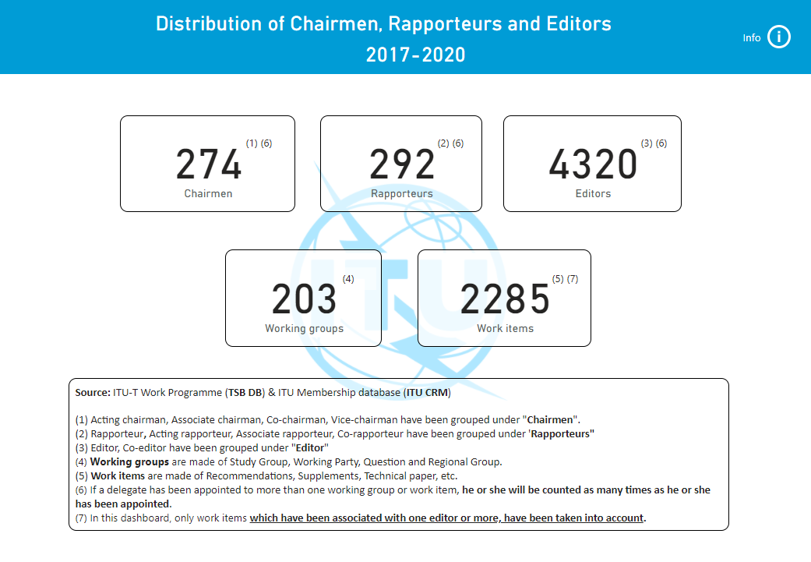

Figure 2: ITU-T SG5 Work Programme chairmanship distribution
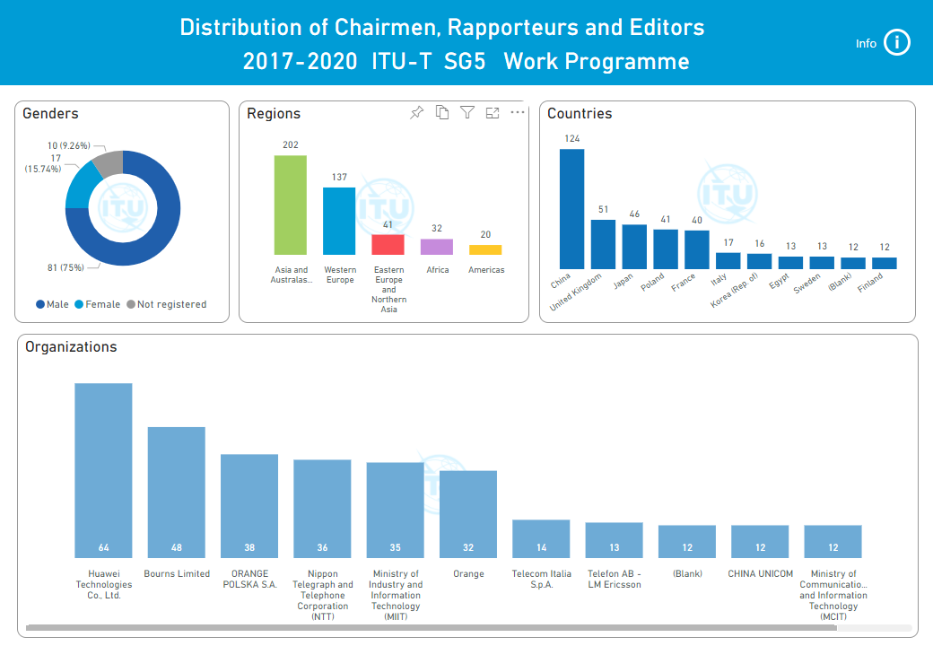

Figure 3: ITU-T Work Programme chairmanship distribution for Africa
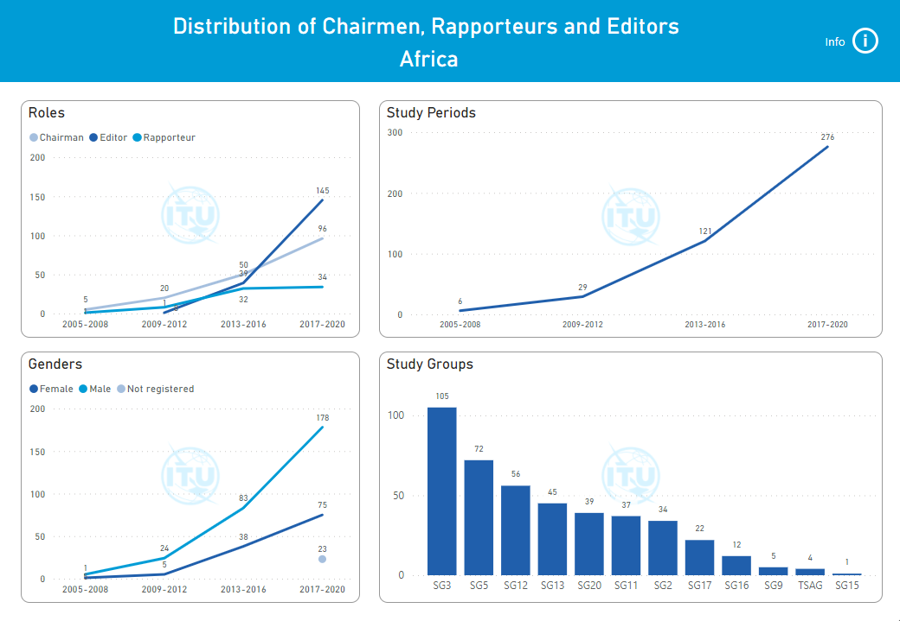

Figure 4: Top 5 SG9 editors for current Study Period
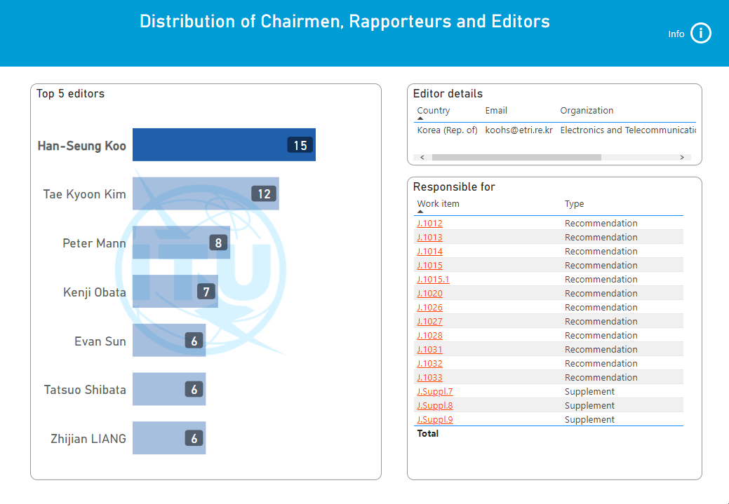

Figure 5: SG16 meeting decisions and documents overview for current Study Period
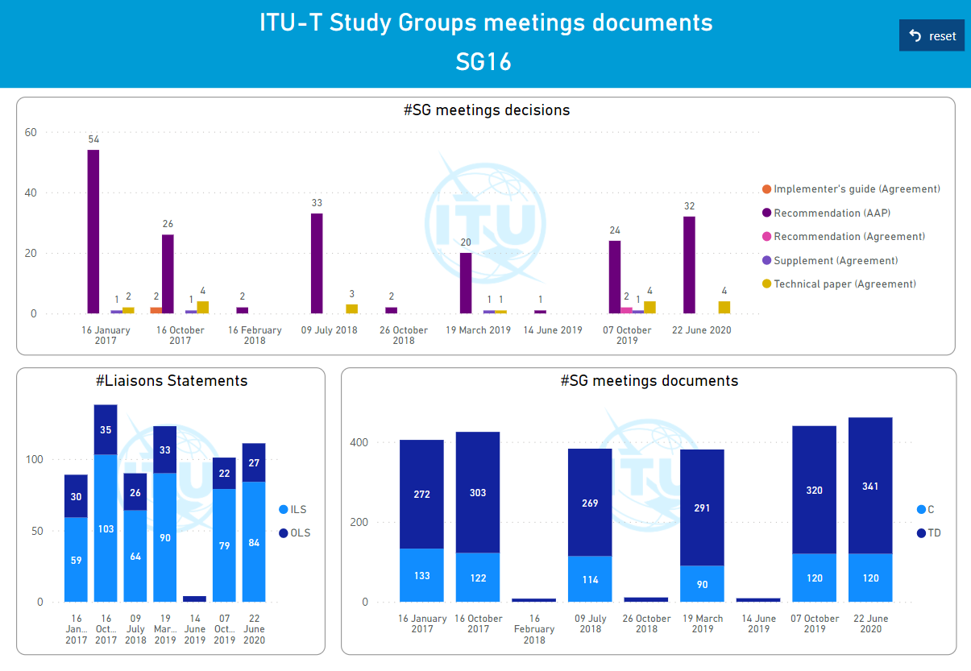

Figure 6: ITU-T SG20 work items trends & distribution
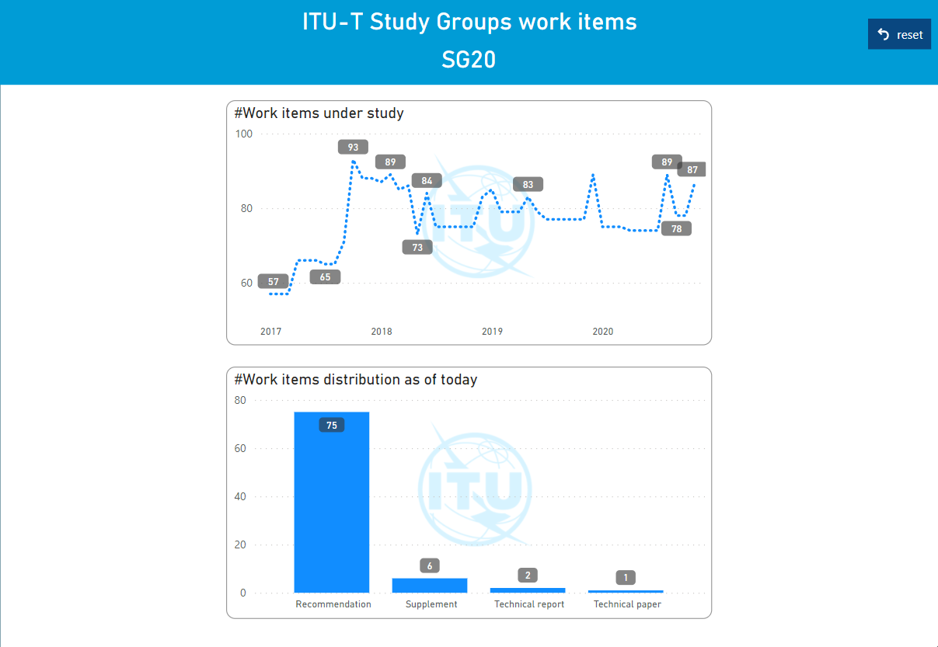

Figure 7a: ITU-T events metrics (2019-2020)
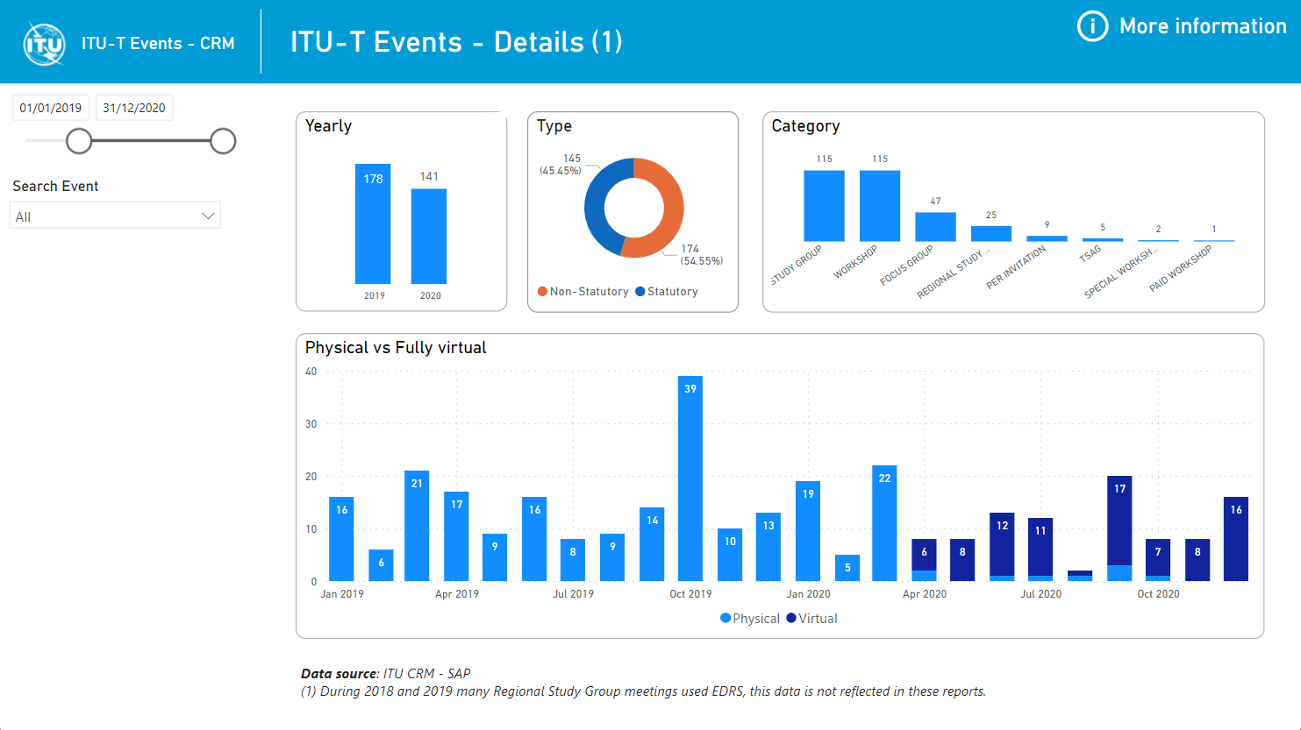

Figure 7b: ITU-T events metrics (2019-2020)
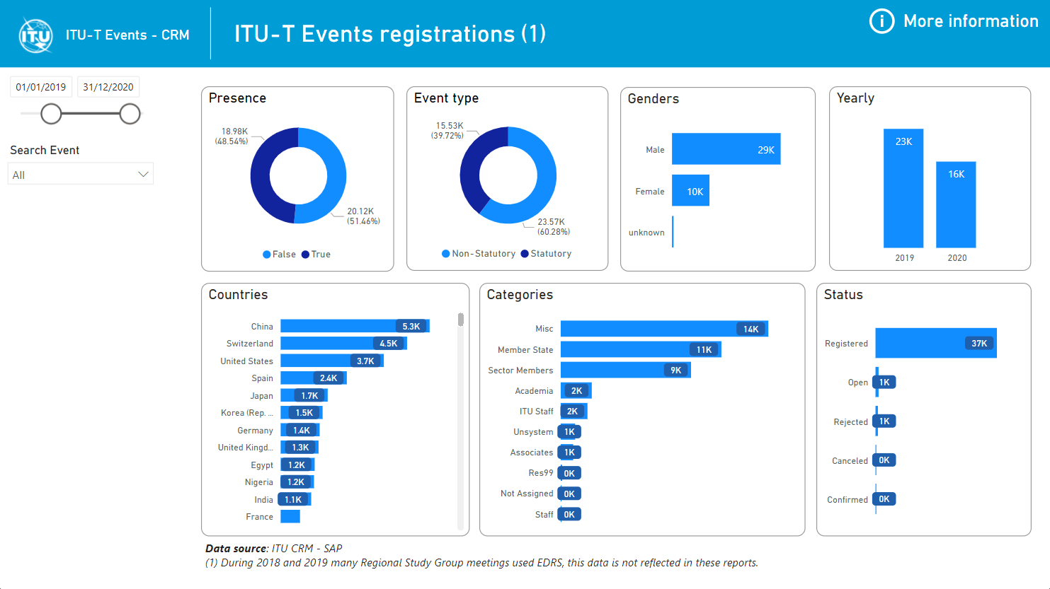

Figure 7c: ITU-T events metrics (2019-2020)



