 | INTERNATIONAL TELECOMMUNICATION UNION  TELECOMMUNICATION  STANDARDIZATION SECTOR  STUDY PERIOD 2017-2020 |  |  | TSAG-TD727R1
 |  |  |  | TSAG
 |  |  |  | Original: English
Question(s): |  |  | N/A | Geneva, 10-14 February 2020
TD
Source: |  |  | TSB
Title: |  |  | Update on Bridging the Standardization Gap activities
Purpose: |  |  | Information
Contact: |  | Bilel Jamoussi  ITU-T Study Group Department |  | Tel: +41 22 730 6311  E-mail: Bilel.Jamoussi@itu.int  Bridging@itu.int

Keywords: | Implementation of WTSA-16 Resolution 44 and RESOLUTION 123 (Rev. DUBAI, 2018); fellowships;
Abstract: | This TD underscores the main activities carried out under the purview of the BSG programme (in line with WTSA-16 Resolution 44). TSAG is invited to consider the updated information on BSG provided by the TSB Director.

An integral part of ITU’s mission, ‘Bridging the Standardization Gap’ (BSG) aims to address the disparities in the ability of developing countries to access, implement and influence the development of international standards at the ITU. Accordingly, the BSG, through various linked programmes has been fostered the effective participation of developing countries in ITU-T's standards-making process.
BSG programme is built around five main pillars:
- Awareness: raising awareness through activities such as regional group meetings.
- Know-How: developing the right skills and capabilities for international standards-making through training course such as ITU-T A.1 course.
- Community: building a strong community through ITU Regional Standardization Forums and Regional Group meetings
- Engagement: through the provision of fellowships to participate in ITU Study Group meetings
- Partnering: by offering the opportunity to sponsor trainings on ITU-T Standards and contribute to the BSG fund.

Table 1: Relevant Resolutions concerning Bridging the Standardization Gap (BSG)
Relevant Resolutions
Resolution 123 (Rev. Dubai, 2018) of the Plenipotentiary Conference | Bridging the standardization gap between developing and developed countries
WTSA-16 Resolution 44 (Rev. Hammamet, 2016) | Bridging the standardization gap between developing and developed countries
For the implementation of Resolution 123 of the Plenipotentiary Conference, Annex to WTSA Resolution 44 (Rev. Hammamet, 2016), contains an action plan. This action plan details a list of four programmes. In this context, this document provides an overview of activities carried out by the Telecommunication Standardization Bureau (TSB) in line with these programmes (since September 2019).

Programme 1: Strengthening standards-making capabilities
- Recommendation ITU-T A.1: Working Methods of ITU-T Study Groups 2019- Online course: In order to equip new delegates from developing countries with the required knowledge and skills to participate and contribute effectively to the standards work of ITU-T, the online training course on “Recommendation ITU-T A.1: Working Methods of ITU-T Study Groups 2019” has been made available on the ITU Academy platform, free of charge. Each module is a self-contained unit, including course content and quizzes. After achieving a score of 80% overall, one can obtain a certificate of achievement. The course is supplemented by the BSG hands-on training sessions/workshops which are often collocated with ITU-T Study Group meetings and SG regional meetings. The online course is comprised of six core modules including:
- Standardization in ITU-T
- Managing the study groups
- Coordination
- Inputs to the study groups
- Outputs of the study groups
- Further infrastructure supporting the study group process
This course has had over 824 enrolments and has awarded 382 certificates through the platform.

- Geographical distribution of Study Group meetings, regional group meetings and regional standardization forums: The ITU-T Study Group meetings and regional group meetings are held across the globe in different regions to allow interested stakeholders in the region the opportunity to participate physically in the meetings. Additionally, regional groups within ITU-T Study Groups also serve as channels to coordinate and improve the quality of technical contributions from developing countries. Regional standardization forums (RSFs) (often collocated with regional group meetings) are also utilized as a platform to deliver tutorials related to ITU-T working methods and various topics including (but not limited to) EMF, mobile financial services, big data etc. Since August 2019, 9 regional group meetings have been held. Two regional standardization forums have been organized:
- Colombo, Sri Lanka, 1 October 2019: ITU Regional Standardization Forum (RSF) on “Addressing Competition Issues in ICT Economy”
- Dubai, UAE, 22 October 2019: ITU Inter-Regional Standardization Forum on “Operational issues on numbering, emergency service and OTTs”

- Remote participation: The ITU-T Study Group meetings and Focus Group meetings (including workshops) have integrated the use of web-conferencing tools (including GoToMeetings and Zoom), which allow for participants to attend the meeting remotely (as required), present contributions and to this end be able to effectively contribute to the standards development process at ITU-T.

- Pilot project for SMEs in ITU-T: Through a new launched pilot project, SMEs are allowed to participate in certain designated ITU-T Study Groups. This provide them with the unique opportunity to understand the standardization process at ITU-T. The ITU-T Study Groups which are a part of this pilot project include:

- ITU-T Study Group 5: Environment climate change and circular economy
- ITU-T Study Group 11: Signalling requirements, protocols and test specifications
- ITU-T Study Group 16: Multimedia
- ITU-T Study Group 20: IoT, smart cities & communities

Figure 1: Geographical distribution of SMEs participating in the pilot project

Programme 2: Assisting developing countries with respect to the application of standards
- Creation of National Standardization Secretariat (NSS): To drive the coordination and actions related to ICT standardization, developing countries are encouraged to establish a national-level standardization secretariat (NSS), which can help boost participation in ITU-T Study Groups. The steps for establishing an NSS are elaborated in its guideline document “Towards the Establishment of a National Standardization Secretariat for ITU-T: Options and Guidelines” (2019). As provided in this guideline document, the main benefits for having an NSS are as follows:
- increased effectiveness through coordinated participation and positions by industry and government players across multiple ITU-T study groups;
- avoidance of conflicting positions in the same or in different ITU-T study groups;
- improved awareness regarding exchange of information with ITU-T;
- better dissemination of information from ITU to appropriate national experts;
- increased efficiency in the use of limited human and financial resources; and
- implementation of more ITU-T Recommendations.
Zambia is the first country to have established an NSS. Since the conception of this idea of having NSSs, the related guidelines have been revised. Many other countries have already commenced the establishment of NSSs in their respective regions.
- Implementation programmes:
The following initiatives and programmes within ITU-T focus on implementation of existing standards (ITU-T Recommendations) while exploring new domains:
- AI and Data Commons: This initiative aims to approach problem-solving using AI and data and make it available as a common resource to achieve scale and the 2030 Sustainable Development Goals
- Smart Incubator: This programme facilitates the linking of innovations to the standardization process (including defining, promotion and adoption of ITU-T standards and specifications). In this context, ITU Smart Incubator enables start-ups or SMEs by having them join the standardization process right at the start.
- United for Smart Sustainable Cities: This is an initiative which promotes the use of public policies for the integration of ICTs for the establishment of smart sustainable cities (SSC).
- SG Mentoring Programme: This programme continues to assist new delegates gain knowledge on the ITU-T working methods and promote participation and contribution from developing countries.
Other activities and surveys related to the implementation of ITU-T Recommendations are conducted in collaboration with BDT through the ITU regional offices and (as appropriate) liaison offices.

Programme 3: Human resources capacity building
- Organization of BSG hands-on training sessions/workshops: Keeping in mind the need to equip delegates from developing countries with the skills and knowledge to participate and contribute to ITU-T meetings, BSG hands-on trainings (and other related trainings) are regularly organized and collocated with ITU-T Study Group meetings. These trainings provide delegates with a snapshot of structures, management, coordination mechanisms and operating procedures of ITU-T study groups as defined in Recommendation ITU-T A.1. Over 700 delegates have been trained, representing 74 countries and 80 organizations. In 2019, over 300 delegates from various developing countries have been trained.
A training on the other aspects of the Resolution 44 was collocated with the Regional Preparatory Meeting of ATU, in Entebbe, Uganda in October 2019. The training was delivered (from Geneva) on the TSB tools and services, with the objective of covering a range of services to empower delegates for more active and efficient participation in ITU-T meetings. The full programme can be found here.

Table 2: List of BSG trainings and events carried out since September 2019 and planned during the first quarter of 2020
Date | Related Study Group/Event | Location
12 September 2019 | SG20 Regional Group for Latin America | El Salvador
1 October 2019 | Regional Standardization Forum-SG3 Regional Group for Asia and Oceania | Colombo, Sri-Lanka
20-21 October 2019 | SG2 Regional Group for Africa, SG2 Regional Group for the Arab Region, SG3 Regional Group for the Arab Region | Dubai, United Arab Emirates
22 October 2019 | SG13, SG11 | Geneva, Switzerland
25 November 2019 | SG20 | Geneva Switzerland
February 2020* | SG13 Regional Group for Africa | Abuja, Nigeria
4 March 2020* | SG11 | Geneva, Switzerland
16 March 2020 | Arab Smart Agriculture Forum | Doha, Qatar
July 2020* | SG11, SG13 | Geneva, Switzerland
*planned trainings
- Fellowships to attend ITU-T meetings: TSB offers fellowships (and partial fellowships) to delegates from least developed countries (LDCs) and developing countries based on availability of budget. Within this study period, the number of fellowships awarded have increased steadily. Delegates who have been granted a fellowship are expected to submit an (applicable) contribution to the Study Group meeting they will be attending. Since August 2019, 85 fellowships have been provided.

Figure 2: Fellowships granted to attend ITU-T meetings (since August 2019)

- Contributions from developing countries: Developing countries have been extensively involved in the work of the Study Groups. There has been a significant increase in the number of the contributions submitted by developing countries within this study period.

Figure 3: Contributions submitted by developing countries within this study period
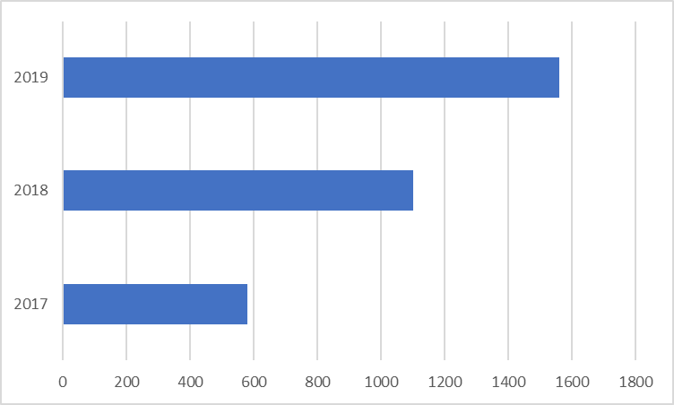

Figure 4: Representation from developing countries in the Study Group management teams between study periods
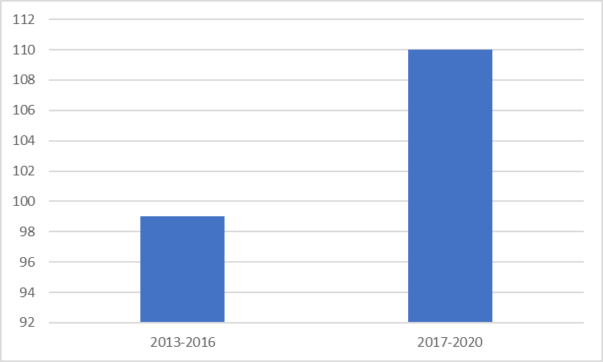

Programme 4: Fundraising for bridging the standardization gap

In addition to voluntary contributions from member states, the TSB continues to allocate a certain portion of its regular budget for granting fellowships to attend ITU-T Study Group meetings.

Discussion of points raised in C100

The proposal presented in C100 (received in January 2020 for TSAG) to foster the establishment of additional NSS is commendable and the BSG programme looks forward to supporting the proponents and the regions in this endeavour.

____________________

In accordance PP Resolution 209 (Dubai, 2019)

