 | INTERNATIONAL TELECOMMUNICATION UNION  TELECOMMUNICATION  STANDARDIZATION SECTOR  STUDY PERIOD 2017-2020 |  |  | TSAG-TD610
 |  |  |  | TSAG
 |  |  |  | Original: English
Question(s): |  |  | N/A | Geneva, 23-27 September 2019
TD
Source: |  |  | TSB
Title: |  |  | Update on the Implementation of WTSA-16 Resolution 44
Purpose: |  |  | Information
Contact: |  | Bilel Jamoussi  ITU-T Study Group Department |  | Tel: +41 22 730 6311  E-mail: Bilel.Jamoussi@itu.int

Keywords: | Implementation of WTSA-16 Resolution 44 and RESOLUTION 123 (Rev. DUBAI, 2018), fellowships;
Abstract: | This TD provides an overview of the activities carried out under the purview of WTSA-16 Resolution 44. TSAG is invited to consider the information provided by the TSB Director in view of C047 by University of Nigeria received in December 2018.
WTSA Resolution 44 (Rev. Hammamet, 2016) describes an action plan for the implementation of Plenipotentiary Resolution 123 (Rev. Busan, 2014). Under this action plan, four key programmes have been envisioned. This document provides an outline of some activities carried out by the Telecommunication Standardization Bureau (TSB) in line with these programmes within the action plan, while also addressing the key points raised in C047 (submitted in December 2019 for TSAG).

Programme 1: Strengthening standards-making capabilities
- Online training course on ITU-T Working Methods: TSB developed and updated the training course on “Recommendation ITU-T A.1: Working Methods of ITU-T Study Groups 2019”, which is available on the ITU Academy platform to all interested stakeholders, free of charge. Upon completion of the course, participants will gain a deeper understanding of the ITU-T standardization process. Upon successful completion of the examination at the end of the course, participants are awarded a certificate. To this day, this course has been attended by 824 participants and has awarded 382 certificates.
- Remote participation availability: All ITU-T Study Group and Focus Group meeting (including workshops) can be attended using web conferencing tools including GoToMeetings and Zoom. Focus Groups such as the Focus Group on Vehicular Multimedia (FG-VM) have also explored the option of having their main meetings online to facilitate participation from various regions.

Programme 2: Assisting developing countries with respect to the application of standards
- Bridging the Standardization Gap (BSG) programme is an initiative specifically designed to address the disparities in the ability of developing countries, relative to developed ones, to access, implement and influence ITU's international standard. . The programme is built around 5 main pillars:
  - Awareness: raising awareness through activities such as regional group meetings.
  - Know-How: developing the right skills and capabilities for international standards-making through training course such as ITU-T A.1 course.
  - Community: building a strong community through ITU Regional Standardization Forums and Regional Group meetings
  - Engagement: through the provision of fellowships to participate in ITU Study Group meetings
  - Partnering: by offering the opportunity sponsor trainings on ITU-T Standards and contribute to the BSG fund.
- NSS Guidelines: Through the BSG programme, TSB has assisted developing countries to establish the National Standardization Secretariat (NSS), which serve as the cornerstone for the overall coordination of standardization activities and country-specific participation in ITU-T Study Groups. The steps for establishing an NSS are covered in guideline document “Towards the Establishment of a National Standardization Secretariat for ITU-T: Options and Guidelines” (2019. The NSS (as highlighted in the guideline document) aims for:
- increased effectiveness through coordinated participation and positions by industry and government players across multiple ITU-T study groups;
- avoidance of conflicting positions in the same or in different ITU-T study groups;
- improved awareness regarding exchange of information with ITU-T;
- better dissemination of information from ITU to appropriate national experts;
- increased efficiency in the use of limited human and financial resources; and
- implementation of more ITU-T Recommendations.
The establishment of the NSS needs to be initiated by the Responsible Agency (RA), which is the entity designated by the concerned Member State to deal ITU related matters. The RA serves as the driving force in the establishment of the NSS in the respective countries adopting a “top-down approach” both for the creation of NSS and its core functions. Countries like Zambia have already established an NSS with other countries also embarking on a similar path based on the NSS guidelines developed by ITU-T.
- Implementation-based programmes: TSB has a range of programmes including (but not limited to) Smart Incubator and the United for Smart Sustainable Cities, focussed on the implementation of the ITU-T Recommendations. The core implementation channels for ITU-T Recommendations continue to be driven in collaboration with BDT through the ITU regional offices and liaison offices in various countries.

Programme 3: Human resources capacity building
- BSG Trainings: A series of BSG trainings have been delivered to allow interested delegates to become familiar with the ITU-T Working Methods, in order to be able to contribute to the standardization work in the Study Groups. Some of the trainings and events based on BSG are listed in Table 1. To this day, over 580 delegates have been trained, representing 72 countries and 74 organizations. A total of 34 trainings have been provided in 11 training locations around the world.

Table 1: List of BSG trainings and events carried out and planned for 2019
Date | Related Study Group/Event | Location
18 February 2019 | ITU Regional Standardization Forum on Emerging Economic, Regulatory and Policy Trends For an Inclusive, Sustainable and Trustworthy Digital World | Antananarivo, Madagascar
27 March 2019 | BSG Interactive workshop-SG2 | Managua, Nicaragua
17 May 2019 | World Telecommunication & Information Society Day | Geneva, Switzerland
27 August (morning) | SG5 Regional Group for Africa, SG20 Regional Group for Africa | Abuja, Nigeria
12 September 2019 | SG20 Regional Group for Latin America | San Salvador, El Salvador
1 October 2019 | Regional Standardization Forum-SG3 Regional Group for Asia and Oceania | Colombo, Sri-Lanka
20-21 October 2019 | SG2 Regional Group for Africa, SG2 Regional Group for the Arab Region, SG3 Regional Group for the Arab Region | Dubai, United Arab Emirates
22 October 2019 | SG13, SG11 | Geneva, Switzerland
25 November 2019 | SG20 | Geneva Switzerland

- Fellowships: TSB offers fellowships to delegates from least developed countries (LDCs) and developing countries based on availability of budget. Within this study period, the number of fellowships awarded have increased steadily. It is expected that in the remaining months of 2019, more fellowships could be granted. All delegates who have been granted a fellowship are expected to submit an (applicable) contribution to the Study Group meeting they will be attending.

- Contributions from developing countries: Developing countries have been extensively involved in the work of the Study Groups. There has been a significant increase in the number of the contributions submitted by developing countries within this study period.

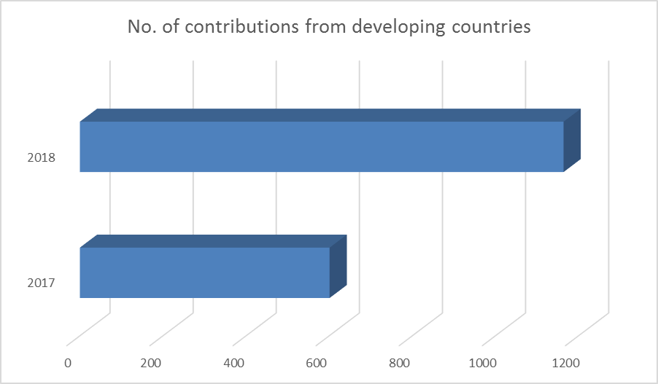

Programme 4: Fundraising for bridging the standardization gap

In addition to voluntary contributions from member states, the TSB sets aside a portion of its regular budget for granting fellowships to attend ITU-T Study Group meetings.

Discussion of points raised in C047

The proposals presented in C047 (received in December 2018 for TSAG) were discussed between TSB and the proponent in July 2019. During the discussion, the following points were highlighted:
- TSB published an updated NSS guidelines in May 2019 to provide simplified instructions on setting up an NSS. Accordingly, countries in the African region are welcome to utilize the NSS guidelines to establish their own NSS to consolidate their work relating to ITU-T standardization.
- TSB has been delivering BSG trainings at several regional meetings of ITU-T Study Group that delegates from developing countries understand the working methods of ITU-T Study Groups and are actively able to contribute to the standardization work. Additional BSG training sessions are being planned in collocation with Study Group meetings too. The number of fellowships awarded in 2017 were 140 and in 2018, TSB was able to grant 191 fellowships. In keeping with Resolution 44, TSB will continue to give fellowships throughout the course of this study period.
- All delegates applying for fellowships to attend ITU-T Study Group meetings are required to ensure that they submit relevant and meaningful contributions to further the work of a given Study Group. This is a requirement that has been specifically mentioned in the application form for the fellowships (for attending Study Group meetings).
- In 2019, the theme for World Telecommunication and Information Society Day (WTISD), held each year on 17 May, placed the focus on Bridging the Standardization Gap, with the goal to raise awareness on the importance of supporting developing countries in their efforts to enhance their capacity to participate in the development and implementation of international standards. The celebrations held at ITU hosted a high level panel discussion on the theme “Digital transformation enabled by inclusive international standards” in front of an audience of Ambassadors and Diplomats, encouraging this latter to implement measures to bridge the standardization gap in their respective country. The celebrations concluded with the WTISD certificate award ceremony recognizing the top contributors to ITU standards and Bridging the Standardization Gap efforts. Six laureates were awarded under the five categories of BSG programme:
- Awareness rewarding the most engaged regional organization in the co-organization of meetings with ITU from 2015 to 2018‬‬: Asia Pacific Telecommunity Wireless Group (AWG).‬
- Know-how recognizing one individual for having followed the BSG training programme and for having rapidly evolved into an impactful position: Mr Lwando M. Bbuku, ZICTA, Zambia.
- Community recognizing two Member States, from Developing and Developed country, as most frequents hosts of ITU standardization meetings from 2015 to 2018: respectively, Tunisia and the United States of America.
- Engagement category recognizing the most active Member State in ITU Standards Development (largest number of contributions, editors, and delegates 2015-2018)‬‬: The People’s Republic of China‬
- Partnering category recognizing the most active Member State in ITU Standards Development (largest number of contributions, editors, and delegates 2015-2018)‬‬: The Republic of Korea.‬

____________________

