 | INTERNATIONAL TELECOMMUNICATION UNION  TELECOMMUNICATION STANDARDIZATION SECTOR  STUDY PERIOD 2017-2020 |  |  | TD 219
 |  |  |  | TSAG
 |  |  |  | Original: English
Question(s): |  | N/A |  | Geneva, 26 February - 2 March 2018
TD
(Ref.: SG5 - LS 33 -E)
Source: |  | ITU-T Study Group 5
Title: |  | LS on Enhancing ITU-T document templates [from ITU-T SG5]
Purpose: |  | Action
LIAISON STATEMENT
For action to: |  |  | TSAG
For comment to: |  |  | -
For information to: |  |  | ITU-T SG2, SG3, SG9, SG11, SG12, SG13, SG15, SG16, SG17, SG20
Approval: |  |  | ITU-T Study Group 5 meeting (Sophia Antipolis, 22 November 2017)
Deadline: |  |  | N/A
Contact: |  |  | Mick Maytum  Bourns Ltd.  UK | Tel: +44 12348385  E-mail: m.j.maytum@ieee.org

A new liaison statement has been received from SG5.
This liaison statement follows and the original file can be downloaded from the ITU ftp server at http://handle.itu.int/11.1002/ls/sp16-sg5-oLS-00033.docx.

 | INTERNATIONAL TELECOMMUNICATION UNION  TELECOMMUNICATION  STANDARDIZATION SECTOR  STUDY PERIOD 2017-2020 |  |  |  | SG5-LS33
 |  |  |  |  | STUDY GROUP 5
 |  |  |  |  | Original: English
Question(s): |  |  | 8/5 |  | Sophia Antipolis, 13-22 November 2017
Ref.: SG5-TD333-R2
Source: |  |  | ITU-T Study Group 5
Title: |  |  | LS on Enhancing ITU-T document templates [to TSAG and all ITU-T Study Groups]
LIAISON STATEMENT
For action to: |  |  |  | TSAG
For comment to: |  |  |  | -
For information to: |  |  |  | All ITU-T Study Groups
Approval: |  |  |  | ITU-T Study Group 5 meeting (Sophia Antipolis, 22 November 2017)
Deadline: |  |  |  | N/A
Contact: |  | Mick Maytum  Bourns Ltd.  UK |  |  |  | Tel: +44 12348385  E-mail: m.j.maytum@ieee.org

Keywords: | Word Template; Macros; IEEE; IEC; ITU-T
Abstract: | Other standards development organisations, like the IEC, ETSI and IEEE, offer document templates with embedded macros to help authors and editors produce documents faster and with styling consistent to that SDOs formats. This document describes the benefits of embedded macros as an encouragement for the ITU-T to produce something similar.
Readers of this document may be familiar with the range of ITU-T document templates such as Recommendation, Supplement, Technical Report and Technical Paper. These are simply styles by example documents with no extra functionalities.
Other standards development organisations, like the IEC, IEEE and ETSI, offer document templates with embedded macros to help authors and editors produce documents faster and with styling consistent to that of SDOs formats. The IEC standard document template can be obtained from http://www.iec.ch/standardsdev/resources/draftingpublications/writing_formatting/IEC_template/iec_template.htm along with comprehensive use instructions and a style list. The IEEE standard document template can be obtained from https://standards.ieee.org/develop/stdsreview.html along with template tips and instructions.
When opened these embedded macro templates show Add-in toolbars with icons or dropdown menus to run the macros. The two examples below show a picture of the Add-ins toolbars together with the figure label as they would appear in the templates.
Figure 1 – IEC macros Add-ins toolbar
Figure 2 — IEEE macros Add-ins toolbar
There are formatting differences from the ITU-T styles, the IEEE uses letter sized pages and the IEC a mixture of Arial and Times New Roman fonts. Different techniques are used for term definitions.
In the IEEE template one first selects the “Term: Definition” text to be formatted and then selects if numbering is required and the term level before clicking Save and Format.
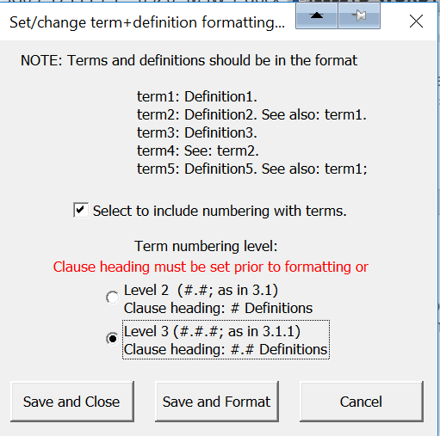
The result is:

3.1 Terms defined elsewhere
3.1.1 Term 1: Definition 1
The IEC template does something similar using an input form, but you end up with a very different term and definition format to the ITU-T.
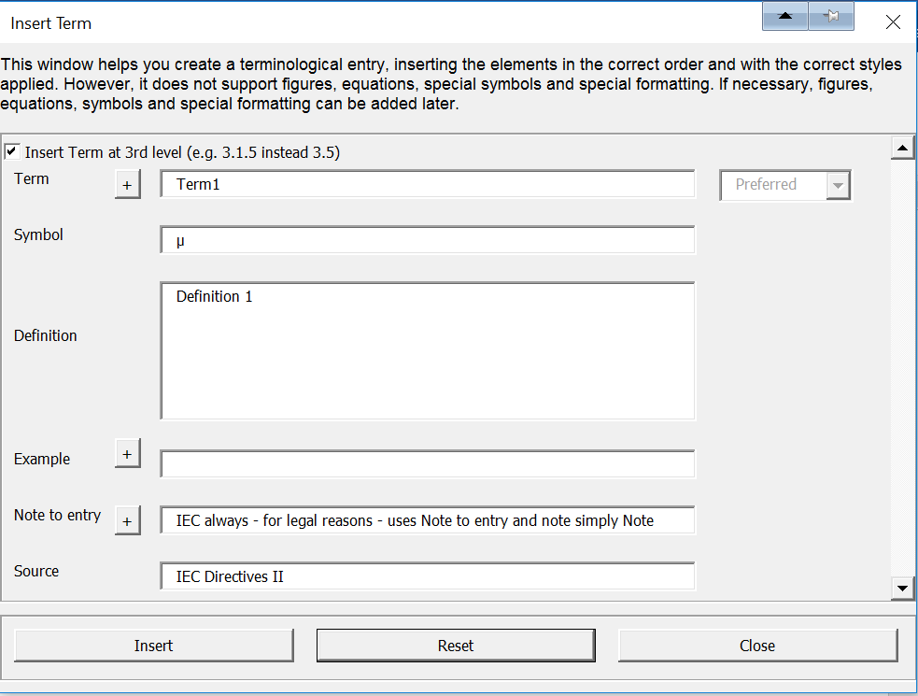
The result is:

3 Terms defined elsewhere
3.1.1
Term1
µ
Definition 1
Note 1 to entry: IEC always - for legal reasons - uses Note to entry and not simply Note
[SOURCE: IEC Directives II]
In both cases you can sort the terms and they will automatically renumber. The same applies to auto-numbered clause headings, figures, tables and equations in the main body text or Annexes.
Summary
Adding macros to a template gives the document editors powerful tools to speed up document creation in a style consistent with the SDO concerned. It would be a great benefit to those creating ITU-T documents if such macros could be incorporated in the ITU-T templates.
Proposal
Writing a macro set to accomplish all of the possible ITU-T styling actions is a major task. To bring stakeholders the early benefit of a macro-enabled template, a template could be produced with a reduced set of styling macros. This would give stakeholder benefits quickly while using minimal resource effort. A simple three-function macro set could be to:
- insert clause headers from level one to level five;
- note(s) entry; and
- third level term and definition styling.
Later an enhanced version could add the following:
- table of contents generation;
- table numbering;
- figure numbering;
- equation numbering;
- annex clause numbering; and
- appendix clause numbering.
ITU-T Study Group 5 would like to bring this matter to the attention of TSAG in order to facilitate the work of ITU-T SG5 and other interested Study Groups.
_______________________

