|  |  |  |  |  |
| --- | --- | --- | --- | --- |
| ITU logo | INTERNATIONAL TELECOMMUNICATION UNION  **TELECOMMUNICATION STANDARDIZATION SECTOR**  STUDY PERIOD 2017-2020 | | TD 098 | |
| **TSAG** | |
| **Original: English** | |
| **Question(s):** | | N/A | Geneva, 1-4 May 2017 | |
| **TD** | | | | |
| **Source:** | | Director, Telecommunication Standardization Bureau | | |
| **Title:** | | Electronic working methods services and database applications report | | |
| **Purpose:** | | Information | | |
| **Contact:** | | Al Dayao  TSB | | Tel: +41 22 730 5857  Fax: +41 22 730 5853  Email: [tsbedh@itu.int](mailto:tsbedh@itu.int) |

|  |  |
| --- | --- |
| **Keywords:** | Electronic Working Methods, SharePoint Collaboration sites, Databases, Web sites, E-meetings |
| **Abstract:** | This document describes actions taken in the past year to improve electronic work methods and tools for the membership. |

# Action Required: TSAG is invited to note this document.

# 1 Developments on the ITU-T website

TSB continuously creates and updates web pages to ensure that correct and current information is always available.

## 1.1 New ITU-T web areas

Several new web areas have been created since TSAG February 2016 including new web pages for focus group, special projects, workshops, seminars and other events held by ITU-T.

Some of the notable sites that have been created since the last TSAG meeting are:

[ITU-T Study Groups (Study Period 2017-2020)](http://www.itu.int/en/ITU-T/studygroups/2017-2020/)

[AI for Good Global Summit](http://www.itu.int/en/ITU-T/AI/Pages/201706-default.aspx)

[Symposium on The Future Networked Car](http://www.itu.int/en/fnc/2017/)

[ITU workshop on "Security Aspects of Blockchain"](http://www.itu.int/en/ITU-T/Workshops-and-Seminars/201703/)

[7th Green Standards Week](http://www.itu.int/en/ITU-T/Workshops-and-Seminars/gsw/201704/)

[ITU Women in Standardization Expert Group (WISE)](http://www.itu.int/en/ITU-T/wise/)

[Global Standards Symposium](http://www.itu.int/en/ITU-T/wtsa16/gss/)

[WTSA-16](http://www.itu.int/en/ITU-T/wtsa16/)

# 2 Tools and Applications

TSB and ITU IS and C&P Departments continue to develop several applications and further enhanced existing facilities to support and improve the electronic working methods of the members. Since the last TSAG, key achievements include:

## 2.1 Document Management System for Rapporteur Group Meetings

The ITU IS Department together with TSB have developed a system for managing documents of ITU-T Rapporteur Group Meetings (RGM) in a well-structured and secured environment. This new system which is based on MS SharePoint was used extensively at the previous [SG13 co-located Rapporteur group meetings](https://extranet.itu.int/meetings/ITU-T/T13-SG13RGM/12068-160418/SitePages/Welcome.aspx) in April 2016 and the [Interim Rapporteur group meetings for SG20](https://extranet.itu.int/meetings/ITU-T/T13-SG20RGM/13307-160502/SitePages/Welcome.aspx) in May 2016. At the start of the new Study Period 2017-2020, several ITU-T Study Groups notably Study Groups 3, 9, 15 and 16 have also started using the new RGM system and the Rapporteurs have continued to provide invaluable feedback for further improving the system.

The new ITU-T RGM system is now available for any Rapporteur group wishing to utilise and take advantage of its improved capabilities such as:

* Automatic and real-time mirroring of documents in the IFA.
* Automatic generation and update of documents lists.
* Archiving of documents after the meeting.
* Setting of deadlines with a procedure for managing late submissions.
* Distinct permission levels on RGM sites and documents.

The current and past RGM meetings may be accessed here: <http://itu.int/go/itu-t/rgm>

A comprehensive support and FAQs page offering RGM tips and best practices is available for users at: <http://itu.int/go/itu-t/rgm-support>

A very detailed online user guide for the RGM System complete with videos is available at:   
<http://itu.int/go/itu-t/rgm-guide>

A feedback form for the new RGM system has also been prepared and we invite all users of the system to fill in the form. Your feedback and suggestions will be very helpful for us in assessing and improving the quality of our services. The RGM Feedback Form is available here: <http://itu.int/go/itu-t/rgm-feedback>

The RGM system is part of several services available in the ITU-T SharePoint collaboration sites and is restricted to ITU-T Members and may be accessed using a TIES account.

## 2.2 ITU-T SharePoint Collaboration Sites

The ITU-T SharePoint Collaboration sites have been developed to further improve the electronic working methods of ITU-T Study Groups. The collaboration site allows members to conduct online discussions and work on documents in a secure and shared environment. In addition, basic social media functionalities are also available to encourage lively and productive discussions between the members. Most of the collaboration sites are restricted to ITU-T Members and may be accessed using a TIES account. Some collaboration sites which are open to non-members may be accessed using ITU Guest accounts. The ITU-T SharePoint collaboration home site may be accessed here:  
<https://extranet.itu.int/sites/ITU-T/>

## 2.3 Search engine (February 2017)

A new search engine is now available from the ITU-T homepage. This search engine will allow you to easily find your relevant ITU-T documents, publications and other resources, in 6 languages. The search engine allows you to drill down using specific filters or to browse for interesting content using the thematic search. The thematic search is organized around key ITU standardization prioritize such as cybersecurity, big data, cloud, IoT and more. We would like to encourage you to give the new search engine a try and find the standards information you are looking for. The new search engine is available here: <https://www.itu.int/net4/ITU-T/search/>

## 2.4 ICT standards roadmap (on going, End of May 2017)

The ITU-T Roadmap for ICTs standards is intended to support the standardization for a given ICT domain (e.g. Security, E-Health, IoT and SC&C, OTN, ANT, etc.) by identifying existing published standards, standards that are currently under development, and areas where a need for standards has been identified but work has not been initiated yet.

The ITU-T Roadmap is publicly available online, where some designated ITU-T contributors with supplementary access rights, will be able to maintain it, as a Wiki. Contributors are members of ITU-T (TIES), as experts in the domain they are responsible for, they will be designated by the respective ITU-T Study Groups. Their access rights will be updated by TSB secretariat on demand.

Contributors will have to maintain domains, subdomains, and the mapping to the respective standards already approved or still under development. An initial draft of the online roadmap for your consideration and feedback: http://www.itu.int/net4/ITU-T/roadmap. Since this is an early draft, please note that the data are incomplete and are included only to illustrate some of the features.

Two key features are under development and will be shared with you at a later date:

Additional filters in the left-hand side bar, e.g., standards per organization/entity.

An administrative function to allow nominated ITU experts to update the roadmap directly via the web.

## 2.5 National Numbering Plans (NNPs) (on going, May 2017)

Following [Resolution 91 (Hammamet, 2016)](http://handle.itu.int/11.1002/pub/80ee9b98-en?locatt=format:http) – “Enhancing access to an electronic repository of information on numbering plans published by the ITU Telecommunication Standardization Sector”, TSB started to investigate the possible ways for improving access to the ITU national numbering plans repository that were already available [online](https://www.itu.int/oth/T0202.aspx?parent=T0202) as PDF and MS Word file, compliant with presentation methodology introduced in [ITU-T E.129 (01/2013)](http://handle.itu.int/11.1002/1000/11617-en?locatt=format:pdf&auth) (see [TD 230-GEN](http://handle.itu.int/11.1002/doc/80924eb6/80923f53-en?locatt=format:docx) describing status of NNP available on the ITU web site in 2013 as a sample).

After a first analysis, a common and standard structure has been defined to cover as far as possible the various possibilities that have been published into that repository. This structure has been defined into a XML Standard Document (XSD), which is one of the most common language used to define the fields of a structure and its properties.

As a first approach, TSB proposes to transform, when feasible, the MS Word numbering plans into an XML file, compliant with the XML. Doing so, the national numbering plans can be processed by a machine. In the meantime, as XML can be easily transformed into another format, some human readable format such as MS Word or Excel, will be still available from the ITU repository.

See Draft version of XML standard document for National Numbering Plans presentation in recent [TD 143-GEN](http://handle.itu.int/11.1002/doc/80f59787/80f59802-en?locatt=format:docx). It is planned to have a first prototype with some NNPs ready for demo in May 2017.

## 2.6 ITU-T Mailing lists

The mailing lists continue to be very useful tools in the work of the study groups and other groups. There are **303 active ITU-T mailing lists** with a total of **30270 subscribers** currently being used as shown in the table below.

|  |  |  |
| --- | --- | --- |
| **Group** | **Mailing lists** | **Subscribers** |
| **TSAG** | 6 | 479 |
| **SG2** | 32 | 2034 |
| **SG3** | 25 | 1509 |
| **SG5** | 19 | 1113 |
| **SG9** | 3 | 26 |
| **SG11** | 22 | 1133 |
| **SG12** | 28 | 2739 |
| **SG13** | 20 | 2754 |
| **SG15** | 29 | 5990 |
| **SG16** | 18 | 850 |
| **SG17** | 18 | 1785 |
| **SG20** | 16 | 2169 |
| **Focus Groups** | 4 | 748 |
| **Joint Coordination Activities** | 10 | 1223 |
| **Other groups** | 53 | 5718 |
| **Total** | **303** | **30270** |

# 3 Electronic meetings

In response to PP-10 Resolution 167 (*Strengthening ITU capabilities for electronic meetings and means to advance the work of the Union*), TSB continues to improve the electronic meeting facilities for the members. TSB now provides GoToMeeting and Adobe Connect as remote participation tools for e-Meetings.

TSB uses Adobe Connect as the official remote participation tool to complement physical meetings that are held in ITU HQ in Geneva. GoToMeeting is still used for fully virtual and ad-hoc meetings.

**3.1 E-meeting sessions organized**

For the period from **June 2016** to **March 2017**, a total of **937 e-Meetings** were provided using GoToMeeting and Adobe Connect with **5041 online attendees.**

The complete figures are shown in Tables 1 and 2.

Table 1: E-Meetings organized with Adobe Connect complementing physical meetings in Geneva (June 2016 – March 2017)

|  |  |  |
| --- | --- | --- |
| **Group** | **Total Meetings** | **Online Attendees** |
| **TSB (Includes workshops, seminars, events, regional and other meetings)** | 16 | 165 |
| **TSAG** | 13 | 217 |
| **RevCom** | 1 | 4 |
| **SG2** | 14 | 24 |
| **SG3** | 2 | 60 |
| **SG5** | 40 | 100 |
| **SG9** | 4 | 16 |
| **SG11** | 24 | 83 |
| **SG12** | 16 | 57 |
| **SG13** | 30 | 86 |
| **SG15** | 0 | 0 |
| **SG16** | 19 | 65 |
| **SG17** | 14 | 48 |
| **SG20** | 39 | 204 |
| **Focus Groups** | 4 | 15 |
| **Joint Coordination Activities** | 9 | 41 |
| **Total** | **245** | **1185** |

Table 2: E-Meetings organized with GoToMeeting as fully virtual (June 2016 – March 2017)

|  |  |  |
| --- | --- | --- |
| **Group** | **Total Meetings** | **Online Attendees** |
| **TSB (Includes workshops, seminars, events, regional and other meetings)** | 149 | 684 |
| **TSAG** | 11 | 55 |
| **RevCom** | 0 | 0 |
| **SG2** | 7 | 21 |
| **SG3** | 7 | 24 |
| **SG5** | 151 | 547 |
| **SG9** | 26 | 88 |
| **SG11** | 26 | 109 |
| **SG12** | 19 | 78 |
| **SG13** | 40 | 224 |
| **SG15** | 32 | 392 |
| **SG16** | 7 | 19 |
| **SG17** | 28 | 203 |
| **SG20** | 115 | 707 |
| **Focus Groups** | 74 | 705 |
| **Joint Coordination Activities** | 0 | 0 |
| **Total** | **692** | **3856** |

In addition to the remote participation tools, from June 2016 to March 2017 the ITU IS Department also provided live (audio-only) webcasts for 16 ITU-T meetings. The archives are available through the Study Groups main pages.

**3.2 Statistics on the use of E-Meetings in Rapporteur group meetings**

The following are automatically generated reports for each ITU-T study group showing the number of Rapporteur group meetings which were held using the remote participation tools provided by ITU and face-to-face Rapporteur group meetings held in different venues. The statistics cover the period from June 2016 to April 2017.

|  |  |  |  |  |
| --- | --- | --- | --- | --- |
| **ITU-T Study Group 2 Rapporteur Group meeting statistics from 01 June 2016 to 25 April 2017** |  |  |  |  |
|  | Generated using the TSB DB Reports tool As-of 4/25/2017 12:47:35 PM | | |

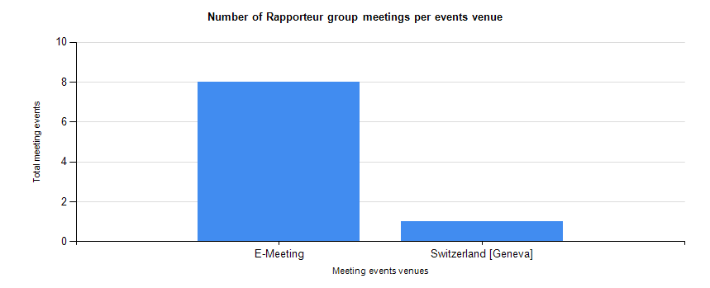

|  |  |  |  |  |
| --- | --- | --- | --- | --- |
| **ITU-T Study Group 3 Rapporteur Group meeting statistics from 01 June 2016 to 25 April 2017** |  |  |  |  |
|  | Generated using the TSB DB Reports tool As-of 4/25/2017 12:48:38 PM | | |

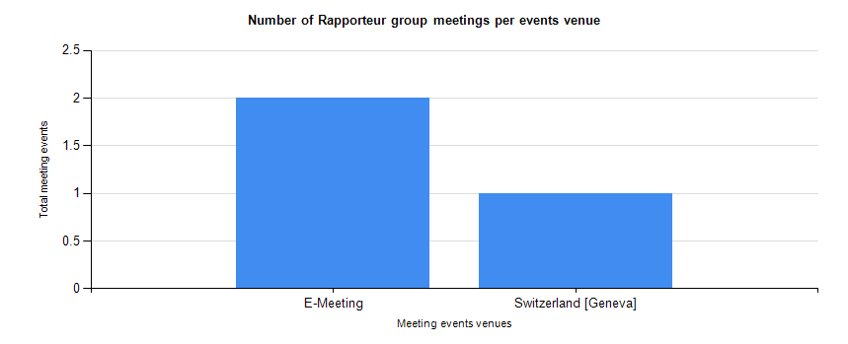

|  |  |  |  |  |
| --- | --- | --- | --- | --- |
| **ITU-T Study Group 5 Rapporteur Group meeting statistics from 01 June 2016 to 25 April 2017** |  |  |  |  |
|  | Generated using the TSB DB Reports tool As-of 4/25/2017 12:49:22 PM | | |

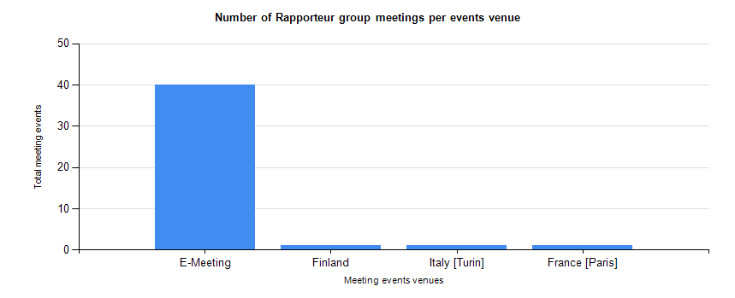

|  |  |  |  |  |
| --- | --- | --- | --- | --- |
| **ITU-T Study Group 9 Rapporteur Group meeting statistics from 01 June 2016 to 25 April 2017** |  |  |  |  |
|  | Generated using the TSB DB Reports tool As-of 4/25/2017 12:49:43 PM | | |

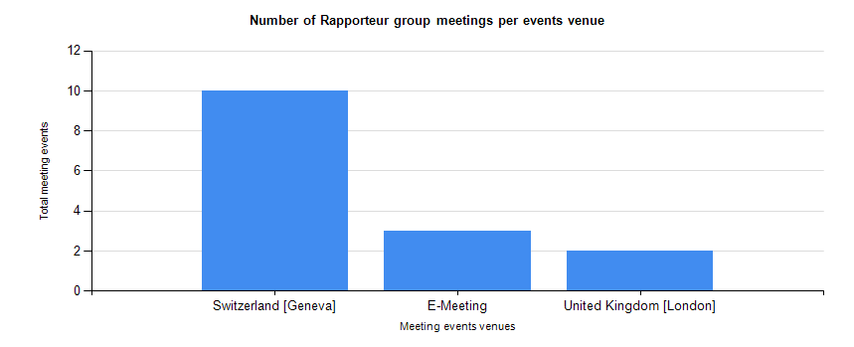

|  |  |  |  |  |
| --- | --- | --- | --- | --- |
| **ITU-T Study Group 11 Rapporteur Group meeting statistics from 01 June 2016 to 25 April 2017** |  |  |  |  |
|  | Generated using the TSB DB Reports tool As-of 4/25/2017 12:50:07 PM | | |

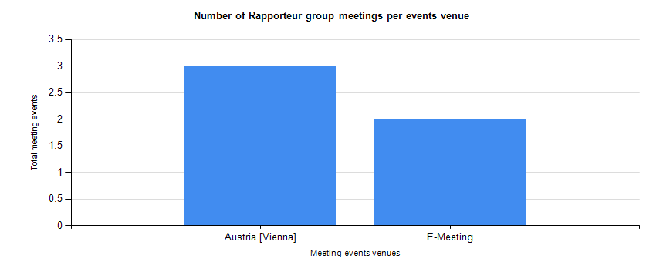

|  |  |  |  |  |
| --- | --- | --- | --- | --- |
| **ITU-T Study Group 12 Rapporteur Group meeting statistics from 01 June 2016 to 25 April 2017** |  |  |  |  |
|  | Generated using the TSB DB Reports tool As-of 4/25/2017 12:50:38 PM | | |

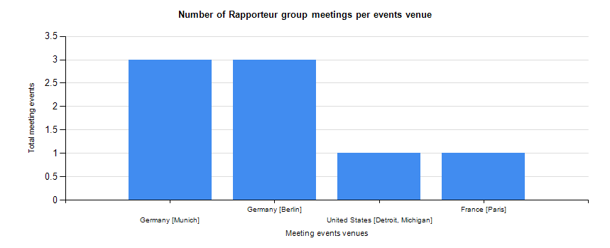

|  |  |  |  |  |
| --- | --- | --- | --- | --- |
| **ITU-T Study Group 13 Rapporteur Group meeting statistics from 01 June 2016 to 25 April 2017** |  |  |  |  |
|  | Generated using the TSB DB Reports tool As-of 4/25/2017 12:51:04 PM | | |

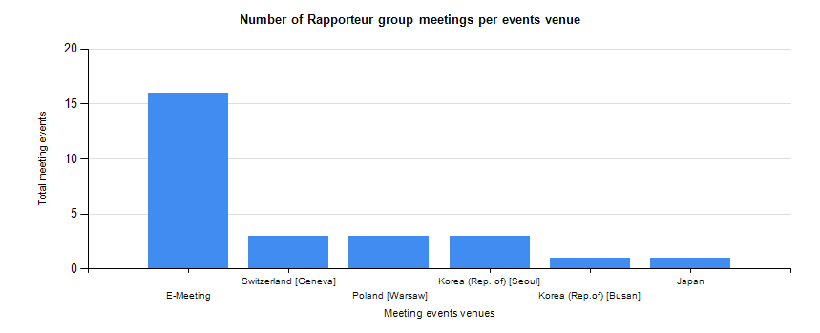

|  |  |  |  |  |
| --- | --- | --- | --- | --- |
| **ITU-T Study Group 15 Rapporteur Group meeting statistics from 01 June 2016 to 25 April 2017** |  |  |  |  |
|  | Generated using the TSB DB Reports tool As-of 4/25/2017 12:51:30 PM | | |

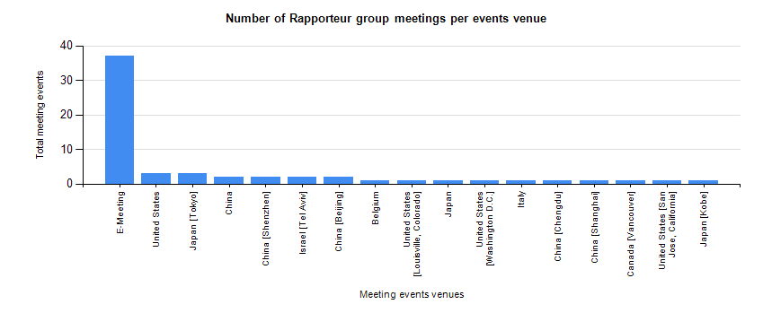

|  |  |  |  |  |
| --- | --- | --- | --- | --- |
| **ITU-T Study Group 16 Rapporteur Group meeting statistics from 01 June 2016 to 25 April 2017** |  |  |  |  |
|  | Generated using the TSB DB Reports tool As-of 4/25/2017 12:51:51 PM | | |

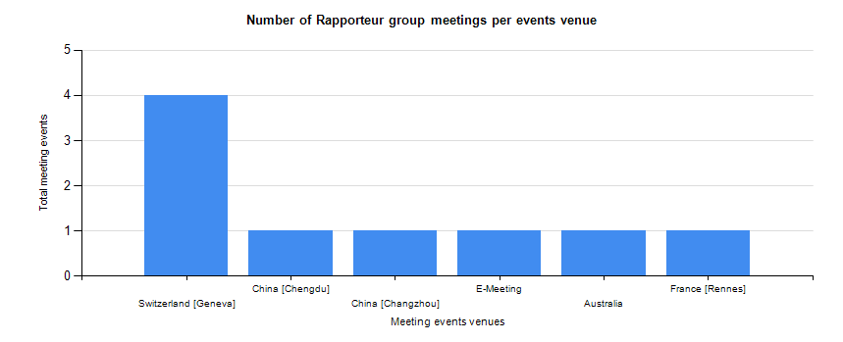

|  |  |  |  |  |
| --- | --- | --- | --- | --- |
| **ITU-T Study Group 17 Rapporteur Group meeting statistics from 01 June 2016 to 25 April 2017** |  |  |  |  |
|  | Generated using the TSB DB Reports tool As-of 4/25/2017 12:52:16 PM | | |

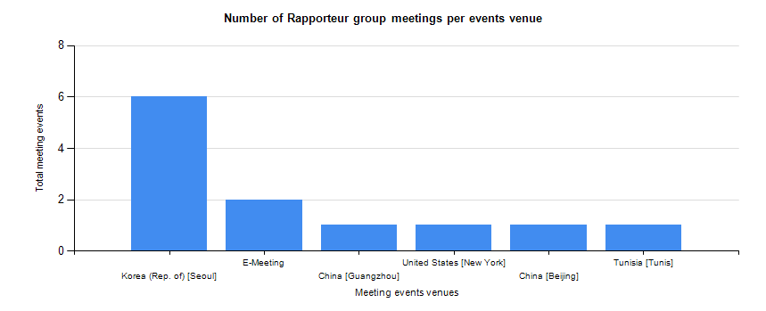

|  |  |  |  |  |
| --- | --- | --- | --- | --- |
| **ITU-T Study Group 20 Rapporteur Group meeting statistics from 01 June 2016 to 25 April 2017** |  |  |  |  |
|  | Generated using the TSB DB Reports tool As-of 4/25/2017 12:52:38 PM | | |

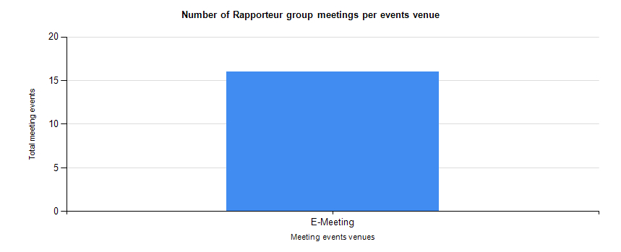

# 4 Updates on Action Items related to EWM

ITU-T Membership regularly provides TSB with feedback, requests for new tools or improvements for their electronic working. TSB reviews these requests and are added to the list of EWM Action items to be processed as appropriate. The current action items and ongoing activities are listed in the table below.

| Action items | | | | | | | | | |
| --- | --- | --- | --- | --- | --- | --- | --- | --- | --- |
| N° | | Action | | Timescale | | Priority | | Remark | |
| A-1 | | Provide automated upload of TDs (DDP for TDs) | | New Study Period 2017-2020 | | High | | TSB has been trialling a SharePoint-based infrastructure for managing Rapporteur Group Meetings (RGM) documents and believes that, after proper testing of the RGM infrastructure and modifications to interface with DMS posting, this platform is better suited for the next version of DDP that will support posting of TDs. TSB is planning to introduce it as early as possible in the new Study Period 2017-2020. | |
| A-2 | | Improvements to the Sync tool:   1. Possibility to add the option to download per Question. 2. Add the filter/selection function, e.g. show only documents allocated to a single question. 3. Add capability to sort columns by clicking on the column header alternating ascending/descending order, e.g. sort document numbers, and source. 4. Changing computer system clocks forward results in the tool not recognizing the documents already downloaded when sync is next requested.  Possibility to use a verification method that is independent of the user’s local clock settings. 5. Users with some corporate security options on their PCs also require the ability to control proxy settings for the tool to work for them.  These features might be added as “Advanced” settings. 6. Evaluate the possibility to develop a Linux-compatible version of the sync tool. 7. Evaluate the possibility to develop mobile versions of the sync tool 8. Suggestion to not synchronize large documents and just add a link to the FTP area. | | New Study Period 2017-2020 | | Medium | | #1 Not possible in the current system; will be explored and implemented if possible.  #2 Filtering by Questions is now available.  #3 Implemented.  #4 Is being explored, will be implemented as soon as possible.  #5 Is being explored, will be implemented as soon as possible.  #6 Is being explored.  #7 Is being explored.  #8 Will be explored. | |
| A-3 | | Improvements to the LS site: e.g. Sorting by WP or Question; improve search capabilities which are currently too limited. | | New Study Period 2017-2020 | | Medium | | Is being explored, will be implemented as soon as possible. | |
| A-4 | | Enable a way to select by Question apart from finding it in the Questions column to improve filtering or viewing meeting documents by Question. For example, a pull-down menu on the Questions column header may improve the user experience. | | New Study Period 2017-2020 | | Medium | | Done | |
| A-5 | | Evaluate the possibility to develop mobile versions of the ITU website. | |  | | Medium | | The ITU IS Web team is currently working on a mobile version of the ITU website. | |

| Ongoing activities | | | | |
| --- | --- | --- | --- | --- |
| N° | Activity | Timescale | Priority | Remark |
| O-1 | TSAG to liaise with Study Groups concerning working methods issues, including Electronic Working Methods | Ongoing | Medium | Ongoing |
| O-2 | TSB to assure that the XML properties of all the documents are properly filled in before being posted. | Ongoing | High |  |
| O-3 | TSB to update the EWM frequently asked questions (FAQ) web page | As required | High | Ongoing |
| O-4 | TSB to provide statistics on the number of Sector Members and Members who have requested electronic copies of documents in lieu of paper copies | Ongoing | Medium | Ongoing |
| O-5 | TSB to use the t13tsagwm e-mail reflector and discussion forum to keep participants informed about their progress in EWM implementation | Ongoing | High | Ongoing |
| O-6 | TSB to use the SG EWM Coordinators, the t13tsagwm reflector and discussion forum to review proposed major web page format and present proposals before adopting those changes | Ongoing | High | Ongoing |
| O-7 | Availability of wireless LAN, outlet power, etc. should be verified before the start of the workday for ITU-T meetings | Ongoing | High | Ongoing |
| O-8 | TSB to verify posted documents by checking external web (manually or automatically) | Ongoing | High | Ongoing |

_________________