 | INTERNATIONAL TELECOMMUNICATION UNION  TELECOMMUNICATION  STANDARDIZATION SECTOR  STUDY PERIOD 2017-2020 |  |  |  | TD 019
 |  |  |  |  | TSAG
 |  |  |  |  | Original: English
Question(s): |  |  | N/A |  | Geneva, 1-4 May 2017
TD
(Ref.: SG12 - LS 8 -E)
Source: |  |  | ITU-T Study Group 12
Title: |  |  | LS on feedback from SG12 to SG11/CASC and TSAG regarding tests of the compatibility between mobile phones and vehicle hands-free terminals [from ITU-T SG12]
LIAISON STATEMENT
For action to: |  |  |  | TSAG
For comment to: |  |  |  | -
For information to: |  |  |  | ITU-T SG11, CASC
Approval: |  |  |  | ITU-T Study Group 12 meeting (19 January 2017)
Deadline: |  |  |  | -
Contact: |  | Kwame Baah-Acheamfuor  SG12 Chairman  Ghana |  |  | Tel: +233 24 6375700  E-mail: kwame.baah-acheamfuor@nca.org.gh

A new liaison statement has been received from SG12.
This liaison statement follows and the original file can be downloaded from the ITU ftp server at http://handle.itu.int/11.1002/ls/sp16-sg12-oLS-00008.docx.

 | INTERNATIONAL TELECOMMUNICATION UNION  TELECOMMUNICATION  STANDARDIZATION SECTOR  STUDY PERIOD 2017-2020 |  |  |  |  | COM 12 – LS 8 – E
 |  |  |  |  |  | Original: English
Question(s): |  |  | 1, 4/12 |  |  | Geneva, 10-19 January 2017
LS
Source: |  |  | ITU-T Study Group 12
Title: |  |  | LS on feedback from SG12 to SG11/CASC and TSAG regarding tests of the compatibility between mobile phones and vehicle hands-free terminals
LIAISON STATEMENT
For action to: |  |  |  | TSAG
For information to: |  |  |  | ITU SG11, CASC/11
Approval: |  |  |  | ITU-T Study Group 12 meeting (19 January 2017)
Deadline: |  |  |  | -
Contact: |  | Kwame Baah-Acheamfuor |  |  | E-mail: kwame.baah-acheamfuor@nca.org.g
 |  | Joachim Pomy |  |  | Email: jp@joachimpomy.de

Keywords: | C&I, conformance, P.1100, P.1110, P.1140
Abstract: | SG12 would like to inform TSAG and SG11 regarding issues found in the tests of the compatibility between mobile phones and vehicle hands-free terminals and actions taken by SG 12 to update Recommendations P.1100, P.1110 and P.1140.

Background
The ITU Conformance & Interoperability program has conducted three test events regarding compatibility of mobile phones and vehicle hands-free terminals.
http://www.itu.int/en/ITU-T/C-I/Pages/HFT-mobile-tests/test_event_3.aspx
The purpose of these events was to test mobile phones according to chapter 12 of ITU-T P.1100 and P.1110. Mobile phones that have received a PASS verdict are listed in the ITU product conformity database.
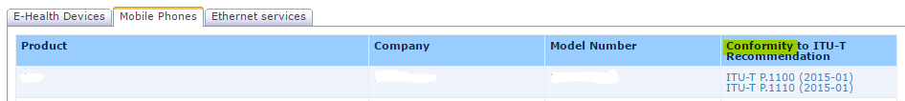
The history of the test is summarized in the Annex to this liaison statement.
Feedback on this topic can be found in SG12-C.54, from a company participating in the third test event.
This input led to discussions at the SG12 meeting about the usage of the words “shall” and “should” in requirements of Recommendations and actions required to overcome the problem of interpreting which tests are mandatory and which tests are optional.

Discussions in SG12
In SG12 quite some discussion came up concerning the usage of the words “shall” and “should” and their meaning in the context of Recommendations. The usage of the word “shall” in ITU-T is defined in Recommendations by a Note in each Recommendation as follows:

Current instructions on how to read Recommendations
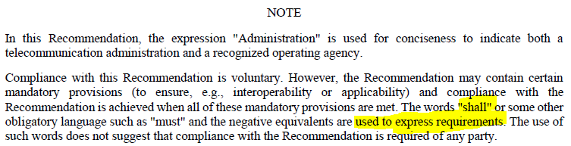

This section clearly instructs the reader that a mandatory requirement is expressed by the word “shall”.

Current instructions on how to write Recommendations
In the author’s guide for drafting ITU-T Recommendations the following definitions can be found:
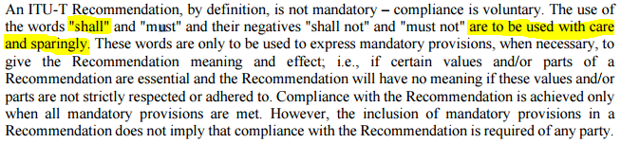
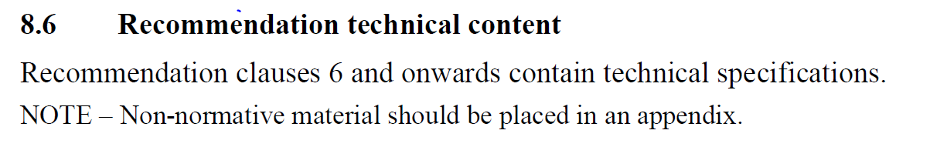
Authors are instructed to use the word “shall” with care and sparingly and only to express “mandatory provisions, when necessary, to give the Recommendation meaning and effect”. Section 8.6 in the author’s guide defines clauses 6 downwards to contain technical specification and non-normative material should be placed in an Annex. This could give a false impression that “should” statements need to be moved into an informative appendix. To use the word “shall” sparingly as advised today may be counterproductive in this context.

Actions taken and to be taken
1. SG12 kindly asks TSAG to update the author’s guide and provide more unambiguous and clear guidelines for writing Recommendations especially in view of the pass/fail verdicts in conformance testing.
2. The following actions were taken by SG12 in the updates of Recommendations P.1100, P.1110 and P.1140:
– Occurrences of “should” were removed from the text from clause 6 onwards and replaced by “shall” where it was found agreeable. Only in cases where the use of “should” would have no impact on the desired performance requirements and associated test methods “should” remains.
– In some clauses in Chapter 12 of Recommendations P.1100 and P.1110 the test procedures were made more clear and unambiguous.
– Error corrections, test adaptations, adaptations of requirements and text improvements were made in various sections of Recommendations P.1100, P.1110 and P.1140 based on input received.
– Based on new technical input the Recommendations were improved further.

Further conclusions
1. SG12 is continuing the co-operation with SG11, CASC regarding testing on the basis of P.1100/P.1110/P.1140, but SG12 notes that P.1100/P.1110/P.1140 is under the SG12 remit and expects that the tests conducted in the C&I program are conducted strictly according to these Recommendations.
2. Some details of the test procedure being used at the events have been suggested for integration into P.1100/P.1110. Following a potential approval, this is expected to remove the incentive of applying specific procedures that are not found in the ITU-T documents. If there is nevertheless a proposal from C&I test events to use extended or adapted procedures, C&I is invited to liaise via SG11 with SG12 so the matter can be resolved in SG12 using normal agreement/consent processes, before such procedures are used in C&I testing.
3. SG12 suggests that the test reports are divided into different parts so that the mandatory test results are presented first with expected vs. actual behaviour and pass/fail verdict point-by-point. SG12 furthermore suggests that the supplementary expert analysis information is presented separately, with appropriate marking of the informative nature of this information.

ANNEX
• TSB informed SG12 about the Call for Expression of Interest (EOI) for the first ITU-T test event (December 2013, TD325);
• ITU conducted first test event (12-16 May 2014, web page);
• TSB presented a brief report of the first test event in SG12 meeting (September 2014, TD455);
• Automotive industry urged ITU to publish Whitelist (see C15/24 of the ITU Council-15, newslog);
• TSB announced a call for bid for selecting testing laboratory which will perform tests at the ITU test events which ITU started organizing on the regular basis (September 2015, see newslog);
• Head Acoustics was selected to perform the tests at the ITU test events;
• ITU conducted second test event (23-27 May 2016, www.itu.int/go/hft-test-event-2);
• Anonymous testing reports are available on the events’ web pages (first test event, second test event);
• SG12 informed SG11 on the Recommendations which are suitable for C&I testing (e.g. P.1100/P.1110 are among them – e.g. see TD998r1) (June 2016);
• P.1100/P.1110 were proposed as a candidates for new joint certification scheme ITU/GCF (see report of CASC – TD1306 and iLS-TD17) (July 2016);
• ITU conducted third test event (15-16 November 2016, www.itu.int/go/hft-test-event-3);
• Feedback was given by Sony Corporation in C54: “Caution and proposals regarding the C&I testing” (January 2017, https://www.itu.int/md/T17-SG12-C-0054/en).

_______________________

