 | INTERNATIONAL TELECOMMUNICATION UNION  TELECOMMUNICATION  STANDARDIZATION SECTOR  STUDY PERIOD 2017-2020 |  | TSAG-C38
 |  |  | TSAG
 |  |  | Original: English
Question(s): |  | N/A |  | Geneva, 26 February – 2 March 2018
CONTRIBUTION
Source: |  | Russian Federation
Title: |  | Issues of ITU-T work organization
Purpose:
Contact: |  | Evgeny Tonkikh  Russian Federation |  |  | Tel: +7 495 6471734  E-mail: et@niir.ru
Contact: |  | Dmitry Cherkesov  Russian Federation |  |  | Tel: +7 985 2390600  E-mail: dcherkesov@gmail.com

Keywords: | ITU-T Working methods; reports; EWM
Abstract: | The document proposes measures to increase the ITU-T and TSAG work's efficiency, as well as raises concerns about the requirements for the publication of the meetings' reports held by the Sector. The measures include the unification of the ITU-T SG pages, the establishment of clear deadlines for the publication of Reports, the definition of the usage rules (principles) of the projector facilities for presenting and reviewing documents at the meetings.

Introduction
The Telecommunication Standardization Sector (ITU-T) work is organized in accordance with WTSA decisions. WTSA-16 adopted a number of Resolutions and Recommendations, including Resolution 1 "Rules of procedure of the ITU Telecommunication Standardization Sector", Resolution 22 "Authorization for the Telecommunication Standardization Advisory Group to act between world telecommunication standardization assemblies", Resolution 32 "Strengthening electronic working methods for the work of the ITU Telecommunication Standardization Sector", Recommendation A.1 "Working methods for study groups of the ITU Telecommunication Standardization Sector". All of them are aimed at improving the quality of ITU-T work, ensuring transparency of its work and decisions.

Discussion
1. In some cases after the meetings complete the Study Groups (SGs) and the Telecommunication Standardization Advisory Group (TSAG) provide final Meeting Reports with long delays, or, create the so-called Executive Summary as the text of the report located directly on the site (web-page). It contradicts ITU-T Recommendation A.1 (section 1.7) and ITU-T Resolution 1 (sections 4.7, 4.8).
There are no meeting's reports section now at the corresponding web-pages of SGs and TSAG (previous Study period had those sections). For example, it could be seen for TSAG meetings, at the current web-page https://www.itu.int/en/ITU-T/tsag/2017-2020/Pages/default.aspx and at the web-page of previous study period https://www.itu.int/en /ITU-T/tsag/2013-2016/Pages/default.aspx (see Figure 1 and Figure 2 in Annex 1 for TSAG case, the situation for most SGs is similar).
The analysis of the Meeting Reports publication timing after meetings completion date are displayed below:

2. SGs websites (pages) differ from each other, including the presence and names of identical sections and documents (see examples in Figure 3 and Figure 4 in Annex 2).
3. During the SGs' meetings (for example, at the last meeting of SG 2 ITU-T) of different levels (working group, study questions), many documents are not displayed on the big screen of the meeting room. It applied not only to information documents but for actively discussed documents (i.e. documents are of interest or concerns to delegates). Such practice creates difficulties for delegates during the discussions.

Proposals
1. Recommendation A.1 states that
«1.7.1 A report on the work done during a meeting of a study group, working party or joint working party shall be prepared by TSB. Reports of meetings not attended by TSB should be prepared under the responsibility of the chairman of the meeting…».
The participants' list analysis shows that the SG' advisors are present at each SG meeting.
We ask the TSB Director to organize work with a prompt elaboration of the final report (similar way as in TSAG - no later than 6 weeks after the end of the meeting, as specified in Resolution 1) with uploading it on the ITU-T web-site for each SG meeting (It should be general report of the whole meeting not only of plenary session).
We propose to establish a deadline for the SG meetings report's publication as 6 weeks (similar to TSAG, see Resolution 1) and invite the TSB Director to monitor the implementation of deadlines. If necessary, we suggest fixing such deadline date for SG meetings reports' publication in the Recommendation A.1
2. Resolution 1 does not point who should personally prepare the report as an outcome of the TSAG meeting, it only states that «4.8 A report on its activities shall be prepared by TSAG after each meeting. This report is to be made available within an objective of six weeks after the closure of the meeting and is to be distributed in accordance with normal ITU-T procedures».
We ask the TSB Director together with the TSAG Chairman (or TSAG management team) to identify the responsible persons for the Report preparation.
3. We ask the TSB to provide direct links to Meeting Reports on the ITU-T web pages for TSAG and SGs (as it existed in the previous study periods for both SGs and TSAG).
4. We ask the TSB to make unification of the SGs and TSAG web-pages, setting the deadline for this work.
5. Both WTSA Resolution 32 aimed at improving electronic working methods and TSB provide wide opportunities for SG's steering bodies (chairpersons, rapporteurs, TSB advisors) to use all available means to ensure the convenience and transparency of discussions and decision-making process on any available documents. It is regrettable that practice of the documents’ presentation on the screen is leaving. During the WTSA-16 and at the first SGs meetings sufficient management staffs in each SG were agreed (including SG vice-chairmen from most regional organizations). Also, TSB advisers assist in the work of the SG. There are a few ways to present documents at the meeting, among them via the help of the TSB staff, the management teams of the SG, WG and Study Questions or Rapporteur group, as well as via help of (document’s) authors. We propose to discuss these issues, and take a TSAG decision (as one option) about responsibility for the presentation of documents:
- TSB representative(s) or one of the vice-chairmen (possibly on the basis of rotation)
at SG meetings;
- Chairman together with the TSB and vice-chairmen (possibly on the basis of rotation)
at the WG meetings;
- Question rapporteur together with the (contribution) authors
at the Study question or Rapporteur group meetings.

Annex 1
Comparison of TSAG web-pages of the past and current study periods
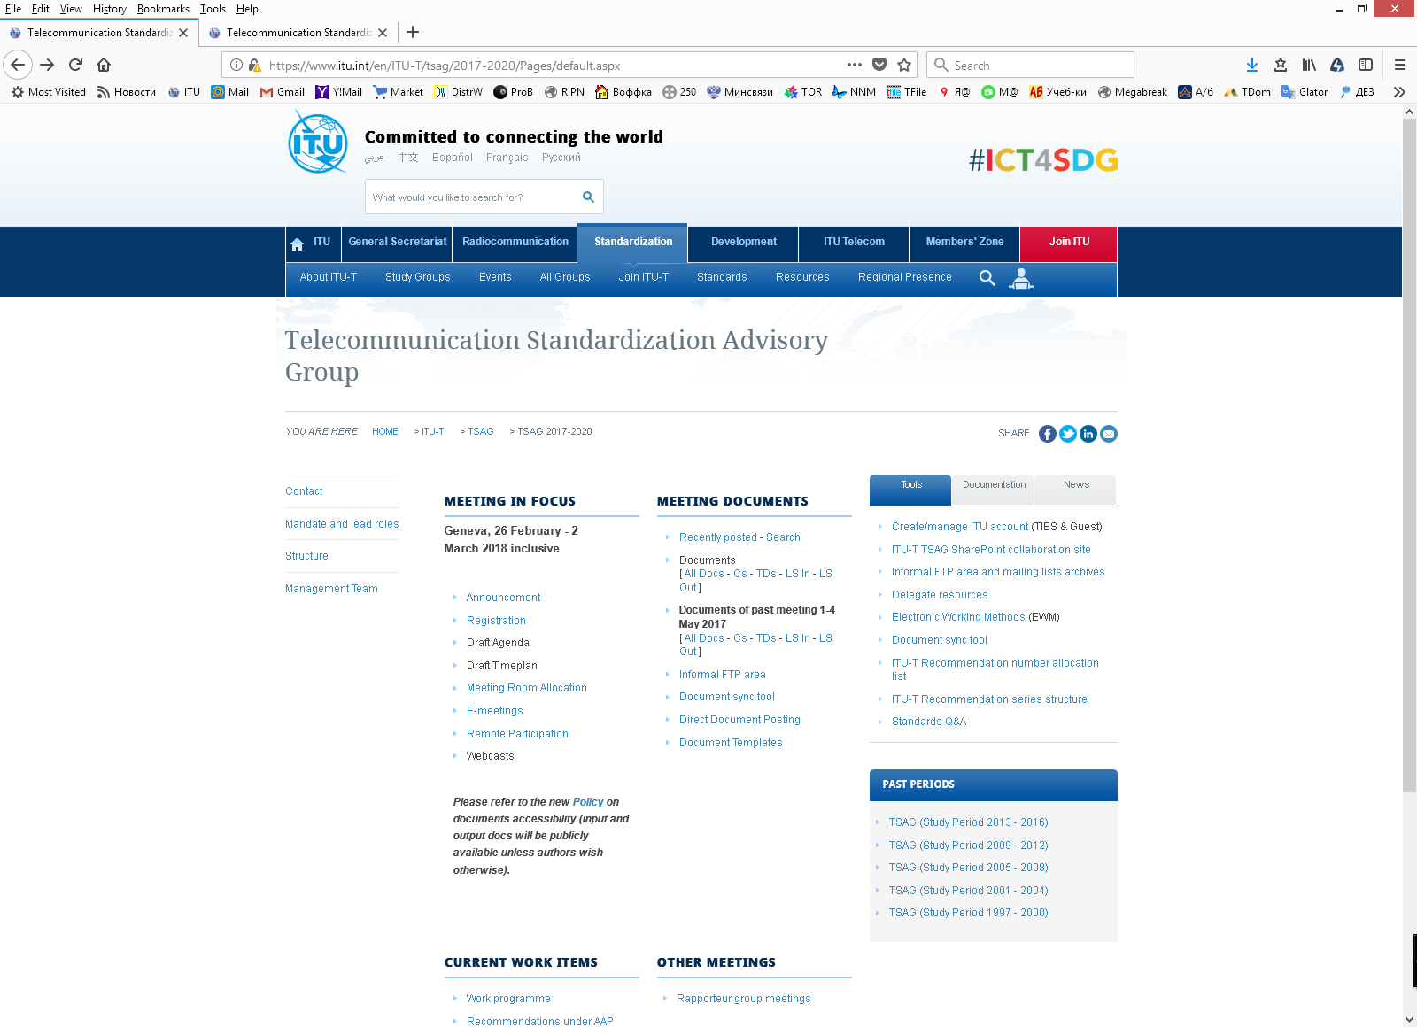
Fig. 1. There isn't section "Meeting Reports" on TSAG web-page of the current study period

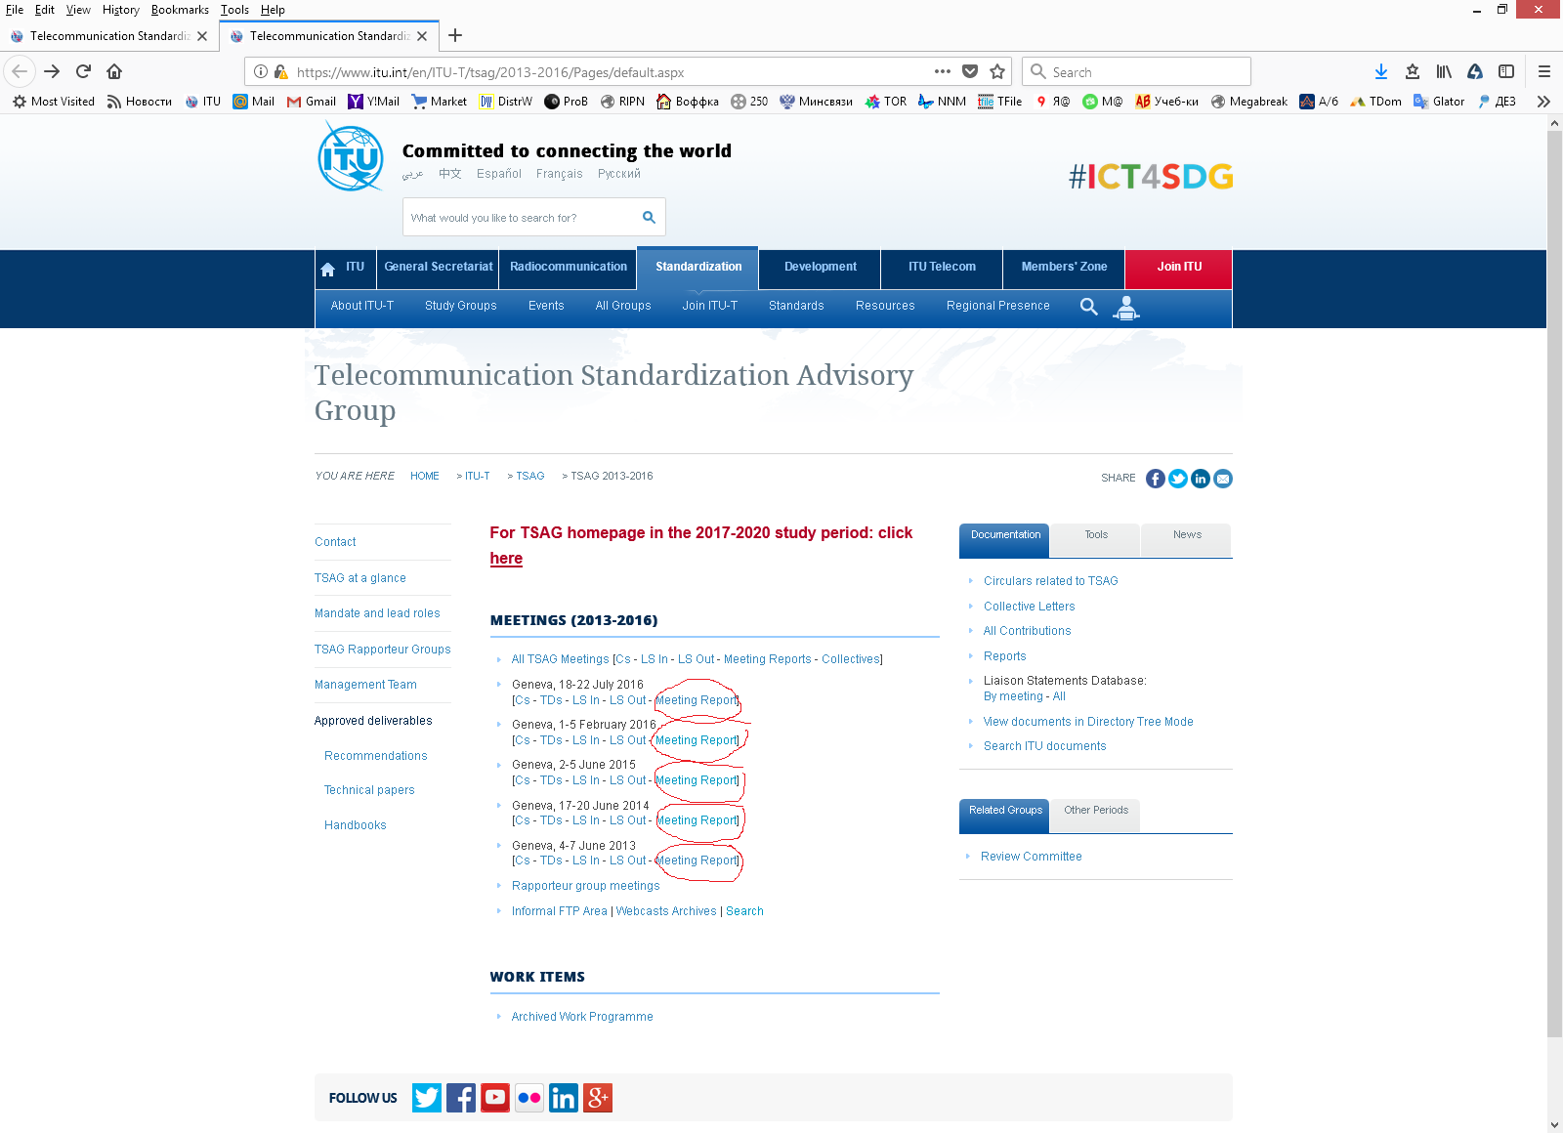
Рис. 2. There is section "Meeting Reports" on TSAG web-page of the previous study period
Annex 2
Comparison of different ITU-T SGs web-pages
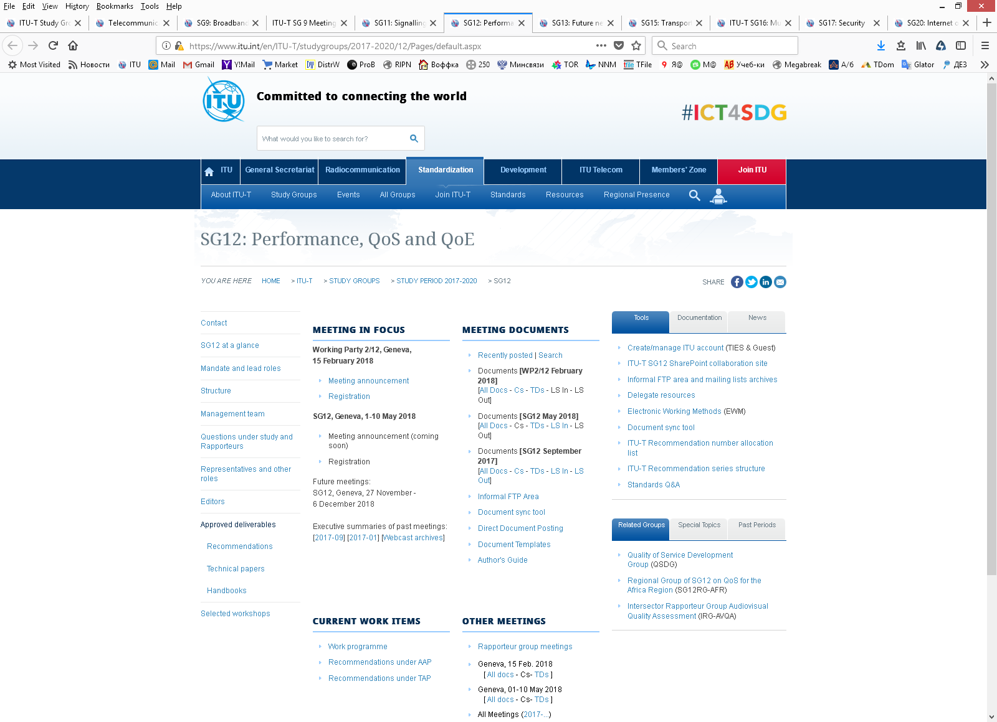
Fig. 3. SG 12 ITU-T web-page structure
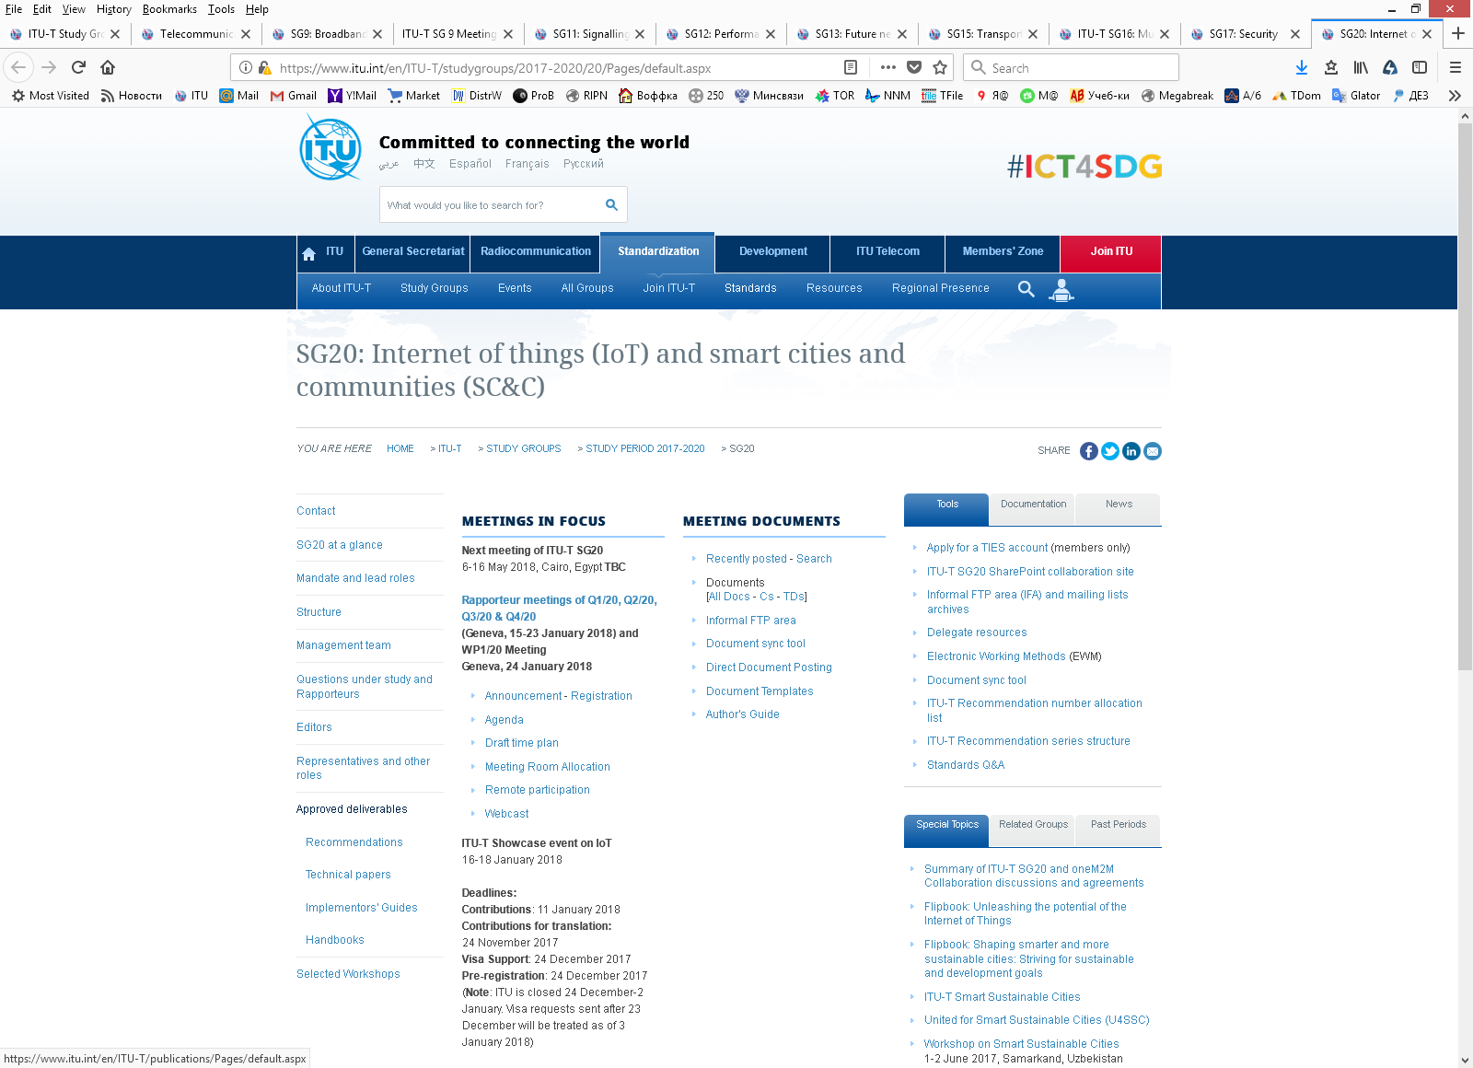
Fig. 4. SG 20 ITU-T web-page structure

