|  |  |  |  |  |  |
| --- | --- | --- | --- | --- | --- |
| ITU Logo | INTERNATIONAL TELECOMMUNICATION UNION  **TELECOMMUNICATION STANDARDIZATION SECTOR**  STUDY PERIOD 2017-2020 | | TSAG-C37 | | |
|  |  | | **TSAG** | | |
|  |  | | **Original: English** | | |
| **Question(s):** | | N/A | | Geneva, 26 February – 2 March 2018 | |
| **CONTRIBUTION** | | | | | |
| **Source:** | | Huawei Technologies Co., Ltd | | | |
| **Title:** | | Some proposals to enable ITU-T to define standards to meet more demands from OTT and vertical industries | | | |
| **Purpose:** | | Proposal | | | |
| **Contact:** | | Noah LUO Huawei Technologies,Co.,Ltd | | | Tel: +44(0)1189208954 Fax: + 44(0)1189208120 E-mail: noah@huawei.com |
| **Contact:** | | Xuming LI Huawei Technologies,Co.,Ltd | | | Tel: +86(755)28567683 Fax:  E-mail: lixuming@huawei.com |
| **Contact:** | | Paul Coverdale Huawei Technologies,Co.,Ltd | | | Tel: Tel: +1 613 820 6643 Fax:  E-mail: coverdale@sympatico.ca |

|  |  |
| --- | --- |
| **Keywords:** | DCI, Opening ecosystem of DWDM network, cooperation, standards organizations |
| **Abstract:** | In its effort to seek to maintain its role as one of the leading SDOs to develop ICT technical standards to meet the demands of many sorts of industries, ITU-T needs to focus on one of the new aspects ——attracting and serving areas like OTT and vertical industries. OTT and vertical industries, alike, have great needs for innovative communications technologies for many scenarios, one of which, for example, is Data Center Interconnection (DCI). ITU-T’s work in optical communications and networking can be a very valuable basis for meeting such demands from OTT and vertical industries. With such a solid foundation in existence, what ITU-T’s needs is some very open, friendly and collaborative environment to attract the participation from OTT and vertical industries to bring in their requirements to our standards definition process, which will lead to the standards these market sectors really need. This contribution starts by offering some analysis of standards and industry landscape and concludes with a set of proposals aiming to help ITU-T build an open, friendly and collaborative environment oriented to OTTs and vertical industries. |

# Introduction

ITU-T is the most important SDO for the telecom industry, it has a long history of developing ICT technical standards that it can take pride in with numerous great successes in this this area in general, with a leading role in Optical Transport Standards such as optical, WDMs specifications in particular in the past 30 years.

ITU-T is now seeking to expand its influence and standards usages to new industry areas. Two of these new industry areas are of great potentials and values: OTT and vertical industries.

1. **OTT** increases the need for network equipment to satisfy the scenarios, including data center networking and interconnection, etc. Thus it needs the corresponding standards to support the network requirements of OTT.

**2. Vertical industries such as Transportation,** Energy, Manufacturing/Industrial Automation, Banking, Finance, etc have strong requirements to adopt the telecom technologies and standards

ITU-T has a very solid capability to define standards in those areas like optical communications and networking to be of interest to OTT and vertical industries.Taking OTN standards as an example, there are a large number of global operators and vendors including chip vendors and system vendors that have contributed heavily in the standards as shown in the Figure 1 below.

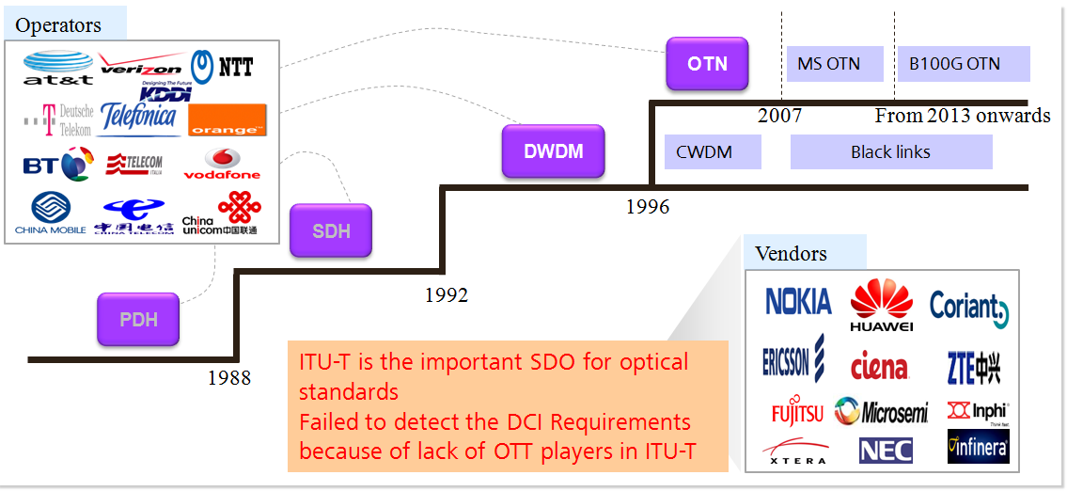

Figure 1 **An overview: Optical Transport Standards in ITU-T**

Currently, OTT players are very eager and active to deploy their own network infrastructure to provide better experiences to their customers, and have begun to extensively adopt optical, WDM, TDM technologies, so it generates more and more standards needs. However, it seems that ITU-T has not yet identified DCI as a strategic vantage point and developed a set of useful standards correspondingly because of requirements, due to a lack of OTT players’ active participation in ITU-T.

We think that the Challenges for ITU-T will be more open, to gain trust from vertical industries and OTT, to build up technical competence and capabilities. We think that OTT related studies in ITU include the following ways.

**Aspect One is about s**tudy of OTT’s business and services models in relation to telecom services, and proposals to deal with OTT using regulatory and other tools from a telecom’s perspective, and long-term study and more complex.

**Aspect Two** is about potential requirements from OTT for network technologies, and standards, and realistic and present, and mainly technical and little political considerations, and creation of business opportunities for the industry

We think that the challenges for ITU-T are to be more open, to gain trust from vertical industries and OTT, to build up technical competence and capabilities. We think that OTT-related studies in ITU-T should include the following ways.

In recognition of this very important issue, Huawei, at the ITU-T CTO Group held on 24th September 2017 in Busan, Korea, provided a contribution to promote an OTT and vertical industry- oriented standardization vision. It was well received and supported by other companies during the meeting and eventually led to a paragraph in the meeting’s communiqué:

***Participants recommended to ITU-T to engage with OTT and vertical sector organizations to identify, understand and respond to their networking requirements in a timely and accurate manner.***

At this TSAG meeting, Huawei wish to use the consensus achieved at the last year’s CTO Group meeting as a basis, to further promote the ideals of collaborating with OTT and vertical industries.

# Discussion

1. Data Center Interconnection is a fast growing market

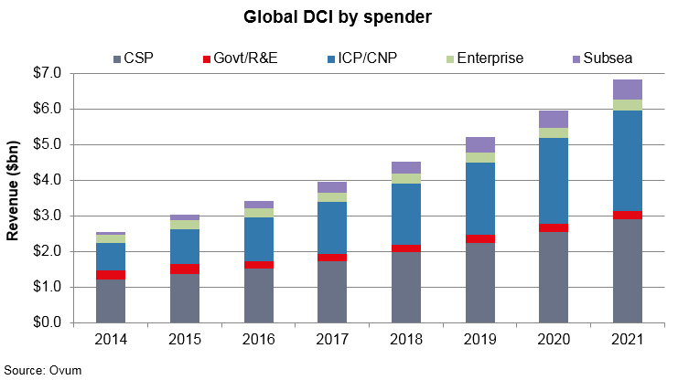

Figure 2 Global DCI by spender

From the Figure 2, we can see that DCI is an area of great importance and values for both vertical industries and OTT. In addition, the key requirements of DCI network include short distance, large bandwidth, low-cost optical (WDM) technology.

1. **Optical industry is changing**

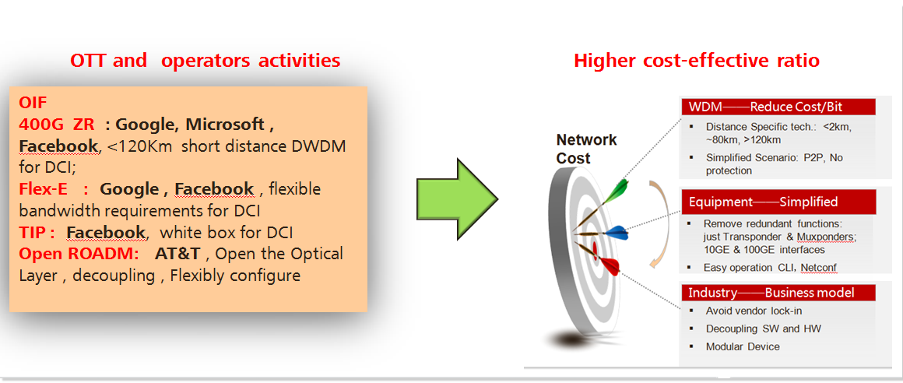

Figure 3 Optical industry change

We note the following changes:

* OTTs are taking various measures to reduce network costs because of the exponential bandwidth growth.
* WDM technologies, equipment and even business model are changing under OTTs’ driving.
* OTT and operators are turning to OIF for optical interface related standards and are forming MSAs like Open ROADM to develop optical network equipment specifications

As a natural consequence of OTT’s efforts to reduce the costs associated with underlying network equipment, some tendencies such as pursuit of white-label/white-box devices will have increasing impacts on the current standards and eco-systems. In seeking a win-win equilibrium, there must be some appropriate balance between technical functions/performances and costs, and such a balance should be well addressed in standards.

1. **Inter-organization collaboration and synergy for a healthy eco-system**

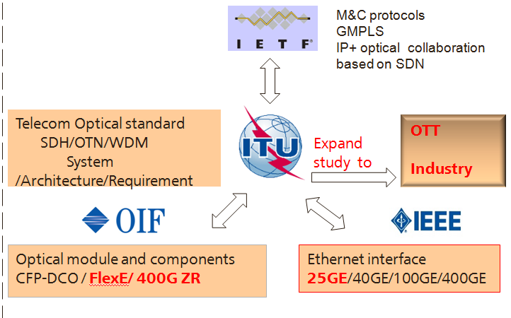

Figure 4 SDOs collaboration

As an important SDO for telecom standards, ITU-T should seek to play a more active role in standard and industry promotion, making itself as the leader in making use of the telecom standards to OTT and vertical industries.

# Proposal

Based on the previous analysis, we would like to set forth the following proposals for consideration:

1. As an important standards organization, ITU-T TSAG and TSB needs to consider how to absorb OTT and vertical industry players to join ITU-T network standards work by winning their trust.
   1. It’s proposed that ITU-T need to cope with the fixed network, especially optical network, industry changes driven by OTT.
   2. The standards process in ITU-T should be more agile to respond quickly to the emerging requirements from OTT, vertical industry, and telecom industry as well.
   3. Some studies are needed both in SGs and TSAG to ensure an understanding of how the standards governing underlying network equipment can achieve a good balance between technical functions/performances and costs which will help the industry eco-system to attain a win-win equilibrium.
2. ITU-T TSAG needs to consider how to achieve collaboration and synergy with other SDOs such as OIF, IETF, IEEE, BBF, ETSI and etc, on the standardization for OTT and vertical industries. Some suggestions are provided for discussion:
   1. In the beginning, a seminar/workshop on this topic may be a good way to achieve deep mutual understanding.
   2. Secondly, developing some strategies to induce the requirements work from other organizations with high participation level from OTT and/or vertical industries into ITU-T to aid our standardization work. (The seeds can be sowed somewhere else, the harvest is in ITU-T).
   3. Thirdly, ITU-T needs to be able to make agreements with other organizations about an appropriate and reasonable division of job: even if the requirements have not taken place in ITU-T, however, the technical standardization can still happen in ITU-T given our relative advantage and strength in this area.
3. ITU-T TSAG should consider how to arrange and collaboration the standards research works within ITU-T for OTT and vertical industry,
   1. Based on the current division of responsibilities, SG15 is the most appropriate place for developing optical communications technologies standards. However, since SG3 is also involved in OTT related services and policy studies, and SG20 in vertical industries related studies, a comprehensive understanding of who have been doing what is needed to create an effective synergy. New work is expected to be focused on blank areas and to avoid overlapping and duplication as much as possible.
   2. ITU-T SG15 could be the initial study group to launch new study work to expand its optical standards scope to cover not only Long Haul, but also DCI/Metro and include optical components, optical modules, etc., to meet more emerging requirements from OTT.

_______________________