|  |  |  |  |  |  |
| --- | --- | --- | --- | --- | --- |
| ITU logo | INTERNATIONAL TELECOMMUNICATION UNION  **TELECOMMUNICATION STANDARDIZATION SECTOR**  STUDY PERIOD 2017-2020 | | | TSAG-C030 | |
| **TSAG** | |
| **Original: English** | |
| **Question(s):** | | N/A | | Geneva, 26 February-2 March 2018 | |
| **CONTRIBUTION** | | | | | |
| **Source:** | | | Côte d’Ivoire, Togo, Zambia, Zimbabwe, Guinea, Sierra Leone, Senegal, Gambia, Mali, Burkina Faso, Sudan, Rwanda, Democratic Republic of Congo, Comoros, Madagascar, Niger, Nigeria, Sao Tome e Principe | | |
| **Title:** | | | The importance of ITU-T Regional Groups in Bridging the Standardization Gap | | |
| **Purpose:** | | | Proposal | | |
| **Contact:** | | | Hilda Mutseyekwa  PORTAZ  Zimbabwe | | Email: [hilda.mutseyekwa@potraz.gov.zw](mailto:hilda.mutseyekwa@potraz.gov.zw) |
| **Contact:** | | | Lancine Fofana ARTCI  Côte d'Ivoire | | Email: [fofana.lancine@artci.ci](mailto:fofana.lancine@artci.ci) |
| **Contact:** | | | Lwando Bbuku ZICTA  Zambia | | Email: [lbbuku@zicta.zm](mailto:lbbuku@zicta.zm) |
| **Contact:** | | | Steven Zikpi ARTP  Togo | | Email: [szikpi@artp.tg](mailto:szikpi@artp.tg) |

|  |  |
| --- | --- |
| **Keywords:** | WTSA-16 Resolution 44 |

**Introduction**

We have noted with significant concern that during several ITU meetings, comments were made by some members about the existence and working methods of regional groups. These comments criticized, e.g. the fact that some MS are not part of a regional group. On this point, we would like to note that regional groups can be created for regions at any time and for specific study groups. SG3 has 6 such RGs and has been a pioneer upon whose example other SGs have formed regional groups.

From our experience as an African Region, we have seen how the work in the regional groups helps exchange views, determine regional priorities and build consensus for the overall success of the parent meeting. And it must be noted that this is being done in all regions of the world be it in such formal ways through ITU or other mechanisms such as regional organizations or informal collaboration. All these means should be encouraged by TSAG and different ITU bodies.

In the current fast-paced technological environment we live in, it is important to maximize the opportunities to collaborate and build consensus from the grassroots up - otherwise the risk is that we will only reach consensus after a particular trend has passed and the technology has moved on. Regional groups of ITU-T SG3 for example enabled wider participation in decision-making. SG3 parent meeting received written contributions from more than 70 Members to make it the most diverse Group in ITU-T.

**Role of ITU-T Regional Groups**

Regional Groups within ITU-T Study Groups have proven effective mechanisms to assist in bridging the standardization gap by stimulating effective participation in ITU-T Study Groups and increasing the number and quality of contributions from developing countries that could eventually lead to standards.

The ITU-T SG3 Regional Group for Africa (SG3 RG-AFR) has been very active in shaping international standardization-making through notably the exponential rise in the number and quality of written contributions from African members to Study Group 3 parent meetings in Geneva. Many of the recent standards approved, or currently being discussed, in SG3 were initially proposed and/or discussed at the SG3 regional group for Africa.

It is also important to note that ITU-T SG3 Regional Group for Africa (SG3 RG-AFR) was one of the first Regional Groups that was created in 1968 by the IVth Plenary Assembly of the CITT together with the Regional Groups for Latin America, Asia and Europe.



.

**Bridging the Standardization efforts**

The close collaboration between the Management team of the Regional group and TSB secretariat for SG3 enabled the implementation of BSG activities. Since the Sao Tome and Principe meeting, interactive hands-on session delivered by the Counsellor on working methods, drafting and presenting contribution have been implemented together with one-to-one coaching sessions. These efforts combined with a new Regional model for effective participation led to an exponential growth of the quantity of contributions as shown in the figure below.

The participation in the SG3RG-AFR has also reached an unprecedented level of more than 100 participants from more than 20 countries.

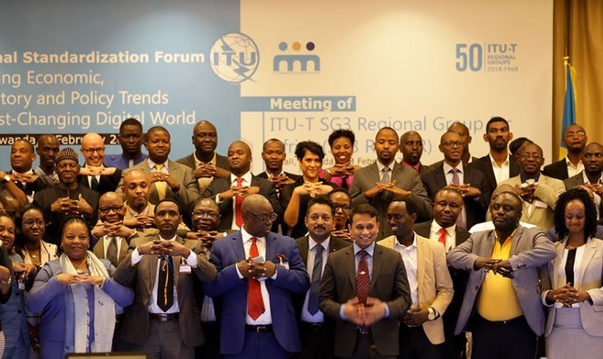

These innovative BSG efforts generalised to other Regional Groups of SG3 have shown similar significant impact. These efforts carried over the past 4 years enabled SG3 to become the most diverse group in ITU-T and to play its role of strengthening the ties between technology, business and policy

**Proposal**

Members States above propose to TSAG to invite Chairmen of ITU-T Study Groups to disseminate information i.e. TDs to their respective SG members on the history and importance of Regional Groups in Bridging the Standardization Gap.

Furthermore, Member States above request TSAG to recognize the unique nature of the pioneer regional groups of ITU-T SG3, in term of their long history, size diversity, effective participation and ensure the allocation of appropriate/ proportionate support and resources. It is important to acknowledge that the success of SG3 RG under Res. 26 led to the genesis and the evolution of WTSA Resolutions 54 and 44.

Member States above also support [C25](https://www.itu.int/md/T17-TSAG-C-0025/en) to this TSAG meeting mainly the creation of BSG Regional and sub regional Hubs.

__________________