|  |  |  |  |  |  |
| --- | --- | --- | --- | --- | --- |
| ITU Logo | INTERNATIONAL TELECOMMUNICATION UNION  **TELECOMMUNICATION STANDARDIZATION SECTOR**  STUDY PERIOD 2017-2020 | | TSAG-C.12 | | |
| **TSAG** | | |
| **Original: English** | | |
| **Question(s):** | | N/A | | Geneva, 1-4 May 2017 | |
| **CONTRIBUTION** | | | | | |
| **Source:** | | Japan | | | |
| **Title:** | | “Society 5.0” | | | |
| **Purpose:** | | Proposal | | | |
| **Contact:** | | Yuki Naruse Ministry of Internal Affairs and Communications Japan | | | Tel: +81-3-5253-5770 Email: [y.naruse@soumu.go.jp](mailto:y.naruse@soumu.go.jp) |

|  |  |
| --- | --- |
| **Keywords:** | Standardization Strategy, RG-SS, Society 5.0 |
| **Abstract:** | This contribution suggests Rapporteur Group on Standardization Strategy (RG-SS) established by TSAG to take account of Member States’ national plans and other SDOs’ plans when developing ITU-T’s standardization strategy. As for Japan, the government has created the 5th Science and Technology Basic Plan and sets “Super Smart Society (Society 5.0)” as its goal, which will be described in the contribution. |

**1. Introduction**

TSAG has established Rapporteur Group on Standardization Strategy (RG-SS) whose Terms of Reference includes development of standardization strategy. The Japanese government has created the 5th Science and Technology Basic Plan, a comprehensive plan to promote science and technology in Japan over a five-year term (FY2016 to FY2020) and sets the realization of “Super Smart Society (in which we have named “Society 5.0”)” as its goal. We believe that this will be of interest to our ITU-T members, and in order to achieve this goal, Japan is very much interested in the development of standardization strategy in ITU-T.

**2. Society 5.0**

The 5th Science and Technology Basic Plan, a comprehensive plan to promote science and technology in Japan over a five-year term (FY2016 to FY2020) adopted by the Cabinet in January 2016, aims to realize a future society “Society 5.0”. The Society 5.0 makes the most of ICTs to facilitate human prosperity.

Society 5.0 is following on from hunting-and-gathering society, agrarian society, industrial society, and information-oriented society, “Society 5.0” refers to a new social mode of production which:

1) brings about a humancentric society in which people can lead high-quality lives full of comfort and vitality,

2) by realizing the advanced fusion of cyberspace and physical space,

3) and by providing goods and services that granularly address manifold latent needs regardless of locale, age, sex, language, or any other consideration, to balance economic advancement with the resolution of social problems.

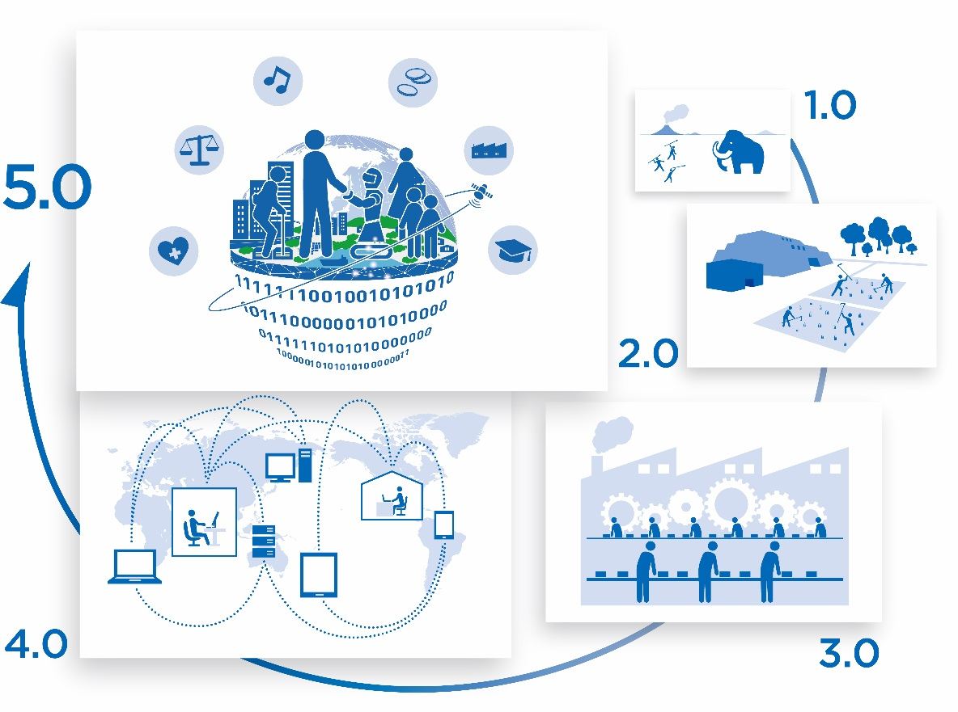

Society 5.0

Society 5.0 contributes to achieve the Sustainable Development Goals (SDGs) such as “good health & well-being” and “work & economic growth” and links to the development of standardization strategy of ITU-T.

(For further details, please refer to the following website: <http://www8.cao.go.jp/cstp/english/basic/5thbasicplan_outline.pdf>)

**3. Conclusion**

We believe that the creation of RG-SS by TSAG is important, and Japan suggests RG-SS to take account of Member States’ national plans and other SDOs’ plans in existence, in the part related to the mandate of ITU-T, when developing ITU-T’s standardization strategy.

_______________________