 |  | International telecommunication union  Telecommunication Standardization Bureau
 |  |  | Geneva, 04 August 2021
Ref: | Addendum 1 to TSB Collective letter 12/20  SG20/CB |  | - To Administrations of Member States of the Union;  - To ITU-T Sector Members;  - To ITU-T Associates of Study Group 20;  - To ITU Academia
Tel: | +41 22 730 6301
Fax: | +41 22 730 5853
Email: | tsbsg20@itu.int
Web: | https://www.itu.int/go/tsg20
Subject: | Joint ITU-T SG5 and ITU-T SG20 Newcomers’ session
Dear Sir/Madam,
In addition to TSB Collective letter 12/20 of 06 July 2021, please find herewith additional information pertaining to a change of date for the Newcomers’ session.
- The newcomers’ session will be jointly organized with ITU-T Study Group 5 and will take place virtually on 27 September 2021 from 1100 to 1300 hours, Geneva Time. Please find more information available at: https://www.itu.int/en/ITU-T/studygroups/2017-2020/20/Pages/newcomers-session/202110.aspx.

I wish you productive and enjoyable meetings.
Yours faithfully,  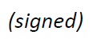  Chaesub Lee  Director of the Telecommunication  Standardization Bureau | 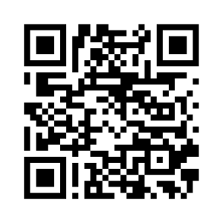
 | Latest meeting information

