Union internationale des télécommunications
Bureau de la Normalisation des Télécommunications

Genève, le 21 juillet 2017

Réf.: | Lettre collective TSB 2/16 | – Aux administrations des Etats Membres de l'Union;  – aux Membres du Secteur UIT-T;  – aux Associés de l'UIT-T participant aux travaux de la Commission d'études 16;  –aux établissements universitaires participant aux travaux de l'UIT
Tél.: | +41 22 730 6805
Fax:  E-mail:  Web: | +41 22 730 5853  tsbsg16@itu.int  http://itu.int/go/tsg16
Objet: | Réunion de la Commission d'études 16; Macao (Chine), 16-27 octobre 2017
Madame, Monsieur,
J'ai l'honneur de vous informer que la Commission d'études 16 (Codage, systèmes et applications multimédias) se réunira à Macao (Chine), du 16 au 27 octobre 2017 inclus, à l'aimable invitation de la Macao Convention and Exhibition Association de la République populaire de Chine.
Plusieurs autres réunions se tiendront en parallèle au cours de cette période, notamment celles des Groupes JCT-VC et JVET, ISO/CEI JTC1 SC29 WG 1 (JPEG) et WG 11 (MPEG), et de la JCA sur les aspects multimédias des cyberservices. Il convient de noter que l'inscription à chacune de ces réunions s'effectuera séparément de l'inscription à la réunion de la Commission d'études 16.
Je tiens à vous informer que la réunion s'ouvrira à 11 h 15 le premier jour. L'enregistrement des participants débutera à 8 h 30 à l'entrée du lieu de la réunion. Les précisions relatives aux salles de réunion seront communiquées via la liste de diffusion de la CE 16 et seront affichées sur place par l'organisme hôte. Des renseignements complémentaires sur la réunion sont donnés à l'Annexe A, et des informations d'ordre pratique figurent dans l'Annexe D. En plus de ces informations, l'organisme hôte a conçu un site web pour aider les délégués dans leur préparation en vue de cette réunion (http://itutsg16.medmeeting.org).
Le projet d'ordre du jour et le projet de programme de travail de la réunion, établis en accord avec le Président (M. Noah Luo, République populaire de Chine) et l'équipe de direction de la Commission d'études 16, figurent respectivement dans les Annexes B et C.
Des mini-ateliers pourront être organisés pendant la réunion de la CE 16, par exemple sur les services en immersion. Des précisions supplémentaires seront données sur le site web de la CE 16 (http://itu.int/go/tsg16).

Je vous souhaite une réunion constructive et agréable.
Veuillez agréer, Madame, Monsieur, l'assurance de ma considération distinguée.

Chaesub Lee  Directeur du Bureau de la normalisation  des télécommunications  Annexes: 4 | 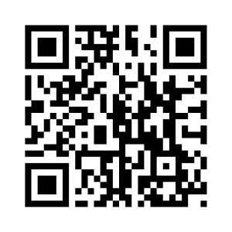 CE 16 de l'UIT-T
 | Informations les plus récentes concernant la réunion

ANNEXE A
PRÉSENTATION DES CONTRIBUTIONS
DÉLAI DE SOUMISSION DES CONTRIBUTIONS: Le délai de soumission des contributions est de 12 jours calendaires avant la réunion. Ces contributions, qui seront publiées sur le site web de la Commission d'études 16, doivent donc parvenir au TSB le 3 octobre 2017 au plus tard. Les contributions reçues au moins deux mois avant le début de la réunion pourront être traduites, si la demande en est faite.
POSTAGE DIRECT/SOUMISSION DES DOCUMENTS: Il existe un système de postage direct des contributions en ligne. Le système permet aux Membres de l'UIT-T de réserver des numéros de contribution et de transférer/réviser leurs contributions directement sur le serveur de l'UIT-T. Vous trouverez de plus amples informations et des indications sur le système de postage direct à l'adresse: http://itu.int/net/ITU-T/ddp/.
GABARITS: Pour élaborer les documents que vous soumettrez à la réunion, veuillez utiliser l'ensemble de gabarits (templates) mis à votre disposition. Ces gabarits sont accessibles sur la page web de chaque Commission d'études de l'UIT-T, sous "Delegate resources" (http://itu.int/ITU-T/studygroups/templates). Le nom de la personne à contacter au sujet de la contribution, ses numéros de télécopie et de téléphone ainsi que son adresse électronique doivent figurer sur la page de couverture de tous les documents.
MÉTHODES DE TRAVAIL ET INSTALLATIONS
INTERPRÉTATION: Comme convenu avec l'équipe de direction de la CE 16 de l'UIT-T, cette réunion se tiendra en anglais seulement.
RÉUNIONS SANS DOCUMENT PAPIER: La réunion se déroulera sans document papier.
Des équipements de RÉSEAU LOCAL SANS FIL (WLAN) seront à la disposition des délégués sur place.
IMPRIMANTES: Des imprimantes seront mises sur place à la disposition des délégués.
INSCRIPTION et BOURSES
INSCRIPTION: Afin de permettre à l'organisme hôte de prendre les dispositions nécessaires, veuillez faire parvenir par lettre, par télécopie (+41 22 730 5853) ou par courrier électronique (tsbreg@itu.int) au plus tard le 16 septembre 2017, la liste des personnes qui représenteront votre Administration, Membre de Secteur, Associé, établissement universitaire, organisation régionale et/ou internationale ou autre entité. Les Administrations sont invitées à indiquer également le nom du Chef de délégation (et du Chef adjoint, le cas échant).
Veuillez noter que l'inscription préalable des participants aux réunions de l'UIT-T se fait en ligne sur le site web de la CE 16 de l'UIT-T.
BOURSES: Nous avons le plaisir de vous informer que deux bourses partielles par administration peuvent être accordées, en fonction des ressources financières disponibles, afin de faciliter la participation des pays les moins avancés ou des pays à faible revenu. Veuillez noter en outre que lorsque deux (2) bourses partielles sont demandées, l'une au moins doit être sollicitée pour un billet d'avion en classe économique. Toute demande de bourse doit être agréée par l'administration concernée de l'Etat Membre de l'UIT. Les demandes de bourses (établies à l'aide du Formulaire 1 ci-joint) doivent être retournées à l'UIT au plus le 4 septembre 2017. Veuillez noter que les critères sur la base desquels il est décidé d'attribuer une bourse sont les suivants: budget disponible au TSB; contributions fournies à la réunion par le demandeur; répartition équitable entre les pays et les régions; enfin, parité hommes-femmes. L'inscription préalable à la réunion est obligatoire.
PRINCIPALES ÉCHÉANCES (avant la réunion)
Deux mois avant la réunion: | 16/08/2017 | – soumission des contributions dont la traduction est demandée  – demandes de commodités d'accessibilité  – demandes de lettre pour faciliter l'obtention du visa
Six semaines avant la réunion: | 04/09/2017 | – demandes de bourses
Un mois avant la réunion: | 16/09/2017 | – inscription préalable (en ligne depuis la page d'accueil de la commission d'études)
12 jours calendaires avant la réunion: | 03/10/2017 | – dernier délai pour la soumission des contributions

FORM 1 - FELLOWSHIP REQUEST

Meeting of ITU-T Study Group 16
(Macao, China, 16-27 October 2017)
Request for one partial fellowship
(Submission deadline: 4 September 2017)
Please return completed form, preferably by email, to:  ITU Fellowships, Geneva (Switzerland) |  |  | E-mail: fellowships@itu.int  Tel: +41 22 730 5227  Fax: +41 22 730 5778
Applications from women are encouraged
Registration number (required):
(Pre-registration is online only)
Title(s) of contributions submitted/planned:
Country (list of eligible countries):
Name of the Administration/Organization:
Professional role/title:
Mr/Mrs/Ms:
Applicant’s family name:
Applicant’s given name:
Address:
Telephone:
Fax:
Email:
Passport number:
Date and place of issue:
Passport valid until (date):
Nationality:
Date of birth:
Please select your preferred fellowship type (one only),
which ITU will do its best to accommodate:
☐ Economy class air ticket (duty station -> Macao -> duty station)
☐ Subsistence allowance intended to cover accommodation, meals & misc. expenses
Signature of applicant: |  |  |  | Date:
TO VALIDATE THIS FELLOWSHIP REQUEST, THE NAME, TITLE AND SIGNATURE OF THE CERTIFYING OFFICIAL DESIGNATING THE PARTICIPANT MUST BE COMPLETED BELOW, ALONG WITH AN OFFICIAL STAMP.
N.B. IT IS IMPERATIVE THAT FELLOWS BE PRESENT FROM THE FIRST TO THE LAST DAY OF THE MEETING.
Signature and stamp  of certifying official: |  |  |  | Date:

ANNEX B
Draft agenda

Opening of meeting, meeting agenda and documentation
Status of texts consented, agreed, deleted and current list of Implementors guides
Approval of previous SG16 meeting report (SG16-R1 to R4)
Feedback and status reports on interim activities and collaboration matters (inter alia ITU-T SG9, ITU-T SG12, IETF, IEC TC100, ISO/IEC JTC1/SC 29/WGs 1 & 11, CITS)
Promotion activities and workshops of interest to SG16
Objectives for this meeting
Guidelines for the meeting of Working Parties and of Plenary Question
IPR Roll call
Review and approval of meeting results, including update of SG16 work programme
Future work
Date and place of the next meeting of SG16
Miscellaneous
Closing of the meeting

ANNEX C
Draft Timetable of SG16 meeting (Macao, China, 16-27 October 2017)

Notes:
"P" stands for plenary.
Question 1/16, which is allocated to the Plenary, will have sessions as needed during the meeting.
The Joint Collaborative Team on Video Coding (JCT-VC) is tentatively planned to meet also during the weekend. See http://itu.int/go/jctvc for final dates and other details. Sessions of the related but separate informal Joint Video Experts Team (JVET) between ITU-T Q6/16 and ISO/IEC JTC1 SC29/WG11 (MPEG) is expected to start meeting on Wed 18 October 2017, further details will be announced in the Q6/16 mailing list.
For schedule updates, please see: http://itu.int/go/tsg16.

ANNEX D
Practical information
(Please see an updated version of this practical information on the SG16 website.)
- Meeting Venue
Venue: Holiday Inn Macao Cotai Central
Address: Level 4, Holiday Inn Macao Cotai Central
Sands Cotai Central,
Cotai Strip, Macao, China
Tel: +853 2828 2228
Website: https://www.sandscotaicentral.com/offers/holiday-inn-macao.html
Conference Venue Floor Plan
https://www.sandscotaicentral.com/content/dam/macao/sandscotaicentral/master/main/home/meetings/floorplans-charts/holidayInn-factsheet-stay-connected_en.pdf
- Hotels
A block of rooms at preferential prices has been made at the conference hotel:
Holiday Inn Macao Cotai Central
Address: Sands Cotai Central, Cotai Strip, Macao, China
Tel: +853 2828 2228
Hotel Booking System: http://itutsg16.medmeeting.org/
Hotel reservations will be carried out through the online system above.
Delegates can walk between the hotel and the meeting venue, which only takes less than one minute. Further details will be provided shortly in the logistics information document on the conference website.
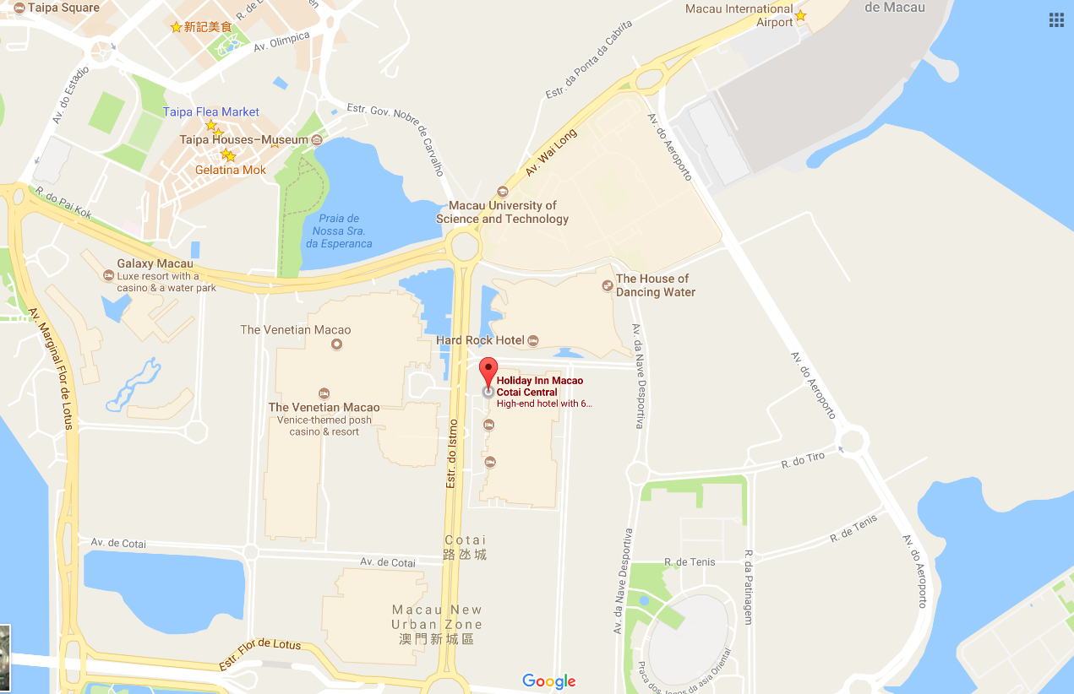
- Passports and Visas
Non-residents of the Macao Special Administrative Region are required to possess a valid passport and "entry permit" or "visa" for entry to Macao, except for people prescribed by certain law, administrative regulation or international law document.
3.1 DO I NEED A VISA?
Visit: http://www.fsm.gov.mo/psp/eng/EDoN.html to find out whether you need a visa or not.
- Macao is either visa free or visa-upon-arrival for most countries.
- Only visitors from Bangladesh, Nepal, Nigeria, Pakistan, Sri Lanka and Vietnam are required to apply for a Macao visa in advance through a Chinese embassy or consulate.
- Visitors from mainland China can apply for a Hong Kong Macao Entry Permit to travel to Macao for up to seven days at your local Immigration Authority/Police Bureau. If you need a business visa to stay at Macao for more than seven days, please contact the Conference Secretariat to issue you an invitation letter no later than September 22.
3.2 INVITATION LETTER
If you need a letter of invitation, please fill out the invitation letter form available at the following URL and send it as early as possible with a copy of your travel document by e-mail to Conference Secretariat at itutsg16macau@gmail.com, in order to leave plenty of time to process the application. To receive an invitation letter, requests should be submitted before 16 August 2017.
Invitation letter form: https://www.medmeeting.org/Upload/user/785821/file/20170715/‌20170715122804_8527.pdf
- Transportation and site information
How to get to Macao:
4.1 By air
- Helicopters
East Asia Airlines and Heli Express Limited co-operates aircraft between the helipads on the Macao and Hong Kong Ferry terminal (Outer Harbour Ferry Terminal).
Hotline:
Macao (853) 2872 7288
Hong Kong (852) 2108-9898
Shenzhen: (86) 755-2777-8333
Website: www.heliexpress.com
- Aircraft (Via Macao International Airport)
The airport is located on Taipa Island and is 15 minutes away from the Macao Ferry Terminal, 20 minutes from the Barrier Gate and only 10 minutes away from the COTAI Frontier Post. It operates 24 hours a day.
Hotline
Macao: (853) 2886 111
Website: www.macao-airport.com
There are approximately a dozen and a half companies flying to and from Macao, connecting to several cities in Mainland China, Korea (Rep. of) and Southeast Asia. For more information on immigration and customs formalities, please visit www.fsm.gov.mo.
4.2 By sea (via Hong Kong International Airport)
- To and from Hong Kong
Tourists can find quite a number of jetfoils and Catamarans available, run by TurboJET or First Ferry, which differ in speed, comfort and price.
- TurboJET
Hotline
Macao : (853) 87907039
Hong Kong: (852) 28593333
Shenzhen: (86) (755) 2777 6818
Website: www.turbojet.com.hk
- First Ferry
Hotline
Macao: (853) 2872 6301
Hong Kong: (852) 2131-8181
Website: www.nwff.com.hk
- Cotai Chu Kong Shipping Management Services Co., Ltd
Hotline
Macao: (853) 2885 0595
Hong Kong: (852) 2359 9990
Website: http://www.cotaiwaterjet.com/index.html
The above information is for reference only. For more information, please visit http://www.macaotourism.gov.mo.

5. Local information
5.1 Currency exchange
The Pataca (MOP) is Macao’s official currency. The exchange rate is MOP103.20 = HKD100.00. There is an acceptable variation up to 10%. Roughly 8 Patacas is equivalent to 1 US Dollar. Please check the currency exchange rate in the local bank system or use the following link as a reference: http://www.xe.com.

5.2 Climate
Annual average temperature is about 23ºC (73ºF) and ranges from 20ºC (68ºF) to 26ºC (79ºF). Humidity levels are high in the city, where the average annual relative humidity tops 79%. October to December is the most pleasant season to visit Macao, when visitors can enjoy warm autumn days with low humidity.

5.3 Time Zone: GMT+8:00

5.4 Electricity
The electricity in Macao is generally 220V, 50Hz. Please make sure you have the proper adapter.

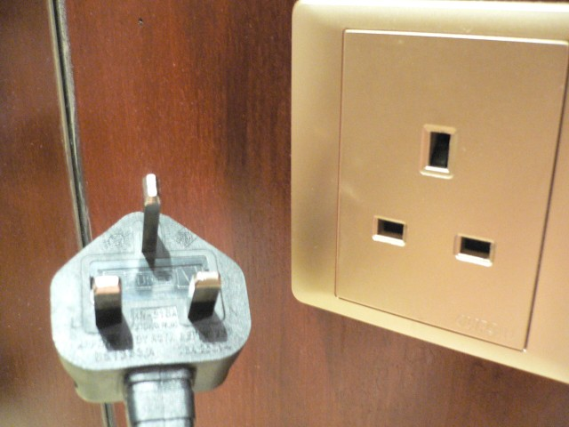

5.5 Emergency Numbers: In case of emergency, please dial 999/110/112.

5.6 Nearest Hospital
University Hospital
Block H, Macao University of Science and Technology, Avenida Wai Long, Taipa, Macao
Tel: (853) 28821838
Fax: (853) 28821788
E-mail: hospital_enquiry@must.edu.mo

5.7 If you have any questions about the meeting arrangements, please contact (preferably by e-mail) the local contact person:
Conference Manager
Mr Andrew Jiang
Macao Convention & Exhibition Association
Tel: +853 2871 5616
Fax: +853 2871 5606
E-mail: itutsg16macau@gmail.com
Conference Website: http://itutsg16.medmeeting.org/en

__________________

