International telecommunication union
Telecommunication Standardization Bureau
 |  |  | Geneva, 21 July 2017
Ref: | TSB Collective letter 2/16 |  | - To Administrations of Member States of the Union;  - To ITU-T Sector Members;  - To ITU-T SG 16 Associates;  - To ITU Academia
Tel: | +41 22 730 6805
Fax: | +41 22 730 5853
Email: | tsbsg16@itu.int
Web: | http://itu.int/go/tsg16
Subject: | Meeting of Study Group 16; Macao, China, 16-27 October 2017
Dear Sir/Madam,
It is my pleasure to inform you that Study Group 16 (Multimedia coding, systems and applications) will meet in Macao, China from 16 to 27 October 2017 inclusive, at the kind invitation of the Macao Convention and Exhibition Association of the People’s Republic of China.
Several other meetings will be collocated during the period, in particular JCT-VC and JVET, ISO/IEC JTC1 SC29 WG1 (JPEG) and WG11 (MPEG), as well as the JCA on multimedia aspects of e-services. It should be noted that registration for each of these events is separate from that of Study Group 16.
I should like to inform you that the meeting will open at 1115 hours on the first day. Participant registration will begin at 0830 hours at the venue entrance. Detailed information concerning the meeting rooms will be circulated via the SG16 e-mail list and displayed onsite by the host. Additional information about the meeting is set forth in Annex A, while practical information can be found in Annex D. In addition to the information in this Annex, the host has kindly prepared a website to help delegates prepare for this meeting: please see http://itutsg16.medmeeting.org.
The draft Agenda of the meeting and the draft Timetable, prepared in agreement with the Chairman of Study Group 16 (Mr Noah Luo, People’s Republic of China) and its management team, are set out in Annexes B and C, respectively.
Mini-workshops may be planned during the SG16 meeting, for example on immersive services. Further details will be provided in the SG16 website (http://itu.int/go/tsg16).
I wish you a productive and enjoyable meeting.

Yours faithfully,  Chaesub Lee  Director of the Telecommunication  Standardization Bureau | 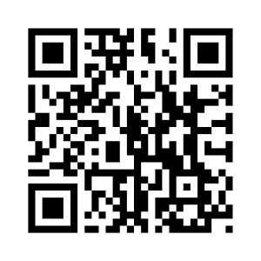ITU-T SG16
 | Latest meeting information
Annexes: 4
ANNEX A
MAKING CONTRIBUTIONS
DEADLINE FOR CONTRIBUTIONS: The deadline for contributions is 12 calendar days before the meeting. Such contributions will be published on the Study Group 16 website and must therefore be received by TSB not later than 3 October 2017. Contributions received at least two months before the start of the meeting may be translated, if requested.
DIRECT POSTING/DOCUMENT SUBMISSION: A direct posting system for contributions is available
online. The direct posting system allows ITU-T members to reserve contribution numbers and to upload/revise contributions directly to the ITU-T web server. Further information and guidelines for the direct posting system are available at the following address: http://itu.int/net/ITU-T/ddp/.
TEMPLATES: Please use the provided set of templates to prepare your meeting documents. The templates are accessible from each ITU-T study group web page, under “Delegate resources” (http://itu.int/ITU-T/studygroups/templates). The name, fax and telephone numbers and e-mail address of the person to be contacted about the contribution should be indicated on the cover page of all documents.
WORK METHODS AND FACILITIES
INTERPRETATION: As per agreement of the ITU-T SG16 management team, this meeting will be held in English only.
PAPERLESS MEETINGS: The meeting will be run paperless.
WIRELESS LAN facilities will be available for use by delegates at the venue.
PRINTERS: Printers will be made available to the delegates at the venue of the event.
REGISTRATION and FELLOWSHIPS
REGISTRATION: To enable the Host to make the necessary arrangements, please send by letter, fax (+41 22 730 5853), or e-mail (tsbreg@itu.int), not later than 16 September 2017, the list of people who will be representing your Administration, Sector Member, Associate, Academic Institution, regional and/or international organization, or other entity. Administrations are requested also to indicate the name of their head of delegation (and deputy head, if applicable).
Please note that pre-registration of participants for ITU-T meetings is carried out online on the ITU-T SG16 website.
FELLOWSHIPS: We are pleased to inform you that two partial fellowships per administration may be awarded, subject to available funding, to facilitate participation from Least Developed or Low Income Countries. Please further note that when two (2) partial fellowships are requested, at least one must be an economy class air ticket. An application for a fellowship must be authorized by the relevant Administration of the ITU Member State. Fellowship requests (please use enclosed Form 1) must be returned to ITU not later than 4 September 2017. Please note that the decision criteria to grant a fellowship include: the available TSB budget, contributions by the applicant to the meeting, equitable distribution among countries and regions, and gender balance. Pre-registration for the meeting is mandatory.

KEY DEADLINES (before meeting)
Two months | 2017-08-16 | - submit contributions for which translation is requested  - requests for accessibility accommodations  - requests for visa support letters
Six weeks | 2017-09-04 | - fellowship requests
One month | 2017-09-16 | - pre-registration (online via the study group homepage)
12 calendar days | 2017-10-03 | - final deadline for contributions

FORM 1 - FELLOWSHIP REQUEST

Meeting of ITU-T Study Group 16
(Macao, China, 16-27 October 2017)
Request for one partial fellowship
(Submission deadline: 4 September 2017)
Please return completed form, preferably by email, to:  ITU Fellowships, Geneva (Switzerland) |  |  | E-mail: fellowships@itu.int  Tel: +41 22 730 5227  Fax: +41 22 730 5778
Applications from women are encouraged
Registration number (required):
(Pre-registration is online only)
Title(s) of contributions submitted/planned:
Country (list of eligible countries):
Name of the Administration/Organization:
Professional role/title:
Mr/Mrs/Ms:
Applicant’s family name:
Applicant’s given name:
Address:
Telephone:
Fax:
Email:
Passport number:
Date and place of issue:
Passport valid until (date):
Nationality:
Date of birth:
Please select your preferred fellowship type (one only),
which ITU will do its best to accommodate:
☐ Economy class air ticket (duty station -> Macao -> duty station)
☐ Subsistence allowance intended to cover accommodation, meals & misc. expenses
Signature of applicant: |  |  |  | Date:
TO VALIDATE THIS FELLOWSHIP REQUEST, THE NAME, TITLE AND SIGNATURE OF THE CERTIFYING OFFICIAL DESIGNATING THE PARTICIPANT MUST BE COMPLETED BELOW, ALONG WITH AN OFFICIAL STAMP.
N.B. IT IS IMPERATIVE THAT FELLOWS BE PRESENT FROM THE FIRST TO THE LAST DAY OF THE MEETING.
Signature and stamp  of certifying official: |  |  |  | Date:

ANNEX B
Draft agenda

Opening of meeting, meeting agenda and documentation
Status of texts consented, agreed, deleted and current list of Implementors guides
Approval of previous SG16 meeting report (SG16-R1 to R4)
Feedback and status reports on interim activities and collaboration matters (inter alia ITU-T SG9, ITU-T SG12, IETF, IEC TC100, ISO/IEC JTC1/SC 29/WGs 1 & 11, CITS)
Promotion activities and workshops of interest to SG16
Objectives for this meeting
Guidelines for the meeting of Working Parties and of Plenary Question
IPR Roll call
Review and approval of meeting results, including update of SG16 work programme
Future work
Date and place of the next meeting of SG16
Miscellaneous
Closing of the meeting

ANNEX C

Draft Timetable of SG16 meeting (Macao, China, 16-27 October 2017)

Notes:
"P" stands for plenary.
Question 1/16, which is allocated to the Plenary, will have sessions as needed during the meeting.
The Joint Collaborative Team on Video Coding (JCT-VC) is tentatively planned to meet also during the weekend. See http://itu.int/go/jctvc for final dates and other details. Sessions of the related but separate informal Joint Video Experts Team (JVET) between ITU-T Q6/16 and ISO/IEC JTC1 SC29/WG11 (MPEG) is expected to start meeting on Wed 18 October 2017, further details will be announced in the Q6/16 mailing list.
For schedule updates, please see: http://itu.int/go/tsg16.

ANNEX D
Practical information
(Please see an updated version of this practical information on the SG16 website.)

Meeting Venue
Venue: Holiday Inn Macao Cotai Central
Address: Level 4, Holiday Inn Macao Cotai Central
Sands Cotai Central,
Cotai Strip, Macao, China
Tel: +853 2828 2228
Website: https://www.sandscotaicentral.com/offers/holiday-inn-macao.html
Conference Venue Floor Plan
https://www.sandscotaicentral.com/content/dam/macao/sandscotaicentral/master/main/home/meetings/floorplans-charts/holidayInn-factsheet-stay-connected_en.pdf

Hotels
A block of rooms at preferential prices has been made at the conference hotel:
Holiday Inn Macao Cotai Central
Address: Sands Cotai Central, Cotai Strip, Macao, China
Tel: +853 2828 2228
Hotel Booking System: http://itutsg16.medmeeting.org/
Hotel reservations will be carried out through the online system above.
Delegates can walk between the hotel and the meeting venue, which only takes less than one minute. Further details will be provided shortly in the logistics information document on the conference website.
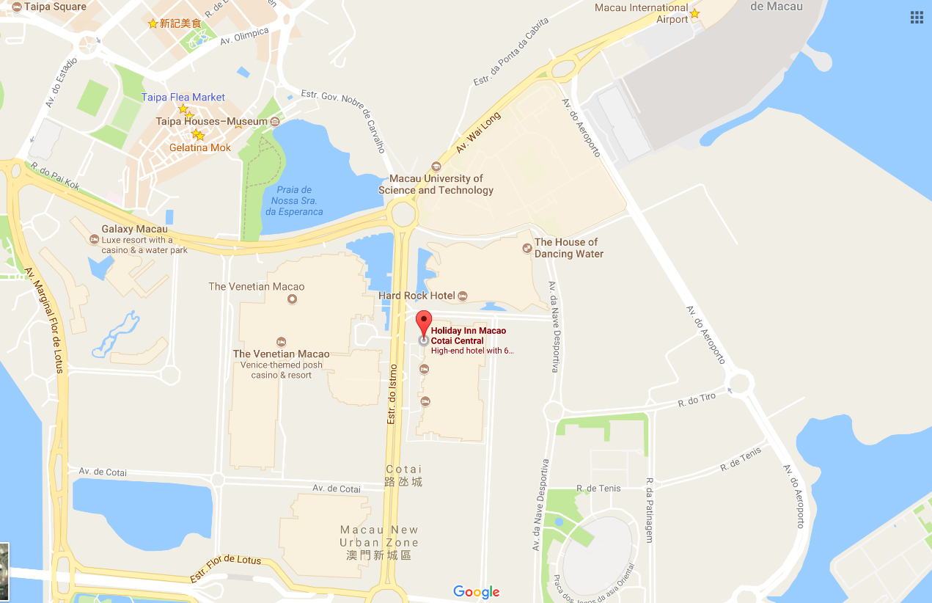

Passports and Visas
Non-residents of the Macao Special Administrative Region are required to possess a valid passport and "entry permit" or "visa" for entry to Macao, except for people prescribed by certain law, administrative regulation or international law document.
3.1 DO I NEED A VISA?
Visit: http://www.fsm.gov.mo/psp/eng/EDoN.html to find out whether you need a visa or not.
- Macao is either visa free or visa-upon-arrival for most countries.
- Only visitors from Bangladesh, Nepal, Nigeria, Pakistan, Sri Lanka and Vietnam are required to apply for a Macao visa in advance through a Chinese embassy or consulate.
- Visitors from mainland China can apply for a Hong Kong Macao Entry Permit to travel to Macao for up to seven days at your local Immigration Authority/Police Bureau. If you need a business visa to stay at Macao for more than seven days, please contact the Conference Secretariat to issue you an invitation letter no later than September 22.
3.2 INVITATION LETTER
If you need a letter of invitation, please fill out the invitation letter form available at the following URL and send it as early as possible with a copy of your travel document by e-mail to Conference Secretariat at itutsg16macao@gmail.com, in order to leave plenty of time to process the application. To receive an invitation letter, requests should be submitted before 16 August 2017.
Invitation letter form: https://www.medmeeting.org/Upload/user/785821/file/20170715/‌20170715122804_8527.pdf

Transportation and site information
How to get to Macao:
4.1 By air
- Helicopters
East Asia Airlines and Heli Express Limited co-operates aircraft between the helipads on the Macao and Hong Kong Ferry terminal (Outer Harbour Ferry Terminal).
Hotline:
Macao (853) 2872 7288
Hong Kong (852) 2108-9898
Shenzhen: (86) 755-2777-8333
Website: www.heliexpress.com
- Aircraft (Via Macao International Airport)
The airport is located on Taipa Island and is 15 minutes away from the Macao Ferry Terminal, 20 minutes from the Barrier Gate and only 10 minutes away from the COTAI Frontier Post. It operates 24 hours a day.
Hotline
Macao: (853) 2886 111
Website: www.macao-airport.com
There are approximately a dozen and a half companies flying to and from Macao, connecting to several cities in Mainland China, Korea (Rep. of) and Southeast Asia. For more information on immigration and customs formalities, please visit www.fsm.gov.mo.
4.2 By sea (via Hong Kong International Airport)
- To and from Hong Kong
Tourists can find quite a number of jetfoils and Catamarans available, run by TurboJET or First Ferry, which differ in speed, comfort and price.
- TurboJET
Hotline
Macao : (853) 87907039
Hong Kong: (852) 28593333
Shenzhen: (86) (755) 2777 6818
Website: www.turbojet.com.hk
- First Ferry
Hotline
Macao: (853) 2872 6301
Hong Kong: (852) 2131-8181
Website: www.nwff.com.hk
- Cotai Chu Kong Shipping Management Services Co., Ltd
Hotline
Macao: (853) 2885 0595
Hong Kong: (852) 2359 9990
Website: http://www.cotaiwaterjet.com/index.html
The above information is for reference only. For more information, please visit http://www.macaotourism.gov.mo.

5. Local information
5.1 Currency exchange
The Pataca (MOP) is Macao’s official currency. The exchange rate is MOP103.20 = HKD100.00. There is an acceptable variation up to 10%. Roughly 8 Patacas is equivalent to 1 US Dollar. Please check the currency exchange rate in the local bank system or use the following link as a reference: http://www.xe.com.

5.2 Climate
Annual average temperature is about 23ºC (73ºF) and ranges from 20ºC (68ºF) to 26ºC (79ºF). Humidity levels are high in the city, where the average annual relative humidity tops 79%. October to December is the most pleasant season to visit Macao, when visitors can enjoy warm autumn days with low humidity.

5.3 Time Zone: GMT+8:00

5.4 Electricity
The electricity in Macao is generally 220V, 50Hz. Please make sure you have the proper adapter.

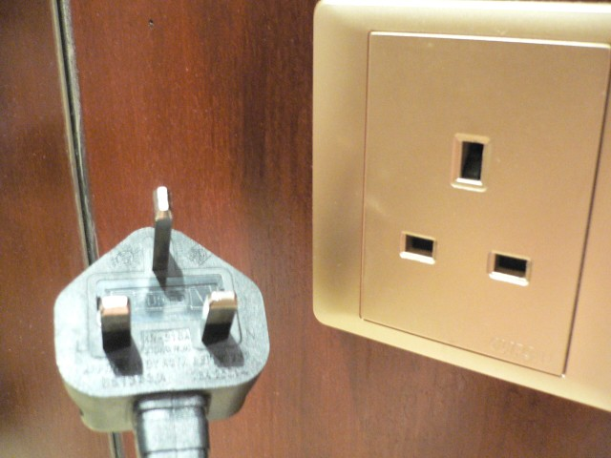

5.5 Emergency Numbers: In case of emergency, please dial 999/110/112.

5.6 Nearest Hospital
University Hospital
Block H, Macao University of Science and Technology, Avenida Wai Long, Taipa, Macao
Tel: (853) 28821838
Fax: (853) 28821788
E-mail: hospital_enquiry@must.edu.mo

5.7 If you have any questions about the meeting arrangements, please contact (preferably by e-mail) the local contact person:
Conference Manager
Mr Andrew Jiang
Macao Convention & Exhibition Association
Tel: +853 2871 5616
Fax: +853 2871 5606
E-mail: itutsg16macao@gmail.com
Conference Website: http://itutsg16.medmeeting.org/en

__________________

