International telecommunication union
Telecommunication Standardization Bureau
 |  |  | Geneva, 14 February 2020
Ref: | Corrigendum 1 to Collective letter 10/13  SG13/TK |  | - To Administrations of Member States of  the Union;  - To ITU-T Sector Members;  - To ITU-T Associates of Study Group 13;  - To ITU Academia
Tel: | +41 22 730 5126
Fax: | +41 22 730 5853
E-mail: | tsbsg13@itu.int
Web: | http://itu.int/go/tsg13
Subject: | Meeting of ITU-T Study Group 13; Geneva, 13 March 2020
Dear Sir/Madam,
Further to the decision of TSAG meeting on 14 February 2020, with the agreement of Study Group 13 Chairman (Mr Leo Lehmann) and TSB, the deadline for the contributions to the SG13 meeting of 13 March 2020 is moved to 18 February 2020. Therefore, the table with key deadlines, should read as shown below:
Key deadlines:
13 January 2020 | - Submit ITU-T Member contributions for which translation is requested
13 February 2020 | - Pre-registration (via the online registration form on the study group homepage)
13 February 2020 | - Submit requests for visa support letters (via the online registration form;  see details in Annex A)
18 February 2020 | - Submit ITU-T Member contributions (via Direct Document Posting)
I wish you a productive and enjoyable meeting.
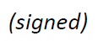  Yours faithfully,  Chaesub Lee  Director of the Telecommunication  Standardization Bureau | 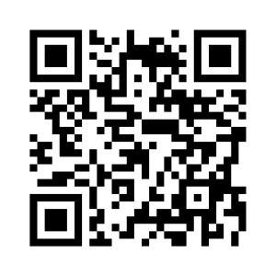 ITU-T SG13
 | Latest meeting information

