 |  | International telecommunication union  Telecommunication Standardization Bureau
 |  |  | Geneva, 27 February 2020
Ref: | Corrigendum 2 to Collective letter 10/13  SG13/TK |  | - To Administrations of Member States of  the Union;  - To ITU-T Sector Members;  - To ITU-T Associates of Study Group 13;  - To ITU Academia
Tel: | +41 22 730 5126
Fax: | +41 22 730 5853
E-mail: | tsbsg13@itu.int
Web: | http://itu.int/go/tsg13
Subject: | Meeting of ITU-T Study Group 13; Geneva, 13 March 2020
Dear Sir/Madam,
This Corrigendum is issued to correct the information about planned JCA-IMT2020 meeting of 5 March 2020.
Due to the current epidemic situation restricting travel, subsequent unavailability of the JCA chairman, nor JCA
Vice-chairman for running 5 March 2020 meeting and proximity of this meeting to the previous one, the 5 March 2020 JCA-IMT2020 meeting is postponed till July.
The next JCA-IMT2020 meeting will therefore take place alongside ITU-T SG13 meeting, on Tuesday, 21 July 2020, 18:00 – 19:30 in Geneva supported by the remote access tool.
I wish to thank you for your understanding.
Yours faithfully,  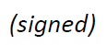  Chaesub Lee  Director of the Telecommunication  Standardization Bureau | 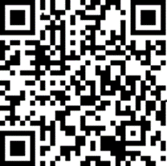
 | JCA_IMT2020 homepage

