|  |  |  |  |  |
| --- | --- | --- | --- | --- |
| cid:image003.png@01D43AF0.079B0930 | | **International telecommunication union**  **Telecommunication Standardization Bureau** | |  |
|  | | | Geneva, 5 September 2018 | |
| Ref: | **TSB Collective letter 3/9** | | - To Administrations of Member States of the Union;  - To ITU T Sector Members;  - To ITU T Associates of Study Group 9;  - To ITU Academia | |
| Tel: | +41 22 730 5858 | |
| Fax: | +41 22 730 5853 | |
| Email: | [tsbsg9@itu.int](mailto:tsbsg9@itu.int) | |
| Web: | <http://itu.int/go/tsg09> | |
| Subject: | **Meeting of Study Group 9; Bogota, Colombia, 21-28 November 2018** | | | |

Dear Sir/Madam,

It is my pleasure to inform you that Study Group 9 (*Broadband cable and TV*) will meet in Bogota, Colombia, from 21 to 28 November 2018 inclusive, at the kind invitation of the *Comisión de Regulación de Comunicaciones* of Colombia.

I would like to inform you that the meeting will open at 0930 hours on the first day. Participant registration will begin at 0830 hours at the venue entrance. Detailed information concerning the meeting rooms will be circulated via the SG9 e-mail list and displayed onsite by the local host. Additional information about the meeting is set forth in **Annex A**, while practical information can be found in **Annex D**.

The draft **Agenda** of the meeting and its draft **Timetable**, prepared in agreement with the Chairman of the Study Group 9 (Mr Satoshi Miyaji) and its management team, are set out in **Annexes B** and **C**,respectively.

A workshop on **“The Future of TV for the Americas”** is also being organized during the SG9 meeting in Bogota. A link to the workshop webpage, including the detailed programme of the workshop, will be made available from the SG9 webpage (<http://itu.int/ITU-T/go/sg9>).

**Key deadlines**:

|  |  |  |
| --- | --- | --- |
| Two months | 21-09-2018 | - [Submit ITU-T Member contributions](http://itu.int/net/ITU-T/ddp/) for which translation is requested |
| Six weeks | 10-10-2018 | - Submit fellowship requests (the application form and guidelines can be found [here](http://www.itu.int/en/ITU-T/studygroups/2017-2020/09/Documents/SG9_Fellowships.docx))  - Submit interpretation requests (via the online pre-registration form) |
| One month | 21-10-2018 | - Pre-registration ([online](https://www.itu.int/online/edrs/REGISTRATION/edrs.registration.form?_eventid=3001099) or via the study group homepage  <http://itu.int/ITU-T/go/sg9>)  - Submit requests for visa support letters (a request template can be found in ANNEX E ) |
| 12 calendar days | 08-11-2018 | - [Submit ITU-T Member contributions](http://itu.int/net/ITU-T/ddp/) |

I wish you a productive and enjoyable meeting.

|  |  |
| --- | --- |
| Yours faithfully,  *(signed)*  Chaesub Lee Director of the Telecommunication Standardization Bureau | This QR code redirects to the latest meeeting information at: http://handle.itu.int/11.1002/groups/sg9ITU-T SG9 |
| Latest meeting information |

**Annexes**: 5

**ANNEX A**

**WORKING METHODS AND FACILITIES**

**DOCUMENT SUBMISSION AND ACCESS:** The meeting will be run paperless. Member Contributions should be submitted using [Direct Document Posting](http://itu.int/net/ITU-T/ddp/); draft TDs should be submitted by e-mail to the study group secretariat using the [appropriate template](https://www.itu.int/en/ITU-T/studygroups/Pages/templates.aspx). Access to meeting documents is provided from the study group homepage, and is restricted to ITU-T Members/[TIES account holders](http://www.itu.int/TIES/).

**INTERPRETATION:** As per agreement of the ITU-T SG9 management team, this meeting will be held in English only.

**WIRELESS LAN** facilities will be available for use by delegates at the venue. Detailed information is available in **ANNEX D** item 6.

**PRE-REGISTRATION AND FELLOWSHIPS**

**PRE-REGISTRATION**:Pre-registration is mandatory and is to be done online via the study group homepage **at least one month before the start of the meeting**. The membership is invited to include women in their delegations whenever possible. Additionally, and within the same deadline, focal points are requested to send by e-mail ([tsbreg@itu.int](mailto:tsbreg@itu.int)), letter or fax, the list of people who are authorized to represent their organization, indicating the names of the head and deputy head of delegation.

**FELLOWSHIPS**: Two partial fellowships per administration may be awarded, subject to available funding, to facilitate participation from [Least Developed or Low Income Countries](https://www.itu.int/en/ITU-T/gap/Documents/Fellowships_BSG_EligibleCountries.pdf). Please further note that when two (2) partial fellowships are requested, at least one must be an economy class air ticket. An application for a fellowship must be authorized by the relevant Administration of the ITU Member State. Fellowship requests (please use the [online Form](http://www.itu.int/en/ITU-T/studygroups/2017-2020/09/Documents/SG9_Fellowships.docx)) must be returned to ITU no later than **10 October 2018.**Please note that the decision criteria to grant a fellowship include: the available TSB budget, contributions by the applicant to the meeting, equitable distribution among countries and regions, and gender balance. Pre-registration for the meeting is mandatory.

**VISA SUPPORT**: To enter Colombia, you may need a letter of introduction from the host, which you will need to present to the Colombian Embassy/Consulate in your area in order to obtain your visa. The visa must be requested and obtained from the office (embassy or consulate) representing Colombia in your country or, if there is no such office in your country, from the one that is closest to the country of departure. Please be aware that visa approval might take time so kindly make your visa request as soon as possible.

See **item 3 of ANNEX D** for more information.

**ANNEX B**

**Draft Agenda of the SG9 meeting (21-28 November 2018, Bogota, Colombia)**

|  |  |  |
| --- | --- | --- |
| **#** | **Agenda items** |  |
|  | Opening of the SG9 meeting   * 1. Approval of the agenda   2. Approval of the previous SG9 Reports   3. Approval of the meeting time plan   4. Document allocation   5. Incoming liaison statements   6. Meeting facilities and useful information   7. Newcomers’ welcome pack |  |
|  | Feedback on interim activities since the last meeting |  |
|  | SG9 organization   * 1. SG9 Management team   2. Working Party structure and its Management   3. Questions Rapporteurs and Associates   4. Liaison Officers |  |
|  | Contributions for the opening Plenary |  |
|  | PP-18 and TSAG results relevant to SG9 |  |
|  | Report and liaison statements from other Groups/Workshops |  |
|  | Promotion of SG9 work, workshops organization |  |
|  | Documents planned for Approval/Consent/Determination/Agreement at this meeting   * 1. Intellectual Property Rights inquiry |  |
|  | AOB for opening Plenary |  |
|  | | |
|  | Intellectual Property Rights inquiry |  |
|  | Approval/Consent/Determination of draft Recommendations and agreement of other deliverables   * 1. Recommendations   2. Supplements   3. Technical Papers and Reports   4. Others |  |
|  | Approval of Working‑Party reports and Question meeting report |  |
|  | Outgoing Liaison Statements |  |
|  | Agreement to start new work items |  |
|  | Update of the SG9 Work Programme |  |
|  | New/revised Questions (if any) |  |
|  | New appointment of Rapporteurs, Associate Rapporteurs, Liaison Officers |  |
|  | Date and place of the next SG9 meeting |  |
|  | Future Interim Activities (Working Party and Rapporteur meetings) |  |
|  | Future events related to SG9 |  |
|  | AOB for closing Plenary |  |
|  | Closing |  |

***Note 1:*** *Items 1 to 9 are expected to be addressed in the opening Plenary (21 November 2018) and items 10 to 22 are expected to be addressed in the closing Plenary (28 November 2018).*

***Note 2:*** *Updates to the agenda can be found in SG9-TD319.*

**ANNEX C**

**Draft Timetable of the SG9 meeting (21-28 November 2018, Bogota, Colombia)**

|  | **Wednesday 21 November** | | | | **Thursday 22  November** | | | | **Friday 23  November** | | | | **Sat 24 Nov** | **Sun 25 Nov** | **Monday 26  November** | | | | **Tuesday 27 November** | | | | **Wednesday 28 November** | | | |
| --- | --- | --- | --- | --- | --- | --- | --- | --- | --- | --- | --- | --- | --- | --- | --- | --- | --- | --- | --- | --- | --- | --- | --- | --- | --- | --- |
| ***Sessions*** | ***1*** | ***2*** | ***3*** | ***4*** | ***1*** | ***2*** | ***3*** | ***4*** | ***1*** | ***2*** | ***3*** | ***4*** |  |  | ***1*** | ***2*** | ***3*** | ***4*** | ***1*** | ***2*** | ***3*** | ***4*** | ***1*** | ***2*** | ***3*** | ***4*** |
| **PLEN** | **X** | **X** |  |  |  |  |  |  |  |  |  |  |  |  |  |  |  |  |  |  |  |  |  |  | **X** | **X** |
| **WPs** |  | **2** |  |  |  |  |  |  |  |  |  |  |  |  |  |  |  |  |  |  |  |  | **X** | **X** |  |  |
| **Workshop** |  |  |  |  |  |  |  |  |  |  |  |  |  |  | **3** | **3** | **3** | **3** |  |  |  |  |  |  |  |  |
| **Q1/9** (ex.Q1/9) |  |  | -- | -- | -- | -- | -- | -- | -- | -- | -- | -- |  |  |  |  |  |  | -- | -- | -- | -- |  |  |  |  |
| **Q2/9** (ex.Q3/9) |  |  | -- | -- | -- | -- | -- | -- | -- | -- | -- | -- |  |  |  |  |  |  | -- | -- | -- | -- |  |  |  |  |
| **Q4/9** (ex.Q11/9) |  |  | -- | -- | -- | -- | -- | -- | -- | -- | -- | -- |  |  |  |  |  |  | -- | -- | -- | -- |  |  |  |  |
| **Q5/9** (ex.Q4/9) |  |  | -- | -- | -- | -- | -- | -- | -- | -- | -- | -- |  |  |  |  |  |  | -- | -- | -- | -- |  |  |  |  |
| **Q6/9** (ex.Q5/9) |  |  | -- | -- | -- | -- | -- | -- | -- | -- | -- | -- |  |  |  |  |  |  | -- | -- | -- | -- |  |  |  |  |
| **Q7/9** (ex.Q7/9) |  |  | -- | -- | -- | -- | -- | -- | -- | -- | -- | -- |  |  |  |  |  |  | -- | -- | -- | -- |  |  |  |  |
| **Q8/9** (ex.Q8/9) |  |  | -- | -- | -- | -- | -- | -- | -- | -- | -- | -- |  |  |  |  |  |  | -- | -- | -- | -- |  |  |  |  |
| **Q9/9** (ex.Q10/9) |  |  | -- | -- | -- | -- | -- | -- | -- | -- | -- | -- |  |  |  |  |  |  | -- | -- | -- | -- |  |  |  |  |
| **Q10/9** (ex.Q13/9) |  |  | -- | -- | -- | -- | -- | -- | -- | -- | -- | -- |  |  |  |  |  |  | -- | -- | -- | -- |  |  |  |  |
| **Newcomers** |  |  |  |  |  | **1🡪** |  |  |  |  |  |  |  |  |  |  |  |  |  |  |  |  |  |  |  |  |

**Session 1: 0930 – 1045; Session 2: 1115-1230; Session 3: 1430-1545; Session 4: 1615-1730; Session 5: 1800-1915;**

|  |  |
| --- | --- |
| **PLEN** | SG9 Plenary sessions |
| **WPs** | Working Parties 1/9 and 2/9 Plenary sessions |
| **X** | Represents a meeting session |
| **🡪** | Indicates a lunch/evening session |
| **--** | Detailed time plan including Question sessions will be made available from the SG9 webpage as SG9-TD320 |
| **1** | A newcomers orientation session will take place (1230-1330) |
| **2** | SG9 Working Parties Opening Plenaries will be held as part of SG9 Opening Plenary. |
| **3** | Workshop on “***The*** ***Future of TV for the Americas***” (see <http://itu.int/go/TSG9>). |

**Colour legend**

|  |  |  |  |  |  |  |  |  |  |
| --- | --- | --- | --- | --- | --- | --- | --- | --- | --- |
|  | SG and WP Plenary sessions |  | Workshop |  | Questions of WP1 |  | Questions of WP2 |  | Questions of Plenary |

**ANNEX D**

## PRACTICAL INFORMATION

## Meeting Venue

Hotel Casa Dann Carlton, Calle 93B #18-44, Bogota, Colombia

English: <http://www.hotelesdann.com/casa-dann-carlton/?lang=en>

Spanish: <http://www.hotelesdann.com/casa-dann-carlton-complejo-servicios-hoteleros/>

## Transportation and site information

**If you choose a taxi,** the El Dorado Airport has an authorized taxi service through the company "Taxi Imperial", whose vehicles can pick up passengers at the airport, to ensure their safety and comfort. The taxi service can be found at gates 2, 3, 5 and 6 of Terminal 1 and at the Arrivals gate of Terminal 2**.**  Local Website:  <http://www.taxiimperial.com.co>.

**If you decide to take the city’s public transport, "Transmilenio"**, (1) take the green bus called "Articulado" that will take you to the "El Dorado" portal, at Exit 6 of Floor 1. This transport to the portal is free. Once you are in El Dorado, you can buy a card called "Tullave", which is a rechargeable card to pay for public transportation and costs $ 5,000 Colombian pesos. Remember to charge the card with money, taking into account that each trip will cost an additional amount of $ 2,300 Colombian pesos; (2) Enter the platform and look for route number B23 called "Portal El Dorado - Alcalá"; (3) Take the bus for the indicated route and go to the station "Calle 85", which is the tenth stop; (4) There, wait for the easy route "Ruta Fácil Portal Norte" number B1 and go to the station "Calle 100" for two more stops. When leaving the station, you can arrive at your destination either by taking a taxi or by walking.

If you choose to walk from "Calle 100" to the hotel, you may take the following route: <https://www.google.com.co/maps/dir/Estacion+Transmilenio+Cll+100,+Autopista+Nte.,+Bogot%C3%A1/Casa+Dann+Carlton+Hotel+%26+Spa,+Cl.+93b+%2318-99,+Bogot%C3%A1/@4.6815558,-74.0634955,15z/data=!3m1!4b1!4m14!4m13!1m5!1m1!1s0x8e3f9aea6fc27357:0x72769e329f0b64f7!2m2!1d-74.0572775!2d4.6855593!1m5!1m1!1s0x8e3f9aecafb3aabd:0x3559bd6fff4d3d36!2m2!1d-74.0543026!2d4.6803845!3e2>

**Taking private transport:** Should you prefer to take a private transport service, you can access the van service in the airport terminal at Exit 5 on Floor 1. For payment, cash, credit and debit cards are accepted.

**In case you plan to rent a car**, the following instructions may be helpful: From the El Dorado Airport to the meeting venue, Hotel Casa Dann Carlton, the best route is to head east on 26th Street, up to Avenue NQS. Take this road north of the city until you reach "93BIS Street". Then you should turn right onto "Carrera 19" and head towards "Street 93B". The hotel is located at the address number 18-44.

The **hotel map** (meeting venue), Spanish only, is available at the following URL:

<http://www.hotelesdann.com/casa-dann-carlton/ubicacion/>

## Passports and Visas

All foreign visitors entering Colombia must have a valid passport. Visitors from countries whose citizens require a visa should apply for a visa at a Colombian Embassy or Consulate as early as possible and well in advance of travel.

For requesting an invitation letter for visa purposes from the Colombian Administration, please see **Annex E**.

For more information related to entry into Colombia, especially if you need a visa, see:

<http://www.cancilleria.gov.co/en/procedures_services/visa/requirements>

The focal point for visa support in Colombia is:

**Mrs Eliana Guerra Nader**

E-mail: [eguerra@eype.co](mailto:eguerra@eype.co)

Tel: +57 3168765316

## Climate – end of November in Colombia

Monthly Average temperature and precipitation in Bogota, Colombia are given in the table below:

|  |  |
| --- | --- |
|  | November |
| Average Maximum Temperature | 19°C |
| Average Minimum Temperature | 8°C |
| Average Precipitation | 50% |

## Hotels

**Meeting venue:**

Hotel Casa Dann Carlton, Calle 93B #18-44, Bogotá (**MEETING VENUE**)

English: <http://www.hotelesdann.com/casa-dann-carlton/?lang=en>

Spanish: <http://www.hotelesdann.com/casa-dann-carlton-complejo-servicios-hoteleros/>

**Additional hotels:**

* **Holiday Inn Express Bogotá, Cl. 94 #11a-11**

<https://www.ihg.com/holidayinnexpress/hotels/us/es/bogota/bogex/hoteldetail>

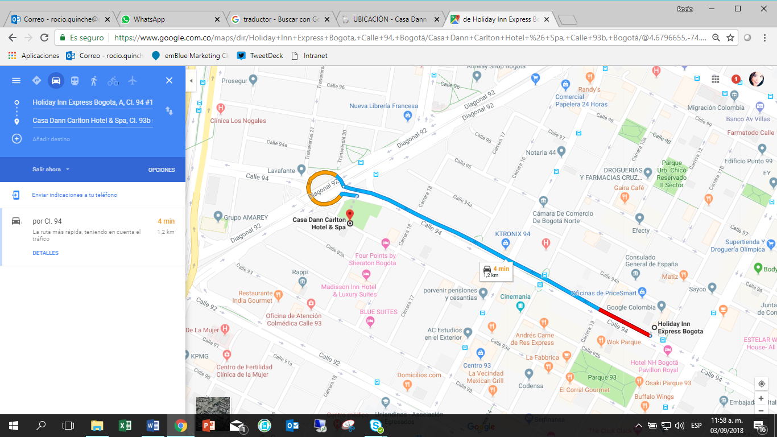

* Hotel Bh Parque 93, Cra. 14 # 93A-69

<http://hotel-rn.com/hw/a373992/index.htm?lbl=ggl&gclid=EAIaIQobChMItvzri5aD3QIViR6GCh2-jwgvEAAYAiAAEgJrb_D_BwE>

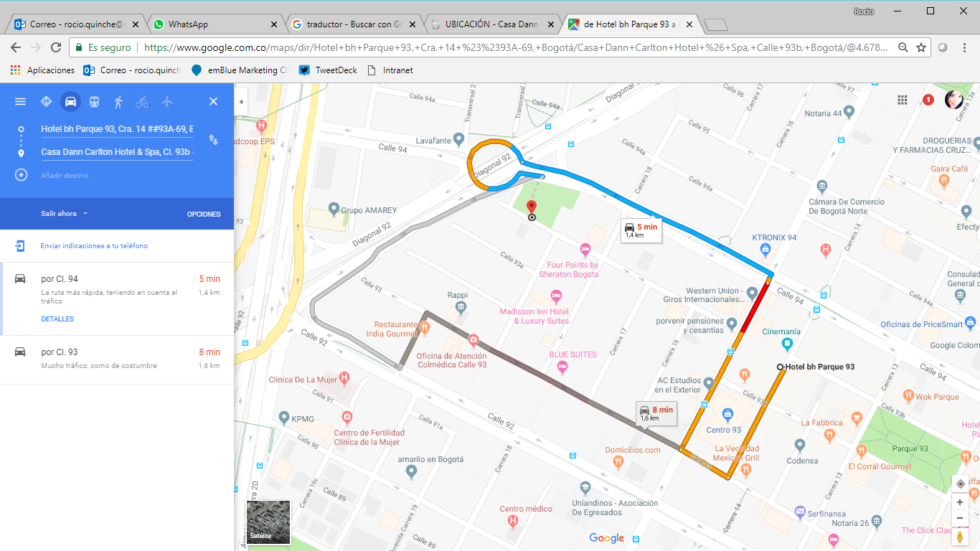

* Best Western Plus 93, Park, Cl. 93 #13-71

<https://www.hotelbestwestern93.com/>

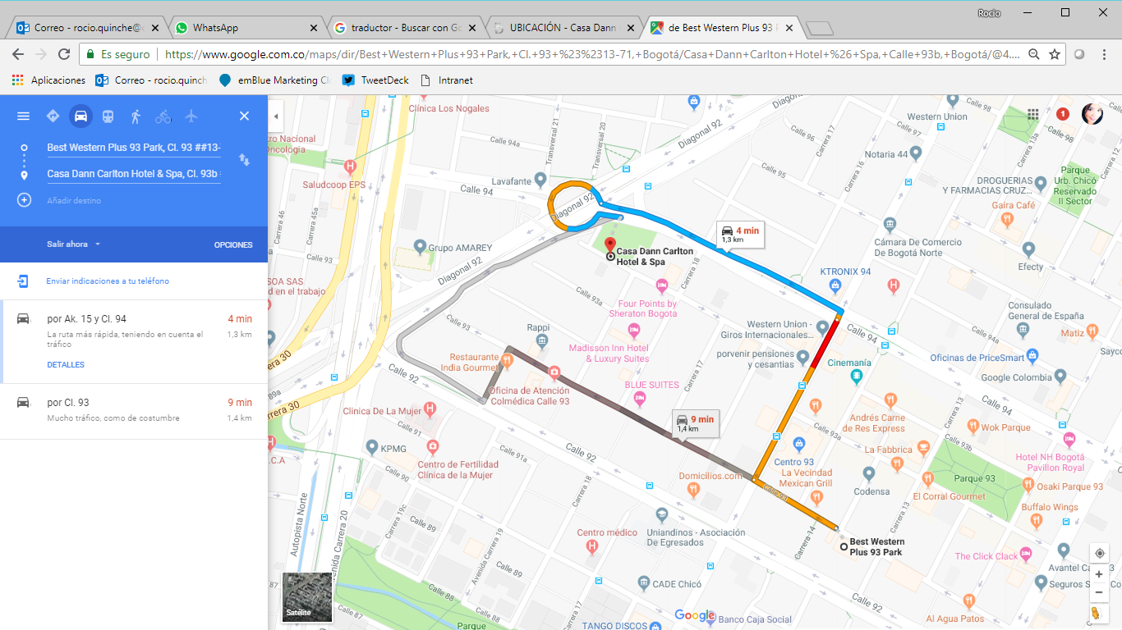

* Hotel GHL Collection 93, Cl. 93 #31

<https://www.ghlhoteles.com/hoteles/colombia/bogota/ghl-collection-93/>

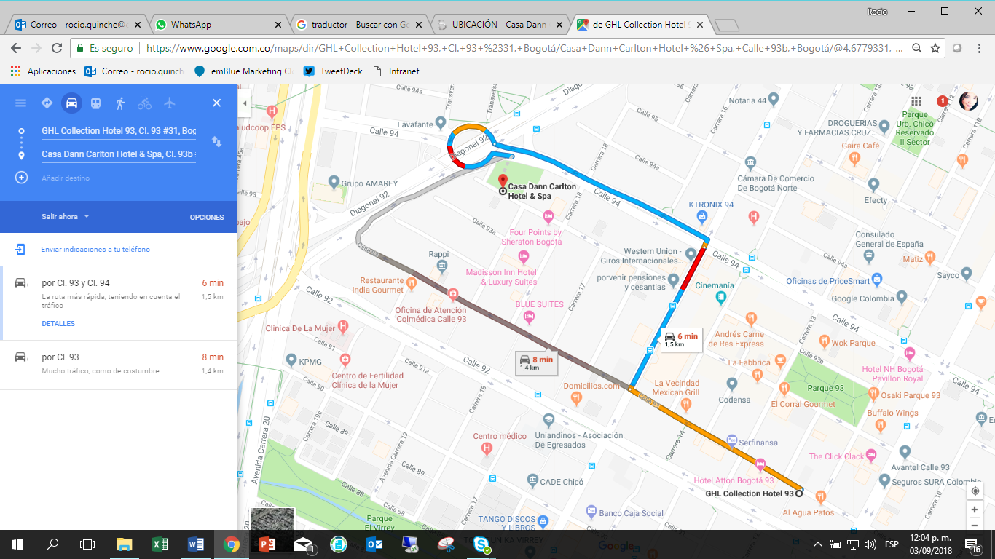

* ESTELAR Windsor House, Cl. 95 #9-97

<https://www.hotelesestelar.com/es/hotel/hotel-estelar-windor-house-all-suites>

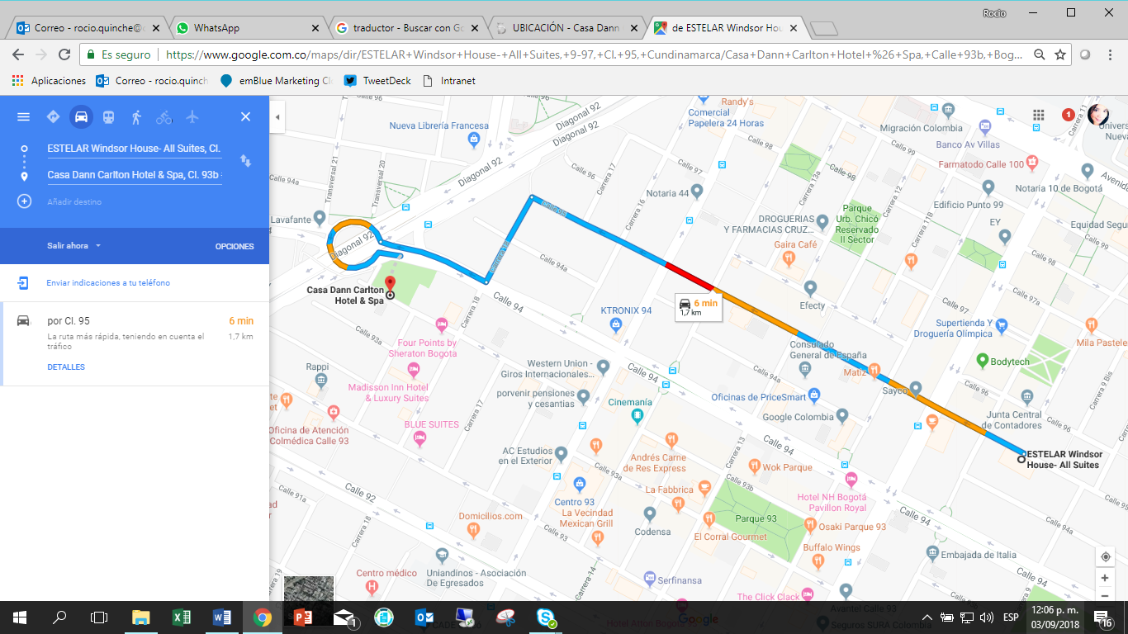

## Internet access and wireless coverage at the venue

The hotel offers Internet service in all areas. You will find more information once at the venue.

## Technical assistance

In case you have any technical problems at the venue (e.g. connecting to the Internet, finding meeting rooms, etc.) please contact for help:

Ms. Angelita María Cárdenas Capacho

Mobile: +57 3112188857

## Electricity

The electricity in Colombia is generally 110V, 60HZ. Please make sure you have the proper adapter. 

This socket is common in Colombia and many other countries.

## Useful information

*Currency exchange*

The currency in **Colombia** is the "**pesos colombianos"**; please check the currency exchange rate in the local bank system or use the following link as a reference: <http://www.xe.com/>.

## Additional information

**10.1 Mobile phones:** Cell (mobile) phone and mobile data coverage is excellent. Most unlocked cell phones will work with a local SIM card.

**10.2 Tipping:** Tipping is recommended; normally it is 10% of the bill (voluntary).

**10.3 Time Zone in November 2018**: UTC/GMT-5:00.

**10.4 Emergency Number:** In case of emergency please dial 123.

**10.5 Sightseeing:** <http://www.colombia.travel/es/a-donde-ir/andina/bogota>

## Contact persons

* Mrs. Mariana Sarmiento: Mobile +57 320 8093858 ([mariana.sarmiento@crcom.gov.co](mailto:mariana.sarmiento@crcom.gov.co))
* Mrs. Eliana Guerra Nader: Mobile +57 316 8765316 ([eguerra@eype.co](mailto:eguerra@eype.co))

# ANNEX E

**INVITATION LETTER REQUEST FORM**

All foreign visitors entering Colombia must have a valid passport. Visitors from countries **whose citizens require a visa should, as soon as possible and** at least **one month** before the start date of the meeting, **apply for a visa** from the office (embassy or consulate) representing Colombia in your country or, if there is no such office in your country, from the one that is closest to the country of departure.

**Online application**: [**https://tramitesmre.cancilleria.gov.co/tramites/enlinea/solicitarVisa.xhtml**](https://tramitesmre.cancilleria.gov.co/tramites/enlinea/solicitarVisa.xhtml)

You may need a letter of invitation from the Colombian host, which you will need to present to the Colombian embassy/consulate in your area in order to obtain your visa. In order to obtain an invitation letter:

1. Please complete the form below.
2. An electronic copy of your passport must be provided with your name, date of birth, nationality, passport number, expiration date of passport, etc., clearly seen on the copy.
3. If you have been to Colombia before, please provide an electronic copy of any previous Colombian visas and/or records.
4. Send the info in sections A, B and C as e-mail attachments to [**mariana.sarmiento@crcom.gov.co**](mailto:mariana.sarmiento@crcom.gov.co). Please mark in the subject***“Invitation letter request for*** ***ITU‑T SG9 meeting (21-28 November 2018)”****.*

(Remember to scan your passport and e-mail it to us so that it is discernible and can be used.)

|  |  |  |  |  |  |
| --- | --- | --- | --- | --- | --- |
| **Company** |  | | | | |
| **Applicant Information** |  | | | **❒ Mr ❒ Miss ❒ Ms ❒ Mrs** | |
|  | | | **Date of birth :** | |
|  | | | **Place of Issue:** | |
| **Date of Issue:** | | | **Date of Expiry:** | |
| **Marital Status:** | | |  | |
| **If the country in which you'll obtain your visa is different from your nationality, please indicate it here:** | | | | |
| **Address** | **Telephone Number:**  **Fax Number:**  **E-mail:** | | | | |
| **Note** |  | | | | |
| **Date of arrival in Colombia** | |  | **Date of departure from Colombia** | |  |

*(Please do not forget to attach a copy of your passport photograph page before sending.)*

***In order to receive an invitation letter, your information should be provided to the host before 21 October 2018.***

***NOTE: The host will do its best to provide invitation letters that are requested late; however, it cannot guarantee that a visa will be received in time for the SG9 meeting.***

________________________