 |  | International telecommunication union  Telecommunication Standardization Bureau
 |  |  | Geneva, 14 April 2020
Ref: | Corrigendum 1 to TSB Collective letter 6/2  SG2/RC |  | - To Administrations of Member States of  the Union;  - To ITU-T Sector Members;  - To ITU-T Associates of Study Group 2;  - To ITU Academia
Tel: | +41 22 730 5415
Fax: | +41 22 730 5853
E-mail: | tsbsg2@itu.int
Web: | http://itu.int/go/tsg2
Subject: | Meeting of Study Group 2; Geneva, 27 May - 5 June 2020
Dear Sir/Madam,
In response to the requirement for organizations to mitigate the effects of the rapidly evolving Covid-19 situation, ITU Management has decided that international meetings scheduled at ITU Headquarters in Geneva as from Monday 16 March 2020 will be conducted with remote participation only until further notice. ITU premises in Geneva will not be accessible to delegates during this period.
As a consequence, and in coordination with the ITU-T Study Group 2 Chairman and management team, the SG2 meeting (Geneva, 27 May - 5 June 2020) will be conducted as a fully virtual meeting. Accordingly, no Fellowships will be awarded, and no interpretation will be offered. The entire meeting will run in English only. An updated and compressed draft agenda and time plan will be issued (SG2-TD964 and SG2-TD963, respectively), taking into account the time difference among remote participants to the extent possible.
Registration is mandatory via the online registration form on the study group homepage. Without registration, delegates will not be able to access the remote participation tool.
The deadline for submitting ITU-T Member contributions is unchanged: 14 May 2020.
Despite the global challenges that we face together, I wish you a productive and enjoyable meeting.
Yours faithfully,  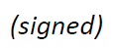  Chaesub Lee  Director of the Telecommunication  Standardization Bureau | 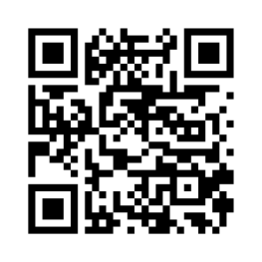 ITU-T SG2
 | Latest meeting information

