|  |  |  |  |
| --- | --- | --- | --- |
| itu_logo | World Telecommunication Standardization Assembly (WTSA-16) Yasmine Hammamet, 25 October - 3 November 2016 | | CCITT/ITU-T 60th Anniversary logo |
|  | |  | |
|  | |  | |
| PLENARY MEETING | | Document 41-E | |
|  | | 27 June 2016 | |
|  | | Original: English | |
|  | | | |
| ITU-T Study Group 3 | | | |
| Draft revised Recommendation ITU-T D.271 "Charging and accounting principles for NGN": Proposed for approval at WTSA-16 | | | |
|  | | | |
|  | | | |

|  |  |
| --- | --- |
| **Abstract:** | WTSA-16 Document 41 contains draft revised Recommendation ITU-T D.271 for Approval at WTSA-16. The content of this Document is identical to COM3-R19. |

MOD SG3/41/1

Draft revised Draft Recommendation ITU-T D.271

Charging and accounting principles for NGN

Summary

Revised Recommendation ITU-T D.271 “Charging and accounting principles for Next-Generation Network (NGN)” sets out the general principles and conditions applicable by administrations for the capability to transport IP packets over IP-based networks between standards-based interfaces and the services that they support.

Keywords

<Optional>

Draft revised Draft Recommendation ITU-T D.271

Charging and accounting principles for NGN

# 1 Preamble

This Recommendation covers charging and accounting principles applicable to NGN services.

# 2 Scope

This Recommendation sets out the general principles and conditions applicable by administrations for the capability to transport IP packets over IP-based networks between standards-based interfaces and the services that they support.

Specific charging and accounting principles for broadcasting issues are not currently addressed in this version of this Recommendation.

# 3 References

None.

# 4 Terms and definitions

## 4.1 Definitions

This Recommendation defines the following terms:

**4.1.1 call**: An association between endpoints that support an instance of a service.

**4.1.2 chargeable packet rate (CPR)**: The chargeable packet rate of a session is a single packet rate parameter used to determine the reservation-based charge element for that session. The CPR is a computed simplification of the traffic contract values of the session to a single packet rate value. The concept of CPR applies only to charging and accounting. It is used only in the reservation‑based charge element. The CPR is computed as a function of the session parameters, such as QoS class, source traffic descriptor and associated tolerances. The use and the calculation function for the CPR are administration-specific.

**4.1.3 distance**: Distance in the context of this Recommendation is related to the facilities made available to the session between the applicable interfaces. It is administration-specific whether and how distance influences the charging parameters. If distance-dependent differentiation is used, an administration may choose to define distance regions or distance zones to simplify its implementation.

**4**.**1**.**4 flow**: A flow is defined as a set of IP packets passing an observation point in the network during a certain time interval [b-ITU-T Y.2233].

**4.1.5 session**: A temporary telecommunications relationship among a group of objects in the service stratum that are assigned to collectively fulfil a task for a period of time [b-ITU-T Y.2091].

**4.1.6 session active phase**: The session's active phase indicates the entire period between session establishment and session release.

**4.1.7 session establishment**: Session establishment indicates the moment the session has been set up and has become available to the user to transport packets. For sessions using signalling (or not), this corresponds to the entry into the 'active' state.

**4.1.8 session release**: Session release indicates the moment the session has become unavailable to the user to transport packets. For sessions using signalling (or not), this corresponds to the departure from the 'active' state.

**4.1.9** **weighted charging rate (WCR)**: WCR is one of the reservation-usage-based charge methods for that session. As shown in the following formula, for each charging parameter, the relevant weight will be negotiated between administrations.

Tariff (Accounting) = ΣCiWi

where:

Ci Charging Factor

Wi relevant weighted rate

## 4.2 Abbreviations and acronyms

This Recommendation uses the following abbreviations:

CAC Call Admission Control [b-ITU-T I.371]

CDR Charging Data Record

CP\_M(.) Charge Parameter – Modification

CP\_R(.) Charge Parameter – Reservation

CP\_S(.) Charge Parameter – Session Set‑up

CP\_U(.) Charge Parameter – Usage

CPR Chargeable Packet Rate

DSCP Differentiated Services Code Point

FSA Flow State Aware

IN-QOSM QoS Model for signalling Integrated Services controlled- load service with

INI Inter-Network Interface

OAM Operation, Administration and Maintenance [b-ITU-T I.610]

PDV Packet Delay Variation [b-ITU-T I.356]

PPR Peak Packet Rate [b-ITU-T I.371]

QoS Quality of Service [b-ITU-T I.356]

SIP Session Initiation protocol

SLA Service Level Agreement

UNI User Network Interface [b-ITU-T I.112] and [b-ITU-T I.413]

CDN Content Delivery Network

# 5 Units, elements, parameters and concepts for charging network utilization

This clause introduces the charging units, the charge elements and their parameters and the concepts recommended to be used to charge for network utilization. The network utilization charges cover the costs related to the utilization of the network resources.

Charge elements and their parameters are introduced below. The use (or not) of such elements and parameters and their values is administration-specific in case of charging, and subject to agreement between the administrations involved in case of accounting.

## 5.1 Charging units

The following charging units are applicable to NGN charging:

• In case duration is used as an element in the charge, the unit is millisecond (ms).

• In case a number of byte is used as an element in the charge, the unit is byte per second (byte/s).

• In case usage is used as an element in the charge, the unit is a number of packets.

NOTE – To ease notation, an administration may choose to use kilo-bytes or megabyte as the unit in charging or accounting, instead of a single byte; the same rule is applied to the packets. Such a choice does not affect the essence of charging or accounting.

## 5.2 Charge elements

For charging individual sessions, the following elements may be used:

• session set‑up charge element (see clause 5.2.1);

• session set‑up attempt charge element (if session set-up signalling is used, see clause 5.2.2);

• reservation-based charge element (see clause 5.2.3);

• usage-based charge element (see clause 5.2.4);

• SLA-based charge element (see clause 5.2.5).

### 5.2.1 Session set-up charge

A session set-up charge may be applied to each successfully established session. This session set-up charge may reflect the resources to establish (and to release) the session, e.g., transport and processing of (or not) messages in all relevant nodes along the route, performing route calculations, performing CAC functions in all relevant nodes and the capacity reserved during the session set-up phase in both directions. Its value is administration-specific in the case of charging end customers and subject to (bilateral) agreements between administrations in case of accounting.

### 5.2.2 Session set-up attempt charge element

A session set-up attempt charge may be applied in case a session has not been successfully established. The session set‑up attempt charge may reflect the resources to attempt the session set‑up (see clause 5.2.1).

NOTE – For providing the user requested QoS, Diffserv, SIP was proposed by the IETF; ITU‑T also proposes QoS signalling.

The application of such a session set‑up attempt charge may depend on the reason for the failure of the attempt. Different policies may be applied according to the cause of the failure, e.g., failure by the network. Such policies are administration-specific in the case of charging end customers and subject to (bilateral) agreements between administrations in case of accounting.

### 5.2.3 Reservation-based charge element

The reservation-based charge element applies a charge for the reservation made in the network for a specific session. It relates to the resources the administration reserves for the duration of the session. For example, reservations are necessary to implement the QoS commitments applicable to the session.

The reservation-based charge may depend on the QoS class, the SLA, the traffic descriptor declared by TE (terminal equipment), and the associated tolerances. An administration may choose to convert these parameters or some of these parameters into a single rate value expressing the reserved resources: the chargeable packet rate. The conversion from session parameters into a chargeable packet rate (CPR) is administration-specific. The reservation-based charge element is determined by multiplying the value of the reservation charge parameter CP\_R(.) applicable to the session with the value of the CPR (if applicable) and with the duration of the session. Another way for reservation-based charge is a WCR that is one of the reservation-usage-based charge element for that session. For each charging factor, the relevant weight can be negotiated with the telecom operator. The value of CP\_R(.) may depend on the QoS class, the SLA, the distance between the applicable interfaces (region or zone) and the charging period. Its value is administration-specific in the case of charging end customers and subject to (bilateral) agreements between administrations in case of accounting.

The reservation-based charge element does not take into account the number of packets admitted into the network nor the number of packets transported by the network. This is addressed by usage‑based charging elements.

NOTE – For providing the user requested QoS, Diffserv, SIP was proposed by the IETF; ITU‑T also proposes QoS signalling.

### 5.2.4 Usage-based charge element

The usage-based charge element applies a charge based on the number of packets admitted into the network and a charge based on the number of packets delivered by the network. The first charge relates to the workload placed on the network; the second charge relates to the NGN service successfully delivered by the network.

The charge may depend on the QoS class, the SLA and on the value of the DSCP. The usage-based charge element is determined by multiplying the value of the usage charge parameter CP\_U(.) applicable to the session by the corresponding number of packets. There may be more than one parameter CP\_U(.); for example, depending on the DSCP information element, whether the parameter relates to the admitted packets or the delivered packets, and on the charging period. Its value is administration-specific in the case of charging end customers and subject to (bilateral) agreements between administrations in case of accounting.

In the case where more than one administration is involved in completing the session, charging for packets delivered to the destination is possible only if the delivered packet/byte counts are available from the terminating administration by mutual agreement. If no such agreement is available, charging cannot (and shall not) rely on delivered packets. In such a case, the usage-based charge element will only relate to the number of packets admitted into the network.

### 5.2.5 SLA-based charge element

The SLA-based charge element applies a charge based on the level of service. In case of DiffServ, SLA will directly map to the DSCP values that are now differently implemented by vendors.

## 5.3 Charging periods

An administration may choose to apply different charges to different periods (if applied), e.g., peak and off‑peak hours. Such periods are referred to as charging periods.

The reservation-based charge element relates to the duration of a session. The value of the reservation charge parameter CP\_R(.) may differ between charging periods. In order to allow the reservation-based charge element to differ for different charging periods, the duration of the session within each charging period must be known. This information can be derived by comparing the start date and time and the end date and time of the session to the charging periods.

The usage-based element relates to the packets admitted into the network and packets delivered by the network. The value of the usage charge parameter(s) CP\_U(.) may differ between charging periods. In order to allow the usage-based charge element to differ for different charging periods, the number of packets within each charging period must be known. Therefore, separate packet/byte counts for each charging period need to be available.

It is not required that all charging elements are the same for different charging periods. For example, it is possible to have two charging periods which have different reservation charging parameters, but identical session set‑up charging elements and identical usage charging parameters. An illustration could be a special rate or charging for off-peak or holidays.

Recording interval

A recording interval is the time interval that pertains to a CDR. Measurements may be registered for the session in several successive CDRs (with a unique identifier that can discriminate between different CDRs) pertaining to successive recording intervals.

The start and end time of a recording interval need to be recorded; for example, the first recording interval for a session is likely to start when it is established. The final recording interval for a session is likely to end when it is released. Intermediate recording intervals may be started and stopped at regular intervals, or by special events, such as an alteration of the session characteristics (e.g., renegotiations of traffic contract, change in call characteristics, or different time periods). Recording intervals may be used if different charges apply to different time intervals.

CDRs shall be generated immediately on the following occasions (see Figure 1):

• at session establishment (indication 0);

• at session release (indication 6);

• during the session's active phase;

• when any of the traffic contract parameters are modified (if relevant signalling is supported);

• at the end of each recording interval (see indications 2, 3, 4, 5). A recording interval may be started for several reasons, for example:

– to cope with a new charging period (e.g., for peak and off-peak hours, see indications 2 and 3);

– to cope with the limited range implemented for the registration of the number of packets (counter roll-over protection, see indication 5);

– to end a recording interval for a long-lasting session (see indication 4);

– to limit the duration of a recording interval and thus to limit the impact of losing a CDR (see indication 4);

– for multisessions: when a leaf is added or removed (not indicated);

– mobility (e.g., roaming or inter-system handover) (not indicated).

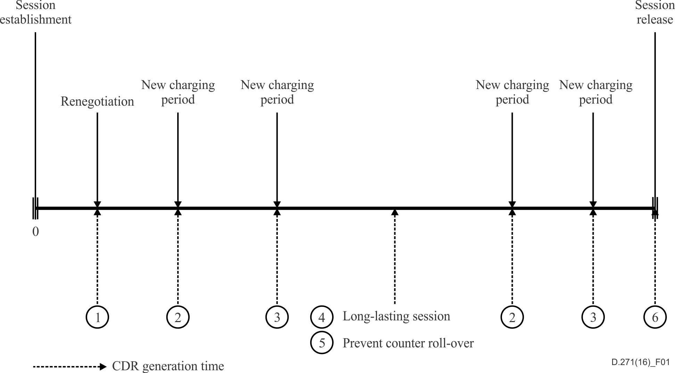

Figure 1 – Illustration of CDR generating moments

**Session characteristics that may affect the charge**

The charge elements described in clause 5.2 depend on a number of characteristics and parameters of the session. Table 1 lists the characteristics that can be used in the charge elements reservation and usage. The column 'available' indicates at what stage of the session lifetime the parameter becomes available.

| Table 1 – Charging session characteristics | | | | |
| --- | --- | --- | --- | --- |
| Characteristics | Applicable | Reservation related charge affected through: | Usage related charge affected through: | When available? |
| QoS class | DiffServ  IN-QOSM,  FSA, MPLS (if applicable) | CP\_R | CP\_U | At session establishment |
| Traffic descriptor (QoS parameter) (if applicable1) | DiffServ  IN-QOSM,  FSA, MPLS (if applicable) | CP\_R | None | At session establishment |
| Identification of the interfaces2 relevant to charging (e.g., also used to determine distance) | DiffServ  IN-QOSM,  FSA, MPLS (if applicable) | CP\_R | CP\_U | At session establishment |
| Session start date and time | DiffServ, IN-QOSM,  FSA, MPLS | CP\_R | CP\_U | At session establishment |
| For each successful renegotiation: date and time and renegotiated traffic descriptor (if applicable1) | DiffServ  IN-QOSM,  FSA, MPLS (if applicable) | CP\_R | None | After each modification (during the session's active phase) |
| Session end date and time | DiffServ IN-QOSM,  FSA, MPLS | CP\_R | None | At session release |
| The number of user packets3 admitted into the network to which QoS guarantees apply4 (if applicable1) | DiffServ  IN-QOSM,  FSA, MPLS | None | *N*admitted,0+1 or *N*admitted,05 | During the session's active phase & at session release |
| The number of user packets3 admitted into the network to which no QoS guarantees apply4 (if applicable1) | DiffServ  IN-QOSM,  FSA, MPLS | None | *N*admitted,15 | During the session's active phase & at session release |
| The number of user packets3 delivered by the network to which QoS guarantees apply4 (if applicable1) | DiffServ,  FSA, MPLS | None | *N*delivered,0+1 or *N*delivered,05 | During the session's active phase & at session release |
| The number of user packets3 delivered by the network to which no QoS guarantees apply4 (if applicable1) | DiffServ | None | *N*delivered,15 | During the session's active phase & at session release |
| DSCP code point | DiffServ,  MPLS | None | CP\_U | Indicate priority |
| QoS class | DiffServ, FSA, MPLS | CP\_R | CP\_U | By SLA |
| Token bucket rate | IN-QOSM, MPLS | CP\_R | None | At session establishment |
| Token bucket size | IN-QOSM, MPLS | CP\_R | None | At session establishment |
| Peak data rate | IN-QOSM, MPLS | CP\_R | CP\_U | At session establishment |
| Minimum policed unit | IN-QOSM, MPLS | CP\_R | None | At session establishment |
| Maximum packet size | IN-QOSM, MPLS | CP\_R | CP\_U | At session establishment |
| Security | DiffServ  IN-QOSM,  FSA, MPLS | CP\_R |  | FFS |
| Content delivery network (CDN) | DiffServ, IN-QOSM,  FSA, MPLS | None | CP\_U | At session establishment |
| 1 These capabilities are under study in the relevant Study Groups and other standardization bodies.  2 The relevant interfaces may be derived from the information provided about the session end-points.  3 The number of user packets includes all user-generated packets, i.e., including user-generated OAM packets (if applicable).  4 This parameter is required for each charging period separately (in combination with the start date and time and end date and time of the charging period).  5 The letter *N* indicates a number of packets registered by the network. The index indicates whether that number relates to the number of packets admitted into the network or delivered by the network. | | | | |

## 5.4 Viable combinations of charge elements

Viable charging schemes can be constructed by using one or more of the charge elements described in clause 5.2.

• The session set-up charge element (SDP, QoS capability of CPE) and the session set‑up attempt charge (if applicable) element can be applied to any session, regardless of its traffic descriptor declared by user or QoS class.

• The session modification charge element and the session modification attempt charge element can be applied to any session for which in-session modification of the session parameters has been specified (if applicable).

• The traffic descriptor/QoS combination of a session determines what charge elements can reasonably be used for reservation and usage. The reservation charge element is applied if reservations are made for the session. Reservations are necessary to guarantee QoS commitments if they apply (such capabilities are under study in the relevant Study Group (SG) in ITU-T and other standardization bodies).

• Reservations may be made also in other cases. Whether to make such reservations is an administration-specific choice. The usage charge element may be applied to sessions to reflect the usage of network resources as a result of admitting packets into the network and delivering them. Such a usage-based charge can be applied in case QoS commitments do apply, and in case no commitments apply.

• For supporting user requested service, network operators may have different QoS mapping policies depending on their network infrastructure. (See clause 7.2.5.)

• Viable charging schemes using the reservation charge element or the usage charge element or both are needed to be studied for all relevant traffic descriptors and QoS classes.

# 6 Charging end-customers

The charges for services delivered to end-customers normally consist of the following components:

– network access component;

– network utilization component.

## 6.1 Network access component

The network access component is intended to cover the cost for providing the access to the service for the customer. Its establishment is administration-specific and is not addressed in this Recommendation.

## 6.2 Network utilization component

The network utilization charges cover the costs related to the utilization of the network resources.

The charge units, charge elements, charge parameters and concepts described in clause 5 apply to charging end-customers. The use of such elements and parameters and their values are administration-specific.

# 7 Accounting between administrations

Different approaches may be considered for accounting between administrations:

• Traditional accounting mechanisms may be used.

• Sender keeps all (SKA) by mutual agreement, each administration charges its respective end-customers.

• Accounting may be based on the charge units, charge elements, charge parameters and concepts described in clause 5. Accounting according to such principles is detailed in the following subclauses.

The method of accounting, the use (or not) of the elements and their parameters as described in clause 5 and their values, as well as the aggregation method/weighted charging rate, are subject to agreement between the administrations involved.

## 7.1 Network access component

In the case of interconnection, accounting charges are an administration-specific matter. Factors that determine the interconnect access charges may be similar to the factors in customer access charges. They are subject to agreement between the administrations involved.

## 7.2 Network utilization component

For accounting charges that apply to sessions, the same charging elements, as described in clause 5.2, are relevant. Viable combinations of these charging elements are given in clause 5.4. The application of each principle in accounting is subject to (bilateral) agreement of the administrations involved.

When accounting between administrations involves large numbers of sessions, simplified charging arrangements may be negotiated. For example, an administration need not be charged per session, but may be charged for an aggregation of sessions as described below.

### 7.2.1 Assumptions

Two assumptions underlie the description of accounting in this clause. Figures 2 and 3 are used in the description of the assumptions.

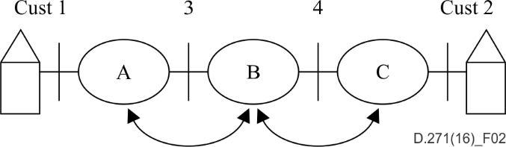

Figure 2 – Three administrations realize a session through intersession (cascaded organization)

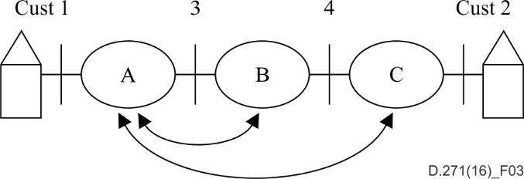

Figure 3 – Three administrations conduct a session through intersession (star organization)

Assumptions:

1) Administrations A and B have an interconnect agreement that determines separately accounting from A to B and accounting from B to A. It is up to the administrations to determine the settlement arrangements.

2) In the cascaded organization (Figure 2), any administration conducting a session deals with only the two parties adjacent to itself:

– the customer or administration A starts the session at the edge of the network and submits the connection to administration B;

– administration B continues the session to administration C at the terminating edge of the network.

For example: Suppose that customer 1 in Figure 2 requests from administration A a (uni-directional) session to customer 2, and that customer 1 is the charged party,

– Administration A will charge customer 1 for the session from customer 1 to customer 2.

– Administration B will charge administration A for the session portion from '3' to customer 2.

– Administration C will charge administration B for the session from '4' to customer 2.

3) In the star organisation (Figure 3), there is one root organization and one or more leaf organizations.

– The administration that establishes the session acts as root and deals with its customer and with each of the administrations acting as a leaf. It establishes the session from the customer to the edge of network interfacing to the next administration.

– An administration acting as leaf deals only with the administration acting as root and, when applicable, with its customer. It establishes the session as requested by the root between two network edges or, when it is the destination administration, between a network edge and its customer.

For example: Suppose that customer 1 in Figure 3 requests from administration A a (unidirectional) session to customer 2, and that customer 1 is the charged party,

– Administration A will charge customer 1 for the session from customer 1 to customer 2.

– Administration B will charge administration A for the session portion from '3' to '4'.

– Administration C will charge administration A for the session from '4' to customer 2.

NOTE – An administration will aggregate only the sessions of the same administration that enters the network. Sessions established for different originating administrations are not combined together.

### 7.2.2 Aggregation within charge elements for accounting

To reduce the number of parameters stored and used for accounting between administrations, parameters of several sessions may be aggregated and summarized into a smaller set of parameters to which a charge is applied. Aggregation takes place over an agreed aggregation period, for example, one month.

The aggregation of session parameters is described in the following subclauses for the three charge elements that build the charging options for NGN services. Subclause 7.2.2.1 describes aggregation for session set‑up charges. Subclause 7.2.2.2 describes aggregation for the reservation-based charges. Subclause 7.2.2.3 describes aggregation for the usage-based charges.

Each subclause describes a generic aggregation that allows for differentiated accounting by session type, distance region or zone and time of day. It is administration-specific whether to apply differentiation in accounting tariffs. Subclause 7.2.3 summarizes the parameters that result from the generic case of differentiated aggregation. Any less differentiated aggregation can be inferred from the parameters for the generic case presented in Table 1.

#### 7.2.2.1 Aggregation for session set‑up charge element

Over the period of aggregation, all instances of session set‑up on the intersession interface are cumulated. For an interface between administrations A and B, this implies that all sessions set up by B at the request of A are counted. Separately, all the sessions set up by A at the request of B are counted. Each of these two counts reflects the accounting information for the session set‑up charging elements over the period of aggregation for one of the parties.

Aggregation of session set‑up charging may be differentiated depending on the characteristics of the session that the administrations choose. Examples are the session mode and the charging period.

#### 7.2.2.2 Aggregation for reservation-based charging element

The reservation-based charging element reflects resources reserved in the network for the session. For a single session, the resource reservation is determined by a number of parameters: the QoS class, the traffic descriptor declared by user and the associated traffic descriptor. The reservation‑related charge may also be affected by other session characteristics as listed in Table 1, for example, the distance between the applicable interfaces (region or zone) and the charging period.

For accounting, aggregation over several parameters for each session is complex. To simplify aggregation of several sessions, each session is assigned to an aggregation group. Each aggregation group contains sessions with the same value of the reservation charge parameter CP\_R(.). For each session, the value of the chargeable packet rate (CPR) is multiplied by the session duration; this yields a number of packets expressing the capacity that has been reserved for that session. The resulting number of packets is added to the group's total of reserved capacity.

Administrations may differentiate the reservation charging parameter with respect to a number of characteristics. For example, it may be expected that the reservation-based charging element may be differentiated according to the following session characteristics (see Table 1).

• QoS class combination;

• session mode (if applicable);

• distance between the applicable interfaces (region or zone);

• charging period.

Therefore, accounting groups may be created for each relevant combination of these characteristics for which a different value of the reservation charging parameter CP\_R(.) is used. Each of the relevant characteristics has a finite number of possibilities, if it is assumed that the distance between the applicable interfaces is distinguished by zones or regions[[1]](#footnote-1). Therefore, the number of aggregation groups required for aggregating the reserved capacity is finite. Per aggregation group, the aggregation results in a single value expressing the aggregated reserved capacity. Multiplication by the reservation charging parameter CP\_R(.) applicable to the group allows conversion into monetary units.

#### 7.2.2.3 Aggregation for usage-based charging element

The usage-based element reflects resources used in the network for the session. For a single session, the resource usage is determined by a number of parameters: the QoS class, the traffic descriptor and the associated number of packets given in clause 5.4. The usage-related charge may also be affected by other session characteristics as listed in Table 1, for example, the distance between the applicable interfaces (region or zone) and the charging period.

For accounting, similar parameters are relevant. In view of the large number of sessions to be accounted for at an intersession interface between two administrations, aggregation of usage charging parameters is described below.

The number of delivered packets is not necessarily available if more than one administration is involved in the session. Also, if it is available, it cannot be verified by both parties involved in intersession administration at an interface. Therefore, the number of delivered packets cannot be used in accounting.

To allow reconciliation of packet counts by both parties, it is recommended that the receiving administration also registers the number of packets discarded by the NPC (if applicable), if an NPC is present at the INI, and that this number is aggregated and specified together with the corresponding number of packets admitted into the network.

Each session yields a number of packets for the usage-based charge in each charging period, at a given interface. To simplify aggregation of several sessions, each session is assigned to an aggregation group. Each aggregation group contains sessions with the same value of the usage charge parameter(s) CP\_U(.). For each session, the relevant number of packets is added to the group's total number of packets. For each aggregation group, separate packet count values are used depending on whether QoS commitments pertain to the packets or not.

The traffic descriptor/QoS combination of a session determines whether:

• QoS commitments pertain to all packets admitted into the network on a compliant session;

• QoS commitments pertain to a subset of the packets admitted into the network on a compliant session;

• QoS commitments do not pertain to packets admitted into the network.

The traffic descriptor/QoS combination of a session thus determines whether one or two values are relevant to reflect the number of packets admitted into the network on the session. The contribution of each session to the aggregated usage-based charge will be its relevant packet count values in the aggregation period.

Administrations may differentiate the usage charging parameter with respect to a number of characteristics. For example, it may be expected that the usage-based charging element may be differentiated according to the following session characteristics (see Table 1).

• traffic descriptor/QoS class combination;

• session mode;

• distance between the applicable interfaces (region or zone);

• charging period.

Therefore, accounting groups may be created for each relevant combination of these characteristics for which a different value of the usage charging parameter CP\_U(.) is used. Each of the relevant characteristics has a finite number of possibilities, if it is assumed that the distance between the applicable interfaces is distinguished by zones or regions1. Therefore, the number of aggregation groups required for aggregating the used capacity is finite. Per aggregation group, the aggregation results in one or more total values expressing the used capacity. Multiplication with the usage charge parameter(s) CP\_U(.) applicable to the group allows conversion into monetary units.

### 7.2.3 Accounting parameters resulting from aggregation for network utilization

The aggregated parameters collected for accounting at an interface pertain to:

• session set-up charge element;

• reservation-based charge element;

• usage-based charge element.

For the session set‑up charging element, the aggregated parameter is the number of session set‑ups at that interface, in a given direction. Different charging periods (time of day) can be applied to the session set‑up charging element.

For the reservation-based charging element and the usage-based charge element, Table 1 gives an overview of the parameters yielded by the generic differentiated accounting described in clauses 7.2.2.2 and 7.2.2.3.

In summary: for both charge elements 'reservation' and 'usage', aggregation is performed separately by:

• QoS class and traffic descriptor combination;

• session mode (if applicable);

• distance between the applicable interfaces (region or zone);

• charging period.

The aggregated parameters for the reservation-based and the usage-based charging elements are both expressed in packets. For 'reservation', they are the chargeable packets that are a result of resource reservations. For 'usage', they are actual packets admitted into the network. Thus, the parameters are of a different nature though expressed in the same unit.

An administration defines values for the charging parameter for reservation CP\_R(.) and for the charge parameter(s) for usage CP\_U(.) to be used for accounting for each combination of traffic descriptor/QoS class, distance region or zone and charging period that it offers. This does not imply that such charging parameters must be different for each combination. In the simplest case, an administration may choose to use a single reservation packet price and a single usage packet price for all traffic descriptor/QoS combinations it offers and for all charging periods.

**7.2.4 Separate charge elements for accounting (FFS)**

**7.2.4.1 Session set‑up charge element (FFS)**

**7.2.4.2 Reservation-based charge element (FFS)**

**7.2.4.3 Usage-based charge element (FFS)**

**7.2.4.4 Accounting parameters aggregation for network utilization (FFS)**

**7.2.5 Accounting parameters resulting from QoS interworking**

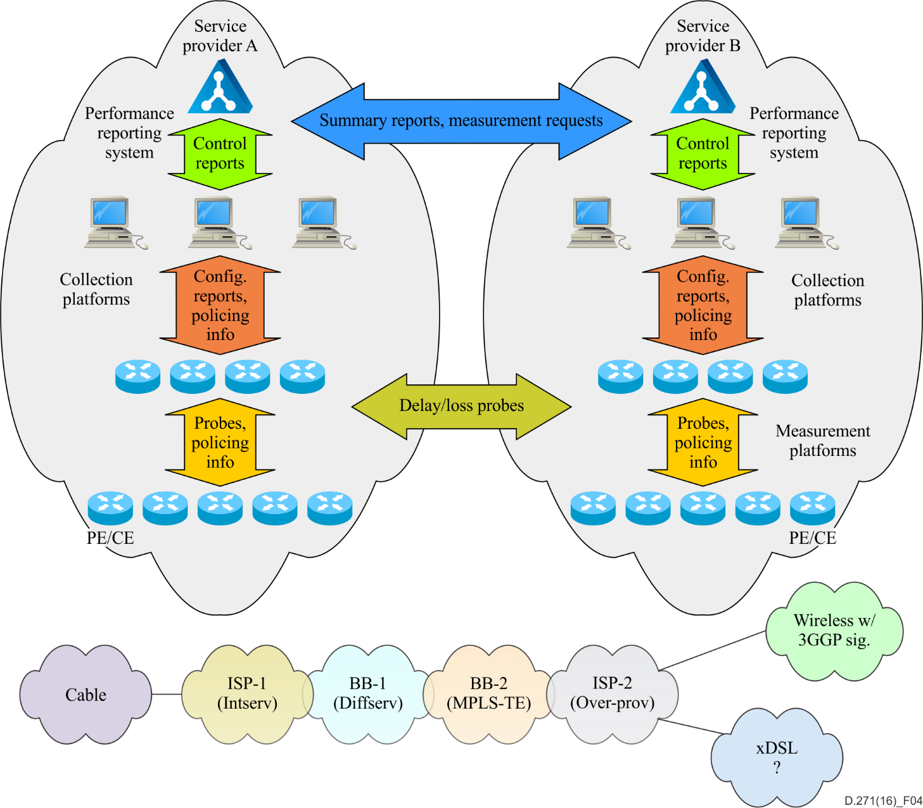

Figure 4 – QoS interworking accounting parameters

For supporting user requested service, administrations may have different QoS mapping policies depending on their network infrastructure.

# 8 Charging parameters

## 8.1 Charging parameters for DiffServ

DiffServ approaches the problem of QoS by dividing traffic into a small number of classes and allocating network resources on a per-class basis. Relevant charging parameters are listed in Table 1.

## 8.2 Charging parameters for SIP-initiated services

SIP is a signalling protocol that has management and control over communication sessions between unicast or multicast sessions. Designed to function in the application layer, it offers a host of applications and services that make use of elements for call setup and signalling for IP-based communications. The inclusion of SIP in this document is due to its capacity to become a strong contender for signalling in the telecommunications for future next generation and ubiquitous networks. Telecom operators must implement appropriate adaptation regarding measuring SIP data passing thru their network. Relevant charging parameters are included in Table1.

8.3 Charging parameter for MPLS

MPLS is a mechanism in high performance telecommunication networks that directs data from one network node to the next based on shortest path labels rather than long network addresses that help to avoid complex lookups in a routing table.

## 8.4 Charging parameter for CDN:

The main purpose of CDNs is to push the content closer to the users in order to decrease the downloading time and to avoid network congestion, which in turn provides for more efficient digital content delivery. It is recommended that the issue of CDNs be revisited and updated in future revisions of this Recommendation.

Bibliography

[b-ITU-T D.224] ITU-T Recommendation D.224 (1999), *Charging and accounting principles for ATM/B-ISDN*.

[b-ITU-T I.112] ITU-T Recommendation I.112 (1993), *Vocabulary of terms for ISDNs*.

[b-ITU-T I.356] ITU-T Recommendation I.356 (2000), *B-ISDN ATM layer cell transfer performance*.

[b-ITU-T I.371] ITU-T Recommendation I.371 (2004), *Traffic control and congestion control in B-ISDN*.

[b-ITU-T I.413] ITU-T Recommendation I.413 (1993), *B-ISDN user-network interface*.

[b-ITU-T I.610] ITU-T Recommendation I.610 (1999), *B-ISDN operation and maintenance principles and functions*.

[b-ITU-T Q.1762] ITU-T Recommendation Q.1762/Y.2802 (2007), *Fixed-mobile convergence general requirements*.

[b-ITU-T Y.1401] ITU-T Recommendation Y.1401 (2008), *Principles of interworking*.

[b-ITU-T Y.2012] ITU-T Recommendation Y.2012 (2006), *Functional requirements and architecture of the NGN release 1*.

[b-ITU-T Y.2091] ITU-T Recommendation Y.2091 (2008), *Terms and definitions for Next Generation Networks*.

[b-ITU-T Y.2111] ITU-T Recommendation Y.2111 (2006), *Resource and admission control functions in Next Generation Networks*.

[b-ITU-T Y.2233] ITU-T Recommendation Y.2233 (2008), *Requirements and framework allowing accounting and charging capabilities in NGN*.

# \_\_\_\_\_\_\_\_\_\_

1. The case where distance is not used as a differentiating factor can be viewed as a case with a single distance region or zone. [↑](#footnote-ref-1)