|  |  |
| --- | --- |
| **Telecommunication Standardization Bureau** |  |
|  |  |

Geneva, 19 February 2013

|  |  |  |
| --- | --- | --- |
| Ref: | **TSB Collective letter 1/SG3RG-AO** |  |
| Tel: Fax:  E-mail: | +41 22 730 6311 +41 22 730 5853 [tsbsg3@itu.int](mailto:tsbsg3@itu.int) | * To the members of the Study Group 3 Regional Group for Asia and Oceania (SG3RG-AO) |

|  |  |
| --- | --- |
| **Subject:** | **Meeting of the Study Group 3 Regional Group for Asia and Oceania (SG3RG-AO), Tokyo, Japan, 9-10 April 2013** |

Dear Sir/Madam,

We are pleased to inform you that, at the kind invitation of the Ministry of Internal Affairs and Communications of Japan (MIC), ITU-T Study Group 3 Regional Group for Asia and Oceania (SG3 RG-AO) will hold its meeting at the Keio Plaza Hotel, Tokyo, Japan, on 9 (afternoon) and 10 April 2013.

The meeting will be preceded by a one and a half day Seminar, focusing on costs and tariff issues, and country cases organized by the Telecommunication Development Bureau (BDT), which will take place on 8 and 9 (morning) April 2013.

The BDT Seminar will start at 0930 hours on Monday 8 April 2013. The meeting of the SG3RG-AO will start at 1400 hours on Tuesday 9 April. The event will be restricted to delegates and representatives of administrations and operating agencies of the region, in conformity with §2.3.2 of Section 2 of Resolution 1 of the WTSA-12.

Participant registration will begin at 0830 hours at the Keio Plaza hotel. Detailed information concerning the meeting rooms will be displayed at the entrances of the venue. Additional information about the meeting is set forth in **Annex A.**

The draft **Agenda** of the meeting, as prepared by the Chairman of SG3RG-AO, is set out in **Annex B**.

Practical information relating to the venue is enclosed as **Annex C.**

I wish you a productive and enjoyable meeting.

Yours faithfully,

Malcolm Johnson  
Director of the Telecommunication  
Standardization Bureau

Annexes: 3

**ANNEX A**(to TSB Collective letter 1/SG3RG-AO)

**MAKING CONTRIBUTIONS**

**DEADLINES FOR CONTRIBUTIONS:** We invite you to submit your contributions by electronic mail to the following address [tsbsg3@itu.int](mailto:tsbsg3@itu.int). The deadline for contributions is 12 (twelve) calendar days before the meeting. Such contributions will be published on the Study Group 3RG-AO website and must therefore be received by TSB **not later than 27 March 2013**.

**TEMPLATES:** Please use the provided set of templates to prepare your contribution. The templates are accessible at <http://itu.int/ITU-T/studygroups/templates>. The name, fax and telephone numbers and e-mail address of the person to be contacted about the contribution should be indicated on the cover page of all documents.

**WORK METHODS AND FACILITIES**

**INTERPRETATION:** In agreement with the Chairman of the SG3RG-AO, the seminar and the meeting will be conducted in English, without interpretation.

**WIRELESS LAN:** Facilities and Internet access will be available at the venue of the event.

**REGISTRATION and FELLOWSHIPS**

**REGISTRATION:** To enable the organisers to make the necessary arrangements, please send by letter, fax (+41 22 730 5853) or e-mail ([tsbreg@itu.int](mailto:tsbreg@itu.int)) **not later than 2 April 2013**, the list of people who will be representing your Administration, Sector Member, Associate, Academic Institution, regional and/or international organization or other entity. Administrations are requested also to indicate the name of their head of delegation (and deputy head, if applicable).

**Please note that pre-registration of participants to ITU-T meetings is carried out *online* at the ITU-T website   
(**[**http://www.itu.int/en/ITU-T/studygroups/2013-2016/03/sg3rgao/Pages/default.aspx**](http://www.itu.int/en/ITU-T/studygroups/2013-2016/03/sg3rgao/Pages/default.aspx) **).**

**FELLOWSHIPS:** We are pleased to inform you that one partial fellowship for each eligible country **within the Asia and Oceania region only,** will be awarded, subject to available funding, to facilitate participation from Least Developed or Low Income Developing Countries (<http://itu.int/en/ITU-T/info/Pages/resources.aspx>).  Fellowship requests (please use enclosed **Form 1)**, must be returned to ITU not later than **11 March 2013.**

**KEY DEADLINES (before meeting)**

11 March: -fellowship requests

27 March: -contributions

2 April: -registration

**FORM 1 - FELLOWSHIP REQUEST**

(to TSB Collective letter 1/SG3RG-AO)

|  |  |  |  |  |  |  |  |
| --- | --- | --- | --- | --- | --- | --- | --- |
|  | **ITU-T Study Group 3RG-AO meeting** and **Associated BDT Seminar**  Tokyo, Japan, 8-10 April 2013 | | | | | |  |
| **Please return to:** | | | **ITU**  **Geneva (Switzerland)** | | **E-mail :** [**bdtfellowships@itu.int**](mailto:bdtfellowships@itu.int)  **Tel: +41 22 730 5227**  **Fax: +41 22 730 5778** | | | |
| **Request for one partial fellowship to be submitted before  11 March 2013** | | | | | | | |
|  | | | | Participation of women is encouraged | | |  | |
| Registration Confirmation I.D. No: …………………………………………………………………………… (Note: It is imperative for fellowship holders to pre-register via the on-line registration form at <http://www.itu.int/en/ITU-T/studygroups/2013-2016/03/sg3rgao/Pages/default.aspx> )  **Country: _____________________________________________________________________________________________________**  **Name of the Administration or Organization: ______________________________________________________________________**  **Mr. / Ms. _______________________________________(family name) ______________________________________(given name)**  **Title: ____________________________________________________________________________________________________** | | | | | | | | |
| **Address: ____________________________________________________________________________________________________**  **______________________________________________________________________________________________________________**  **Tel.: ____________________________ Fax: ____________________________ E-Mail:_________________________________**  **PASSPORT INFORMATION :**  **Date of birth: _______________________________________________________________________________________________**  **Nationality: __________________________________________ Passport number: ________________________________________**  **Date of issue: ___________________ In (place) : _____________________________Valid until (date): _______________________** | | | | | | | | |
| **Please select your preference for one of the two options below:** | | | | | | | | |
|  | | | | | | | | |
| **□ Economy class air ticket (duty station / Japan / duty station).**  **□ Daily subsistence allowance intended to cover accommodation, meals & misc. expenses.** | | | | | | | | |
|  | | | | | | | | |
| **Signature of fellowship candidate:** | | | | | | **Date:** | | |
| **TO VALIDATE FELLOWSHIP REQUEST, NAME, TITLE AND SIGNATURE OF CERTIFYING OFFICIAL DESIGNATING PARTICIPANT MUST BE COMPLETED BELOW WITH OFFICIAL STAMP.**  **N.B. IT IS IMPERATIVE THAT FELLOWS BE PRESENT FROM THE FIRST DAY TO THE END OF THE MEETING.** | | | | | | | | |
| **Signature** | | | | | | **Date** | | |

**ANNEX B**(to TSB Collective letter 1/SG3RG-AO)

**Draft Agenda**

1. Opening of the meeting
2. Adoption of the agenda
3. Available documents
4. Review of SG3RG-AO and ITU activities
5. SG3RG-AO/TAS cost model enhancements (LRIC)
6. Results of WCIT-12
7. Results of WTSA-12
8. Traffic declarations and settlement procedures
9. Accounting rate issues:

9.1 Mobile termination charge and mobile roaming

9.2 Shortening of the settlement period (D.195) and establishment of a dispute resolution procedure

9.3 Discussion on network externalities

9.4 Settlement of mobile data communication including SMS, MMS, Video/Music

9.5 Financial aspects of network security

9.6 NGN Charging

1. IP Telephony
2. IP traffic recording
3. International Internet Connectivity
4. Effect of migration of traditional traffic to hubbing
5. Review of International Telecommunication Regulations
6. Future work programme
7. Other business
8. Next meeting

**ANNEX C**(to TSB Collective letter 1/SG3RG-AO)

**Practical information for participants**

1. **VENUE**

**Keio Plaza Hotel Tokyo**

**Address:** 2-2-1 Nishi-Shinjuku, Sinjuku-ku, Tokyo 160-8330, Japan

**Tel**: +81 3 3344 0111

**Fax**: +81 3 3345 8269

**Website**: <http://www.keioplaza.com/>

The area map nearby the Keio Plaza Hotel Tokyo is referred to Figure 1.

In the meeting room, delegates can connect to the Internet using their laptops with a wireless LAN card (802.11b/g). WEP key/ SSID will be informed at the venue.

1. **CONFERENCE FACILITIES AND REGISTRATION**

For Participants of SG3 RG-AO, registration services will be available at the **ASAHI** room (Secretariat’s room) on the 44th floor during the specified times.

- Sunday 7 April between 15:00 and 18:00

- Monday 8 and Tuesday 9 April between 08:30 and 16:00

- Wednesday 10 April between 08:30 and 11:00

The meeting will open at 09:00 hours at the **AKEBONO** room next to the **ASAHI** room.

1. **ACCESS TO The Keio Plaza Hotel Tokyo**

Participants from foreign countries will enter Japan through **Narita Airport** (New Tokyo International Airport) or **Haneda Airport (**Tokyo International Airport)

Narita Airport: <http://www.narita-airport.jp/en/index.html>

Haneda Airport: <http://www.haneda-airport.jp/inter/en/>

The recommended transportation options from either airport to the venue are described in following below.

* 1. **From Narita Airport to the Keio Plaza Hotel Tokyo**
* Narita Airport limousine

There is a direct limousine bus from Narita Airport to the Keio Plaza Hotel Tokyo.

Airport ticket counters are located in the arrival lobbies of terminal 1 and 2 at the Narita Airport. The Airport limousine bound for the Keio Plaza Hotel Tokyo leaves every 30 to 40 min and takes about 120 min. For more detailed information, please see the following Web site:

Airport limousine: <http://www.limousinebus.co.jp/en/platform_searches/index/2/18>

* JR Narita Express train

The JR Narita Express (N’EX) bound for Sinjuku Station (or Ikebukuro Station) leaves every 30 to 60 min and takes about 90 min. It takes 5 min by walking from West Exit, Shinjuku Station to the Keio Plaza Hotel Tokyo. For more detailed information, please see the following Web site:

JR Narita Express (N’EX) train:

<http://www.narita-airport.jp/en/access/train/index.html>

<http://jreast-shinkansen-reservation.eki-net.com/pc/english/common/timetable/e_nex_u/index.html>

* 1. **From Haneda Airport to the Keio Plaza Hotel Tokyo**
* Haneda Airport limousine

There is a direct limousine bus from Haneda Airport to the Keio Plaza Hotel Tokyo.

The Airport limousine bound for the Keio Plaza Hotel Tokyo leaves every 60 min and take about 75 min. For more detailed information, please see the following Web site:

Airport limousine: <http://www.limousinebus.co.jp/en/platform_searches/index/4/18>

The figures below show the several ways and details to access to the venue from Narita Airport or Haneda Airport.

1. **HOTELS**
   1. **Keio Plaza Hotel Tokyo**

The Keio Plaza Hotel Tokyo has hold rooms for the participants of SG3 RG-AO at the following preferential rates.

|  |  |
| --- | --- |
| Room Rate (JPY)  (including breakfast) | |
| Single use | 16,000 |
| Twin use | 18,000 |

All reservation requests must be made no later than 17th of March 2013. Availability and room rates are not guaranteed after this date. Participants are requested to book directly to the hotel by sending e-mail using the Reservation Form 2. The reservation will be valid upon receipt for confirmation from the Keio Plaza Hotel Tokyo by fax or e-mail.

* 1. **Other Hotels in Shinjuku area**

The following hotels are recommended in Shinjuku area. Participants are requested to book your hotel room by contacting directly to the hotel. Rooms of below three hotels have not been hold for participants of SG3 RG-AO, therefore, participants are requested to book their hotel rooms as early as possible.

|  |  |  |  |  |
| --- | --- | --- | --- | --- |
|  | | Room Rate (SAMPLE,JPY) | | Remark |
| **Shinjuku Washington Hotel** |  | Single use | 14,400 - 15,400 | 6 minute walk to the venue |
|  | Twin use | 17,000 – 20,000 |
| URL | <http://shinjuku.washington-hotels.jp/> | |
| **Kadoya Hotel** |  | Single use | 7,560 - 11,870 | 2 minute walk to the venue |
|  | Twin use | 13,650 - 17,750 |
| URL | <http://www.kadoya-hotel.co.jp/eng/> | |
| **Keio Presso Inn Shinjuku** |  | Single use | 9,400 | 8 minute walk to the venue |
|  | Twin use | 13,500 |
| URL | <http://www.presso-inn.com/en/hotel/shinjuku.html> | |

The locations of these three hotels are referred to Figure 1.

1. **VISA AND IMMIGRATION INFORMATION:**

Participants who require a visa should apply for a visa at a Japanese consulate or diplomatic mission in their respective country well in advance of their departure.

Participants are also advised to contact their local travel agents or carriers. The Embassy may take at least two weeks for visa processing.

For more information, please visit the website of the Ministry of Foreign Affairs of Japan at:

<http://www.mofa.go.jp/j_info/visit/visa/>

Participants who need an invitation letter and/or visa supporting documents for entering Japan shall fill out all items in Application Form 3, then fax or email the form to the following contact point together with a copy of photograph page of the passport no later than 6th of March 2013.

Hideki Suganami (Mr.) / Junkichi Fujisawa (Mr.)

The ITU Association of Japan

Phone: +81 3 5357 7625/+81 3 5357 7626

Fax: +81-3-3356-8170

E-mail: [sg3-visa@ituaj.jp](mailto:sg3-visa@ituaj.jp) (Email is the preferable communication means.)

1. **TECHNICAL TOUR**

Half day Technical Tour will be planned. Detail will be announced at the meeting.

1. **PRACTICAL INFORMATION**
   1. **About Tokyo:**

Tokyo, the capital of Japan, is one of the largest cities of the world with a population of 13-million.

<http://www.metro.tokyo.jp/ENGLISH/>

* 1. **Weather:**

The temperature in Tokyo during April ranges from 5 to 15urary degrees centigrade. Average rainfall in April is about 130 mm in Tokyo.

* 1. **Time Zone:** GMT + 9 hours.
  2. **Banks & Currency:**

The Japanese currency unit is Japanese Yen (JPY). There are four kinds of bills (10,000 yen, 5,000 yen, 2,000 yen and 1,000 yen) and six kinds of coins (500 yen, 100 yen, 50 yen, 10 yen, 5 yen and 1 yen) used. Only Japanese Yen (JPY) is accepted at stores and restaurants. Major foreign currencies may be exchanged to JPY at foreign exchange banks at the International Airports on presentation of your passport. Japanese banks are usually open Monday to Friday from 9:00 to 15:00. The exchange rate as of 15th February 2012 is 91 Japanese Yen to 1 US Dollar. Major credit cards are accepted by most hotels, restaurants, department stores, but not local small shops.

* 1. **Tipping:** Tipping is not customary in Japan.
  2. **Electricity:** The standard power supply in Japan is 100 volts. The frequency is 50 Hz in eastern Japan including Tokyo. The type of power outlet/connector used in Japan is

A type which is a two-parallel-pronged type.

1. **LOCAL CONTACT POINT:**

For any information and arrangement of the events please contact:

INAMI Toshiyuki (Mr.)

Standardization Division, Ministry of Internal Affairs and Communications

Phone: +81-3-5253-5771, Fax: +81-3-5253-5764

E-mail: [sg3-local@ml.soumu.go.jp](mailto:sg3-local@ml.soumu.go.jp)

(Email is the preferable communication means)

**Transportation from Narita or Haneda Airport to the Venue**

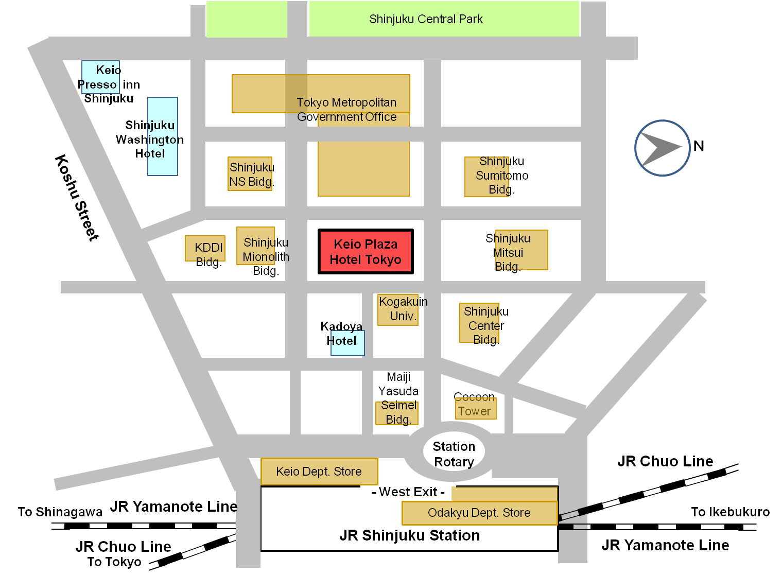

**Figure 1 - Area Map nearby Keio Plaza Hotel Tokyo**

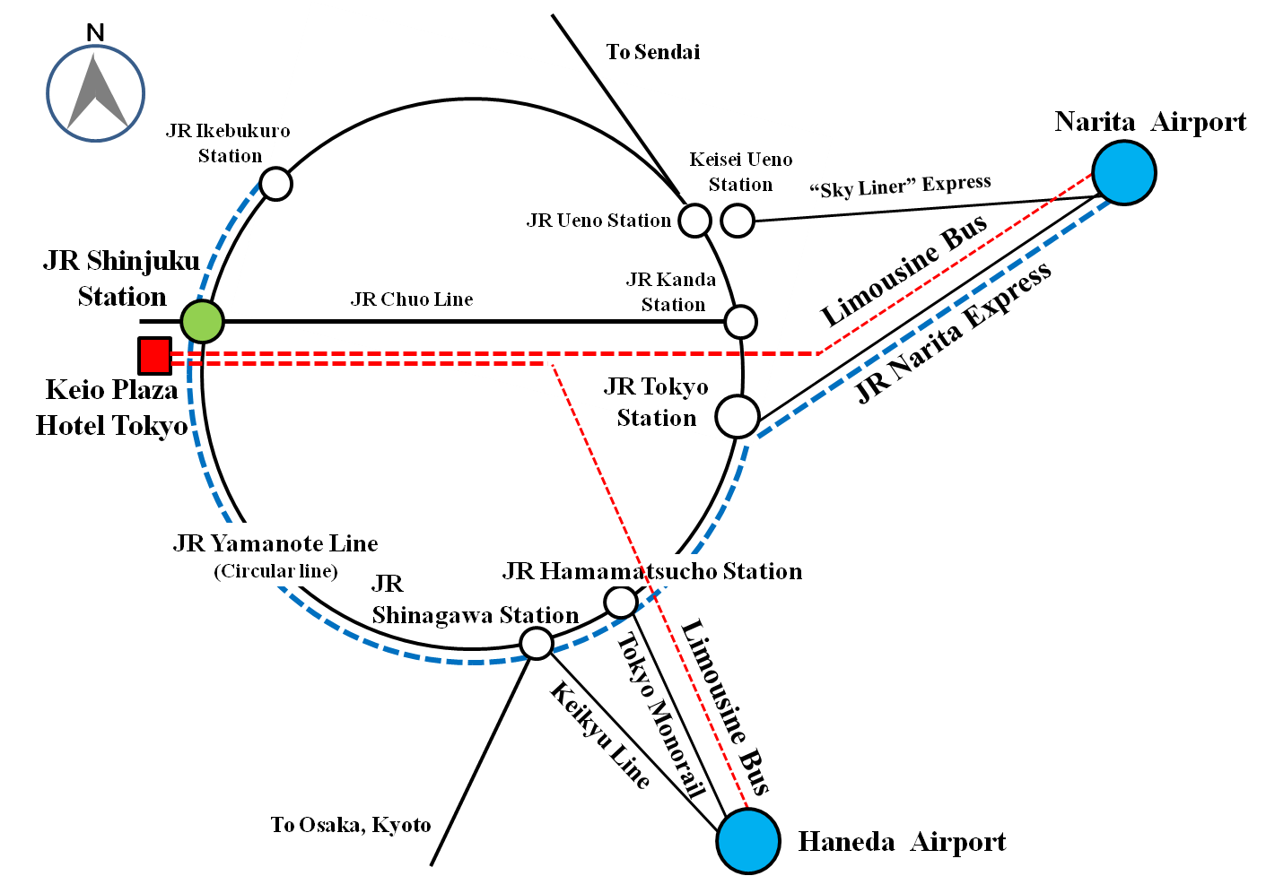

**Figure 2 - Transportation Map from Narita Airport or Haneda Airport**

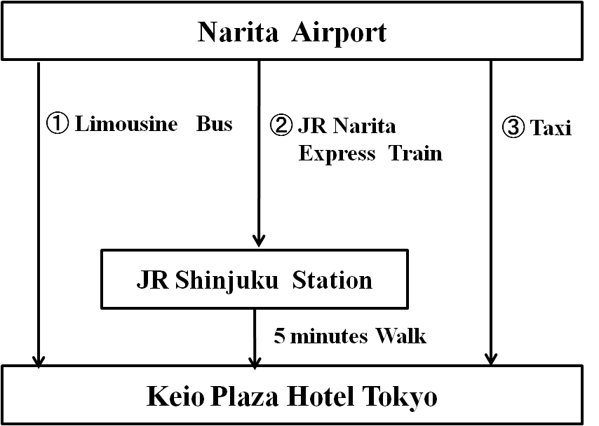

**Figure 3 - Transportation from Narita Airport to the Venue**

**Table 1 - Time required and Vehicle Fee of Transportation from Narita Airport to the Venue**

(Numbers in row correspond to numbers in Figure 3)

|  |  |  |  |  |
| --- | --- | --- | --- | --- |
| No. | Vehicle | Approx. Time Required (minutes) | Vehicle Fee  (JPY) | Remarks |
| 1 | Limousine bus | 120 | 3,000 |  |
| 2 | JR Narita Express Train | 90 | 2,940 |  |
| 3 | Taxi | 100 | approx. 24,000 | not including expressway fare |

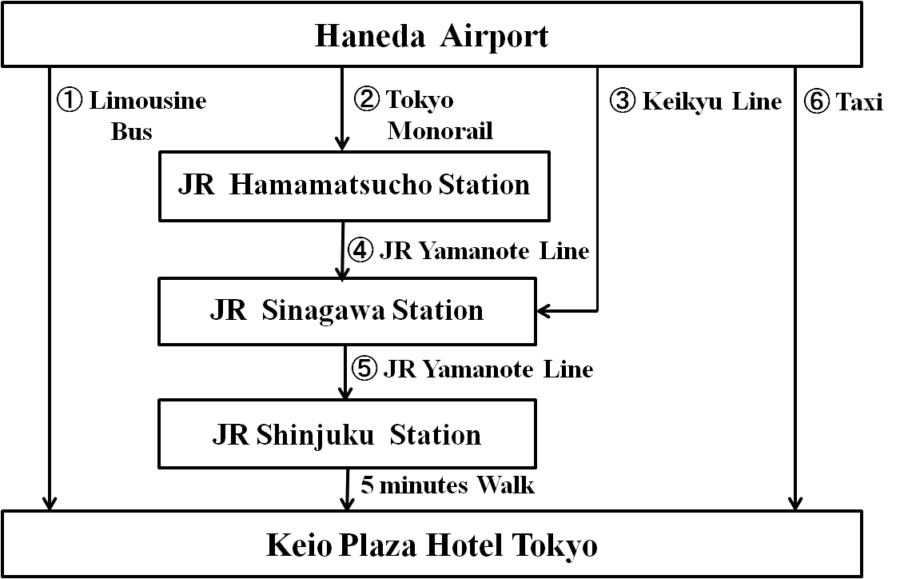

**Figure 4 - Transportation from Haneda Airport to the Venue**

**Table 2 - Time required and Vehicle Fee of Transportation from Haneda Airport to the Venue**

(Numbers in row correspond to numbers in Figure 4)

|  |  |  |  |  |
| --- | --- | --- | --- | --- |
| No. | Vehicle | Approx. Time Required (minutes) | Vehicle Fee  (JPY) | Remarks |
| 1 | Limousine bus | 75 | 1,200 |  |
| 2 | Tokyo Monorail | 20 | 470 |  |
| 3 | Keikyu Line | 20 | 400 |  |
| 4 | JR Yamanote Line | 6 | 190 |  |
| 5 | JR Yamanote Line | 19 |
| 6 | Taxi | 50 | approx.8,600 | not including expressway fare |

**FORM 2 – Keio hotel reservation form**

(to TSB Collective letter 1/SG3RG-AO)

|  |
| --- |
| ITU-T SG3 RG-AO  Tokyo, Japan, 8-10 April 2013 |
| PLEASE complete and return this form **by e-mail** to: Hotel Reservation Counter (E-mail Address: [**rooms-sales@keioplaza.co.jp**](mailto:rooms-sales@keioplaza.co.jp))  **Deadline of Submission : 17TH of MARCH 2013** - SG3RG-AO |
| Name:  |  |  |  |  |  |  | | --- | --- | --- | --- | --- | --- | | (🖵Mr.🖵Ms.🖵Dr.): |  |  |  |  |  | |  | Family Name |  | Middle Name |  | Given Name |   **Organization:**  **Full Address:** 🖵 (Office 🖵Home) Country:Address:Phone No. Fax No. E-mailName of Accompanying Person(s), if any:  |  |  |  |  |  |  | | --- | --- | --- | --- | --- | --- | | (🖵Mr.🖵Ms.🖵Dr.): |  |  |  |  |  | |  | Family Name |  | Middle Name |  | Given Name |  PASSPORT INFORMATION:Passport No. : Expiry Date: / / (DD/MM/YYYY)Nationality:Room Type : 🖵**Single use (15,000 JPY)** 🖵**Twin use (18,000 JPY)**  **Check-in and Check-out Date:**  **Check in date**: / / (DD/MM/YYYY) **Check out date:** / / (DD/MM/YYYY)  **Smoking or Non Smoking**  🖵**Smoking Room** 🖵**Non Smoking Room**  **Credit Card**  🖵**MasterCard** 🖵**VISA** 🖵**JCB** 🖵**American Express** 🖵**Diners Club**  **Card number:**  **Name of card holder:** **Expiry Date :** / / (DD/MM/YYYY)  **Conformation Reply from Hotel:**  🖵**Fax Your Fax No.**  🖵**E-mail　Your E-mail Address** |
| **Date: Signature:** |

**FORM 3 – Application form for Visa Supporting document**

(to TSB Collective letter 1/SG3RG-AO)

|  |
| --- |
| **ITU-T SG3 RG-AO**  **Tokyo, Japan, 8-10 April 2013** |
| **Application Form for Visa Supporting Documents** | |
| Name  |  |  |  |  |  |  | | --- | --- | --- | --- | --- | --- | | (🖵Mr. 🖵Ms. 🖵Dr.) |  |  |  |  |  |  aaa Family Name Middle Name Given Name Your full name in Chinese characters(*):  **\*If you are a Chinese participant, please write your name in Chinese characters.** Official TitleDepartment:Organization **(**)**:  **\*\*If you are a Chinese participant, please write your organization in Chinese characters as well.** Country (where you live)Address (*1): **(*1) VISA supporting documents will be sent to the address above by courier service.** Phone No. Fax No. E-mailPASSPORT INFORMATION:Passport No. : Date of Issue: / / (DD/MM/YYYY)Expiry Date : / / (DD/MM/YYYY)Place of Birth: Date of Birth: / / (DD/MM/YYYY)Nationality: **FLIGHT INFORMATION**(*2) **:**  **Arrival** in Tokyo (Haneda / Narita) from city Date / / Flight No. Time  **Departure** from Tokyo(Haneda/Narita) to city Date / / Flight No. Time  **(*2) For VISA supporting documents, a planned flight schedule is available as well.**  **HOTEL ACCOMMODATION**  This information is **NOT for hotel reservation order sheet, but NEEDED for staying schedule for visa supporting documents.** Hotel name : **Check in date**: / / (DD/MM/YYYY) **Check out date**: / / (DD/MM/YYYY) If making your own accommodation arrangement other than recommended hotels in Tokyo, please indicate your contact address and phone number:Hotel Address **Hotel phone No.**  **Date: Signature:**  **Deadline of Submission: 7th of March 2013 for all visa related documents** | |
| **Please Return this form To:**  Hideki Suganami (Mr.) / Junkichi Fujisawa (Mr.)  The ITU Association of Japan  Phone: +81 3 5357 7625/+81 3 5357 7626 Fax: +81-3-3356-8170  E-mail: [sg3-visa@ituaj.jp](mailto:sg3-visa@ituaj.jp) **(Email is the preferable communication means)** | |

___________________