|  |  |  |  |  |
| --- | --- | --- | --- | --- |
| itu_logo | | **International telecommunication union**  **Telecommunication Standardization Bureau** | |  |
|  | | | Geneva, 6 November 2015 | |
| Ref: | **TSB Collective letter 2/20** | | - To Administrations of Member States of the Union;  - To ITU‑T Sector Members;  - To ITU‑T SG 20 Associates; and  - To ITU Academia | |
| Tel: | +41 22 730 6301 | |
| Fax: | +41 22 730 5853 | |
| E-mail: | [tsbsg20@itu.int](mailto:tsbsg20@itu.int) | |  | |
| Subject: | **Meeting of Study Group 20; Singapore, 18-26 January 2016** | | | |

Dear Sir/Madam,

It is my pleasure to invite you to attend Study Group 20 on *IoT and its applications including smart cities and communities*) which is to meet in Singapore from 18 to 26 January 2016 inclusive at the kind invitation of the Infocomm Development Authority of Singapore (IDA). The SG20 meeting will be preceded by a Forum on Internet of Things in Smart Sustainable Cities: A New Age of Smarter Living which will take place on 18 January 2016.

I should like to inform you that the meeting will open at 1700 hours on the first day. Participant registration will begin at 0830 hours. Detailed information concerning the meeting rooms will be available onsite and provided at the registration desk. General information about the meeting is set forth in **Annex A**, while practical information can be found in **Annex B**.

The draft **agenda** of the meeting, as prepared by the Chairman of the study group (Mr Nasser Al Marzouqi, United Arab Emirates), is set out in **Annex D**. The draft **timetable** will be made available at:[http://itu.int/go/tsg20](http://www.itu.int/go/tsg20).

I would like to take this opportunity to inform you that a meeting of the Joint Coordination Activity on Internet of Things and Smart Cities & Communities (JCA-IoT&SCC) will take place during this SG20 meeting.

Kindly note that some sessions will take place during the weekend.

I wish you a productive and enjoyable meeting.

Yours faithfully,

Chaesub Lee  
Director of the Telecommunication  
Standardization Bureau

**Annexes**: 4

**ANNEX A**

(to TSB Collective letter 2/20)

**MAKING CONTRIBUTIONS**

**DEADLINES FOR CONTRIBUTIONS:** The deadline for contributions is 12 (twelve) calendar days before the meeting. Such contributions will be published on the Study Group 20 website and must therefore be received by TSB **not later than 5 January 2016.** Contributions received at least **two** months before the start of the meeting may be translated, if requested.

**DIRECT POSTING/DOCUMENT SUBMISSION:** A direct posting system for contributions is available on-line.   The direct posting system allows ITU‑T members to reserve contribution numbers and to upload/revise contributions directly to the ITU‑T web server.  Further information and guidelines for the direct posting system are available at the following address: <http://itu.int/net/ITU-T/ddp/>.

**TEMPLATES:** Please use the provided set of templates to prepare your meeting documents.  The templates are accessible from each ITU‑T study group web page, under “Delegate resources” (<http://itu.int/ITU-T/studygroups/templates>).  The name, fax and telephone numbers and e-mail address of the person to be contacted about the contribution should be indicated on the cover page of all documents.

**WORK METHODS AND FACILITIES**

**INTERPRETATION:** As per agreement of ITU-T SG20 management team, this meeting will be held in English only.

**PAPERLESS MEETINGS:** The meeting will be run paperless.

**WIRELESS LAN** facilities will be available for use by delegates at the venue. Detailed information is available in **ANNEX B** item 6.

**PRINTERS:** Printers will be made available to the delegates at the venue of the event.

**REGISTRATION, NEW DELEGATES and FELLOWSHIPS**

**REGISTRATION:** To enable TSB to make the necessary arrangements, please send by letter, fax (+41 22 730 5853) or e-mail ([tsbreg@itu.int](mailto:tsbreg@itu.int)) **not later than 18 December 2015**, the list of people who will be representing your Administration, Sector Member, Associate, Academic Institution, regional and/or international organization or other entity. Administrations are requested also to indicate the name of their head of delegation (and deputy head, if applicable).

**Please note that pre-registration of participants to ITU-T meetings is carried out *online* at the ITU‑T website (**[**http://itu.int/en/ITU-T/studygroups/2013-2016/20**](http://itu.int/en/ITU-T/studygroups/2013-2016/20/)**).**

**FELLOWSHIPS:** We are pleased to inform you that two partial fellowships per administration will be awarded, subject to available funding, to facilitate participation from Least Developed or Low Income Developing Countries (<http://itu.int/en/ITU-T/info/Pages/resources.aspx>). Please further note that when two (2) partial fellowships are requested, at least one must be an economy class air ticket. An application for a fellowship must be authorized by the relevant Administration of the ITU Member State. Fellowship requests (please use enclosed **Form 1)**, must be returned to ITU not later than **7 December 2015**.Please note that the decision criteria to grant a fellowship include: the available TSB budget; contributions by the applicant to the meeting; equitable distribution among countries and regions, and gender balance.

**VISAS**: To enter Singapore, you may need a letter of introduction (Form V39A) from the host, which you will need to present to the Singapore Embassy/Consulate in your area in order to obtain your visa (see **ANNEX C** for the Invitation letter). The visa must be requested and obtained from the office (embassy or consulate) representing Singapore in your country or, if there is no such office in your country, from the one that is closest to the country of departure. Please be aware that visa approval might take time so kindly make your visa request as soon as possible.

**KEY DEADLINES (before meeting)**

|  |  |  |
| --- | --- | --- |
| Two months | 18 November 2015 | - submit contributions for which translation is requested |
| Six weeks | 7 December 2015 | - fellowship requests |
| Four weeks | 21 December 2015 | - requests for visa support letters |
| One month | 18 December 2015 | - pre-registration |
| 12 calendar days | 5 January 2016 | - final deadline for contributions |

# ANNEX B (to TSB Collective letter 2/20) PRACTICAL INFORMATION

## Meeting Venue

The meeting will be held on the Level 3 of Suntec Singapore Convention & Exhibition Centre.

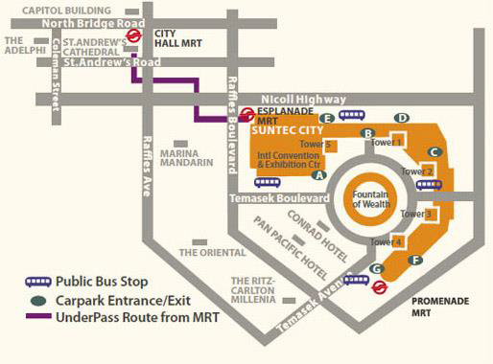The contact details of the venue is as follows:

Suntec Singapore

Convention & Exhibition Centre

1 Raffles Boulevard

Singapore 039593

## Transportation and site information

**Transportation:**

## The venue is approximately 20km from Singapore Changi Airport and it takes about 20 minutes by car from Singapore Changi Airport to the venue.

## Public Taxi

## Public Taxi is readily available at all terminals at Singapore Changi Airport.

## All taxis are metered. Fares must be charged according to the taxi meter, plus applicable surcharges. More information can be found here: <http://www.taxisingapore.com/taxi-fare/>

## Public Train (Mass Rapid Transit, MRT)

* + The train station is accessible by foot from Terminal 2 or Terminal 3.
  + To get to the city, transfer to the westbound train at Tanah Merah station. The last train that connects to the last westbound train at Tanah Merah station leaves Changi Airport station at 11.18pm. All the trains and gantries at the stations are luggage-friendly.
  + Suntec Singapore Convention & Exhibition Centre is accessible via Promenade station, Esplanade station or City Hall station.

## Passports and Visas

Generally, foreigners who do not require visas for entry and are visiting Singapore as tourists may be given up to 30-day social passes upon their arrival in Singapore. All foreign visitors entering Singapore must have a valid passport. Visitors from countries whose citizens require a visa should at the earliest time and well in advance of travel apply for a visa at a Singapore Embassy or consulate. Please visit the following website to check if you require a visa for entry into Singapore: <http://www.ica.gov.sg/page.aspx?pageid=96&secod=94>

For an introduction letter, please see **Annex C**.

## Climate – during January

Monthly Average values of the temperature and precipitation in Singapore are given in the table below:

|  |  |
| --- | --- |
|  | June |
| Average Max Temperature | 30http://www.travelchinaguide.com/images/c-words/degree.gifC / 86http://www.travelchinaguide.com/images/c-words/degree.gifF |
| Average Minimum Temperature | 24http://www.travelchinaguide.com/images/c-words/degree.gifC / 75http://www.travelchinaguide.com/images/c-words/degree.gifF |
| Average Precipitation | 200mm |

## <http://www.nea.gov.sg/weather-climate>

## Hotels

Hotels close to the venue:

**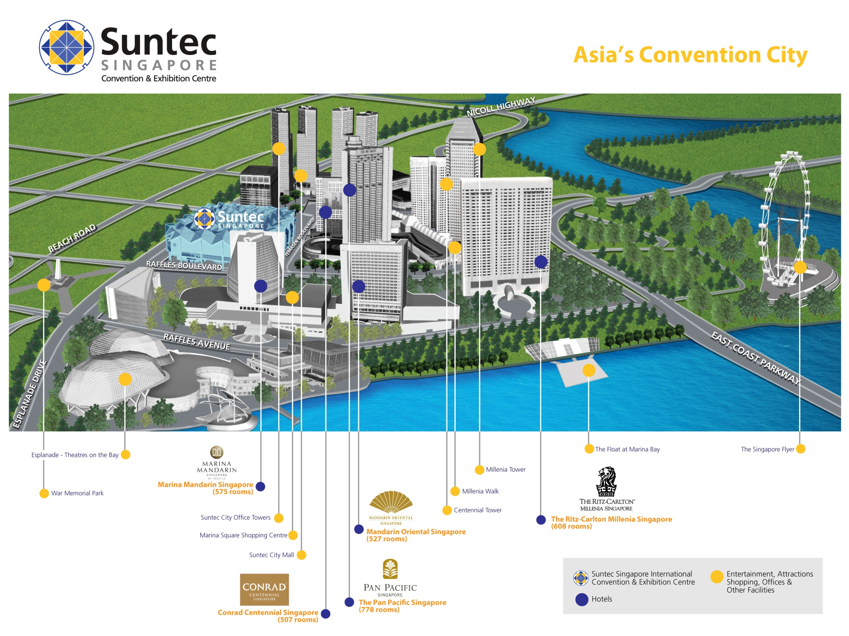**

* Conrad Centennial Singapore
  + 2 Temasek Boulevard, Singapore 038982

Website: [www.conradhotels.com](http://www.conradhotels.com)

* Marina Mandarin Singapore
  + 6 Raffles Boulevard, Marina Square, Singapore 039594

Website: [www.meritushotels.com](http://www.meritushotels.com)

* Mandarin Oriental Singapore
  + 5 Raffles Avenue, Marina Square, Singapore 039797

Website: [www.mandarinoriental.com](http://www.mandarinoriental.com)

* Pan Pacific Singapore
  + 7 Raffles Boulevard, Marina Square, Singapore 039595

Website: [www.panpacific.com](http://www.panpacific.com)

* Ritz-Carlton Millenia Singapore
  + 7 Raffles Avenue, Singapore 039799

Website: [www.ritzcarlton.com](http://www.ritzcarlton.com)

## Internet access and wireless coverage

All meeting rooms will have a wireless network with access to the Internet. Every guest room offers a high-speed Internet access for free. The access to Internet will be granted using the LAN technologies listed below:

* Wireless via WiFi: 802.11bgn and 802.11ac – Both accessible on 2.4GHz and 5GHz

## Technical assistance

In case you have any technical problem at the venue (e.g. connecting to internet, finding meeting rooms etc.) please contact for help:

* Ms Mary Ho ([mary.ho@suntecsingapore.com](mailto:mary.ho@suntecsingapore.com)); or
* Mr Edwin Low ([edwin\_kf\_low@ida.gov.sg](mailto:edwin_kf_low@ida.gov.sg)).

## Electricity

[](http://www.google.co.uk/url?sa=i&source=imgres&cd=&cad=rja&uact=8&ved=0CAkQjRwwAGoVChMIqePRhdyRyAIVhbsUCh37dQ38&url=http://www.iec.ch/worldplugs/typeG.htm&psig=AFQjCNGiOpj9trMWrii6P9kJM37hmucNYA&ust=1443254479199112)Singapore’s voltage is 220-240 volts AC, 50 cycles per second. Most hotels can provide visitors with a transformer, which can convert the voltage to 110-120 volts 60 cycles per second. The power plugs used in Singapore are of the three-pin, square shaped type.

## Useful information

*Currency exchange*

# The currency in Singapore is the Singapore Dollar. Apart from banks and hotels, money can be changed wherever the sign “Licensed Money Changer” is displayed. Most shopping complexes have a licensed money changer. Visitors are discouraged from changing money with unlicensed money changers

# Exchange rate:

# Online exchange rates are shown at: <http://www.xe.com/>

Exchange rate as of 3 November 2015:

|  |  |
| --- | --- |
| US Dollar: 1$ | 1.3992 SGD |
| Euro: 1€ | 1.5315 SGD |

## Additional information

**Tipping:** Tipping is not very common in Singapore. It is prohibited at the airport and discouraged at hotels and restaurants, as most have already added a 10% service charge to the bill. Taxi drivers do not get tipped.

**Time Zone**: GMT+8:00.

**Emergency Number:** In case of emergency please dial 999.

## About Singapore:

## Located in Southeast Asia, Singapore has a land area of about 710 square kilometres, making her one of the smallest countries in the world and the smallest in the region. Although small in size, Singapore commands an enormous presence in the world today with its free trade economy and highly efficient workforce. Also, her strategic location in the region has enabled her to become a central sea port along major shipping routes.

## At present, Singapore’s population stands at about 5.5 million people, with English as the main language of instruction, and a mother tongue for each major ethnicity. One of the distinctly Singaporean things one will notice is a ubiquitous collage of cultures. Coming together as a society and living in harmony, there are four major races – namely the Chinese (majority), Malay, Indian and Eurasian. Each community offers a different perspective of life in Singapore in terms of culture, religion, food and language.

## Being a multi-racial society, Singapore is as diverse as it is cohesive. With so much to see and do, this is perhaps best experienced through your encounters with the locals. And if you’re feeling nostalgic and looking to discover old world charm, you can explore and experience the island’s key historical landmarks or memorials. You can also embark on a heritage trail and enjoy the sights and sounds at various cultural precincts, notably Chinatown, Little India and Kampong Glam.

## For more information about what you can do in Singapore, please visit [www.yoursingapore.com](http://www.yoursingapore.com)*.*

## Contact persons

**Infocomm Development Authority of Singapore (IDA)**

10 Pasir Panjang Road

#10-01

Singapore (117438)

Mr Edwin Low

Email: [Edwin\_kf\_low@ida.gov.sg](mailto:Edwin_kf_low@ida.gov.sg)

Or

Ms Eunice Lim

Email: [Eunice\_lim@ida.gov.sg](mailto:Eunice_lim@ida.gov.sg)

# ANNEX C (to TSB Collective letter 2/20)

**INVITATION LETTER REQUEST FORM**

All foreign visitors entering Singapore must have a valid passport. Visitors from countries **whose citizens require a visa should at the earliest time and well in advance of travel apply for a visa at a Singapore Embassy or consulate.** You may need a letter of invitation from the Singapore host, which you will need to present to the Embassy/Consulate in your area in order to obtain your visa. The visa must be requested as soon as possible and at least four (4) weeks before the start date of the meeting and obtained from the office (embassy or consulate) representing Singapore in your country or, if there is no such office in your country, from the one that is closest to the country of departure. In order to obtain the invitation letter, please:

1. Fill out the form below
2. Provide the electronic copy of your passport (the name, date of birth, nationality, passport number, valid date of passport, etc. must be seen clearly)
3. Send as email attachments to [edwin\_kf\_low@ida.gov.sg](mailto:edwin_kf_low@ida.gov.sg) or [Eunice\_lim@ida.gov.sg](mailto:Eunice_lim@ida.gov.sg). Please mark as reference in the subject **“Invitation letter request for** **ITU‑T SG20 meeting”**:

(It is recommended to scan your passport page and email it to us so that it is discernible and can be used).

|  |  |  |  |  |  |
| --- | --- | --- | --- | --- | --- |
| **Company** |  | | | | |
| **Applicant Information** |  | | | **❒Mr ❒Miss ❒Ms ❒Mrs** | |
|  | | | **Date of birth :** | |
|  | | | **Place of Issue:** | |
| **Date of Issue:** | | | **Date of Expiry:** | |
| **Marital Status:** | | |  | |
| **If the country in which you'll obtain your visa is different from your nationality, please indicate it here:** | | | | |
| **Address** | **Telephone Number:**  **Fax Number:**  **E-mail:** | | | | |
| **Note** |  | | | | |
| **Date of arrival in Singapore** | |  | **Date of departure from Singapore** | |  |

*(Please do not forget to attach a copy of your passport photograph page before sending.)*

***In order to receive an invitation letter, your information should be provided to the host before 21 December 2015.***

**FORM 1 - FELLOWSHIP REQUEST**

(to TSB Collective letter 2/20)

|  |  |  |  |  |  |  |  |
| --- | --- | --- | --- | --- | --- | --- | --- |
|  | **ITU-T Study Group 20 meeting**  **Singapore, 18-26 January 2016** | | | | | |  |
| **Please return to:** | | **ITU**  **Geneva (Switzerland)** | | **E-mail:** [**bdtfellowships@itu.int**](mailto:bdtfellowships@itu.int)  **Tel: +41 22 730 5227**  **Fax: +41 22 730 5778** | | | |
| **Request for one partial fellowship to be submitted before 7 December 2015** | | | | | | | |
|  | | | Participation of women is encouraged | | |  | |
| Registration Confirmation I.D. No: …………………………………………………………………………… (Note: It is imperative for fellowship holders to pre-register via the online registration form at: [**http://itu.int/en/ITU-T/studygroups/2013-2016/20**](http://itu.int/en/ITU-T/studygroups/2013-2016/20/))  Country**: \_\_\_\_\_\_\_\_\_\_\_\_\_\_\_\_\_\_\_\_\_\_\_\_\_\_\_\_\_\_\_\_\_\_\_\_\_\_\_\_\_\_\_\_\_\_\_\_\_\_\_\_\_\_\_\_\_\_\_\_\_\_\_\_\_\_\_\_\_\_\_\_\_\_\_\_\_\_\_\_\_\_\_\_\_\_\_\_\_\_\_\_\_**  Name of the Administration or Organization**: \_\_\_\_\_\_\_\_\_\_\_\_\_\_\_\_\_\_\_\_\_\_\_\_\_\_\_\_\_\_\_\_\_\_\_\_\_\_\_\_\_\_\_\_\_\_\_\_\_\_\_\_\_\_**  Mr / Ms  **\_\_\_\_\_\_\_\_\_\_\_\_\_\_\_\_\_\_\_\_\_\_\_\_\_\_\_\_\_\_\_**(family name) **\_\_\_\_\_\_\_\_\_\_\_\_\_\_\_\_\_\_\_\_\_\_\_\_\_\_\_\_\_\_\_\_**(given name)  Title: **\_\_\_\_\_\_\_\_\_\_\_\_\_\_\_\_\_\_\_\_\_\_\_\_\_\_\_\_\_\_\_\_\_\_\_\_\_\_\_\_\_\_\_\_\_\_\_\_\_\_\_\_\_\_\_\_\_\_\_\_\_\_\_\_\_\_\_\_\_\_\_\_\_\_\_\_\_\_\_\_\_\_\_\_\_\_\_\_\_\_\_\_\_\_\_\_\_** | | | | | | | |
| Address**: \_\_\_\_\_\_\_\_\_\_\_\_\_\_\_\_\_\_\_\_\_\_\_\_\_\_\_\_\_\_\_\_\_\_\_\_\_\_\_\_\_\_\_\_\_\_\_\_\_\_\_\_\_\_\_\_\_\_\_\_\_\_\_\_\_\_\_\_\_\_\_\_\_\_\_\_\_\_\_\_\_\_\_\_\_\_\_\_\_\_\_\_\_\_\_\_\_\_\_\_\_**  **\_\_\_\_\_\_\_\_\_\_\_\_\_\_\_\_\_\_\_\_\_\_\_\_\_\_\_\_\_\_\_\_\_\_\_\_\_\_\_\_\_\_\_\_\_\_\_\_\_\_\_\_\_\_\_\_\_\_\_\_\_\_\_\_\_\_\_\_\_\_\_\_\_\_\_\_\_\_\_\_\_\_\_\_\_\_\_\_\_\_\_\_\_\_\_\_\_\_\_\_\_**  Tel**.: \_\_\_\_\_\_\_\_\_\_\_\_\_\_\_\_\_\_\_\_\_\_\_\_\_** Fax**: \_\_\_\_\_\_\_\_\_\_\_\_\_\_\_\_\_\_\_\_\_\_\_\_\_** E-Mail: **\_\_\_\_\_\_\_\_\_\_\_\_\_\_\_\_\_\_\_\_\_\_\_\_\_\_\_\_\_\_\_\_\_\_**  PASSPORT INFORMATION**:**  Date of birth**: \_\_\_\_\_\_\_\_\_\_\_\_\_\_\_\_\_\_\_\_\_\_\_\_\_\_\_\_\_\_\_\_\_\_\_\_\_\_\_\_\_\_\_\_\_\_\_\_\_\_\_\_\_\_\_\_\_\_\_\_\_\_\_\_\_\_\_\_\_\_\_\_\_\_\_\_\_\_\_\_\_\_\_\_\_\_\_\_**  Nationality**: \_\_\_\_\_\_\_\_\_\_\_\_\_\_\_\_\_\_\_\_\_\_\_\_\_\_\_\_\_\_** Passport number**: \_\_\_\_\_\_\_\_\_\_\_\_\_\_\_\_\_\_\_\_\_\_\_\_\_\_\_\_\_\_\_\_\_\_\_\_\_\_\_**  Date of issue**: \_\_\_\_\_\_\_\_\_\_\_\_\_\_** In (place)**: \_\_\_\_\_\_\_\_\_\_\_\_\_\_\_\_\_\_\_\_\_\_\_\_\_**Valid until (date): **\_\_\_\_\_\_\_\_\_\_\_\_\_\_\_\_\_\_** | | | | | | | |
| Please select your preference  (which ITU will do its best to accommodate) | | | | | | | |
| **□ Economy class air ticket (duty station / Geneva / duty station)**  **□ Daily subsistence allowance intended to cover accommodation, meals & misc. expenses** | | | | | | | |
|  | | | | | | | |
| **Signature of fellowship candidate:** | | | | | **Date:** | | |
| TO VALIDATE FELLOWSHIP REQUEST, NAME, TITLE AND SIGNATURE OF CERTIFYING OFFICIAL DESIGNATING PARTICIPANT MUST BE COMPLETED BELOW WITH OFFICIAL STAMP.  N.B. IT IS IMPERATIVE THAT FELLOWS BE PRESENT FROM THE FIRST DAY TO THE END OF THE MEETING. | | | | | | | |
| **Signature:** | | | | | **Date:** | | |

**ANNEX D**

(to TSB Collective letter 2/20)

Draft Agenda

1. Opening of the meeting
2. Adoption of the agenda
3. Approval of the report of the first meeting
4. IPR roll call
5. Working Parties meetings
6. Question 1/20 Meeting
7. ITU-T Study Group 20 SharePoint collaboration site
8. Preparation for WTSA -16
   1. Deletion and/or Merger of Questions
9. Participation of SMEs
10. ITU-T Study Group 20 Incoming Liaison Statements Report
11. Joint Coordination Activity on IoT and SCC
12. Collaboration matters
13. Promotion activities and bridging the standardization gap
    1. Workshops, Trainings and Forums of interest to SG20
14. Outgoing liaison statements/communications
15. Reports of the meetings of Working Parties
16. Agreement/approval of informative texts
17. Consent/determination/approval/deletion of Recommendations
18. Review of the work programme
19. Approval of Outgoing liaison statements/communications
20. Identify new topics for future Technology Watch reports
21. Future activities
    1. Planned meetings in 2016
    2. Planned e-meetings in 2016
22. Other business
23. Closure of the meeting

\_\_\_\_\_\_\_\_\_