|  |  |  |  |  |
| --- | --- | --- | --- | --- |
| itu_logo | | **国 际 电 信 联 盟**  **电信标准化局** | |  |
|  | | | 2015年11月6日，日内瓦 | |
| 文号： | **电信标准化局第2/20号通函** | | 致：  – 国际电联各成员国主管部门；  – ITU-T部门成员；  – 参加第20研究组工作的ITU-T部门准成员和  – 国际电联学术成员 | |
| 电话： | +41 22 730 6301 | |
| 传真： | +41 22 730 5853 | |
| 电子邮件： | [tsbsg20@itu.int](mailto:tsbsg20@itu.int) | |  | |
| 事由： | **第20研究组的会议，2016年1月18-26日，新加坡** | | | |

尊敬的先生/女士：

应新加坡资讯通信发展管理局（IDA）的善意邀请，我高兴地邀请您出席第20研究组（物联网（IoT）及其应用，包括智慧城市和社区）将于2016年1月18日至26日（含）在新加坡召开的会议。在第20研究组会议之前，将于2016年1月18日举办“可持续智慧城市的物联网：更智慧生活的新时代”论坛。

在此谨通知您，第一天的会议将自17时开始。与会者的注册工作将自8:30时起开始。有关会议厅安排的具体信息将在注册处现场提供。有关该会议的更多信息见本函**附件A**，实用信息见**附件B**。

由研究组主席（Nasser Al Marzouqi先生，阿拉伯联合酋长国）起草的会议**议程**草案见本函**附件D**。**时间表**草案将在以下网址提供：[http://itu.int/go/tsg20](http://www.itu.int/go/tsg20)。

我谨借此机会通知您，在第20研究组此次会议期间，将召开物联网与智慧城市和社区联合协调活动（JCA-IoT&SCC）的会议。

敬请注意，某些会议将在周末举行。

祝您与会愉快且富有成效。

顺致敬意!

电信标准化局主任  
李在摄

**附件**：4件

（电信标准化局第2/20号集体函）

**附件A**

提交文稿

**提交文稿的截止日期：**提交文稿的截止日期为会议召开日的12（十二）个日历日之前。此类文稿将发布在第20研究组的网站上，因此必须在**2016年1月5日之前**寄达电信标准化局。在会议开始日至少**两**个月之前收到的文稿，可以应要求予以翻译。

**直传（DIRECT POSTING）/文件提交**：现已在线提供文稿直传系统。该系统允许ITU-T成员预留文稿编号，并将文稿直接上传至ITU-T的网络服务器或进行修改。有关文稿直传系统的进一步信息和指南见以下网址：<http://itu.int/net/ITU-T/ddp/>。

**模板：**请使用提供的一套模版起草您的会议文件。这些模版可以在ITU-T各研究组网页中的“代表资源”（Delegate resources）（<http://itu.int/ITU-T/studygroups/templates>）处找到。应在所有文件的首页上注明文稿联系人的姓名、传真号码和电话号码以及电子邮件地址。

工作方法与设施

**口译服务**：根据与ITU-T第20研究组管理团队达成的一致意见，本次会议仅以英文进行。

**无纸会议：**会议将为无纸会议。

**无线局域网**设施：将在会场提供，供代表使用。详尽信息见**附件B**第6项。

**打印机：**将在会场提供，供代表使用。

注册、新代表和与会补贴

**注册：**为便于电信标准化局做出必要安排，请通过信函、传真（+41 22 730 5853）或电子邮件（[tsbreg@itu.int](mailto:tsbreg@itu.int)）、在**2015年12月18日之前**将代表贵主管部门、部门成员、部门准成员、学术机构、区域性组织和/或国际组织或其它实体出席会议的人员名单发至我处。同时亦请各主管部门注明其代表团团长的姓名（如有副团长，亦盼一并注明）。

**请注意，ITU-T会议的与会者需通过ITU-T网址（**[**http://itu.int/en/ITU-T/studygroups/2013-2016/20**](http://itu.int/en/ITU-T/studygroups/2013-2016/20/)**）进行网上预注册。**

**与会补贴：**我们高兴地通知您，将视可用资金情况，向每个最不发达国家或低收入发展中国家的主管部门发放两份非全额与会补贴，以促进这些国家的代表与会（<http://itu.int/en/ITU-T/info/Pages/resources.aspx>）。另请注意，在申请两（2）份非全额与会补贴时，至少一份必须是经济舱机票。与会补贴的申请必须得到相关国际电联成员国主管部门的授权。与会补贴申请表（请使用所附**表1**）必须在**2015年12月7日之前**填妥并交回国际电联。请注意，决定是否颁发与会补贴的标准包括：电信标准化局的可用预算情况；申请人向会议提交文稿的情况；国家与区域间的平均分配；性别平衡。

**签证：**入境新加坡，您可能需要主办方的介绍信（表格V39A），您需将其提交驻贵地区的新加坡使馆/领事馆，以办理签证（邀请函见**附件C**）。签证必须向驻贵国的新加坡代表机构（使馆或领事馆）申请并领取。如果贵国没有此类机构，则请向驻出发国最近国家的此类机构申请并领取。请注意，签证的审批需要时间，因此请尽早提出签证申请。

**（会前）重要截止日期**

|  |  |  |
| --- | --- | --- |
| 两个月之前 | 2015年11月18日 | - 提交需翻译的文稿 |
| 六个星期之前 | 2015年12月7日 | - 申请与会补贴 |
| 四个星期之前 | 2015年12月21日 | - 申请签证的证明信 |
| 一个月之前 | 2015年12月18日 | - 预注册 |
| 12个日历日之前 | 2016年1月5日 | - 提交文稿的最后截止日期 |

# ANNEX B (to TSB Collective letter 2/20) PRACTICAL INFORMATION

## Meeting Venue

The meeting will be held on the Level 3 of Suntec Singapore Convention & Exhibition Centre.

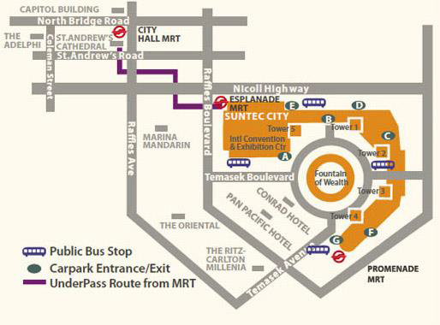The contact details of the venue is as follows:

Suntec Singapore

Convention & Exhibition Centre

1 Raffles Boulevard

Singapore 039593

## Transportation and site information

**Transportation:**

## The venue is approximately 20km from Singapore Changi Airport and it takes about 20 minutes by car from Singapore Changi Airport to the venue.

## Public Taxi

## Public Taxi is readily available at all terminals at Singapore Changi Airport.

## All taxis are metered. Fares must be charged according to the taxi meter, plus applicable surcharges. More information can be found here: <http://www.taxisingapore.com/taxi-fare/>

## Public Train (Mass Rapid Transit, MRT)

* + The train station is accessible by foot from Terminal 2 or Terminal 3.
  + To get to the city, transfer to the westbound train at Tanah Merah station. The last train that connects to the last westbound train at Tanah Merah station leaves Changi Airport station at 11.18pm. All the trains and gantries at the stations are luggage-friendly.
  + Suntec Singapore Convention & Exhibition Centre is accessible via Promenade station, Esplanade station or City Hall station.

## Passports and Visas

Generally, foreigners who do not require visas for entry and are visiting Singapore as tourists may be given up to 30-day social passes upon their arrival in Singapore. All foreign visitors entering Singapore must have a valid passport. Visitors from countries whose citizens require a visa should at the earliest time and well in advance of travel apply for a visa at a Singapore Embassy or consulate. Please visit the following website to check if you require a visa for entry into Singapore: <http://www.ica.gov.sg/page.aspx?pageid=96&secod=94>

For an introduction letter, please see **Annex C**.

## Climate – during January

Monthly Average values of the temperature and precipitation in Singapore are given in the table below:

|  |  |
| --- | --- |
|  | June |
| Average Max Temperature | 30http://www.travelchinaguide.com/images/c-words/degree.gifC / 86http://www.travelchinaguide.com/images/c-words/degree.gifF |
| Average Minimum Temperature | 24http://www.travelchinaguide.com/images/c-words/degree.gifC / 75http://www.travelchinaguide.com/images/c-words/degree.gifF |
| Average Precipitation | 200mm |

## <http://www.nea.gov.sg/weather-climate>

## Hotels

Hotels close to the venue:

**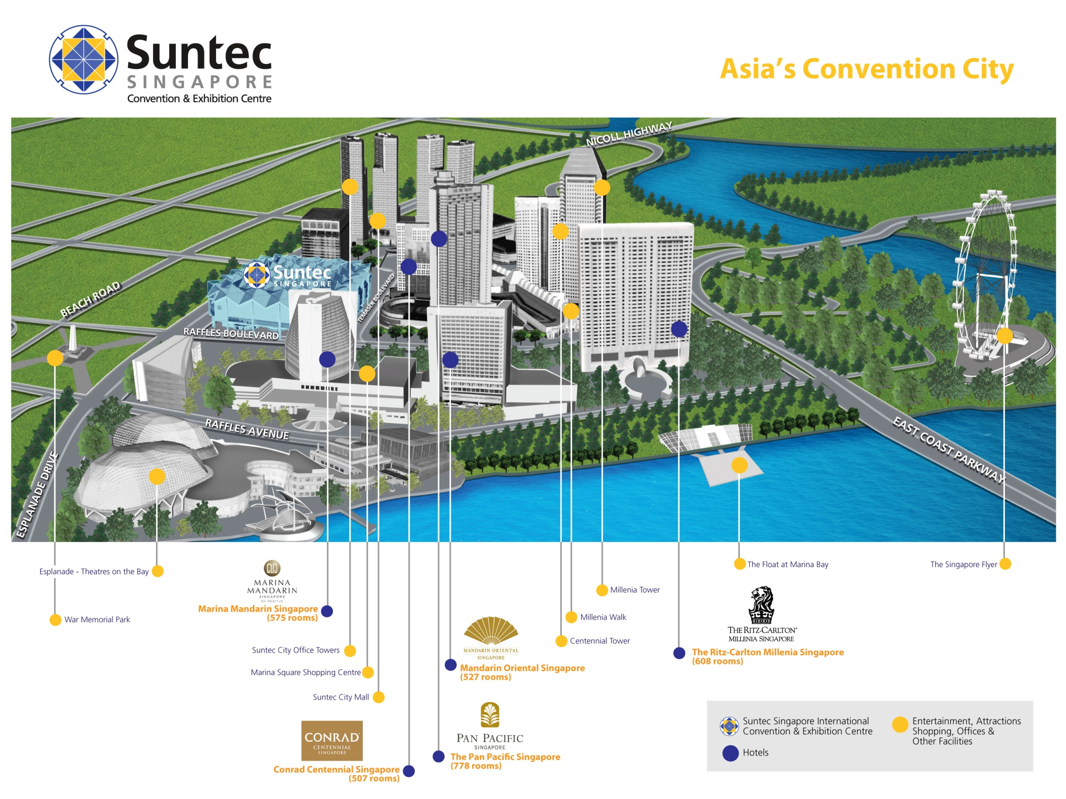**

* Conrad Centennial Singapore
  + 2 Temasek Boulevard, Singapore 038982

Website: [www.conradhotels.com](http://www.conradhotels.com)

* Marina Mandarin Singapore
  + 6 Raffles Boulevard, Marina Square, Singapore 039594

Website: [www.meritushotels.com](http://www.meritushotels.com)

* Mandarin Oriental Singapore
  + 5 Raffles Avenue, Marina Square, Singapore 039797

Website: [www.mandarinoriental.com](http://www.mandarinoriental.com)

* Pan Pacific Singapore
  + 7 Raffles Boulevard, Marina Square, Singapore 039595

Website: [www.panpacific.com](http://www.panpacific.com)

* Ritz-Carlton Millenia Singapore
  + 7 Raffles Avenue, Singapore 039799

Website: [www.ritzcarlton.com](http://www.ritzcarlton.com)

## Internet access and wireless coverage

All meeting rooms will have a wireless network with access to the Internet. Every guest room offers a high-speed Internet access for free. The access to Internet will be granted using the LAN technologies listed below:

* Wireless via WiFi: 802.11bgn and 802.11ac – Both accessible on 2.4GHz and 5GHz

## Technical assistance

In case you have any technical problem at the venue (e.g. connecting to internet, finding meeting rooms etc.) please contact for help:

* Ms Mary Ho ([mary.ho@suntecsingapore.com](mailto:mary.ho@suntecsingapore.com)); or
* Mr Edwin Low ([edwin\_kf\_low@ida.gov.sg](mailto:edwin_kf_low@ida.gov.sg)).

## Electricity

[](http://www.google.co.uk/url?sa=i&source=imgres&cd=&cad=rja&uact=8&ved=0CAkQjRwwAGoVChMIqePRhdyRyAIVhbsUCh37dQ38&url=http://www.iec.ch/worldplugs/typeG.htm&psig=AFQjCNGiOpj9trMWrii6P9kJM37hmucNYA&ust=1443254479199112)Singapore’s voltage is 220-240 volts AC, 50 cycles per second. Most hotels can provide visitors with a transformer, which can convert the voltage to 110-120 volts 60 cycles per second. The power plugs used in Singapore are of the three-pin, square shaped type.

## Useful information

*Currency exchange*

# The currency in Singapore is the Singapore Dollar. Apart from banks and hotels, money can be changed wherever the sign “Licensed Money Changer” is displayed. Most shopping complexes have a licensed money changer. Visitors are discouraged from changing money with unlicensed money changers

# Exchange rate:

# Online exchange rates are shown at: <http://www.xe.com/>

Exchange rate as of 3 November 2015:

|  |  |
| --- | --- |
| US Dollar: 1$ | 1.3992 SGD |
| Euro: 1€ | 1.5315 SGD |

## Additional information

**Tipping:** Tipping is not very common in Singapore. It is prohibited at the airport and discouraged at hotels and restaurants, as most have already added a 10% service charge to the bill. Taxi drivers do not get tipped.

**Time Zone**: GMT+8:00.

**Emergency Number:** In case of emergency please dial 999.

## About Singapore:

## Located in Southeast Asia, Singapore has a land area of about 710 square kilometres, making her one of the smallest countries in the world and the smallest in the region. Although small in size, Singapore commands an enormous presence in the world today with its free trade economy and highly efficient workforce. Also, her strategic location in the region has enabled her to become a central sea port along major shipping routes.

## At present, Singapore’s population stands at about 5.5 million people, with English as the main language of instruction, and a mother tongue for each major ethnicity. One of the distinctly Singaporean things one will notice is a ubiquitous collage of cultures. Coming together as a society and living in harmony, there are four major races – namely the Chinese (majority), Malay, Indian and Eurasian. Each community offers a different perspective of life in Singapore in terms of culture, religion, food and language.

## Being a multi-racial society, Singapore is as diverse as it is cohesive. With so much to see and do, this is perhaps best experienced through your encounters with the locals. And if you’re feeling nostalgic and looking to discover old world charm, you can explore and experience the island’s key historical landmarks or memorials. You can also embark on a heritage trail and enjoy the sights and sounds at various cultural precincts, notably Chinatown, Little India and Kampong Glam.

## For more information about what you can do in Singapore, please visit [www.yoursingapore.com](http://www.yoursingapore.com)*.*

## Contact persons

**Infocomm Development Authority of Singapore (IDA)**

10 Pasir Panjang Road

#10-01

Singapore (117438)

Mr Edwin Low

Email: [Edwin\_kf\_low@ida.gov.sg](mailto:Edwin_kf_low@ida.gov.sg)

Or

Ms Eunice Lim

Email: [Eunice\_lim@ida.gov.sg](mailto:Eunice_lim@ida.gov.sg)

# ANNEX C (to TSB Collective letter 2/20)

**INVITATION LETTER REQUEST FORM**

All foreign visitors entering Singapore must have a valid passport. Visitors from countries **whose citizens require a visa should at the earliest time and well in advance of travel apply for a visa at a Singapore Embassy or consulate.** You may need a letter of invitation from the Singapore host, which you will need to present to the Embassy/Consulate in your area in order to obtain your visa. The visa must be requested as soon as possible and at least four (4) weeks before the start date of the meeting and obtained from the office (embassy or consulate) representing Singapore in your country or, if there is no such office in your country, from the one that is closest to the country of departure. In order to obtain the invitation letter, please:

1. Fill out the form below
2. Provide the electronic copy of your passport (the name, date of birth, nationality, passport number, valid date of passport, etc. must be seen clearly)
3. Send as email attachments to [edwin\_kf\_low@ida.gov.sg](mailto:edwin_kf_low@ida.gov.sg) or [Eunice\_lim@ida.gov.sg](mailto:Eunice_lim@ida.gov.sg). Please mark as reference in the subject **“Invitation letter request for** **ITU‑T SG20 meeting”**:

(It is recommended to scan your passport page and email it to us so that it is discernible and can be used).

|  |  |  |  |  |  |
| --- | --- | --- | --- | --- | --- |
| **Company** |  | | | | |
| **Applicant Information** |  | | | **❒Mr ❒Miss ❒Ms ❒Mrs** | |
|  | | | **Date of birth :** | |
|  | | | **Place of Issue:** | |
| **Date of Issue:** | | | **Date of Expiry:** | |
| **Marital Status:** | | |  | |
| **If the country in which you'll obtain your visa is different from your nationality, please indicate it here:** | | | | |
| **Address** | **Telephone Number:**  **Fax Number:**  **E-mail:** | | | | |
| **Note** |  | | | | |
| **Date of arrival in Singapore** | |  | **Date of departure from Singapore** | |  |

*(Please do not forget to attach a copy of your passport photograph page before sending.)*

***In order to receive an invitation letter, your information should be provided to the host before 21 December 2015.***

**FORM 1 - FELLOWSHIP REQUEST**

(to TSB Collective letter 2/20)

|  |  |  |  |  |  |  |  |
| --- | --- | --- | --- | --- | --- | --- | --- |
|  | **ITU-T Study Group 20 meeting**  **Singapore, 18-26 January 2016** | | | | | |  |
| **Please return to:** | | **ITU**  **Geneva (Switzerland)** | | **E-mail:** [**bdtfellowships@itu.int**](mailto:bdtfellowships@itu.int)  **Tel: +41 22 730 5227**  **Fax: +41 22 730 5778** | | | |
| **Request for one partial fellowship to be submitted before 7 December 2015** | | | | | | | |
|  | | | Participation of women is encouraged | | |  | |
| Registration Confirmation I.D. No: …………………………………………………………………………… (Note: It is imperative for fellowship holders to pre-register via the online registration form at: [**http://itu.int/en/ITU-T/studygroups/2013-2016/20**](http://itu.int/en/ITU-T/studygroups/2013-2016/20/))  Country**: \_\_\_\_\_\_\_\_\_\_\_\_\_\_\_\_\_\_\_\_\_\_\_\_\_\_\_\_\_\_\_\_\_\_\_\_\_\_\_\_\_\_\_\_\_\_\_\_\_\_\_\_\_\_\_\_\_\_\_\_\_\_\_\_\_\_\_\_\_\_\_\_\_\_\_\_\_\_\_\_\_\_\_\_\_\_\_\_\_\_\_\_\_**  Name of the Administration or Organization**: \_\_\_\_\_\_\_\_\_\_\_\_\_\_\_\_\_\_\_\_\_\_\_\_\_\_\_\_\_\_\_\_\_\_\_\_\_\_\_\_\_\_\_\_\_\_\_\_\_\_\_\_\_\_**  Mr / Ms  **\_\_\_\_\_\_\_\_\_\_\_\_\_\_\_\_\_\_\_\_\_\_\_\_\_\_\_\_\_\_\_**(family name) **\_\_\_\_\_\_\_\_\_\_\_\_\_\_\_\_\_\_\_\_\_\_\_\_\_\_\_\_\_\_\_\_**(given name)  Title: **\_\_\_\_\_\_\_\_\_\_\_\_\_\_\_\_\_\_\_\_\_\_\_\_\_\_\_\_\_\_\_\_\_\_\_\_\_\_\_\_\_\_\_\_\_\_\_\_\_\_\_\_\_\_\_\_\_\_\_\_\_\_\_\_\_\_\_\_\_\_\_\_\_\_\_\_\_\_\_\_\_\_\_\_\_\_\_\_\_\_\_\_\_\_\_\_\_** | | | | | | | |
| Address**: \_\_\_\_\_\_\_\_\_\_\_\_\_\_\_\_\_\_\_\_\_\_\_\_\_\_\_\_\_\_\_\_\_\_\_\_\_\_\_\_\_\_\_\_\_\_\_\_\_\_\_\_\_\_\_\_\_\_\_\_\_\_\_\_\_\_\_\_\_\_\_\_\_\_\_\_\_\_\_\_\_\_\_\_\_\_\_\_\_\_\_\_\_\_\_\_\_\_\_\_\_**  **\_\_\_\_\_\_\_\_\_\_\_\_\_\_\_\_\_\_\_\_\_\_\_\_\_\_\_\_\_\_\_\_\_\_\_\_\_\_\_\_\_\_\_\_\_\_\_\_\_\_\_\_\_\_\_\_\_\_\_\_\_\_\_\_\_\_\_\_\_\_\_\_\_\_\_\_\_\_\_\_\_\_\_\_\_\_\_\_\_\_\_\_\_\_\_\_\_\_\_\_\_**  Tel**.: \_\_\_\_\_\_\_\_\_\_\_\_\_\_\_\_\_\_\_\_\_\_\_\_\_** Fax**: \_\_\_\_\_\_\_\_\_\_\_\_\_\_\_\_\_\_\_\_\_\_\_\_\_** E-Mail: **\_\_\_\_\_\_\_\_\_\_\_\_\_\_\_\_\_\_\_\_\_\_\_\_\_\_\_\_\_\_\_\_\_\_**  PASSPORT INFORMATION**:**  Date of birth**: \_\_\_\_\_\_\_\_\_\_\_\_\_\_\_\_\_\_\_\_\_\_\_\_\_\_\_\_\_\_\_\_\_\_\_\_\_\_\_\_\_\_\_\_\_\_\_\_\_\_\_\_\_\_\_\_\_\_\_\_\_\_\_\_\_\_\_\_\_\_\_\_\_\_\_\_\_\_\_\_\_\_\_\_\_\_\_\_**  Nationality**: \_\_\_\_\_\_\_\_\_\_\_\_\_\_\_\_\_\_\_\_\_\_\_\_\_\_\_\_\_\_** Passport number**: \_\_\_\_\_\_\_\_\_\_\_\_\_\_\_\_\_\_\_\_\_\_\_\_\_\_\_\_\_\_\_\_\_\_\_\_\_\_\_**  Date of issue**: \_\_\_\_\_\_\_\_\_\_\_\_\_\_** In (place)**: \_\_\_\_\_\_\_\_\_\_\_\_\_\_\_\_\_\_\_\_\_\_\_\_\_**Valid until (date): **\_\_\_\_\_\_\_\_\_\_\_\_\_\_\_\_\_\_** | | | | | | | |
| Please select your preference  (which ITU will do its best to accommodate) | | | | | | | |
| **□ Economy class air ticket (duty station / Geneva / duty station)**  **□ Daily subsistence allowance intended to cover accommodation, meals & misc. expenses** | | | | | | | |
|  | | | | | | | |
| **Signature of fellowship candidate:** | | | | | **Date:** | | |
| TO VALIDATE FELLOWSHIP REQUEST, NAME, TITLE AND SIGNATURE OF CERTIFYING OFFICIAL DESIGNATING PARTICIPANT MUST BE COMPLETED BELOW WITH OFFICIAL STAMP.  N.B. IT IS IMPERATIVE THAT FELLOWS BE PRESENT FROM THE FIRST DAY TO THE END OF THE MEETING. | | | | | | | |
| **Signature:** | | | | | **Date:** | | |

**ANNEX D**

(to TSB Collective letter 2/20)

Draft Agenda

1. Opening of the meeting
2. Adoption of the agenda
3. Approval of the report of the first meeting
4. IPR roll call
5. Working Parties meetings
6. Question 1/20 Meeting
7. ITU-T Study Group 20 SharePoint collaboration site
8. Preparation for WTSA -16
   1. Deletion and/or Merger of Questions
9. Participation of SMEs
10. ITU-T Study Group 20 Incoming Liaison Statements Report
11. Joint Coordination Activity on IoT and SCC
12. Collaboration matters
13. Promotion activities and bridging the standardization gap
    1. Workshops, Trainings and Forums of interest to SG20
14. Outgoing liaison statements/communications
15. Reports of the meetings of Working Parties
16. Agreement/approval of informative texts
17. Consent/determination/approval/deletion of Recommendations
18. Review of the work programme
19. Approval of Outgoing liaison statements/communications
20. Identify new topics for future Technology Watch reports
21. Future activities
    1. Planned meetings in 2016
    2. Planned e-meetings in 2016
22. Other business
23. Closure of the meeting

\_\_\_\_\_\_\_\_\_\_\_\_