|  |  |  |
| --- | --- | --- |
| INTERNATIONAL TELECOMMUNICATION UNION | | **STUDY GROUP 3** |
| **TELECOMMUNICATION STANDARDIZATION SECTOR**  STUDY PERIOD 2013-2016 | | **TD 25 (PLEN/3)-E** |
| **Original: English** |
| **Question(s):** | 1/3 | Geneva, 27-31 May 2013 |
| **TD** | | |
| **Source:** | BDT | |
| **Title:** | ITU Study on international Internet connectivity – Focus on Internet connectivity in Latin America and the Caribbean | |



**ITU STUDY ON INTERNATIONAL INTERNET CONNECTIVITY**

**Focus on Internet connectivity in Latin America**

**and the Caribbean**

**September 2012**

This study was prepared by Mr. Oscar Messano under the direction of the Regulatory and Market Environment Division (RME) of the Telecommunication Development Bureau (BDT), in close coordination with ITU-T Study Group 3. The content of this report was presented during the Seminars and Meetings of the Regional Groups of the ITU Study Group 3 for Africa (SG3RG-AFR) in May 2012 and for Latin America and the Caribbean (LAC SG3RG) in March 2012, for review.

**Table of Content**

Introduction and Objectives 4

Executive Summary 6

IIC – Definition of International Internet Connectivity (IIC) 7

Interconnection and the IICs at a Global Level 8

National and International Internet Interconnection (IIC) 10

Broadband Services on networks that operate on Wireless (WiFi or others) 15

The economic model of Interconnection and Broadband 18

Final summary 25

EU/LAC Comparative 28

Internet Exchange Points (IXPs) 32

Projects within the region 47

Best Practices 52

Diagnosis 56

Final summary 57

Project based on Best Practices 59

GLOSSARY - ACCRONYM – ABBREVIATION 64

**ITU STUDY ON INTERNATIONAL INTERNET CONNECTIVITY**

**Focus on Internet connection in Latin America and the Caribbean**

# Introduction and Objectives

The main objective of this study is to develop models of best practices that will assist countries, to attain significant improvements with regards to broadband penetration, with particular emphasis in marginal and rural areas. This study is based on the experience of countries from Sub-Saharan Africa and Latin America and the Caribbean. The models proposed in this study are based on diverse economic and technical experiences, as well as marketing models that are being developed and implemented in sub-Saharan Africa, and Latin America and the Caribbean.

Concerning the economic and technical analysis, the greatest barrier to obtain results corresponds to the economic aspects. Some main questions are raised along this study, such as how can infrastructure be deployed in these regions?, while at the same time providing affordable Internet access to all?, how to make Internet available and affordable to low income potential users? How to lower the cost of International Internet Connectivity, which is a significant factor for many countries?

In both sub-Saharan Africa and Latin America, the development of the objectives outlined in this study face significant challenges.

The state of the art in these two regions will be looked at from a general perspective (particular in some instances); normal practices regarding Internet access, statistical comparisons on value and quality of services to end users, and how these correlate to with developed countries.

The study will look at how the interconnection value chain is developed, at both national and international level, which is a very important factor in the development and deployment of networks.

What is the added value of the NAPs (Network Access Point) or IXPs (Internet Exchange Point), and how they influence the development of broadband penetration, contents and improved quality of service to the end user.

One of the most significant elements in the analysis of international interconnection is the use of a regional backbone that can keep data traffic within a certain region, instead of having it transit countries in another region or continents.

The possible solutions to this mode of interconnection will be described. Can a regional backbone be created? Are the traffic exchange points (IXPs/NAPs) part of the solution?

Finally, and taking into account the problems that have been highlighted with regards to national and international interconnection, some possible solutions will be proposed considering the best practices implemented in both regions, including models that can be replicated in order to resolve interconnection and broadband deployment deficiencies, and which also consider the development of local content, etc.

# Executive Summary

The contents of this study focus on the key players of the interconnection issue, both at national and international level, and their characteristics. It also describes the Internet Exchange Point/Network Access Point IXPs/NAPs and their importance in the development of broadband, as well as the significant role of the backbones.

Interconnection is the cornerstone of the Network of Networks: the Internet. It can be considered to be the most important factor conditioning the growth of the Net, since it affects all the services that are accessible therein. The bandwidth is directly proportional to the capacity of the T1 first network operator level, , and the cost of the Mb is an element that affects its use. In the existing model, the pure SME operators Pure Internet Service Providers (pISPs as we have identified them in this study), have very little bargaining power with respect to the T2 and T1 operators, and this drastically limits their growth and the development of their services.

Observing the results from the study of broadband in the two regions, the concentration of Internet services is evident. The incumbent companies are those which usually concentrate the traffic in these regions. These companies handle close to 80% of the interconnection market, and their tariffs make it difficult, if not impossible, for pISPs to compete.

The advantages with regards to technology, as well as the economic equation for the pISPs, and last but not least the development of broadband, spotlight the IXP/NAP as the replicable solution, not only for these two regions, but also for countries with similar problems.

There are also barriers arising from the regulatory context, such as lack of competition or unfair competition, in instances where there is poor regulation, or where regulation is not enforced.

It can also be noted that the deployment of broadband is limited to large and medium urban centers. In some cases where regulatory policy and subsidies are implemented, then it also becomes available in areas that are marginal or afford very low purchasing capability.

The participation of cellphones is discussed; in terms of the deployment of devices it shows exponential growth. The 5.6 billion existing units means that approximately 80% of the population on our planet is holding a cellphone. In this sense, the study describes the success and limitations of the mobile Internet. Undoubtedly this technology is ideal for voice communication and text messaging, but it is not satisfactory when 3G cellular networks are employed for broadband access. It should be noted that in European countries this system works well.

There are certain instances where state bureaucracy, and the lack of clear policies , are important barriers to the deployment of new networks and the development of the Internet.

It is evident that the corporate associations and the non-governmental organizations (NGOs), are an important resource for supporting the development of the Internet in developing countries contributing to the reduction of the digital divide.

Some other barriers to the development and access of Internet are highlighted, such as the lack of power supply, illiteracy, generational and cultural divides, etc.

It is also examined how the issue of interconnection and transit, which runs across both of the regions covered in this study, is affected by the installation of traffic exchange points (NAPs/IXPs).

Finally we come to the analysis of the issues involved, as well as the possible ways of resolving them. Special emphasis is used to describe the best practices that can contribute to easing the problems that have been exposed, bearing in mind the differences that pertain to each region.

# IIC – Definition of International Internet Connectivity (IIC)

At the highest level, International Internet Connectivity (IIC), is provided by those companies known as T1 (Tier 1), who are large operators of high capacity networks, as can be seen in the various modules of this study. Other operators connect to that Tier 1 backbone either directly, or through other companies. The T1 providers refer to each other as “peers”, a term which originated from the premise that outbound traffic was similar to inbound, as regards the Internet.

The number of companies defined as T1 operators is not significant, and this enables and facilitates the commercial agreements between them. They usually have global presence, or at least they operate in a number of different countries and/or continents.

With respect to submarine cables, we usually find that these are owned by consortiums of companies (and even some governments participate through national operators). As regards their employment, it is a normal procedure that the link capacity is apportioned out according to the percentage of investment of each member of the consortium.

Cases can arise in which certain anchorage sites (this refers to the places where the submarine cable reaches land), enable the development of traffic exchange points (NAPs/IXPs), under the management of the cable operator.

# Interconnection and the IICs at a Global Level

In the global level interconnection layout, the submarine cables have a leading role to play with regards to interconnection and traffic. However, we should not overlook the deployment of land cables, be they copper or fiber optic, the microwave systems, and finally the satellite systems which are not a significant factor of this study, as can be seen further on.

The intercontinental traffic is carried by submarine cables, assuming that many of these cases continue to lay from one country to another through shoreline anchors deployed in different parts of a country or interconnecting countries.

The international traffic is borne by the submarine cables. It can also be assumed that, in many instances, the cables continue to be laid between countries following the coastal lines, and establishing anchorages in various locations of the same country, or interconnecting countries.

Once the submarine cable reaches land, there are several potential variations:

1. The owner or consortium may have an operator designated for this function, and this may involve the technical aspects, the commercial aspects, or both.
2. The owner or company that is a member of the consortium, has operations in this area, region or country, and therefore interconnects to this cable and obtains proprietary international connectivity. This can be repeated by each one of the members, even if any of them were government agencies.
3. The cable operator, one of the participants or the consortium as a whole, do not have operations in this area, region or country, and consequently make the capacity available to the market. Usually, the capacity is sold before the project is finished, thus ensuring financial returns immediately as from the launching date of the cable.
4. Another mode involves providing transit, i.e., a transparent connection to another point in the planet, and this can include a number of services aside from the Internet. This is of no consequence to the party that rents out the cable that enables these services, since it only provides transmission capacity.
5. The operator, the proprietor or the consortium must contract transit from a local company, in order to connect to its operating company, or to whoever it has contracted for the interconnection service.

In those cases involving copper, fiber or microwave land networks, the interconnection conditions do not vary substantially. The commercial conditions will certainly vary in some important cases, as will be seen in this document.

With regards to the interconnection using satellite links, these do not have a significant role in International Internet Connectivity (IIC) in the two regions under discussion, due to the technology limitations and to the associated costs, that result in this type of links not being used massively, but merely as a last alternative solution. However, satellite links are very important in other regions, in particular for Pacific Island nations.

# National and International Internet Interconnection (IIC)

In the international and national communications environments there are different actors with denominations that are specific and describe their activity. The topmost amongst these are known as “tier 1”, sometimes referred to as T1 (which identifies a 1.544 Mbps link).

These operators usually do not pay each other to interconnect, as regards transit (allowing the use of a network to interconnect with another). The contractual conditions may include the costs for this service, but this should not be considered the norm since peer-to-peer contracts are not public, and there are a lot of specific agreements including peering, and also smaller operators.

**T1 Operators**

* The following operators own submarine cables, in some cases also terrestrial cables, are present in 10 countries or more, are active in the Latin America and Caribbean region, and their main activity is provision of connectivity, transit and interconnection of other T1 operators who are their peers. All of them own submarine cables in the region.

|  |  |  |  |  |
| --- | --- | --- | --- | --- |
| **T1 Operators** |  |  |  |  |
| Alba1 | Américas I | Américas II | Antel-Telecom | Atlantis |
| Cable & Wireless | Columbus Networks | GCN | Global Crossing | Globenet |
| GT&T y Telesur | Internexa | LA Nautilus | Maya Networks | Panamericano |
| San Andrés | Tiws | Unisur |  |  |

**Submarine Cables**

* The submarine cable network is extensive and covers the whole planet as can be seen by the graphics that are shown hereafter. In recent years there have been few projects or new layings that can be mentioned. The laying of the submarine cable between Venezuela and Cuba, between Uruguay and Argentina, the Dominican Republic, Jamaica and the Virgin Islands. The reasons for the low investment in technology are varied, i.e., the existing cables have idle capacity, the investment in new laying is high, and these are projects of extended duration.
* But this is changing, and some of the elements of this change are the multimedia services, the network videos and principally digital television, which are exponentially increasing the use of broadband in the networks, and this includes the submarine cables. Another element to be considered is the obsolescence of the existing technology in the existing networks, the latest technology notably increases the capacity of fibers, and no less important is the transmission and reception time (latency), which is vital to the Internet and to interactive Digital TV.

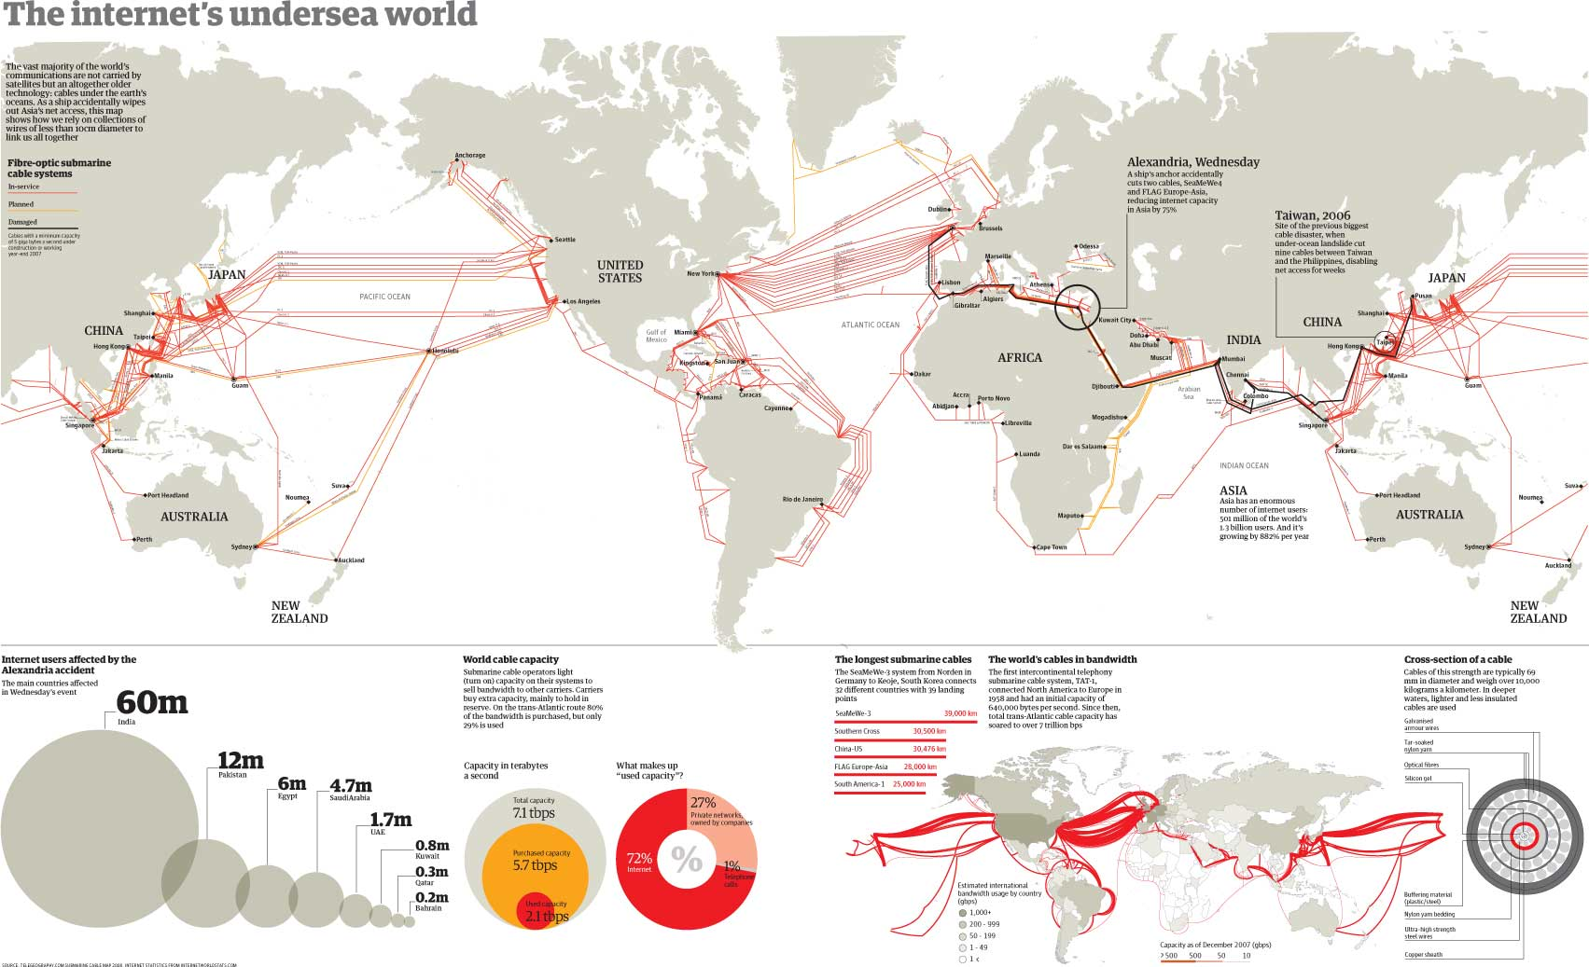

**Image illustrating existing laid cables in the world (2010)**

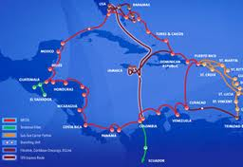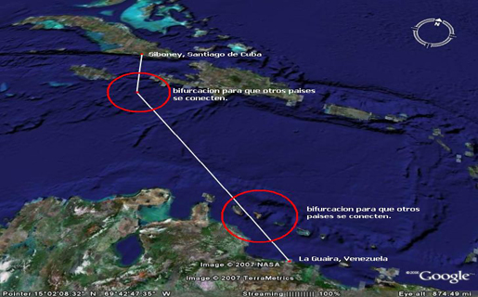

**Laying Venezuela Cuba Laying Rep. Dominicana/Jamaica/Islas Vírgenes**

**T2 Operators**

* T2 operators are those who operate national networks – within a country. Sometimes T1 operators also do so, and as providers of interconnection they offer to provide national transit and even act as ISPs providing the final link in the connectivity chain. This can be seen with telephone companies who provide value added services to the end user (act as an ISP). Aside from these exceptions, the usual function of a T2 is to provide transit between the T1s and the ISPs.

|  |  |  |  |  |
| --- | --- | --- | --- | --- |
| **T2 Operators** |  |  |  |  |
| Ampath | AT&T | Auris | Br Telecom | Centenial |
| Clara | Columbus | BT | Cybernet | Digicel |
| Entel | Esnet | GBLX | GBnrt | Gilat |
| Global Carib | Grant | IFX | Internap | Internet 2 |
| Level 3 | Metrored | Navega Newcom | NTT | Orange |
| FT | Savvis | Seabone | Sprint | TATA |
| Techtel | Telecom | Telesiwch | Telga | Terramark |
| Tnet | Twis | Verison | OX |  |

**ISP´s**

* ISPs, or Internet Service Providers, are those who have a direct relationship with the end user, and aside from connectivity or Internet access, provide different types of services, for example: electronic mail, access to contents, etc. The ISPs mentioned in each case and country, cover between 99% and 83% of the market. As will be seen, those with significant market share are in many cases T1 operators. In each country there is normally a large amount of ISPs operated by SMEs; for example: in Brazil it is estimated that some 4000 SMEs offer ISP services, and in Argentina there are 1800. Usually these companies have a low market penetration as far as number of users is concerned.
* We can classify the ISPs in two large categories: those that, as is indicated in the next tables, perform their activities in high density population areas, and handle important market shares in their area of influence. The second category covers the activities of the SMEs in the outskirts of large cities and/or small population centers in the hinterland of the countries, and they must pay high tariffs in their connectivity and transit agreements, which of course is a barrier to growth of the small operators.

**Landline Broadband ISP Operators**

* The market of broadband access to the Internet in Latin America is distributed between ten large operators. These concentrate approximately 36 million users; Amèrica Mòvil with approximately 15 million users ranks in first place, and at the other extreme is Megacable with 600.000 users. In all countries we have operators whose participation in the market is low considering these figures, and which are in the range of 16.7 to 0.1 percent depending on the country.

|  |  |  |  |  |  |  |
| --- | --- | --- | --- | --- | --- | --- |
| Argentina | Company | % of market |  | Bolivia | Company | % of market |
|  | *Arnet* | *30.3%* |  |  | *AXS* | *15.2* |
|  | *Claro* | *0.9%* |  |  | *Comteco* | *22.5* |
|  | *Fibertel* | *25.3%* |  |  | *Cotas Net* | *39.04* |
|  | *Speedy* | *31.4%* |  |  | *Entel* | *20.0* |

|  |  |  |  |  |  |  |
| --- | --- | --- | --- | --- | --- | --- |
| Brasil | Company | % of market |  | Chile | Company | % of market |
|  | *GVT* | *8.7* |  |  | *Telefónica del Sur* | *5.0* |
|  | *Net Virtua* | *25.9* |  |  | *Claro* | *7.5* |
|  | *OI Velox* | *30.5* |  |  | *VTR* | *37.4* |
|  | *Speedy* | *22.9* |  |  | *Movistar* | *44.2* |

|  |  |  |  |  |  |  |
| --- | --- | --- | --- | --- | --- | --- |
| Colombia | Company | % of market |  | Costa Rica | Company | % of market |
|  | *ETB* | *19.0* |  |  | *ICE* | *66.5* |
|  | *Telefónica-Telecom* | *19.0* |  |  | *Racsa* | *33.5* |
|  | *Telmex* | *23.0* |  |  |  |  |
|  | *UNE-EPM* | *25.0* |  |  |  |  |

|  |  |  |  |  |  |  |
| --- | --- | --- | --- | --- | --- | --- |
| Cuba | Company | % of market |  | Ecuador | Company | % of market |
|  | *Etexsa* | *100.0* |  |  | *Claro* | *9.4* |
|  |  |  |  |  | *C.N. Telecomunicaciones* | *51.1* |
|  |  |  |  |  | *Grupo TV Cable* | *29.2* |

|  |  |  |  |  |  |  |
| --- | --- | --- | --- | --- | --- | --- |
| El salvador | Company | % of market |  | Guatemala | Company | % of market |
|  | *Claro* | *63.9* |  |  | *Claro* | *79.7* |
|  | *Integra* | *7.5* |  |  | *Cybernet* | *4.6* |
|  | *Tigo* | *26.1* |  |  | *Futura Network* | *4.1* |

|  |  |  |  |  |  |  |  |  |  |  |  |  |
| --- | --- | --- | --- | --- | --- | --- | --- | --- | --- | --- | --- | --- |
| Honduras | Company | | % of market | |  | | Jamaica | | Company | | | % of market |
|  | *Cablecolor* | | *13.0* | |  | |  | | *Cable&Wireless* | | | *65.9* |
|  | *Claro* | | *32.2* | |  | |  | | *Flow* | | | *29.5* |
|  | *Navega* | | *30.6* | |  | |  | |  | | |  |
|  | *Sulanet* | | *17.1* | |  | |  | |  | | |  |
|  | *Tigo* | | *2.6* | |  | |  | |  | | |  |
| Mexico | | Company | | % of market | |  | | Panamá | | Company | % of market | |
|  | | *Axtel* | | *3.3* | |  | |  | | *Cable Onda* | *38.1* | |
|  | | *Cablemas* | | *3.0* | |  | |  | | *Freedom* | *55.0* | |
|  | | *Cablevisión* | | *2.9* | |  | |  | |  |  | |
|  | | *Infinitum* | | *68.9* | |  | |  | |  |  | |
|  | | *Megared* | | *5.2* | |  | |  | |  |  | |

|  |  |  |  |  |  |  |
| --- | --- | --- | --- | --- | --- | --- |
| Nicaragua | Company | % of market |  | Peru | Company | % of market |
|  | *Claro* | *92.5* |  |  | *Claro* | *4.8* |
|  | *Icable* | *4.4* |  |  | *Movistar* | *94.0* |

|  |  |  |  |  |  |  |
| --- | --- | --- | --- | --- | --- | --- |
| Republica Dominicana | Company | % of market |  | Trinidad y Tobago | Company | % of market |
|  | *Claro* | *78.2* |  |  | *Flow* | *21.8* |
|  | *Onemax* | *3.2* |  |  | *TSTT* | *69.9* |
|  | *Tricom* | *17.1* |  |  |  |  |

|  |  |  |  |  |  |  |
| --- | --- | --- | --- | --- | --- | --- |
| Uruguay | Company | % of market |  | Venezuela | Company | % of market |
|  | *Antel* | *96.1* |  |  | *ABA* | *82.1* |
|  | *Dedicado* | *3.8* |  |  | *Inter* | *13.4* |
|  |  |  |  |  | *Súper Cable* | *1.8* |

# Broadband Services on networks that operate on Wireless (WiFi or others)

* Firstly what we generically call Wi-Fi is a commercial brand name registered by the Wi-Fi Alliance. This entity certifies if the products conform to certain interoperability norms. It should be made clear that the absence of this logo does not necessarily mean lack of compatibility with those products that bear it.



* The wireless transmission technology (Wi-Fi), enables connectivity in places where the “last mile” or the capillarity of the existing network is low or null. Although the wireless coverage is low, and its characteristics depend on the band it is operating on, the transmission frequency options are, in the 2.4 Ghz and placing a 45 meter high antenna, a coverage of some 8 km circumference can be achieved. If however the 5.8 Ghz frequency is used and with a similar antenna, a coverage of some 3 km circumference is achieved, but the users will enjoy greater bandwidth.
* Wi-Fi is an important tool to address the needs of low density population sites, and in other instances it acts as a supplement to, or competes with, the incumbent operator who, in the end, furnishes the necessary bandwidth that enables the Wi-Fi operator to provide his services. It must also be noted that the employment of Wi-Fi does not require a band usage license, and this is an advantage to small and medium ISPs, who are not obliged to pay the regulator for use of the band. It is estimated that there are more than 500 million users worldwide served by this technology.

There are other wireless technologies such as WiMax, microwave, satellite links, and finally the cellphones.

**WiMAX**

* The first of the technologies we have mentioned – WiMax (Worldwide Interoperability for Microwave Access), similarly to Wi-Fi exists in the WiMax Forum, which certifies the interoperability of the equipment, and as also happens with Wi-Fi, equipment exists which does not have this certification but is totally compatible.
* Its employment enables a solution for the deployment of the so called ‘last mile’, since its coverage area is much larger than that of Wi-Fi, although the costs are higher both in equipment as in the installation of antennae. But this is compensated by a better performance. For example: it can transmit up to 50 km at speeds of 70 Mbps. It also enables mobile bandwidth.

**Microwave**

* Microwave is used specifically for point-to-point links, and can be a solution to reach places without connectivity, with a medium range investment. In comparison with Wi-Fi and WiMax it reaches varies between 24 and 28 km, depending on the equipment and the geographic characteristics. It enables a large amount of communications channels with minimum latency among other features.

**Satellites**

* The last example of this sort, the satellite links is an expensive solution, even though the cost of the antennae has diminished notably over time, as has also happened with the additional devices required, such as the Modem or satellite PCI card (DVB-S), the receiver of signals coming from LNB satellites, Feeder or Wireless, Modem for access to the Internet connection.
* The satellites used in telecommunications are the so called geostationeries, which means that the satellite remains stationary with regards to the surface of the Earth, at a distance of 36.000 km. Within this technology there are various transmission bands with advantages and disadvantages (depending on each case).

[**L**](http://es.wikipedia.org/wiki/Banda_L)**.Band**.

* Frequency Range: 1.53-2.7 GHz.
* These wavelengths can penetrate through terrestrial structures and require less potent transmitters.
* Low data transmission capacity.

**Ku Band.**

* Reception frequency ranges 11.7-12.7 GHz, and in transmission 14-17.8 GHz
* The medium wavelengths penetrate most of the obstacles and transport a large volume of data.
* Most of the bands are assigned.

**Ka Band**

* Frequency range: 18-31 GHz.
* Spectrum for assignments available. The wave lengths transport large data volumes.
* Very potent transmitters required, and they are sensitive to environmental interferences.

**C Band**

* Frequency Range: 3.4-6.4 GHz.
* Less susceptible to climatic effects such as rain compared to Ku and Ka Bands.
* Equipment costs are higher than Ku Band.
* The cost of bandwidth is still high, and to this must be added the logical latency time due to the mere effect of raising the radio signal 36.000 km to the satellite and receiving the downward signal another 36.000 km from the satellite. This has an important effect on Internet surfing but remains a valid option in the absence of other solutions.
* Finally the cellphone network as an option for access to bandwidth. There are different options for bandwidth access using a cellphone, one of them involves using the device as a data modem, the other is the use of a modem usually called USB (Universal Serial Bus), or also Pendrive (USB flash drive). This technology uses 3G band and has certain difficulties which we will expose in the chapter on the Economic Model.



We have briefly described the communications technologies most frequently used in the deployment of broadband, in order to provide an overall view of how Internet basic Connectivity is developed, since interconnection is the raw material of this ‘Network of Networks’.

**Backbone**

One thing we should consider is that backbones are an important element of interconnection. Backbone refers to the interconnection of different geographic points, with certain architecture, usually known as a ring (not so much in reference to its geometric shape, but rather to capture the meaning of completing a ‘circle’ of connections). This architecture enables the connectivity security of the connected points to be high, since if any link between two points of the interconnection is severed, the interconnection would remain in service via another route in the ring.

As an example, in the following graphic we can see a diagram of part of the backbone of the National Science Foundation (NSF) of the United States of America (USA). The NSF managed Internet issues for years; as will be noted in the graphic the interconnection points are closed in a ring, not by the geometric shape but by the name given to data networks in this type of interconnection, where the traffic can go in two directions to reach the same point. If we suppose that the San Diego/NCAR link is severed in San Diego, the traffic could continue to flow routed through the University of Illinois. In this backbone example, there is also a central link which improves the backbone and makes it safer.

In the chapter about the economic model, we will develop the strategic importance of the Interconnection, the NAPs and the backbones, in the deployment of bandwidth in the region.

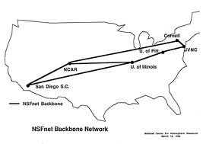

# The economic model of Interconnection and Broadband

The Internet business is based on a value chain which develops as follows: in the final and massive part are the end users, who may be unipersonal as regards to billing and registrable account – normally referred to as “household user”, and it must be considered that behind this “account” there are usually two or more personal users of the service, although only one of them pays for the services. Then we have the small and medium enterprises (SMEs), one account with several users, and finally the corporations where you have one account and hundreds of users. Naturally the costs of these segments of users have different rates.

On the next step upwards, are the Internet Service Providers (ISPs), and to avoid any doubt we define these as companies dedicated to provide access to the Internet as their core business. This is done by means of different means and technologies. The access to home or business can be achieved in different ways, but today it is mostly by means of Broadband, which implies a permanent connection which is not dependent on a phone dialup call, and as its description implies, it is higher bandwidth.

As we saw in the chapter on interconnection, there are a variety of ISPs that can be catalogued by:

* Market they cover
* Type of company
* Geographic deployment.

This subdivided into:

* Local.
* Regional in-country.
* Regional - international.

We have already seen that some ISPs may be included in the segment of those denominated as T1 or T2, and finally we have those known as pure ISPs (pISPs)

The modes of interconnection between an ISP and the user may differ as follows:

* One initial option is done by means of a copper pair, which normally is the same as that used for fixed telephony. In such cases the most-frequently used technology is ADSL and its variants.
* Another option is that used by the provider of cable TV service, which uses the same network to offer Internet access in addition to TV, and some companies also offer telephony as part of the same service.
* Finally, we have the wireless service providers who deliver Wi-Fi services. This is done by means of a transmission node, and the provision and installation of a receiver known as “Access Point”, installed on the customer’s premises.

When a pISP, as we will from now on refer to pure ISPs, is involved, then it must contract interconnection, transit and last mile facilities, and this can all be part of one package of services, (in this instance, the last mile refers to the interconnection from its node, datacenter or any other denomination), as far as the T2, or by means of a T2 or T1 according to the case.

If the ISP has any sort of network deployed with the users, it will use it to reach them. Usually this is accomplished by means of Wi-Fi, otherwise it will also need to contract this service, and this is usually done with the same provider that enables access to the interconnection.

Then we have the T2s, which are Carriers, and own proprietary networks and have the capillarity to reach the end user. Normally the T2s also fulfill the roles of ISPs and consequently, aside from enabling the interconnection of other ISPs, they compete with them for the business of the end users. With regards to international connectivity, the T2s reach agreements with the T1s for the access and transit of international traffic.

Finally and atop the pyramid are the T1s, who own the submarine cables as well as the backbone land networks. The interconnection between them is cost free as it is amongst peers, and it is assumed the inbound traffic will be balanced by the outgoing thus resulting in a neutral balance. The following diagram graphically describes what has been defined.

T1

Flujo

de

$

T2



ISPs

User

With reference to the formality of these operations, it is interesting to comment on the study undertaken this year about what types of contracts were being signed between the various participants of the networks. The study surveyed 4’000 networks and the result was that 99.5% of these did not have signed contracts and the agreements were of an informal nature.

**Generalities of the market**

In those places that have high population density, the competition for market share is usually between the large operators as can be seen in the broadband table. The price to the end user is habitually on a downward curve due to this competition, and in some cities there is more than one large operator. A pISP, or one that does not have a very extensive network can, due to the fact that it has a smaller structure and costs which are low enough, compete in price and service with the larger corporations.

As we go farther from the urban centers, access to the Internet and thus to broadband begins to be complicated for the user, whoever he may be. In order to expand this concept see below a table from a study on broadband penetration which, although in some cases presented data from 2009 and in others from 2010, and likely these figures have changed due to logical growth since then, nonetheless reflects a situation of divide that still prevails.

|  |  |  |  |  |  |  |  |  |
| --- | --- | --- | --- | --- | --- | --- | --- | --- |
| ountries | Local penetration average | | | National penetration | | Local penetration average | | |
| Argentina  June 2009 | | Capital Federal  San Luis  Meuquen | 46.20%  12.90%  11.50% | | 9.30% | | Mendoza  Córdoba  Santa fe  Jujuy | 6.90%  5.20%  3.70%  0.20% | |
| Brazil  December 2009 | | San Paulo  Sur  Sudeste  Centro Oeste | 11.40%  7.00%  6.30%  6.10% | | 6.00% | | Norte  Nordeste | 3.50%  1.40% | |
| Colombia  June 2009 | | Bogotá  Antioquia  Boyacá | 12.30%  6.40%  5.905% | | 4.70% | | Eje cafetero  Cundinamarca  Valle-Choco-Nariño | 4.10%  3.30%  2.20% | |
| Chile  March 2010 | | Región de Antofagasta  Región Metropolitana  Región de Valparaíso | 13.70%  12.90%  10.70% | | 9.90% | | Region of Atacama  Region de Bio Bio  Reg.of Lib. O´higgins  Region of Maule | 8.10%  7.70%&  5.30%  4.30%  4.30% | |
| Perú  December 2010 | | Lima  Arequipa  Tacna | 6.20%  3.50%  3.50% | | 2.90% | | La Libertad  Ica  Moquegua  Lambayeque | 2.7%  2.30%  2.10%  2.10% | |

The solutions to this problem vary according to the place and the country involved, but in summary we could describe them thus. The companies that have activities in these areas are, amongst others, the following:

* Cable TV companies that offer cable TV and add access to the Internet over the same network.
* Telephone Cooperatives that provide service where the incumbents do not, and who have also added access to the Internet to the services they offer.
* pISPs which develop the service mostly using wireless technology (Wi-Fi)
* The incumbents also have activities in many of these places, but charge prices that are very different from those charged in high density population centers, where they are much lower.

Where do these ISPs obtain connectivity and interconnection? They are customers of the Carriers in those places where these have a presence, and in both instances the agreements in their economic aspect, are not advantageous for the pISPs due to the high premium they must pay per megabit contracted for. This is the reason why the pISPs and other actors we have described, contract insufficient bandwidth. Usually in these cases there are no options when it comes to selecting who shall be the provider of interconnection and transit.

The cost per Megabit, which is the raw material in the business of providing access to the Internet, and thus the cost base which will define the tariff the end user will have to pay, is strategic in the business management of these pISPs.

Also, the high price of this factor (the Megabit) will directly influence the quality of the service, as the pISP will try to distribute each megabit between the largest quantity possible of end users, and thus achieve an economic equation that enables its business to be profitable. This will directly affect the quality of the service that is offered.

Can the pISP buy more megabits in order to improve the service? No, this would not be possible, since in this case its costs would increase and it would be unable to compete with the other operators in the area. It could only increase the bandwidth if the market in which it does business offers opportunities to obtain more users.

These economic conditions are what forbid narrowing the digital divide in these zones, and the development is slow since the incumbents are not interested in investing in areas that are not profitable, nor in improving the economic conditions of the contracts with the pISPs.

One of the solutions available in some instances are the national access points NAPs (also referred to as Internet Exchange Points – IXPs). When a NAP is available, the effects become drastically evident.

The typical model of a NAP is described in the following diagram:

Router

Contents - Cache - Root Servers – etc.

Carrier (T2)

National Traffic

Central Switch

Traffic at no Cost

International Traffic

ISP-1

ISP-4

ISP-3

ISP-2

The diagram represents a NAP where:

* In this case four pISPs. The more pISPs concentrated in one NAP, the better the economic equation. In the cooperative model the general expenses of the NAP are shared proportionately by means of a series of pre-established parameters. For example, considering the bandwidth to the Switch port, since a 100 Mg port does not cost the same as 1 Gigabit port. The general services, such as UPS, security, man hours, etc., are common to all members of the NAP.
* These four pISPs connected to the switch interchange traffic between themselves at no cost, except for the general costs as has been described. Consequently all the traffic generated by proprietary applications of these pISPs, such as the users’ mails of each ISP, remain within the NAP traffic, as well as the services each one can offer on the Net, for example the webpages hosted by any of the pISPs.
* Then we have the national traffic, or in other words that which allows connection to other NAPs, or pISPs, and lastly the international traffic or Internet, which in this model has a significant reduction due to the previous options.
* Finally, the joint leasing of bandwidth achieves a considerable reduction of the cost per Megabit. In the example given, it would be perfectly feasible that the joint leasing would be approximately 300 Megabits, while each one separately would be significantly less Megabits, and this joint contracting results in a reduction of the cost of interconnection due to the lower interconnection cost due to volume of leasing. The Carrier or T2 operator economizes infrastructure by having only one point of interconnection, and finally and most importantly, the end user will be benefited with a better standard of quality almost immediately, and later with a lower price for their subscriptions.

Other effects that result from the creation of NAPS are the following:

* The resolution of the DNS (Domain Name System) involves Routers known as Root Servers distributed worldwide.

These are used to resolve the address of the computer where a specific domain name is lodged, for example [www.itu.int](http://www.itu.int) . There is a worldwide system that resolves the address of the computer that hosts that webpage.

Several NAPS within the region have installed mirrors (duplicates) of these Root Servers with two main objectives: reduce the search time, and increase the security of the Internet as a whole.

* Another side benefit are the Caches. The content providers use this technology to improve access to their contents and also reduce the use of international interconnection. The most familiar example is “You Tube”. To get an idea of the magnitude of this application, 24 hours of video are added to You Tube every minute, as reported by the company itself.
* The occupancy of bandwidth for the sending and the access of this significant amount of information is one of the nightmares of the Information sent/received, and the cheaper option involves a fixed limited amount of incumbent companies and the T1 operators, and is the core issue of the so called “Net Neutrality” discussion.

When a cache is installed, as is shown in the diagram of this example of a NAP, we can use the example of the Ecuador NAPs, since the NAPs network of this country, and hence all the network users, have access to the contents in local mode (Cache), without using international bandwidth. The cost-savings that come with using this mode are significant.

Finally, and by way of a summary, it has been demonstrated that the installation of NAPs brings benefits such as:

* An increase in the geographical area of Internet service provision (improved capillarity)
* Reduction of the cost of bandwidth for the providers, in some cases a very important one.
* An increase in the quality of service provided.
* The possibility of providing broadband to locations which are far from urban centers.
* The development of SMEs in this sector

**Cellphones**

Finally, we will mention connectivity by means of cellphones. As we have seen, the interconnection by means of cellular equipment or USB modems is an available technology.

This mode uses a technology known as 3G or third generation, and which enables voice, mobile internet, video calls and mobile TV.

At present, the use of a cellphone as a data access device is a very expensive method. On the one hand, the mobiles that enable this mode are high cost devices, secondly the cost of sending and receiving data is also expensive, and more so if roaming is being used, (i.e. the cellphone is used for this purpose from other networks/countries)

In the case of USB modems, the devices are low cost and sometimes are even free with the subscription to the data transmission service. This subscription usually offers two cost options, one is flat rate which involves paying a monthly fee with unlimited information exchange, such as for example 3 Gb per month.

This technology could be an alternative for the deployment of broadband but as a matter of fact, in high density population areas even though access cells are numerous, the network usage for voice and text messaging ensure these cells operate at maximum capacity, which leaves little bandwidth available for data. This is detrimental to the use of USB modems, which upon being connected only access very limited bandwidth.

In areas of low density population, cells are scarce, resulting in the same limited bandwidth availability.

It is expected that the advent of 4G or fourth generation, which is estimated to be available in some countries within the region by mid 2012, will constitute an additional resource for the development of the mobile Internet, because 4G is based on IP (Internet Protocol), and could provide up to 100Mb for mobile communications and up to 1Gb for static mode communications. The future will determine whether the 4G economic model for data will contribute to reducing the digital divide.

# Final summary

As a summary we can come to some conclusions about the economic model for the interconnection and access to Broadband, and since we have said this is the basic resource of the Network of Networks, we are reviewing the economic model of the Internet itself.

The user whether home or corporate, and who is the last link in the commercial chain, pays different tariffs according to rules that are almost identical in the region.

* For those who reside in high density demographic areas, large or medium cities, and in which there is also competition between the service providers (although we have seen that the market is shared by very few of them), the users benefit from reasonably low tariffs, as well as having the possibility of accessing more services such as, for example, Triple Play, a service which combines Internet, Telephony and Television.
* We must point out that although penetration is larger in these areas, it is still far from reaching a percentage that can demonstrate that the digital breach has been significantly reduced, particularly if compared with countries in Europe and Asia.
* Considering the locations with lower density populations, a strong increase in the access tariff is evident. This is a smaller market and mostly lacks competition. In some cases the presence of a pISP can somewhat improve the greater cost of Internet access. In some countries of the region, the Cooperatives are part of the solution.
* Finally, in the rural areas, the situation is more complicated since the incumbent or large companies have no interest in this segment. The service is usually provided by small pISPs or medium companies and involves wireless systems. The costs for this sector are higher due to the greater cost of the equipment. The service provider must contract bandwidth from the incumbent in the zone, paying a high premium for each Megabit leased. If the solution were satellite, this would add more cost to the service. If we should rank who the most disenfranchised users are, with regards to access to Broadband, this sector would certainly be in first place.

The providers of the Internet’s basic resource – Broadband – have been classified and their roles, as well as the markets they perform in, have been defined. Let us now observe what the economic challenge for each sector is.

* Carriers not included in the ten companies with major market presence. In this case this would depend on the layout of their networks. If these provide connectivity to places where the incumbents and large companies have no presence, they may be able to negotiate reasonable contracts, since they can also become a solution to the needs of these corporations. If on the contrary, their networks are in geographic competition, then each bit versus each dollar will be negotiated, and usually these costs will be higher than in the previous example.
* It must be clearly understood that these costs will be directly reflected in the network access charges that the end user will pay.
* The Cable TV operators in the hinterland locations have different development levels in the region. They have the advantage of owning their own network and usually provide Broadband. This enables them to have captive users – the Cable TV subscribers – and available bandwidth in their own network. Even though the negotiation for access to the Internet with the interconnection and transit corporations will not be easy, they have negotiation tools that can obtain better costs than other participants, especially pISPs.
* Finally the pISPs as we have described them, are small and medium enterprises that usually conduct their business in the small and medium marginal areas in the hinterland. The negotiation of interconnection for this sector is much harder, since the difference in size of their companies is the main obstacle to secure reasonable rates for leasing bandwidth, the truth is that, without this sector the important digital divide that we see in our region would be even wider.

We have presented a general overview of the economic challenges of interconnection and development of Broadband, their actors and how the end user must endure the difficulties of the model. The diagnostic and possible solution of this problem, based on best practices, will be explored next.

# EU/LAC Comparative

It is important to see some data comparing the cost of access to broadband in EU countries, with that in LAC. In November of 2010, CEPAL decided to set up a Broadband Observatory in the region, to be known as “ORBA”, and which was launched in May 2011. Some of the data this Observatory has produced will be shown below.

We can observe that the percentage of mobile broadband subscribers, vis-á-vis the total population of Latin America and the Caribbean, increased from 0.2% in 2005, to 4.7% in 2009, while in the OCDE countries this percentage went from 5% to 49% over the same period.

**Percentage of mobile broadband subscriber vis-á-vis total population, 2002-2009**

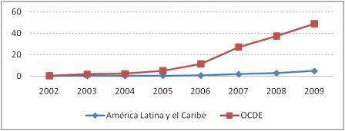

The following graphic reflects the cost of broadband in Latin America and the Caribbean (LAC) in March of this year, showing an average cost of US$ 72.8 dollars per Mb (Mbps), in contrast to the $ 5.9 dollars per Mbps reflected for OECD countries. This is a huge difference.

Bolivia tops the list, where the tariff measured against the Purchasing Power Parity, amounts to $ 300 dollars per Mbps. Panama ends the list, with a cost of $ 17.7 dollars per Mbps. This must be compared to the OECD average of $ 5.9 per Mbps.

**Tariffs en U.S. dollars/PPP per 1 Mbps, Fixed Broadband. March 2011**

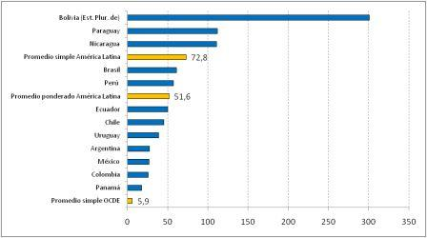

Another of the measurements habitually employed to measure the quality of broadband service, is the speed. The Observatory figures show that during the last year South America had an effective speed increase of 53% in access to Internet broadband, both in the up and down links.

In both cases Chile is the outstanding case, where the uplink speed in April reached 1.767 Mbps, (39% more than in April 2010), and the downlink reached 6.413 Mbps. In Bolivia the uplink speed was 210 Mbps, and the downlink was 428 Mbps (the lowest indicators in the region).

**Evolution of broadband uplink speed**

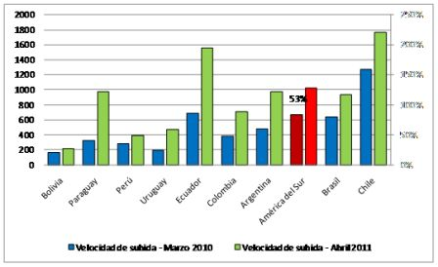

**Evolution of broadband downlink speed**

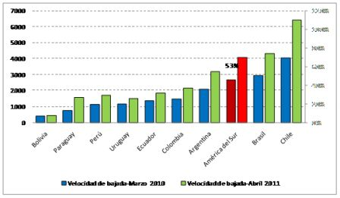

According to the data produced by ORBA, between April 2010 and April 2011, there was a significant improvement in access to fixed broadband service in the region, since the monthly income required for subscribing to 1 Mbps, was reduced throughout Latin America by a little over 37%.

**Ratio of fixed broadband tariff**

**USD average per 1 Mbps/PIB per cápita monthly**

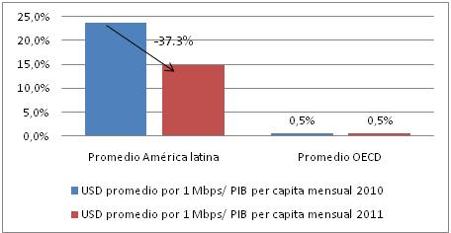

As can be observed, the costs of the service are almost five times higher than the average costs in the OCDE countries.

**Effective downlink and uplink speeds**

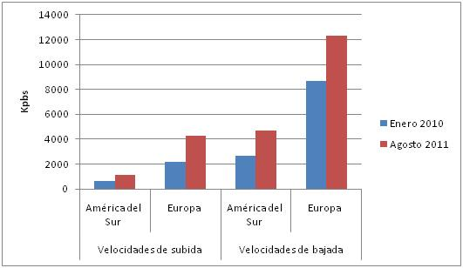

As can be seen in the preceding graphic, the South American countries also showed an improvement in the effective speed of Internet broadband access. The uplink speed increased by 64% between January 2010 and August 2011, while the downlink speed increased 75% over the same period.

But this has not been enough to close the existing breach between the developed countries of Europe and LAC. The uplink speed is almost four times faster than in the LAC region, while the downlink speed is practically three times faster.

# Internet Exchange Points (IXPs)

The Internet Exchange Points (IXPs), also known as NAPs (Network Access Points), are the result of the development of the network of networks – “Internet”.

In the beginnings of the development of the commercial Internet, which would correspond to the year 1995, the countries in the region had some services known as value added services, such as: electronic mail, access to databanks, various online directories, information exchange, etc.

This considered from the viewpoint of interconnection, both locally and internationally, was not a barrier to the use of these services, since they were few and expensive, and hence not for mass consumption.

The development of the Internet, which as is well known was massive and revolutionary, both as regards acceptance as to the diversity of services offered to the user, brought about a new vision of connectivity in general. The ISPs (Internet Service Providers), the few in existence and those that rapidly started up in this new technology business, were encountering some difficulties which were hard to resolve.

Each new company generated a demand for links to interconnect to the rest of the network. We should not forget that the philosophy of the Internet is that of the “network of networks”. On top of this, the conventional method of user access was via telephone lines using what was called “dial-up” mode, which obliged the ISP to lease a pool of telephone lines normally owned by the incumbent companies (both public and private sector), who usually had a communications monopoly.

Thus the Internet business model, where practically all the services were (and still are) free of charge, with the exception of the access charge, offered little opportunity for small and medium enterprises to develop. Although in this document we analyze the situation of Latin America, this same situation was occurring all over the world. This prompted CABASE, the Argentina Internet Association (founded in 1989), and as the first entity in the region which brought together companies specializing in Internet services, to intervene.

After long months of discussions between the various CABASE members, ISPs, Carriers (Interconnect Providers) and Content Providers defined what became the first Internet Exchange in the Latin America region.

CABASE selected the cooperative, non-profit mode for the CABASE Network Access Point (NAP), which began operations in 1998, and which quickly enabled significant cost savings in interconnect lines between providers. Since the intra-NAP traffic had no cost, a new stage of development and growth of the Internet began, in this case in Argentina.

As you will see in the following diagrams, where interconnection is provided through a NAP, the savings in terms of interconnect links and infrastructure, security systems, etc., is immediately evident.

ISP1

ISP2

ISP3

ISP4

Contents

Global Internet Global

**Interconnection diagram of ISPs to the Internet and a Content Provider**

ISP1

ISP2

ISP3

ISP4

Content

Global Internet Global

**N A P**

**Interconnection diagram same as previous but using a NAP**

The success of this project quickly generated replicas in other countries. Colombia, Peru, Chile, amongst others, quickly adopted the associative mode and, whereas not in all cases were the NAPs created in cooperative, non-profit mode, their objective was always the same – to improve the quality and cost of the services.

This CABASE initiative became a regional connectivity policy, and hence an initial meeting was held in Cartagena, Colombia in 2002, with the title of NAPLA (NAP Latin America), and it was organized by the Colombian Informatics and Telecommunications Chamber (CCIT), which operates the Colombia NAPs, and from this point on this became an annual event, usually organized by LACNIC – The Latin America and Caribbean Address Registry.

On the other hand, the Brazil, Argentina and Ecuador models, with a high content of cooperative participation, demonstrate the advantages of developing more than one Internet Exchange per country, which enhance the interconnection, connectivity and security in the respective country.. A brief description of the main characteristics of these projects is presented herein.

The Brazil Project, which is led by the Brazil Internet Steering Committee (CGBr), an entity made up of the different sectors in Brazil Society, and which has the largest amount of NAPs in the region, supports and promotes the development of NAPs in the country. The Sao Paulo NAP is the central point of traffic exchange, and provides training and equipment support for the other NAPs. Each one of the NAPs must accept the common interconnect and routing policies, and are free to develop their own commercial policies.

In Argentina, CABASE – the Argentina Internet Association, as mentioned previously, was the first entity in the region to inaugurate a cooperative NAP in Buenos Aires, which has been operational for more than ten years, and which is currently developing a Project titled “Federalizing Broadband”, which among other objectives aims to develop one or more NAPs per province. Currently six new NAPs are operational, and six more are in development phase.

The case of Ecuador demonstrates that the size of the country is not important, nor the amount of users, but rather the will to grow of the involved participants is the driving force, in this instance the ISPs and the entity that contains them – AEPROVI – Association of ISPs, Carriers and Information Technology. To date they have developed three NAPs.

**Associative models of NAPs.**

In order to clarify concepts, the most common associative models are defined as follows.

* Cooperative Model. A group of companies unite, usually under the umbrella of a non-profit Association, and constitute a NAP. This can also occur within an existing Association, and also a cooperative can associate with another entity in order to participate in a NAP. The economic advantages of this model are that, when a non-profit entity is involved, the cost of the services is notably lower in all aspects.

**Private model.**

This model offers two options

* In the first model, a company develops a NAP and then proceeds to rent out services within its own facilities, for example co-location (which consists of physical space, usually known as a “cage” since the space is closed by means of a metallic fabric, and only the lessee has access to the door).

Housing – in this case the lessee’s equipment is placed in a common space, and is maintained by the NAP personnel. With regards to connectivity, this is generally up to the lessee who can have multipoint connectivity, or else peer-to-peer (p2p), which involves one-to-one links. This is a typical business arrangement between private parties, wherein the lessor chooses who he will route traffic to and how, according to certain values and rules defined by the lessor.

**Mixed Model.**

* This is an unusual case but we can use the Brazil PTT (traffic exchange point) as an example, and in which a non-profit Association – which is also multi-stakeholder – supports a project and cooperates with equipment and operational regulations, leaving the economic model up to the involved participants.

The last type of NAPs refers to those that exist in countries listed as not having NAPs for various motives, such as:

* Telecommunications are run by the government mostly, which means that any interconnection of this type is performed by the government within its facilities.
* Countries where the incumbents have dominant market share and leave little space for competition, as in the case of Mexico where their frontier with the United States makes interconnection a non-contentious issue, in view of the low costs involved.
* Finally, we must consider those countries in which the Internet is not sufficiently developed, thus lacking a critical mass of operators that might develop a NAP.

And finally, with reference to security, the experience of the Haiti earthquake of 2010 demonstrates the undeniable importance of having more than one NAP per country, for the purposes of backup (which means a support system that can encompass software) – which may mean applications (programs) or data files (information) - or equipment (hardware), and where duplicates of all or some of the items described are kept. In the case of a NAP, interconnection links are also included, or in other words a secondary NAP acts as a backup of the primary in the event of natural disasters or destruction.

A list of existing NAPs in the various countries of the region, follows hereon. The details of how they are constituted, number of participants and date of foundation, including in some instances a comment on some of the technical characteristics, and traffic graphics where published. Usually this graphic reflects the bandwidth of the last year or other temporal sequence, and the readings correspond to the period from October 15 to November 2 of 2011.

**NAPs**

|  |  |  |  |  |
| --- | --- | --- | --- | --- |
| **Netherlands Antilles** | Nbr.of NAPs´s - 2 |  |  |  |
| **Location** | Model | Nbr.Part. | Founded | Institution |
| OCIX Philipsburg | Cooperative | 7 | 2008 | Open Caribbean Internet Exchange |
| CAR-IX Curazao | Cooperative | 11 | 2009 | Caribbean Internet eXchange |

In the case of Netherlands Antilles, two NAPS have been created – both by non-profit entities. The first of these – “**OCIX** **- O**pen **C**aribbean **I**nternet e**X**change is a non-profit, neutral, independent Internet Exchange located in Philipsburg, Sint Maarten” (as per their own self-definition). The following are two NAPs traffic charts, one that comprehends one day of traffic, and the other one year of readings.

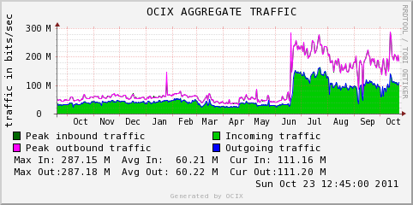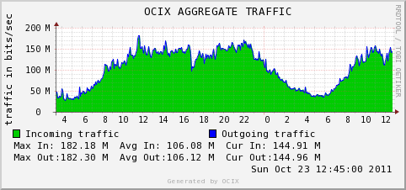

The second case and as self-defined is: ”The CAR-IX is a neutral and independent not-for-profit Internet Exchange”, as with the previous case, we show two charts - one that comprehends one day of traffic, and the other the readings between July and October of 2011.

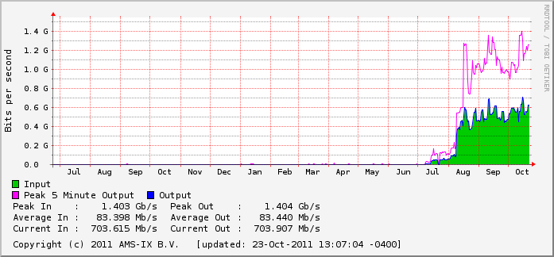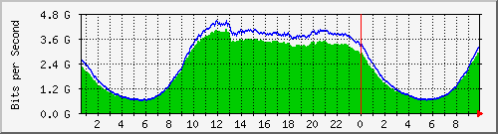

|  |  |  |  |  |
| --- | --- | --- | --- | --- |
| **Argentina** | Nbr. of NAPs´s - 2 |  |  |  |
| **Location** | Model | Nbr Part | Founded | Institution |
| Buenos Aires | Cooperative | 42 | 1996 | CABASE |
| Bahía Blanca | Cooperative | 11 | 2011 | CABASE |
| Neuquen | Cooperative | 12 | 2011 | CABASE |
| Rosario | Cooperative | 17 | 2011 | CABASE |
| Mendoza | Cooperative | 9 | 2011 | CABASE |
| Santa Fe | Cooperative | 6 | 2011 | CABASE |
| Mar del Plata | Cooperative | In Construction | 2011 | CABASE |
| Partido de la Costa | Cooperative | 6 | 2011 | CABASE |
| Cordoba | Cooperative | In Construction | 2011 | CABASE |
| La Plata | Cooperative | In Construction | 2011 | CABASE |

Argentina created the first NAP in the Latin American region, and its success became an example for the deployment of NAPs in the rest of the countries in the region. 13 years later, in mid 2010, a project known as “Federalizing Broadband” was initiated. One of its main premises is the promotion and support for creating other NAPs within the country.

After an arduous task of evangelizing with the regional ISP Cooperatives, including representatives of the governments in each respective province, the creation of these NAPs was agreed upon. We would not like to omit mentioning the involvement of a Carrier that can be considered to be a model as an instrument for development, notwithstanding its own commercial interests.

In summary, in April of this year CABASE’s second NAP is launched, with the inclusion of 12 participants, including ISPs, Telephone Cooperatives and the Government of the province of Neuquèn, which considered that this project contributed to the plans for ICT4D, and also enhancing the range of services that the government could provide to the population of that province.

As an added value, the interconnection to the central NAP (Buenos Aires) provides Access to a mirror of the Root Server F, which resolves searches for Internet addresses locally, without generating traffic to and from the USA. A server from Verisign installed in the Buenos Aires NAP, resolves similar searches for ‘.com’ and ‘.net’ addresses. All this enables an important cost-reduction on international connectivity, as well as improving response time and network security. The following charts correspond to the central NAP (Buenos Aires), covering one day of traffic, and readings from February through October. The charts showing latency and lost packets per connected ISP are also available, thus enabling quality verification of the service provided by the various participants.

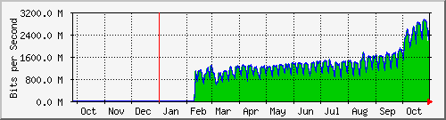

|  |  |  |  |  |
| --- | --- | --- | --- | --- |
| **Brasil** | Nbr. of NAPs´s-16 |  |  |  |
| **Location** | Model | Nbr. Part | Founded | Institution |
|  | Cooper./Commercial | 472 Tot. | 2004 | CGIbr |
| Americana | “ | 11 |  | CGIbr |
| Belo Horizonte | “ | 17 |  | CGIbr |
| Brasilia | “ | 13 |  | CGIbr |
| Campina Grande | “ | 10 |  | CGIbr |
| Campinas | “ | 18 |  | CGIbr |
| Curitiba | “ | 25 |  | CGIbr |
| FloreaNAPsolis | “ | 10 |  | CGIbr |
| Fortaleza | “ | 11 |  | CGIbr |
| Goiania | “ | 11 |  | CGIbr |
| Londrina | “ | 16 |  | CGIbr |
| Porto Alegre | “ | 34 |  | CGIbr |
| Recife | “ | 5 |  | CGIbr |
| Rio de Janeiro | “ | 19 |  | CGIbr |
| Salvador | “ | 21 |  | CGIbr |
| Sao J. Dos Campos | “ | 7 |  | CGIbr |
| San Paulo | “ | 244 |  | CGIbr |

The Brazilian Project known as PTT Metro, is led by the Brazil Internet Steering Committee, and includes the government, academic and private sectors. The general rules to have access to the project are:

* Possess an ASN (Autonomous System Number)
* Both multilateral and bilateral traffic is allowed.
* Only one NAP per locality.
* The ISP must get to the NAP with proprietary or rented fiber
* The CGI can loan the equipment that illuminate said fiber.
* Each NAP decides on its own economic model and on how its participants interact.

The following shows a chart for one day’s traffic of all NAPs

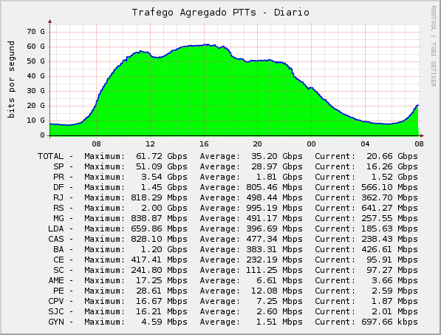

|  |  |  |  |  |
| --- | --- | --- | --- | --- |
| **Colombia** | Nbr. Of NAPs´s - 2 |  |  |  |
| **Location** | Model | Nbr Part | Founded | Institution |
| Bogota | Cooperative | 16 | 1999 | CCIT |
| Bogota | Universidad | n/a | n/a | CIM |
| Bogota | Private | 14 | 2008 | Terramark |

The Colombian Chamber of Informatics and Telecommunications – CCIT, in the year 2008 founded the first NAP in Colombia, and was one of the first pioneers on these initiatives. The Chamber is a non-profit Association, and its core mission was and is the interconnection of the various members of the entity, in order to achieve interconnection and connectivity, thus achieving both economic and technological improvement. Little is known of the University of Colombia NAP, and with regards to Terremark only the information that has been included herein. The traffic in the chart corresponds to the CCIT Nap.

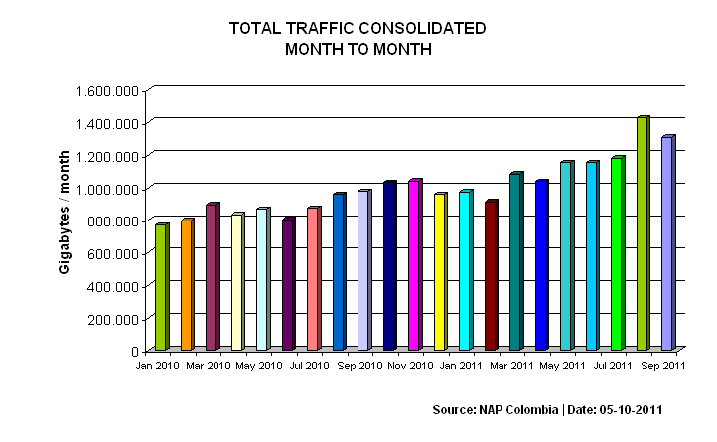

|  |  |  |  |  |
| --- | --- | --- | --- | --- |
| **Cuba** | Nbr. Of NAPs´s - 1 |  |  |  |
| **Location** | Model | Nbr. Of Part | Founded | Institution |
| Havana | State | 5 | 2001 | Etecsa |

ETECSA, the Cuban Telecommunications Company, in 2001 created the Internet Exchange Point, thus taking the first step for development of the Internet on the island.

The connectivity of the island was based until this year on satellite interconnection, and this was an impediment to the development of the Internet, due to the cost of broadband for this type of satellite services, as well as their characteristic latency. Currently the submarine optical fibre cable is installed and finalizing the test period for this link, which connects Cuba to Venezuela, and according to the established timeframe will be operative at the end of 2011. As with the other cases, the following shows a traffic chart from the year 2006 until June of 2011.

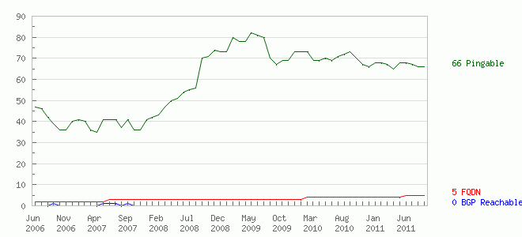

|  |  |  |  |  |
| --- | --- | --- | --- | --- |
| **Chile** | Nbr. Of NAPs´s - 3 |  |  |  |
| **Location** | Model | Nbr. Part | Founded | Institution |
| Santiago | Private | 20 | 1997 | NAPs Chile S.A. |
| Santiago | Private | 13 | n/a | ENTEL |
| Santiago | Private | 14 | n/a | Telefonica Mundo |
| Santiago | Private | 6 | n/a | Equant |
| Santiago | Private | 6 | n/a | Global Crossing |
| Santiago | Private | s/d | n/a | Chilesat |
| Santiago | Private | 1 | n/a | Intercity |
| Santiago | Private | s/d | n/a | AT&T |
| Santiago | Private | s/d | n/a | Manquehue |

The Chilean case, some have special characteristics; when the NAPs began to constitute, how the operators and ISPs were to interact was not too clear. This prompted the Chilean Sub-Secretary of Communications to sanction a regulation for ISP interconnection, on 22nd. October, 1999. This made interconnection between them obligatory. It also regulates the quality of the service as a parameter according to international standards. It stipulates the maximum terms pertaining to the implementation of these interconnections, and also regulates the quality of the service provided to the end user. No overall charts are available.

|  |  |  |  |  |
| --- | --- | --- | --- | --- |
| **Ecuador** | Nbr. of NAPs´s - 3 |  |  |  |
| **Location** | Model | Nbr. Part | Founded | Institution |
| Cuenca | Cooperative | 2 | 2010 | AEPROVI |
| Guayaquil | Cooperative | 9 | 2007 | AEPROVI |
| Quito | Cooperative | 14 | 2001 | AEPROVI |

As previously commented, AEPROVI - Association of ISPs, Carriers and Information Technology, has a policy for traffic which is multilateral and obligatory. As can be seen the Cuenca NAP only has two ISPs, which demonstrates that the advantages of interconnection go beyond the quantity of connected ISPs.

Quito Daily

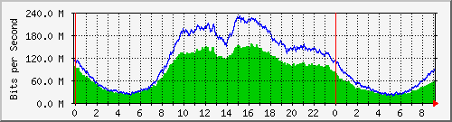

Guayaquil Daily

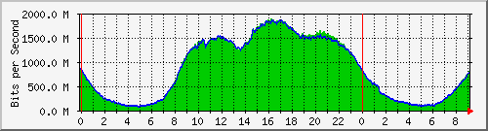

Cuenca Daily

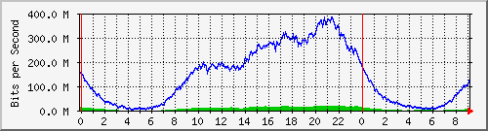

|  |  |  |  |  |
| --- | --- | --- | --- | --- |
| **Haiti** | Nbr. of NAPs´s - 1 |  |  |  |
| **Location** | Model | Nbr. Part | Founded | Institution |
| Puerto Príncipe | Cooperative | 4 | 2009 | AHTIC IT |

The Haitian Association for the development of ICT  ***(***Association Haïtienne pour le développement des TIC) is the operator of the Haiti NAPs, it must be noted that the Haiti NAP continued to operate in spite of the terrible earthquake that hit the country on January 12th., 2010, and it was an important resource in locating buried people. Also, the result of the evaluation of this event by the administrators of the NAP, emphasizes in their final analysis that the possibility of having more than one NAP, drastically reduces the chances of a blackout of communications and services in a country. Thus the quality of security is greater.

|  |  |  |  |  |
| --- | --- | --- | --- | --- |
| **Nicaragua** | Nbr. Of NAPs´s - 1 |  |  |  |
| **Location** | Model | Nbr. Part | Founded | Institution |
| Managua | Cooperative | 15 | 1995 | AIN |

No further information is available.

|  |  |  |  |  |
| --- | --- | --- | --- | --- |
| **Panamá** | Nbr. Of NAPs´s - 1 |  |  |  |
| **Location** | Model | Nbr. Part | Founded | Institution |
| Panamá City | Académico | n/a | n/a | CENACYT |
| Panamá City | n/a | 10 | n/a | Intered Panamá |

Reliable information from Panama not available.

|  |  |  |  |  |
| --- | --- | --- | --- | --- |
| **Paraguay** | Nbr. Of NAPs´s - 1 |  |  |  |
| **Location** | Model | Nbr.Part | Founded | Institution |
| Asuncion | Cooperative | 15 | 2001 | CAPADI |

CAPADI is the Paraguay Chamber of Internet. Although the Chamber has no current general activities at this time, the NAP is operational with some 22 Points of Presence in the country using optical fiber.

|  |  |  |  |  |
| --- | --- | --- | --- | --- |
| **Perú** | Nbr. Of NAPs´s - 1 |  |  |  |
| **Location** | Model | Nbr.Part | Founded | Institution |
| Lima | Private | 9 | 2001 | NAPs Peru |
| Lima | Private | n/a | n/a | Internexa |

After the signing of the agreement for the first NAP, Peru became the fifth country in Latin America to have this system, after Argentina, Brazil, Chile and Colombia. The charts refer to some of the NAP Peru members, not to overall traffic. The uplink traffic, which refers to outbound traffic, is shown in green, the downlink or inbound traffic is shown in blue.

.

Americatel Claro British Telecom

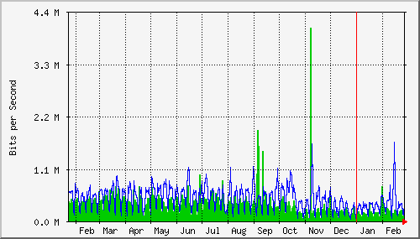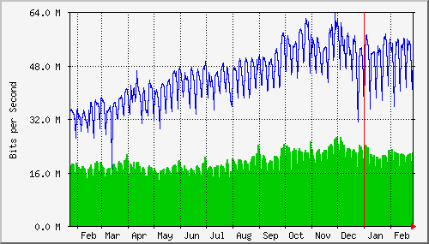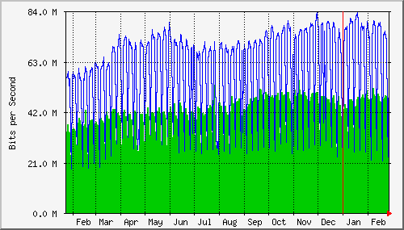

Global Crossing RCP Optical Networks

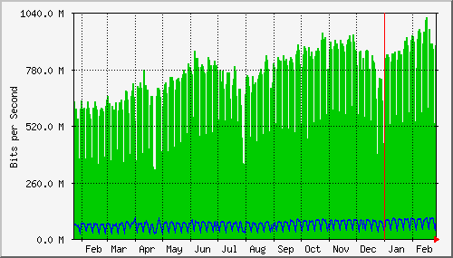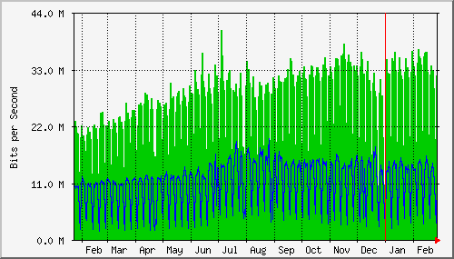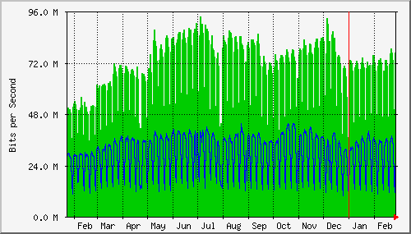

Telefónica del Perú Telmex

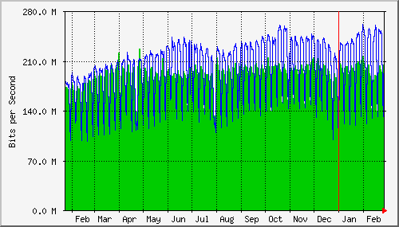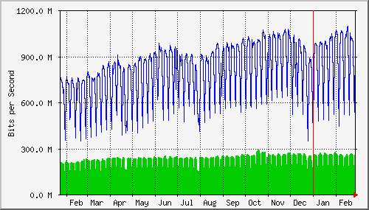

|  |  |  |  |  |
| --- | --- | --- | --- | --- |
| **Dominican Rep.** | Nbr. Of NAPs´s - 1 |  |  |  |
| **Location** | Model | Nbr.Part | Founded | Institution |
| Santo Domingo | Private |  | 2008 | Terremark World |

The definitive NAP will be located in the Santo Domingo Cybernetic Park, where the Caribbean NAP will become operational in the future. It includes a building which will house the new NAP facilities, with 150.000 sq.ft. of space, and strict security measures that will be resistant to high category cyclones, since Santo Domingo habitually is subjected to these climatic phenomena, this is something to be noted.

**The following charts show:**

* The first is the distribution according to institutional model
* The second according to distribution of NAPs per country

**Institutional model of NAPs**

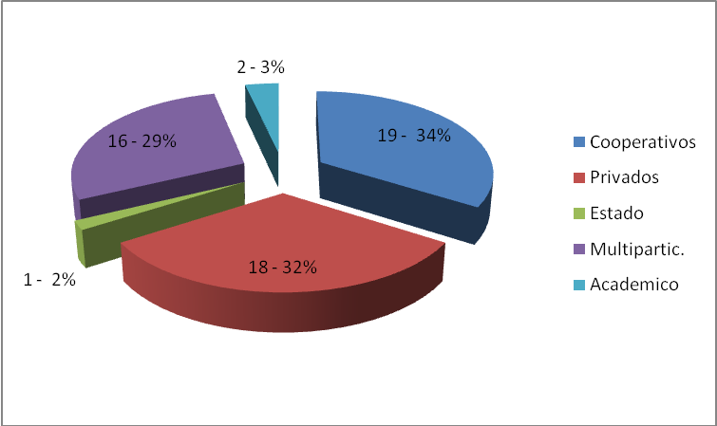

**Number of NAPs per country**

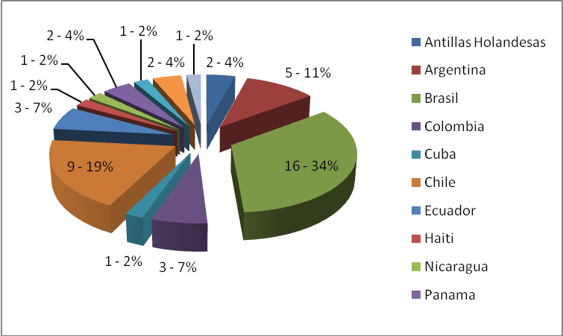

**Countries without NAPs**

The following countries do not have NAPs in either private or non-profit mode, but the communications companies of these countries have NAPs, as far as technical aspects. In countries such as Costa Rica and Uruguay the State has a monopoly in certain areas of the communications services.

|  |  |  |  |
| --- | --- | --- | --- |
| Aruba | Bolivia | Belize | Costa Rica |
| Guayana Francesa | Guatemala | Honduras | México |
| Suriname | El Salvador | Trinidad y Tobago | Uruguay |
| Venezuela |  |  |  |

As we commented in the previous paragraph, in those countries where communications are controlled by the State, the “NAP” is operated by the national Telco, for example: in Costa Rica and Uruguay. In the remaining countries, the NAP operator could be the Telephone Company or the international provider of international communications, which usually provides all the services. The case of Mexico is more complex and more detailed information can be found in the chapter on business model.

This vision of the different options, according to each country, the scale of economy and the constitutive mode, will contribute towards a clear understanding of the importance of the NAPs, in the technical-economic solution of interconnection in Latin America.

# Projects within the region

Three examples of projects have been chosen to demonstrate that States can become involved, and produce the necessary changes that will promote the development of Broadband. If to this we add the development of the NAPs, and the empowerment of pISPs (being able to be competitive), then we are closer to achieving the objective of this study, i.e. the reduction of the Digital Divide, and the enabling of the geographically and economically underprivileged to have access to ICTs. Also included are comments of a high ranking public official in Brazil, which reveal problematic issues that have been previously commented, and are herein confirmed.

**Argentina – Project: “Argentina Connected”**

With regards to infrastructure, the Federal Fiber Optic Network will be developed. It has been declared of Public Interest by means of Decree Nº 1552/2010, which creates the National Plan of Argentina Connected (Map of the Federal Network)

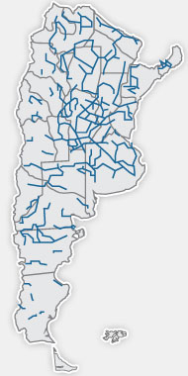

Through Argentina Connected, the National Government will promote the construction of national infrastructure complementary to the existing telecommunications networks (i.e. those owned by the traditional operators)

As a first stage 10000 kilometers of new networks will be developed, reaching a total of 35000 kilometers, thus triplicating the current installed capacity.

Through the deployment of infrastructure and the increased availability of services, a direct impact on the wholesale prices of data carriers is achieved, resulting in a reduction of tariffs to the end user of Internet Broadband and Video. This will generate increased indexes of inclusion and equanimity in the whole country, as regards to access, quality of service and price.

As can be seem on the map, the deployment generates a number of rings (backbones), that contribute to network security as we have noted in the module on backbones. Eight regions have so far been tendered:

* NORTH REGION NOA
* CENTER EAST REGION
* CENTER WEST REGION
* SOUTH NE REGION NEA
* MISIONES REGION
* NORTH PATAGONIA
* SOUTH PATAGONIA
* NORTH NE REGION

The Project also includes a second decision which is shown below:

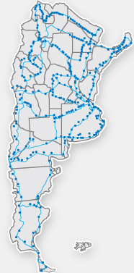

In order to guarantee the availability in all the national territory, of an advanced telecommunications network, there will be a deployment of the Provincial Fiber Optic Network, to be constructed in all the provinces of the Argentine Republic.

Through the deployment of this Network, the objective will be to connect each city in the national territory, enabling interconnection of the trunk network with local operators, who will provide the access services to the home.

According to the time frame, the construction of the Provincial Networks is planned in two stages:

The first to be developed in 2011, includes the construction of 13.300 Km of Fiber Optics.

The second includes the construction of 8.600 KM of Fiber Optics.

**Brazil – National Broadband Plan**

Since 2010 Brazil is developing the National Broadband Plan. Cesar Alvares (Special Advisor to the Presidency) refers to this thus: “The Brazilian government expects to implement a pilot of its National Broadband Plan in 300 cities of the country. The objective of the program is to complete 30 million fixed broadband connections, and 60 million mobile connections by 2014, including Internet connections for all the government agencies, and the more than 70.000 schools that still lack connectivity, as well as the installation of 100.000 new telecommunications community centers.

We also include some paragraphs quoting Rogerio Santanna dos Santos, President of Telebras, who refers to a survey conducted in 2009. These statements confirm the diagnostics of this study:

“In spite of the measures adopted by the Brazilian government, to ensure greater digital inclusion, and the access to Information Technologies of the economically underprivileged populations, there are still large gaps in this field that reinforce the social exclusion in this country.”

“Brazil is the largest user in terms of time and connection, and is also the best connected, which shows that the use of the Internet is an important element of socialization. In spite of this enormous potential however, broadband is expensive in Brazil, is low speed and is concentrated in high income and population density regions. This is because the major part of these services are provided by three companies, who between them have 86% of the Brazilian market, and are committed to servicing the A and B classes.”

“We have the most expensive broadband in the world and even so it is insufficient, since it only exists in large cities and in the wealthiest áreas of the country. The Brazilian government does not intervene in the wealthy suburbs of important Capital cities, since in these places there are many providers to satisfy this demand.”

“The Internet in Brazil is still an urban phenomenon, concentrated in high-income regions, due to the lack of interest of the telecommunications operators, who currently concentrate their business in the higher income and population density areas.”

“This reality demonstrates the urgency to develop the National Broadband Plan (PNBL), in order to bring the Internet to the hinterland, forgotten and condemned to eternal disconnection. We must above all, stimulate the market in this area since there are 1.700 Communications Services Licenses (WCS), already issued by the National Telecommunications Agency (Anatel). Yet in reality there is no competition, sdue to the infrastructure control of regional monopolies, that make it virtually impossible for small providers to offer their services

“These are the reasons why the Brazilian government should use its infrastructure of more than 30.000 kilometers of fiber optics, to participate in the competition segment, which will occur in the service ambient and not in the control of infrastructure”

**Colombia – National Fiber Optics Project**

On November 5th of this year, the tender in Colombia was awarded. The following is a quote from comments published on this award.

“The Colombia Temporary Fiber Optics Union, a joint company formed by TV Azteca and Total Play, has been selected by the Colombia Ministry of Information Technology and Communications (MTIC), to implement and maintain a national fiber optics network. The network will connect 1.078 municipalities, and consists of 15.000 km of fiber optics. The project is a public-private cooperation for a total cost of 670 million dollars, part of which will be provided by the government.

The project will seek to increase the number of connections to the Internet in the country, to 8,8 million by 2014.

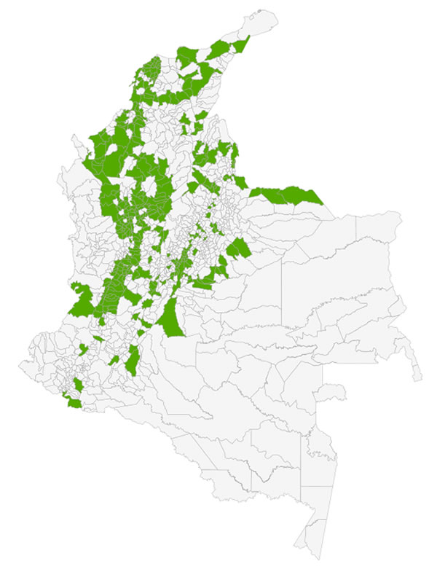

325 Municipalities will be connected by fiber optics. The project will be implemented in three stages, and will be concluded by the year 2014.

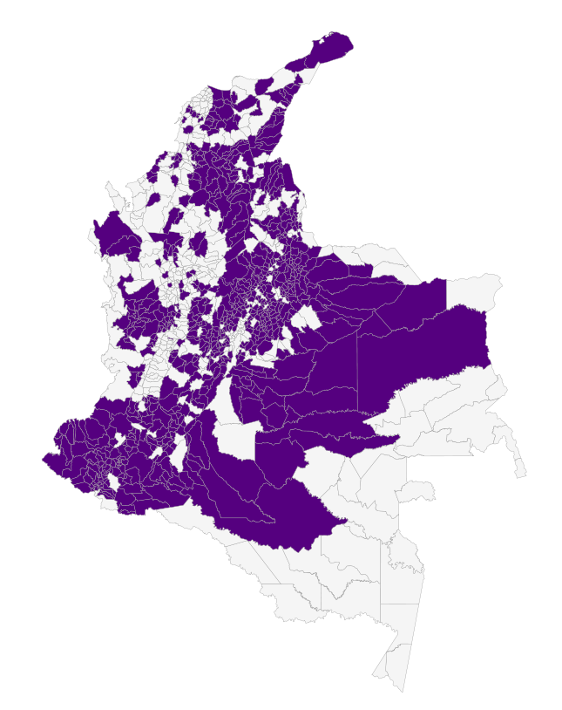

Map of national coverage of the Project, enabling 753 locations to have fiber optic connections. These are included in the 2012/2014 stages.

# Best Practices

In the development of broadband, as we have mentioned before, various factors and actors intervene according to each case, but the study undertaken to review the participation of NAPs as a solution to improve Internet development, hence achieving a reduction of the Digital Divide, (although focused on Latin America does not mean it cannot be replicated in another region), demonstrate that this model takes the lead.

The general experience of countries in the region, whatever model of NAP has been implemented, be it private, multistakeholder or cooperative, has resulted in successful experiences, considering the economic, technical and also human aspects.

Observing the economic aspect, the reduction of economic and technical resources that the use of a NAP enables is important. The drastic reduction in the cost of bandwidth to be contracted, the economies regarding equipment and software, and common or general expenses, are some of the most important items we can mention.

In developing this document, we have described the different NAPs and their models within the region. Of these, the project that CABASE is implementing in Argentina at this time, which is a cooperative model, is the one which contributes the largest benefits to the core of this study, development of Broadband and International Interconnection.

General conditions for participating in a CABASE NAP

* The participating companies must be members of the entity, CABASE, which in this instance is an NGO non-profit institution.
* Then they must file a request to participate in the NAP, and must accept its rules and regulations, which include these definitions:
  + Multilateral, must publish all its routes – all accesses to other networks or services must be accessible to the rest of the group.
  + SLA (service level agreement), which includes the levels of acceptable errors, error recovery times, latency, loss of packets, etc. These readings will be published and accessible without restrictions, thus ensuring operational transparency.
  + Present a technical project for connection to the NAP, which will require the approval of the NAP Technical Coordinator.
  + Reaching the NAP (last mile interconnection) will be defined by the member, but must be contracted and implemented by a Carrier who is a member of CABASE and has presence in this NAP.
  + The equipment required for the interconnection of the member to the NAP will be provided by the participant, and he will be responsible for maintenance of the interconnection and all his equipment.
  + Costs policy: (a) General expenses which are shared equally by all – insurance, energy supply, UPS, security, etc. (b) Participant proprietary costs: rack space utilized as per equipment in use, link port dependant on bandwidth, for example 100 Mb or 1 Gb. All these result in a formula which is defined as a cost index known as “NAP Point”. The minimum participant charge is for 2 NAP Points.
  + Accept the payment terms and the consequences of lack of payment (service cuts and penalties)
  + Contribute to the reserve fund, which will be an amount suitable to the NAP infrastructure, and must be sufficient to address necessary purchases or operations required for contingencies of any sort or origin, for example natural disasters.
* The participating companies have one vote, independently of the size of the company.
* The decisions are taken by consensus, whether the issues be economic or involve technical and commercial policies. When necessary a vote will be called.
* Special cases: This refers to the interconnect requests from the academic or governmental sectors. The difference lies particularly in the sequence of payments, or some other specific necessity.
* The CABASE Board of Directors will be the authority that gives final approval to the NAP resolutions.

All this applies to the CABASE main NAP, which has operated successfully for more than 10 years in a limited territory – the City of Buenos Aires. Whereas undoubtedly this is the geographic area with the greatest concentration of users and Internet Providers, it was not the solution to the problem posed by this study – Interconnection, reduction of the Digital Divide, deployment of Broadband in the hinterland.

During 2010 CABASE launched a project called “Broadband Federalization”, aimed to diminish the inequities of the interconnection for the pISPs in the hinterland, and the services they provide to the populations that are remote from urban centers.

As a first item of the project, a survey was conducted on the networks that existed in the country and were not owned by the incumbents. The result was more than interesting, in view of the amount of fiber optic networks or microwave installations in the country, and which in some cases were not illuminated (operational) or had idle capacity, including the provincial government networks, or public service companies in the same condition.

Once this was completed, contact was made with some of the pISPs in different provinces, and with Carriers (not the incumbents) who had a clear vision of the project and its results for the near future (which involved providing interconnection and transit services at a cost much lower than what the pISPs were then paying).

Very soon a Carrier who was a member of CABASE, made a definite offer for interconnection, quoting costs that in some cases, and for some pISPs, meant a reduction of 90% of the tariff they were currently paying the incumbent for each Mb.

Meanwhile the pISPs in the province of Neuquén, together with the provincial government began to assess the creation of a CABASE NAP in that province (Approx. 1,100 kilometers from Buenos Aires)

The first challenge was convincing the group of the enormous advantages of this “cooperative” association, in terms of the NAP and the non-profit status of CABASE, and that the competition that existed between them, could internally in the NAP become an opportunity for doing multiple business externally.

In the previous point, the experience of years in which the Buenos Aires NAP coordinated the relations between the different participants, pISPs, Carriers, Content Providers and Public Entities, proved to be a positive influence. Maintaining a balance between the interests of different parties which sometimes were in opposition to each other, was an exercise that enabled CABASE to achieve invaluable experience, and this is capitalized in these new initiatives.

In summary, the Neuquen NAP was created as the first milestone of this project. Subsequently, and after this experience, enquiries were received from pISPs from other provinces, as well as Carriers, all interested in participating in this project. It should be noted that those involved in the Neuquen NAP, participated actively in communicating this project and its benefits.

To date, and as can be seen in the Table of the NAPs chapter, the locations of Bahia Blanca, Mendoza, Santa Fe (2), Partido de la Costa (Prov. Of Buenos Aires) are operational. Three more are in construction: Córdoba, Mar del Plata and La Plata (Prov. de Buenos Aires), and finally six more are in evaluation stage – Catamarca, Jujuy, Tucumán, Misiones (2) and San Luis.

This model is perfectly replicable, with logical variations according to country. Its implementation and operational launching is quick, and the benefits for all parties – Carriers. ISPs and users – soon become visible. Given these successes, this can undoubtedly be defined to be an example of best practices in the LA region.

# Diagnosis

Globalization is a phenomenon that can be considered well known and established in the world. Any sort of study that is undertaken must take it into consideration. Various forms of telecommunications, including the Internet, are representative of this phenomenon, since they are global activities par excellence. Given this fact, to undertake a diagnosis on interconnection and broadband, one must first take a picture of the global conditions in which the activity is developed - telecommunications or basically the Internet.

It is well known that the 2010-2011 economic/financial crisis that has struck Europe and the United States, is so huge that it will in some measure or other affect the rest of the world. Among others the effects can be seen on the companies, who do not initiate new projects and, in some cases, suspend or reduce activity in other projects, and telecommunications is not exempt from this.

It is also important to highlight that this sector has not had significant investments in the last years. Adding this to the current situation of the economy, seriously threatens the chances of proceeding with investments in infrastructure that will be required for the development and technical updating of the Internet.

Although the forecasts indicate that the crisis will not seriously affect Latin America, this should be taken at face value, as only the passage of time will tell if these forecasts are accurate. Also it should be noted that the companies that were surveyed regarding the deployment of broadband are all global, and thus are affected by the crisis. They had problems before, and these are accentuated in the present.

The concentration of the market in a few companies is a result of ten years of purchases, mergers of the successful companies in the sector, and the disappearance of those who were unable to compete. All this has contributed to the present situation.

When it comes time for companies to establish priorities or define investments, within a financial scenario that is complex to say the least, both globally as in the local internal economies, then the strategic plan is reduced to:

* Minimum investment with maximum ROI in the short term
* Undertake those improvements that cannot be avoided, to ensure continuity of operations
* Finally, sustain the home market of the corporation

At the same time, it is not unrealistic to think that an important part of the discussion is known as “Net Neutrality”, which is about the participation of providers in the content business, and wherein those who promote the use of enormous amounts of bandwidth, generate the financial need for “partners”, who will assist in building the network required to support the demands of the future. Some examples are digital television, cloud computing, triple play, etc

Whereas the high profitability or high demographic density areas in Latin America have been developed, the rest of the sectors – geographic or demographic – which are not attractive in normal times, will be all the less so in moments of crisis.

If the idea in Latin America is that it is a strategic objective to develop those sectors that have fewer resources, less educational support and less general growth in the use of ICTs, then plans must be devised for projects in which not only the “market” intervenes (as the private sector is referred to, without in the least wanting to discredit this sector), but rather employing a realist vision of the current economic situation.

# Final summary

The factors that converge to impede the development of Broadband in Latin America are:

Lack of investment in the updating and expansion of basic telecommunications infrastructure – Fiber Optics – the building block of interconnection.

Concentration of the market in few companies, which means low competition in the different market segments..

Economic/financial situation with serious difficulties in the global market, and this is applicable particularly to companies of this sector.

Almost exponential growth of the usage of bandwidth worldwide, and the pressure this brings to bear on the incumbents and the large companies, who cannot keep up with this growth in demand.

This set of barriers which is enumerated but not limitative, has been the subject of discussion for several years now in various fora – public, academic, NGOs and private. The current consensus is that the solution cannot emerge from one single sector, but must come from the combination of all parties, and all efforts should flow towards this model if results in the near future are desired.

To reinforce this last paragraph, we will proceed to reproduce some paragraphs from the UNASUR (Union of South American Nations) meeting with the IDB (Inter-American Development Bank), with regards to studies undertaken by the latter:

*“In order to democratize access to broadband, the countries must maximize public-private cooperation, adopt fiscal incentives to promote demand, and support the creation of regional and local services and contents.”*

*“The UNASUR member countries should construct more national and regional connection points, in order to build a regional connectivity network, which would reduce distances for data traffic, and reduce costs. According to the statistics of the Latin America and Caribbean Economic Commission (CEPAL), between 75 and 85 percent of the traffic in the region, including the locally produced content, pass through Miami. Comparatively, the largest percentage of traffic in Europe stays within its frontiers.”*

This last paragraph refers, in its first comment, to the NAPs, and we have already noted the advantages of this mode as a development tool.

The conditions are in place to generate a regional project that can diminish the asymmetries with regards to interconnection and access to Broadband in the entire Latin American region. We also have success models and replicable best practices. In the next module we will see a possible model alternative.

# Project based on Best Practices

In order to define a replicable model that produces results adjusted to the objectives of this study, we must first examine the elements we have detailed in the various modules of this document, re-evaluate them and place them in their true perspective and requisite order, so we can come up with a temporal development agenda that is feasible for most countries in LA.

Firstly we define these objectives:

* Development of infrastructure for Broadband deployment
* Deployment of Traffic Interexchange Points (PITs/NAPs/IXPs)
* Support for small and medium ISPs
* Generate a regional Backbone

Secondly the order in which these objectives must be implemented:

First of all work on developing NAPs must be done. This is because they are the building blocks which enable the other two objectives. As has been seen, the development of a NAP can be divided into two main areas – technological and administrative/commercial.

Whereas in the region there are various models of NAPs, including those of Brazil, Ecuador and Colombia among others, the model which fits this project best, is the one being implemented by CABASE – the Argentina Internet Association in that country, as an example of best practices. It is based on the cooperative model (non-profit), which guarantees transparency and rapid development. Also, this model has demonstrated that its results are rapidly transmitted to the population within the coverage area of each NAP.

With reference to the first area – technological, this does not pose many complications since we are dealing with equipment that is well tested, and which is well known in the countries of the region. It will, of course, be necessary to have technicians that are qualified for the project. We would mention that the economic aspect of the creation of a NAP is not high, the model that is taken from CABASE becomes sustainable with only five participating ISPs.

In the case of the second area – administrative/commercial, here there is an initial requirement for “evangelization” of the potential participants, since we must remember that they are competing companies who must begin to operate cooperatively. This requires a period of adaptation of the participants, in order to demonstrate to them, using operative examples, that the advantages of cooperating far outweigh any potential commercial losses involved in the project.

It is also important to have documentation with clear regulations, covering the following:

* Administration
* Payment methodology
* Payment of links proportionate to their usage
* Service Level Agreement Model
* Models for internal/external meetings coordination
* Definitions regarding contents (e.g. Cache and others), and their usage.
* Other issues

The following shows a model agenda for projects of creating NAPs, with their different stages and objectives:

Agenda Model

|  |  |  |  |  |  |  |  |  |  |  |
| --- | --- | --- | --- | --- | --- | --- | --- | --- | --- | --- |
|  | **30** | **60** | **90** | **120** | **150** | **180** | **210** | **240** | **270** | **300** |
|  |  |  |  |  |  |  |  |  |  |  |
|  |  |  |  |  |  |  |  |  |  |  |
|  |  |  |  |  |  |  |  |  |  |  |
|  |  |  |  |  |  |  |  |  |  |  |

DEFINITIONS

1. Define geographic areas apt for the installation of NAPs – country, State/province, city, etc.
2. After the selection defined in a) , the diverse actors must be approached, as per case and country, seeking to achieve consensus regarding objectives of interconnection and commercial policies, and last but not least – the definition of the technical project.
3. Once the issues of point b) have been resolved, and the agreements signed, the installation of the NAPs ensues involving all aspects – equipment, interconnection, security, etc.
4. Once the NAP regime has become operative, there are important numbers of factors that involve best practices, which on being implemented ensure that the NAP is successfully operated. To enable this, it is imperative to count on the participation of a support “Tutor” for the NAP’s operational and administrative aspects.

The second objective is to evaluate the “Development of infrastructure for the deployment of Broadband”. As regards to its execution it is more of a recommendation than a project in itself. It should be coordinated with official projects (see), and private sector projects, as this would achieve greater synergy in the results.

When defining the mapping of fiber optic deployment, the inclusion of the NAPs, as well as the other variables normally considered in these projects, such as geographical accidents, target population, etc., should be taken into account.

This would enable a facilitating method of interconnection with other networks of various operators, since the NAP would perform as a neutral element in this interconnection. For example: if the operator of fiber optic “A” , should decide to connect to the operator of Fiber Optic “B”, they must negotiate the corresponding agreements between themselves.

Should a NAP be employed for this purpose, then the operator is connecting to a neutral point wherein conditions are the same for all (as has been seen)I, and where all his routes are published. If another operator were connected to the NAP, then the interconnection between them would be automatic.

This model enables the participation of small and medium pISPs. The States could contribute to these projects with some tax benefits, even if on a temporary basis. For example, a tax or municipal levy could be exempted for the first 24 months of operation, as a contribution to its development.

It is also possible to obtain donations from international organizations as regards equipment, which is an important factor during the initial stages of the project. Finally, some financial support for contracting the consultancy of the chosen projects would be of great help.

**Generate a regional Backbone**

It is public knowledge that an important amount of traffic, both intra-country and intra-region, is channeled through the United States. This happens because although we have a number of important networks in several countries, there is no interconnection that can reduce this issue.

The solution calls for the creation of one or several backbones, in order to have interconnection rings. Objectively, these could be one each for South America, Central America and the Caribbean, and finally an interconnection between these.

Although in the contents of this document we have outlined the advantages of Backbones, we should consider the important benefit the creation of these would bring to the region, with respect to network security, the economic aspect, and also the enablement of greater access to bandwidth, which is the final objective of this study.

**Agenda Model**

Whereas in that section of the project that refers to Network infrastructure, some information necessary for evaluating the interconnection needs for the creation of a Backbone is included, it will be necessary to undertake the survey of the best options for each interconnection segment, Country >-< Country, in order to define the potential providers or the creation of a new network. In both cases, the costs should be considered for the economic/financial study, as well as the execution schedule, in order to obtain the necessary economic/financial support from the multilateral organisms.

|  |  |  |  |  |  |  |  |  |  |  |  |  |
| --- | --- | --- | --- | --- | --- | --- | --- | --- | --- | --- | --- | --- |
|  | 30 | 60 | 90 | 120 | 150 | 180 | 210 | 240 | 270 | 300 | 330 | 360 |
|  |  |  |  |  |  |  |  |  |  |  |  |  |
|  |  |  |  |  |  |  |  |  |  |  |  |  |
|  |  |  |  |  |  |  |  |  |  |  |  |  |

DEFINITIONS

1. Identify the operating network providers, the interconnection projects or the creation of new fiber optic networks.

Once the countries to be interconnected are defined, the providers of network infrastructure, or the need for creating this infrastructure, must be identified and surveyed. The providers should be asked to submit their economic/financial proposals in all cases.

1. Evaluation and resolution of contracts

Considering the previous item, the proposals should be studied considering both the economic as well as the technological issues, and then those providers who offer the best options should be selected.

1. Execution of approved contracts

Begin with the tasks described in the previous item, and undertake follow-ups and audits on them, in order to complete the project on schedule.

We should remember that, as noted in the first paragraph, economic/financial support of the international organisms must be obtained to ensure the project can be implemented.

**Recommendation**

Once the two stages of the project have been completed, it will be important, in order to evaluate its success, to use measurement criteria by means of a predetermined protocol. This will establish what improvements have occurred with regards to interconnection, to inbound and outbound regional traffic, as well as the increase of intra-traffic of the various networks. This measurement should be carried out for a period of one year, so that its results can be sufficiently reliable as regards both quantity and quality. An additional and independent project for this purpose must be presented and carried out.

# GLOSSARY - ACCRONYM – ABBREVIATION

3G Third generation mobile telecommunications

ADSL Asymetric Digital Subscriber Line

AfrISPA African Internet Service Provider Association

AGeNTIC Agence Nationale des Technologies de l’Information et de la Communication

AGETIC Agence des Technologies de l’Information et de la Communication

ARICEA Association of Regulators of Information and Communications For Eastern and Southern Africa

ARTAC Association des régulateurs de télécommunications d’Afrique centrale

ATRA Assemblée Africaine des Régulateurs de Télécommunications

BACKBONE Interconnection of Different Geographic Points

BAD Banque Africaine de Développement

BORA Broadband Observatory in the Region

CAB Central Africa Backbone

CABASE Argentina Internet Association

CCK Communications Commission of Kenya

CDMA Code Division Multiple Access

CEEAC Communauté Economique des Etats de l’Afrique Centrale

CEMAC Communauté Economique et Monétaire de l’Afrique Centrale

CMC Community Multimedia Centre

COMESA Common Market for Eastern and Southern Africa

CRASA Communications Regulators' Association of Southern Africa

CTOA Conférence des Télécommunications Ouest Africaine

DNS Domain Name System

DSLAM Digital Subscriber Line Access Multiplexer

ECOWAS Economic Community of West African States

EvDO Evolution – Data Optimized

GISPA Ghana Internet Service Provider Association

GSM Global System for Mobile Communications

IAP Internet Access Provider

ICT Information and Communication Technologies

IDB Inter-American Development Bank

IP Internet Protocol

ISDN Integrated Service Digital Network

ISP Internet Service Providers

ISP Internet Service Provider

ITU Internationale Telecommunication Union

KIXP Kenya Internet Exchange Point

LACNIC The Latin America and Caribbean Address Registry

NAP Netword Access Point

NRA National Regulatory Authority

OECD Organisation for Economic Co-operation and Development

PCMCIA Personal Computer Memory Card International Association

PIB Producto Interno Bruto

POP Point Of Presence

PSTN Public Switched Telephone Network

PTT Traffic Exchange Point

REC Regional Economic Communities

SADC Southern African Development Community

SLA Service Level Agreement

SWITCH Device or Digital Logic Computer Networking

T 1 Tier 1, Identifies a 1.544 Mbps link

TESPOK Telecommunication Service Provider Association of Kenya

UEMOA Union Economique et Monétaire Ouest Africaine

UNASUR Union of South American Nations

UNITEL Union Nationale des Entreprises de Télécommunications de Côte d’Ivoire

USB Universal Serial Bus

VSAT Very Small Aperture Terminal

WATRA West Africa Telecommunications Regulators Association

WiFi WiFi Aliance

WiMax Worldwide Interoperability for Microwave Access

WLL Wireless Local Loop

CEPAL Latin America and Caribbean Economic Commission

**Bibliography / Sources**

Antel Uruguay

Cabase, Cámara Argentina de Internet

Comité Gestor de Brasil

Convergencia Latina

IX-LAC, Federación Latino Americana y Caribe de NAPs

Internexa

Abramulti – Cámara de ISPs del sur de Brasil

Comtelca

www.telegeography.com/research-services/global-bandwidth-research-service/

www.telegeography.com/research-services/internet-exchange-points-

www.aeprovi.org.ec/

www.t1-line.broadbandlocators.com/

www.nsrc.org/STHAM/PY/estado-redes-PY.pdf

www.ccit.org.co/

_______________