|  |  |
| --- | --- |
| **Telecommunication Standardization Bureau** |  |
|  |  |

Geneva, 29 August 2012

|  |  |  |
| --- | --- | --- |
| Ref:  Tel:  Fax: | **TSB Circular 308**  +41 22 730 6828 +41 22 730 5853 | - To Administrations of Member States of the Union;  - To ITU-T Sector Members;  - To ITU-T Associates;  - To ITU-T Academia; |
| E-mail: | [tsbcits@itu.int](mailto:tsbcits@itu.int) | **Copy:**  - To the Chairmen and Vice-Chairmen of ITU-T Study Groups;  - To the Chairmen and Vice-Chairmen of ITU-R WP 5A and ITU-R WP 5D;  - To the Director of the ITU Radiocommunication Bureau;  - To ISO TC 204, ISO TC 22, ARIB, ATIS, CCSA, ETSI, IEEE, ISACC, SAE, TIA, TTA, TTC, UNECE. |

|  |  |
| --- | --- |
| Subject: | **Collaboration on ITS Communication Standards meeting  Vienna (Austria), 28 October 2012** |

Dear Sir/Madam,

It is my pleasure to invite you to the next meeting of the Collaboration on ITS (Intelligent Transport Systems) Communication Standards on Sunday, 28 October 2012 in Vienna, Austria, at the kind invitation of Telecommunications Research Center (FTW). The Collaboration meeting will be held in conjunction with ITS World Congress 2012 (22-26 October 2012) and the International Workshop on Vehicle Communication for Safety and Sustainability (27 October 2012). It is also collocated with the seventh meeting of ITU-T Focus Group on Driver Distraction (29-30 October 2012).

The intent of the Collaboration is to provide a globally recognized forum for the creation of an internationally accepted, globally harmonized set of ITS communication standards of the highest quality in the most expeditious manner possible to enable the rapid deployment of fully interoperable ITS communication-related products and services in the global marketplace.

Participation in the Collaboration is open to:

* representatives of ITU Member States, Sector Members, Associates and Academia, and any individual from a country which is a member of ITU who wishes to contribute to the work,
* any individual from a national, regional or international SDO who wishes to contribute to the work.

In particular, national, regional and international SDOs are encouraged to participate and to join the Collaboration Management.

The terms of reference of the Collaboration and results of the last meeting are reproduced at <http://itu.int/en/ITU-T/extcoop/cits/>.

The Collaboration meeting will open at 0900 hours on 28 October 2012. No registration fee is required for participating in this meeting.

Discussions will be held in English only.

**Registration:** To enable TSB to make the necessary arrangements concerning the organization of the meeting, please register for **the Collaboration on ITS Communication Standards meeting**via the on-line form available at <http://www.itu.int/reg/tmisc/3000449> .

**Meeting documents:** Participants intending to submit a document for discussion at the meeting should send that document using the template available at <http://itu.int/en/ITU-T/extcoop/cits/> to [tsbcits@itu.int](mailto:tsbcits@itu.int) **before 22 October 2012**. “Late or unannounced” documents will be accepted only with the consensus of the meeting participants, or otherwise deferred to a subsequent meeting.

**Remote Participation:** You can participate remotely at the Collaboration on ITS Communication Standards meeting. As a remote delegate you will be able to hear discussions, see documents and presentations and interact with the remote meeting host. If you wish to participate as a remote delegate, you need to register in advance at <http://www.itu.int/reg/tmisc/3000449>.   
Remote participation instructions will be made available to registered participants.

For your convenience, practical information about the meeting venue and how to reach it is reproduced as **Annex 1**.

**Visa:** We would remind you that citizens of some countries are required to obtain a visa in order to enter and spend any time in Austria. The visa must be requested and obtained from the office (embassy or consulate) representing Austria in your country or, if there is no such office in your country, from the one that is closest to the country of departure. Please be aware that visa approval might take time so kindly make your visa request as soon as possible.

Yours faithfully,

Malcolm Johnson  
Director of the Telecommunication  
Standardization Bureau

Annex: 1

ANNEX 1  
(to TSB Circular 308)

**Practical Information**

1. **Venue**

FTW Forschungszentrum Telekommunikation Wien GmbH  
Donau-City-Straße 1  
1120 Vienna  
Austria

|  |  |
| --- | --- |
| techgateTower | **wienplan_groß** |
| ftw_u1 | |

1. **Public transport**

* **From the Airport by Bus to FTW (about 20 min)**Beschreibung: C:\Users\brandtner\Desktop\logo airport lines.JPGTake the Vienna Airport Lines 1183 ( 20 min, € 7 one way )   
    
  and get off at Wien Kaisermühlen VIC (Wagramer Strasse).  
    
  Timetable:  
  <http://www.oebb.at/busplan2012/118300.pdf>   
    
  It is only a few minutes’walk to FTW.
* **From the Airport by Train and Underground line to FTW (about 45 min)**Beschreibung: C:\Users\brandtner\Desktop\logo S-bahn.JPGTake the train S-Bahn S7 (buy 2 Zones for € 4 one way at the ticket machine, 4 €)  
    
  and get off at Praterstern / Wien Nord ( 28 min ).   
    
  Timetable:  
  <http://www.wien-konkret.at/fileadmin/content/Reisen/Flughafentransfer/Flughafentransfer-S7-Fahrplan.pdf> (Flughafen Wien VIE – Wien Praterstern)  
    
  Go downstairs to underground line U1 (direction Leopoldau)   
  and get off at VIC Kaisermühlen (3 Stops).  
    
  For the Underground lines you need another ticket (see Public transport in Vienna).  
  The tickets for the underground lines are available at the information desks ‘Vienna Tourist Info’ or at the ticket machines at the underground lines.
* **Alternatively take a taxi from the airport (about 35 min ).**

1. **Public transport in Vienna**

Information:  
<http://www.wienerlinien.at/media/files/2012/wl_tourist_tickets_de_en_fr_it_es_03-2012_vweb_70490.pdf>

Route finder:   
<http://www.wienerlinien.at/eportal/ep/home.do?tabId=0>

Vienna City Map:  
<http://www.wien.gv.at/stadtplan/en/>

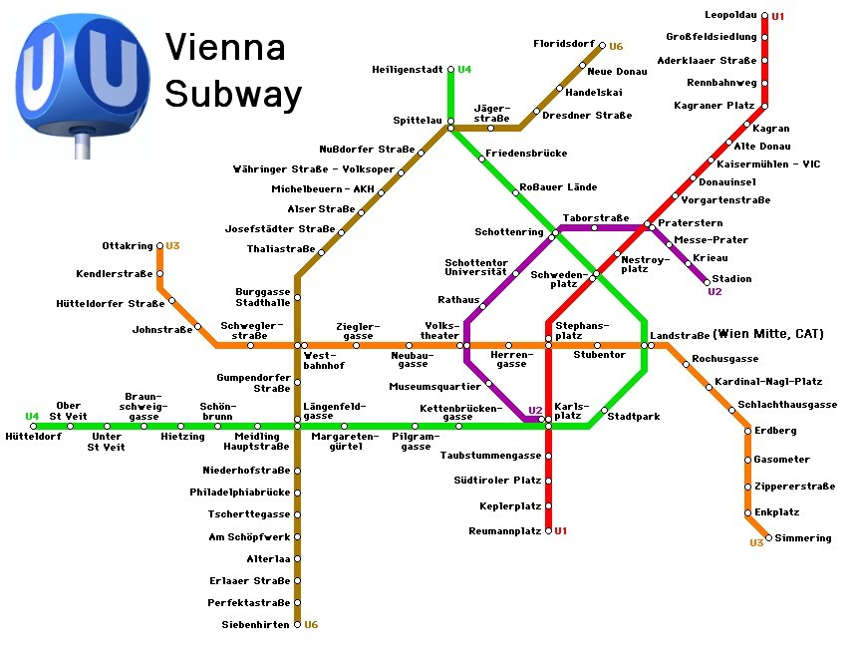

**How to arrive at FTW**

|  |  |
| --- | --- |
| FTW Forschungszentrum Telekommunikation Wien GmbH Tech Gate Vienna, Donau-City-Straße 1, 1220 Wien, 2nd floor, Meeting Room ‘Andromeda’ <http://www.ftw.at/kontakt/Anfahrtsplan-TGV.pdf> | |
| Take the underground line  U1 (red line) in direction Leopoldau  Get off at:  Kaisermühlen – VIC  Take the exit in the direction tagged  ‘Austria Center’ or ‘Schüttaustraße’. |  |
| Go downstairs turn right and proceed in the direction depicted with red dots.  -Tech GATE - |  |
| Take the entrance on the right side  of the bridge of the Tech Gate Building, 2nd Floor, Room ‘Andromeda’ (On Sunday, take the entrance on the left side, go to the 3rd floor and walk over the bridge to the right side) | Beschreibung: C:\Users\brandtner\Desktop\techgate_spil_gross.jpg |

1. **Hotels**

**SUITE NOVOTEL WIEN MESSE**

Radingerstrasse 2  
1020 Wien

Tel: (+43)1/245880

Fax: (+43)1/24588188  
E-Mail: [h3720@accor.com](mailto:h3720@accor.com)

Website: <http://www.accorhotels.com/gb/hotel-3720-suite-novotel-wien-messe/index.shtml>

The hotel is located near underground station U1 Vorgartenstrasse and 2 stops from FTW   
(U1 Kaisermühlen VIC) and 7 min to the City Center.

There is a quota of 20 rooms reserved at this hotel, until **28 September 2012**.  
Please fill Novotel hotel reservation form (attached).   
- Single room incl. breakfast: 106 Euro / room / night   
- Double room incl. breakfast: 118 Euro / room / night  
Individual reservation and payment at the hotel is obligatory for the participants.

**ARCOTEL KAISERWASSER**Wagramer Strasse 8

1220 Wien

Tel: (+43) 1 224 24-0  
Fax: (+43) 1 224 24-710  
E-Mail: [kaiserwasser@arcotelhotels.com](mailto:kaiserwasser@arcotelhotels.com)  
Website: <http://www.arcotelhotels.com/en/kaiserwasser_hotel_vienna/>

Single room without breakfast: about 109 Euro / room / night (plus Breakfast € 20)  
The hotel Arcotel is located opposite the Techgate.

Reservation and payment is on your own responsibility.

**HOTEL CAPRICORNO**Schwedenplatz 3-4  
1010 Wien  
Tel: (+43)153331040  
Fax: (+43)153376714  
E-Mail: [capricorno@schick-hotels.com](mailto:capricorno@schick-hotels.com)  
Website: <http://www.schick-hotels.com/index-hotel-capricorno-vienna.en.htm>

Reservation is on your own responsibility.  
The hotel is located in the Center of Vienna (Underground line U1, Schwedenplatz ).

1. **Restaurants near FTW / Tech Gate**

**Restaurant UNO Kaiserwasser**Wagramer Strasse 8 (location opposite Techgate)  
À la carte: 12.00 a.m. - 2.30 p.m. and 6.00 p.m. - 10.30 p.m.

Kaiserwasser brunch, Sundays, 12.00 a.m. - 3.00 p.m.

Tel. (+43) 1 224 24-866

<http://www.restaurantuno.at/index.asp?lang=en>

**Restaurants in Shopping Center Donauzentrum / Cinemas Donauplex**

U1 Station ‘Kagran’ (2 Stops from U1 ‘Kaisermühlen’)

<http://www.donauzentrum.at/W/do/centre/anfahrt>

1. **Host contact Person**

Name: Dr Peter Fröhlich  
E-Mail: [froehlich@ftw.at](mailto:froehlich@ftw.at)

Telephone: +43 (0)150 528 30 85   
Mobile: +43 (0)664 826 98 65

**HOTEL RESERVATION FORM**

|  |  |
| --- | --- |
| **Suite Novotel Wien Messe**  **Radingerstrasse 2**  **1020 Wien**  **Tel: +43 1 245 88 0**  **e-mail:** [**h3720@accor.com**](mailto:h3720@accor.com) | http://www.fnetravel.com/english/uae/dubaihotel/al-barsha-tecom-greens/suitenovotelmalloftheemirates/suite-novotel-mall-of-the-emirates-logo.jpg |

**Meeting Name: *“*ITU-T*”***

**Date: 28. – 30.10.2012**

***ANMELDEFRIST / DEADLINE: 12.10.12***

**GAST INFORMATION / GUEST INFORMATION**

**Nachname / Surname**: \_\_\_\_\_\_\_\_\_\_\_\_\_\_\_\_\_\_\_\_\_\_\_\_\_\_\_\_\_\_\_\_\_\_\_\_\_\_\_\_\_\_\_\_\_\_\_\_\_\_\_\_\_\_\_\_

**Vorname / Firstname**: \_\_\_\_\_\_\_\_\_\_\_\_\_\_\_\_\_\_\_\_\_\_\_\_\_\_\_\_\_\_\_\_\_\_\_\_\_\_\_\_\_\_\_\_\_\_\_\_\_\_\_\_\_\_\_\_

**Company Name / Address**: \_\_\_\_\_\_\_\_\_\_\_\_\_\_\_\_\_\_\_\_\_\_\_\_\_\_\_\_\_\_\_\_\_\_\_\_\_\_\_\_\_\_\_\_\_\_\_\_\_\_\_\_\_\_\_\_

**PLZ / Postal Code**: \_\_\_\_\_\_\_\_\_\_\_\_\_\_\_\_\_**City & Country**: \_\_\_\_\_\_\_\_\_\_\_\_\_\_\_\_\_\_\_\_\_\_\_\_\_

**Tel.: / Phone**: \_\_\_\_\_\_\_\_\_\_\_\_\_\_\_\_\_\_\_\_\_\_\_\_\_\_\_\_\_\_\_\_\_\_\_\_\_\_\_\_\_\_\_\_\_\_\_\_\_\_\_\_\_\_\_\_

**Fax / e-mail**: \_\_\_\_\_\_\_\_\_\_\_\_\_\_\_\_\_\_\_\_\_\_\_\_\_\_\_\_\_\_\_\_\_\_\_\_\_\_\_\_\_\_\_\_\_\_\_\_\_\_\_\_\_\_\_\_

**ZIMMERINFORMATION / ROOM INFORMATION**

**Ankunft / Arrival: \_\_\_\_\_\_\_\_\_\_\_\_\_\_\_\_ Abreise / Departure: \_\_\_\_\_\_\_\_\_\_\_\_\_\_\_\_**

**Zimmer für 1 Person: 106,00 EUR Room for 1 person: 106,00 EUR**

**Zimmer für 2 Personen: 118,00 EUR Room for 2 persons: 118 ,00EUR**

Die Preise verstehen sich pro Zimmer pro Nacht, inclusive reichhaltigem Buffetfrühstück, Service und allen Abgaben.

Check in ist ab 14:00 Uhr möglich, check out bis 12:00 Uhr:

Mentioned rates are per room per night incl. full buffet breakfast, service and all taxes.

Check in is possible from 2pm on, check out till 12am.

**Buchungs- und Zahlungskonditionen / booking and payment conditions**

**\*** **Die Bezahlung erfolgt direkt im Hotel**. Als Zahlungs- und Buchungsgarantie muss eine Kreditkartennummer mit Ablaufdatum bekannt gegeben werden. Eine kostenlose Stornierung ist bei Fixbuchung bis 72 Stunden vor Anreise möglich. Bei zu später Stornierung oder nicht Anreise (No Show) werden 100 % der gebuchten Leistung von Ihrer Kreditkarte abgebucht.

**\***  **Payment direct in the hotel**. For paying and booking guarantee a credit card number with expiry date is compulsory to qualify the booking. Cancellation free of charge is possible until 72 hours prior arrival. If you cancel your booking too late or in case of No Show, 100 % will be charge from your credit card.

**Kreditkarteninformation / Credit Card Information**

**VISA: □ DINERS: □ AMEX: □ EC / MC: □**

**Kreditkartennr. / credit card number: \_\_\_\_\_\_\_\_\_\_\_\_\_\_\_\_\_\_\_\_\_\_\_\_\_\_\_\_\_\_\_\_\_\_\_\_\_\_\_\_\_\_\_\_\_\_\_\_\_\_\_\_\_\_\_\_\_\_\_**

**Ablauf Datum / expiry date: \_\_\_\_\_\_\_\_\_\_\_\_\_\_\_\_\_\_\_\_\_\_\_\_\_\_\_\_\_\_\_\_\_\_\_\_\_\_\_\_\_\_\_\_\_\_\_\_\_\_\_\_\_\_\_\_\_\_\_**

**Name des Kreditkarteninhabers/Name of credit card holder: \_\_\_\_\_\_\_\_\_\_\_\_\_\_\_\_\_\_\_\_\_\_\_\_\_\_\_\_\_\_\_\_\_\_\_\_\_\_\_\_**