Telecommunication Standardization  Bureau | 

Geneva, 8 September 2010

Ref: | TSB Circular 137  COM 13/TK | - To Administrations of Member States of the Union
Tel:  Fax:  E-mail: | +41 22 730 5126  +41 22 730 5853  tsbsg13@itu.int | Copy:  - To ITU-T Sector Members;  - To ITU-T Associates;  - To the Chairman and Vice-Chairmen of  Study Group 13;  - To the Director of the Telecommunication Development Bureau;  - To the Director of the Radiocommunication Bureau

Subject: | Seventh meeting of the Focus Group on Future Networks (FG-FN)  Busan, Korea, 26-29 October 2010
Dear Sir/Madam,
1 I am pleased to announce that the seventh meeting of the FG-FN is scheduled to take place at the Paradise Hotel, Busan, Korea, from 26 to 29 October 2010, inclusive, at the kind invitation of Electronics and Telecommunications Research Institute (ETRI), Korea.
The meeting will open at 0900 hours on 26 October 2010 at the Sydney meeting room, main building, second floor of the Paradise Hotel.
Detailed information concerning the meeting room and registration will be displayed at the meeting venue. No registration fee is required for participating in this meeting.
2 Discussions will be held in English only. Please also note that this is a paperless meeting.
3 I would like to remind you that the FG-FN is open to ITU Member States, Sector Members and Associates. This FG-FN is also open to any individual from a country which is a member of ITU and who is willing to contribute to the work, which includes individuals who are also members or representatives of interested Standards Development Organizations.
4 As agreed to with the Chairman of the Focus Group, Mr. Takashi Egawa, the initial time plan is given in Annex 1. Updates related to the meeting will be made available on the Focus Group web page: http://www.itu.int/ITU-T/focusgroups/fn/index.html, as well as any contributions received.
5 All contributions to the seventh meeting should be sent to the following electronic email address: tsbsg13@itu.int. In preparing your documents please use the basic template for the FG documents available at http://www.itu.int/oth/T0A0F00000F/en and FG-FN webpage.
As per the FG-FN working procedures the deadline for submission of documents is 18 October 2010.
6 Wireless LAN facilities are available for use by delegates at the venue. Detailed information will be available on site.
7 Additional information on the meeting venue and hotels is provided in Annex 2 and a hotel reservation form for the Paradise Hotel, Busan, Korea can be found in Annex 3.
8 To enable TSB and the host to make the necessary arrangements concerning the organization of the Focus Group meeting, I should be grateful if you would register via the on-line form at http://www.itu.int/ITU-T/focusgroups/fn/index.html, as soon as possible, but not later than 12 October 2010. Please note that pre-registration of participants to the meeting is carried out exclusively online. To easily provide you with any updates concerning the meeting planning, please fill in your valid e-mail address on your registration form.
9 We would remind you that citizens of some countries are required to obtain a visa in order to enter and spend time in Korea. The visa must be requested and obtained from the office (embassy or consulate) representing Korea in your country or, if there is no such office in your country, from the one that is closest to the country of departure. Please be aware that visa approval might take time so kindly make your request for the invitation letter as soon as possible.
Participants who require an invitation letter and/or a visa supporting letter for entering Korea are advised to get in touch with the contact persons in this country whose detailed information is as follows:
- General contact

Hyoung-Jun Kim (ETRI)

E-mail: khj@etri.re.kr

Phone: +82-42-860-6576

Fax : +82-42-861-5404
- Local arrangement

Sangjin Jeong (ETRI)

E-mail: sjjeong@etri.re.kr

Phone: +82-42-860-1877

FAX : +82-42-861-5404
Yours faithfully,
Malcolm Johnson
Director of the Telecommunication
Standardization Bureau
Annexes: 3
ANNEX 1
(to TSB Circular 137)
Time plan for the seventh meeting of the Focus Group on Future Networks
26-29 October 2010

Tuesday  26 October | Wednesday  27 October | Thursday  28 October | Friday  29 October
9:00-18:00 | 9:00 - 18:00 | 9:00 - 18:00 | 9:00 - 18:00
ITU-T  FG-FN | ITU-T  FG-FN | ITU-T  FG-FN | ITU-T  FG-FN
Meeting arrangements and Contributions review | Contributions review | Contributions review | Drafting activities and Wrap up with future planning

ANNEX 2
(to TSB Circular 137)

GENERAL INFORMATION
Seventh meeting of the Focus Group on Future Networks
(26-29 October 2010, Busan, Korea)

- Meeting schedule
- October 26 (Tue)~ October 29 (Fri), 2010
- Meeting location
- Busan, Korea
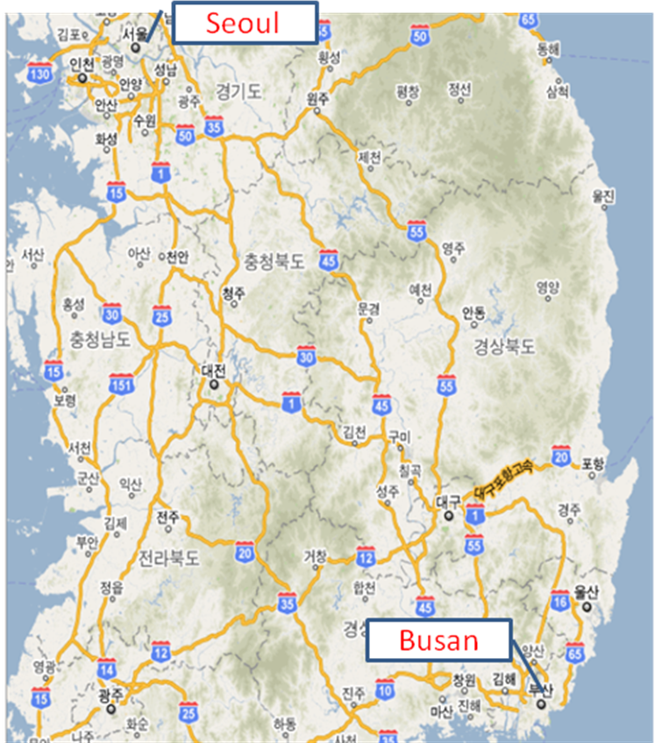

Venue: Paradise Hotel Busan http://busan.paradisehotel.co.kr/en/ (English)
Meeting room: Sydney Room (Main Building, 2F)
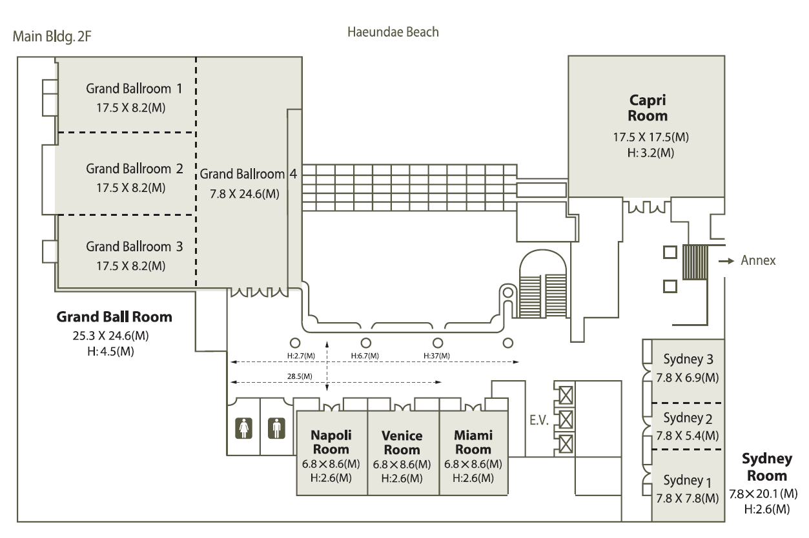

Accommodation: Hotel Paradise (venue)
Special rates are available to FG-FN participants
Service charge and TAX (21%) will be added to the above rate.
Breakfast is not included but available (20,000 KRW/Person plus service charge&TAX).
To reserve a hotel room, fill out the reservation form in Annex 3 and send it to res@paradisehotel.co.kr

Accommodation (other hotels):
There are many hotels around Haeundae beach
- Novotel Busan, http://www.novotelbusan.com/eng/index.php
- Westin Chosun Busan, http://twcb.echosunhotel.com/index_en.asp
- Haeundae Grand Hotel, http://www.grandhotel.co.kr/english/default.aspx

Transport information:
Busan is 50 minutes away from Gimhae (Busan) international airport.
There are domestic flights from Incheon International airport or Gimpo International airport to Gimhae airport.
Also, there are some international flights to Gimhae international airport.
For detailed transportation information please see: http://busan.paradisehotel.co.kr/en/about/location.asp
ANNEX 3
(to TSB Circular 137)
Hotel reservation form for Paradise Hotel, Busan, Korea
Room Reservation Request
ITU-T FG-FN 7th Meeting

Paradise Hotel Busan, Korea
Oct.25~Oct.29.2010

Please fill up this form and send it to Paradise Hotel Busan.

PLEASE COMPLETE IN CAPITAL LETTERS
Personal Information
Mr | Mrs | Ms | First Name | Family Name
Address
Nationality |  | E-mail
Tel |  | Fax
Check in Date & Time |  | Check out Date & Time
Card Type |  | Card Hold's Name
Card No.
Exp. Date | (mm/yy)
Room Requirement
Deluxe city view room | Double Twin | KRW 150,000 | Breakfast  KRW 20,000 per person  1 person 2person
Deluxe side view room | Double Twin | KRW 170,000 | Breakfast  KRW 20,000 per person  1 person 2person
Deluxe sea view room | Double Twin | KRW 190,000 | Breakfast  KRW 20,000 per person  1 person 2person
Special Requests
-. If your Desire room type is not available. Paradise Hotel Busan will select the next best alternative category.
-. All rates are for single or double occupancy and subject to 10% service charge and 11% government tax .
-. Credit card guarantee must accompany your reservation request, your credit card will not be charged for your advance deposit. However card will be charged for late cancellation fees and no-shows, if applicable.
CANCELLATION POLICY
-. There will be 1night charge for any reservation cancelled after 22.Oct.2010.
-. No-show reservation will be charged the group rate for all nights reserved
CHECK-IN TIME 14:00 CHECK-OUT TIME 12:00 NOON
Please return form with your credit card information to : FLIGHT INFORMATION
Paradiase Hotel Busan - Reservations Center FLIGHT TIME
Joongdong 1408-5, Haeundaeku, Busan, Korea zip code : 612-010 ARR:__________/___________
Phone : +82 51 749-2111~3
Fax: +82 51 749-2004 DEP :__________/___________
E-Mail : res@paradisehotel.co.kr web-site : www.paradisehotel.co.kr

